DOCUMENT CONTROL
PROCESS: Digital Account Specialist (Implementation-Support-Proactive)
Revision No. | Effective Date | Originator | Revision History
00 | 12 December 2017 | Arlyn Joy Acain  Jimmy Wapille Jr. | Origination

Process Name: Digital Sales Consultant (Lead Generation-Cold Call-Sales Call)

Step | Process | Duration | Output | Output Requirement
1 | Lead Generation  •Leads from HQ are distributed to the reps.  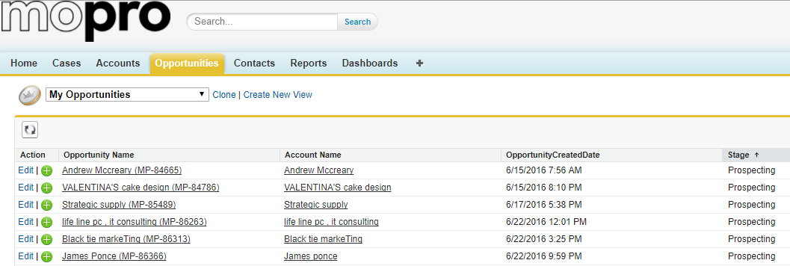  •Excel sheet containing raw data for cold calling are given to the reps from the HQ.  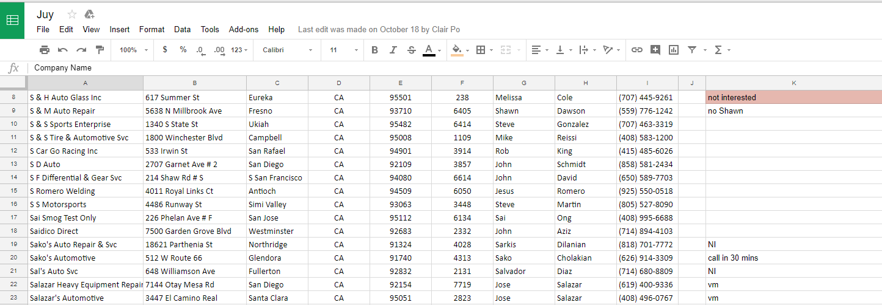  •There are times that the reps would request leads from former DSCs to be assigned to their bucket.  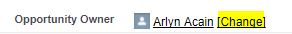 | 0 | •The reps would now have the leads in their bucket.  •The reps should create a lead in leads.mopro.com.  •The Sales Manager would have to confirm if the rep already had contact with the prospect. | •The leads would now be in Salesforce and the reps should go through each lead and contact them.  • The Sales Reps manually input the data of the lead into this form. Required fields are the following:  - First Name  - Last Name  - Email Address  - Phone Number  - Business Name  - Industry  - Source  - Sales Rep  •If the rep was able to speak to the client and set an appointment for the spec reveal, the stage would be changed from Prospecting UTC/Prospecting to Spec Scheduled.  •Once the rep has been in contact with the lead, the Sales Manager would then change the name of the Opportunity Owner.
2 | •The rep contacts the lead and a free site preview is offered.  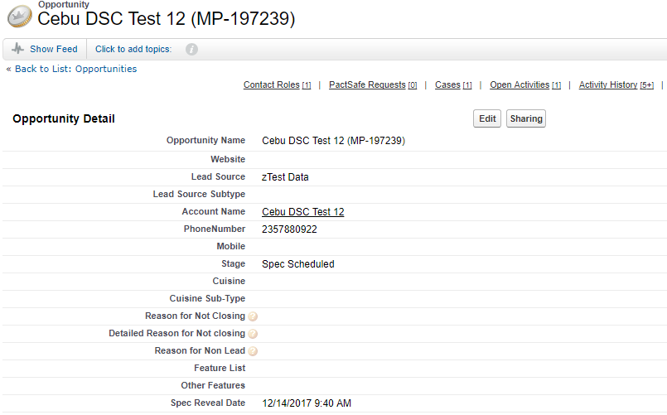  •The rep should gather more information about the client’s business.  In this part of the process, vital information necessary for the Spec Build is collected so the builders may start working on the Spec Build.  If the lead has an existing website, the rep must ask if the contents found on their website could be used to build the spec site. | 20 | •The prospect would have an idea of how a Mopro website looks like.  •Rep should gather more information about the client’s business. | •The rep should call the lead from the Opportunity list.  •The rep should schedule a spec reveal date once the lead agrees to a spec site reveal (unless it's an ambush spec reveal).  •The rep should ask these discovery questions:  • Top of the line business website?  • How much of their revenue is dependent on their online presence?  • How much advantage do they take from Social Media to market their brand/products?  • Do they have tools to check their Competitor’s performance?  • What is the size of their business?  • What is their business classification? Local, National or Global?
2.1 | •If the lead declines:  •General decline  •Not interested  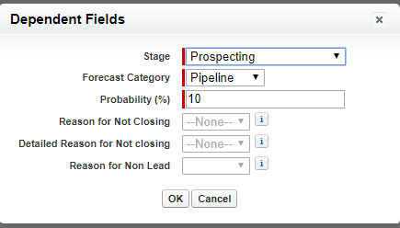  •Removal Request  •If the lead wants to be added to the DNC list  •Wants more information  •If the lead is unable to answer:  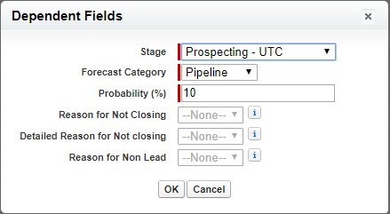 | 5 | •Opportunity is tagged as prospecting  •The rep acknowledges the request and not call the prospect.  •The prospect would receive the requested information through email. | •Open the opportunity, on the “Opportunity Details” under “Stage” ensure that the lead is tagged as prospecting, so the rep could still call the prospect at a later date.  • The rep should notify the Sales Manager about the request and possible replacement for a new lead.  •The rep should send the information via email as requested by the prospect or proactively sends the information.  •The rep must tag the stage as “Prospecting UTC”.  The rep must leave a voicemail so the prospect can call back the soonest time they're available.
2.2 | If the lead agrees to a Spec Reveal:  •Rep MUST create “Spec Site Build Request” through JIRA  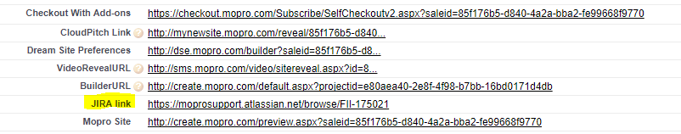  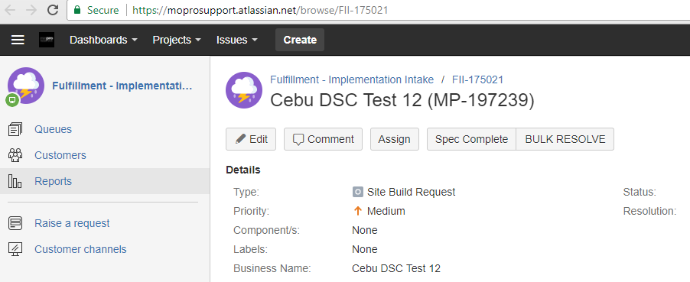  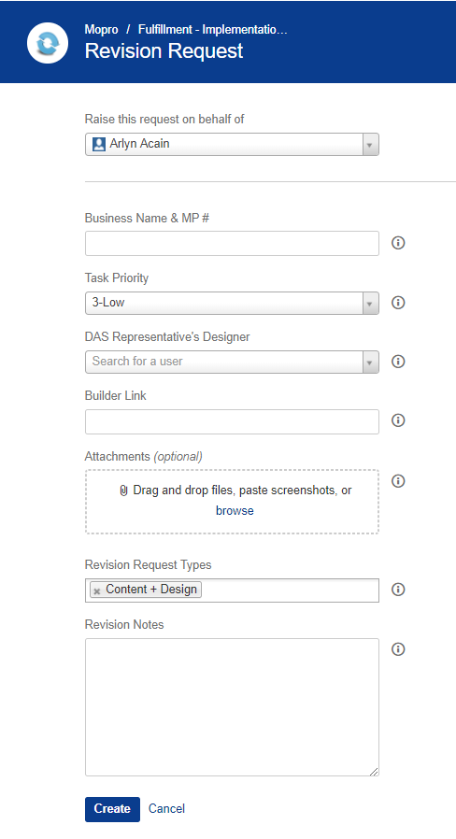 | 10 | •Builder will then work on the spec site based on the information that the rep has gathered based on the first call. | •If the opportunity has a functional JIRA link, the rep should request a spec site build using this format:  •Spec Reveal Deadline: (Philippine time and date)  •Framework type: E-COMM/IDX/V2  •Special Instructions: (provide design preferences or features in this section)  •If the opportunity has a broken JIRA link, the rep should request a spec site build through the Sales POC using this format:  •Sales force ID/link:  •Opportunity name/ MP Number:  •Spec site schedule:  •Framework type: E-COMM/IDX/V2  •Industry:  •Current site:  •Instruction:
3 | •Rep MUST schedule the spec reveal date and time then send a calendar invite via email.  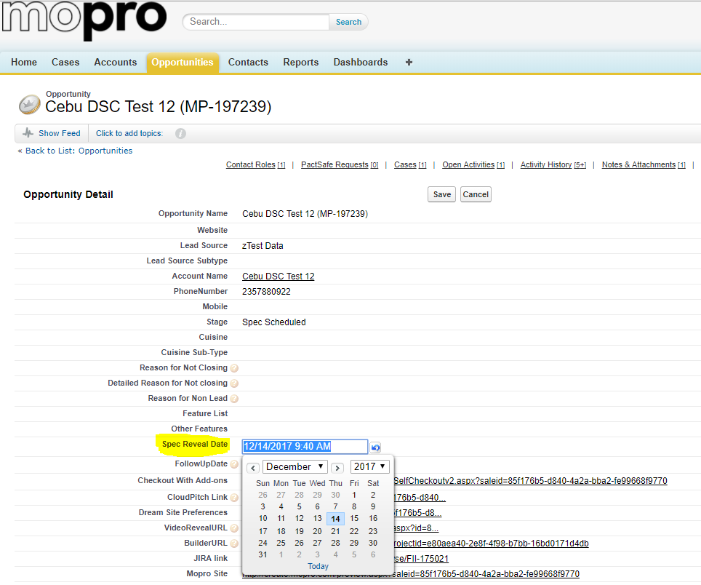  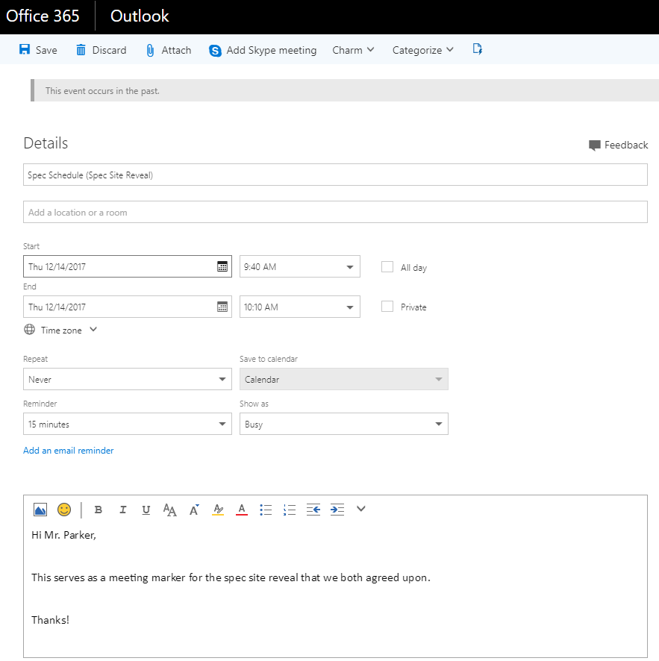 | 5 | •Both the prospect and the rep will be reminded of the appointment | •The rep must select the agreed date and time for the spec reveal  •The rep should also send the prospect a calendar invite.
4 | •The rep should call the prospect on schedule.  •If the client wants to reschedule:  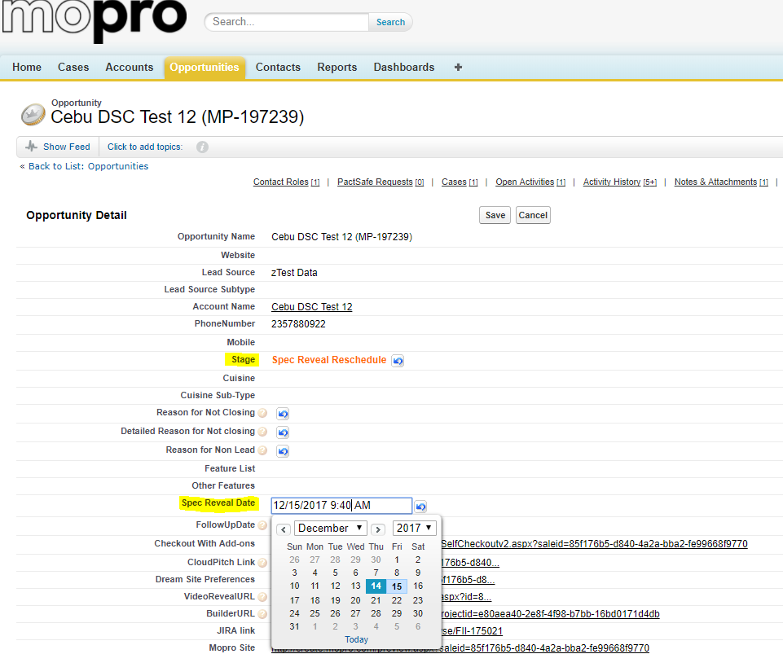  •If the prospect does not show up during the scheduled date and time for the spec reveal:  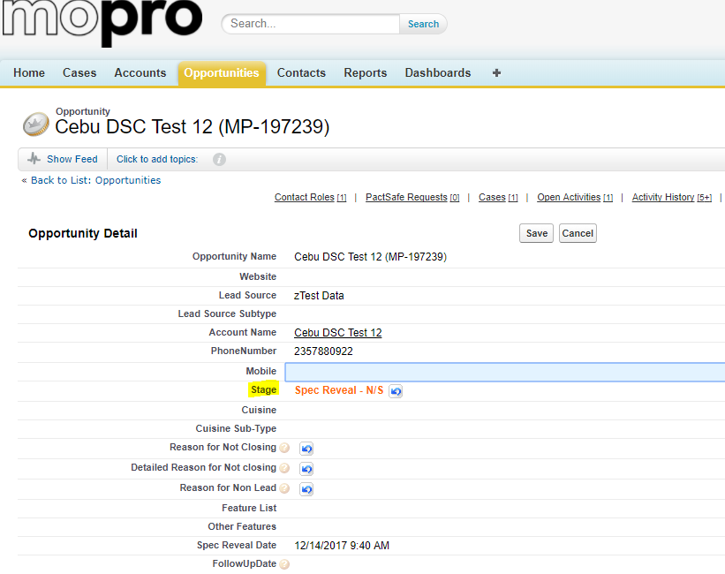  •If the prospect cancels the scheduled spec reveal  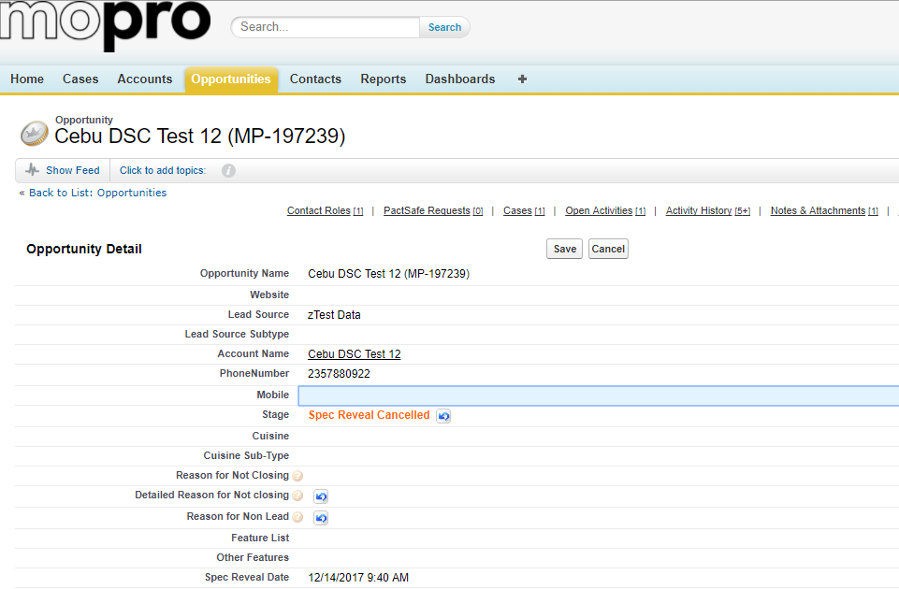  •If the rep was able to do the spec reveal or product presentation  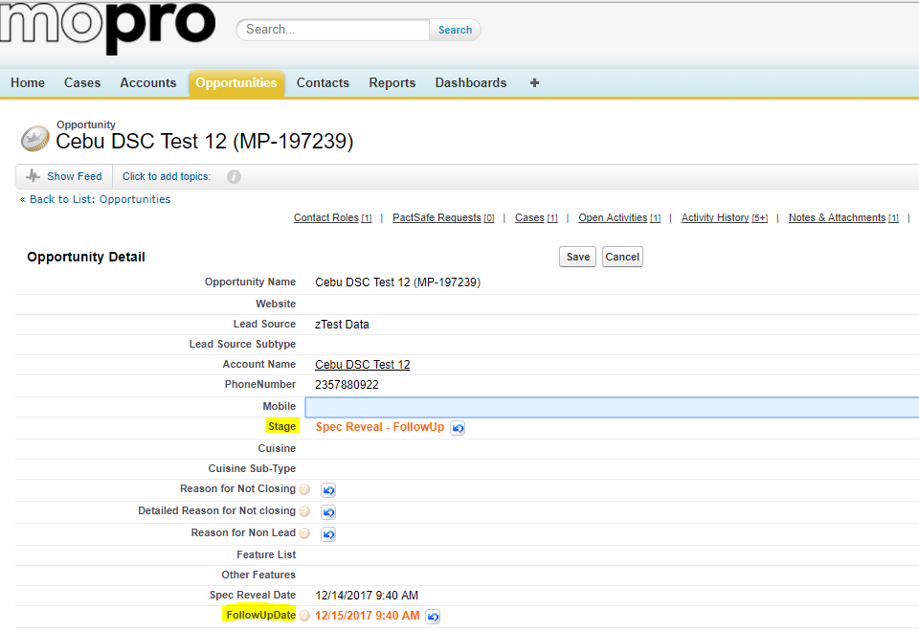  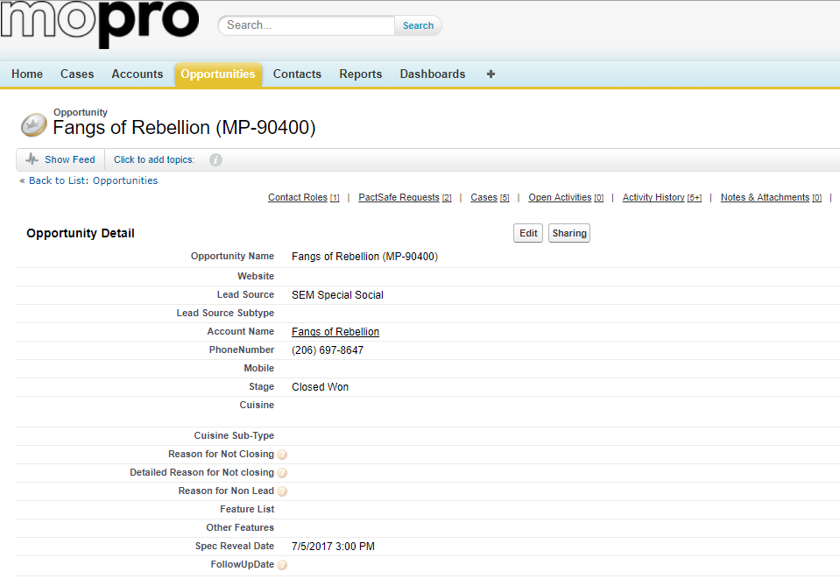  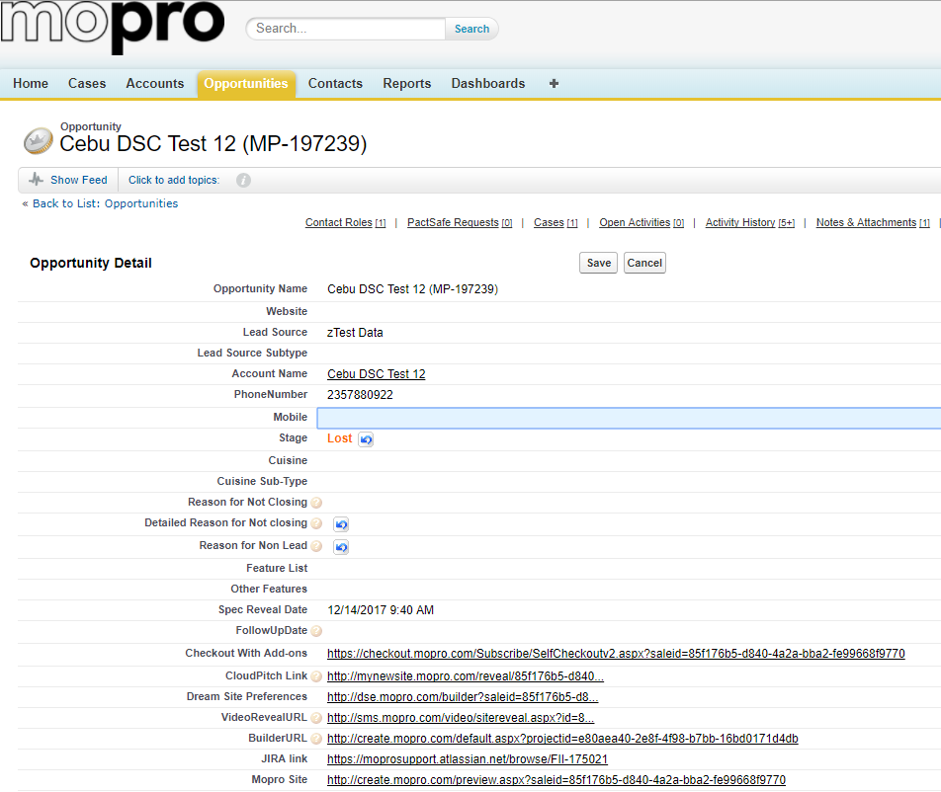  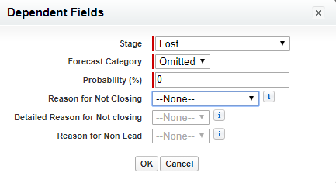 | 5  0  5  ~ |  | Reschedule  •Change staging to “Spec Reveal Schedule”  •Change the Spec Reveal Date to the desired new appointment date  No Show  •Change staging to “Spec Reveal N/S"  •The rep can call the prospect back on another date and time.  Cancelled  •Change staging to “Cancelled”  Show  •Not finished  •Change staging to “Follow-up” if applicable  •Select the date and time on the follow-up date tab  •Closed  •The system will automatically tag the staging to “Closed Won”.  Lost  •Client does not want to sign up after the spec reveal, the rep must take note of the reason and add it to the sales showstopper form.  •The rep should also change the staging to "Lost" and select the reason for not closing the deal.
5 | •Spec Reveal - this is where the Sales Rep reveals the Spec Site (according to when the Spec Reveal Date is scheduled).  •The rep could either show a spec site  or a live Mopro website.  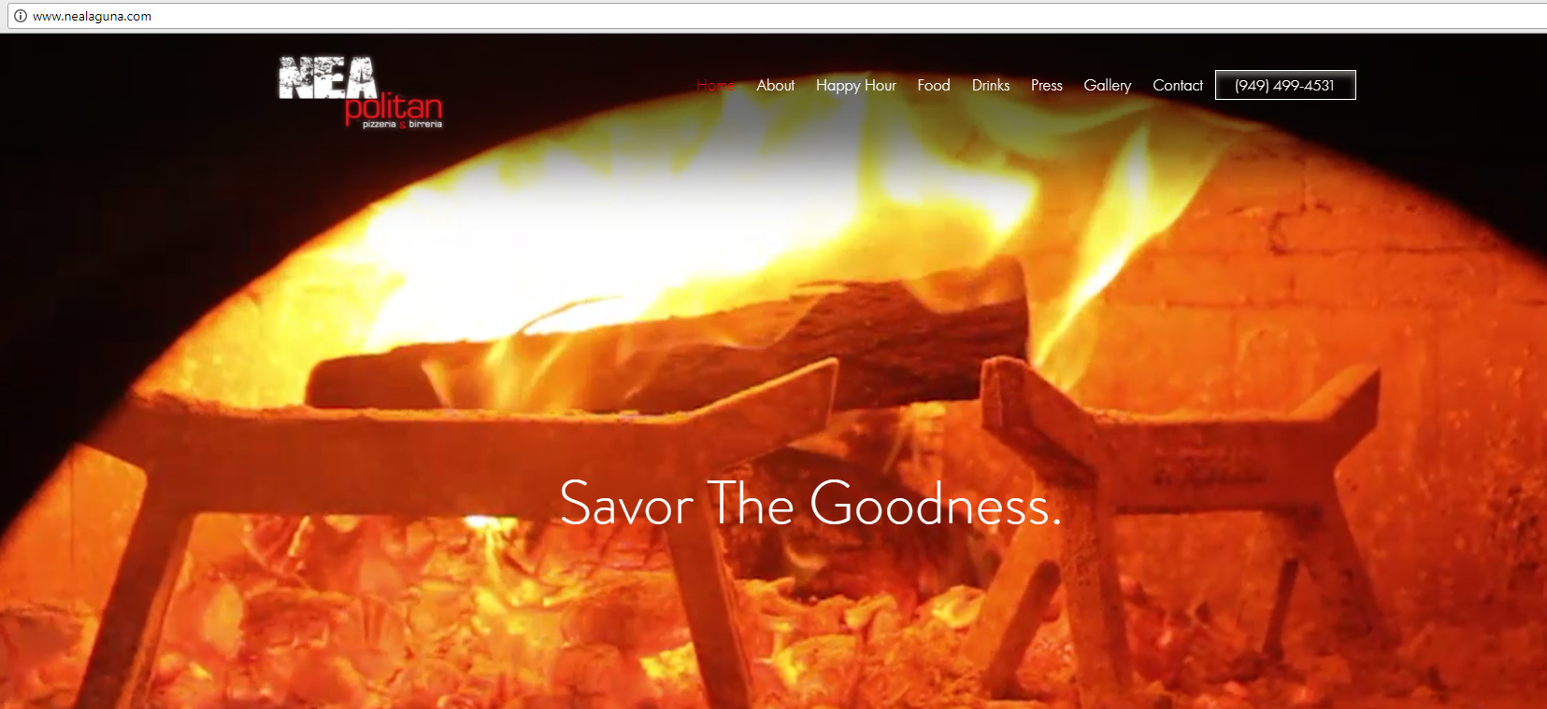  •The rep could also give the prospect a walkthrough of the Digital Command Center.  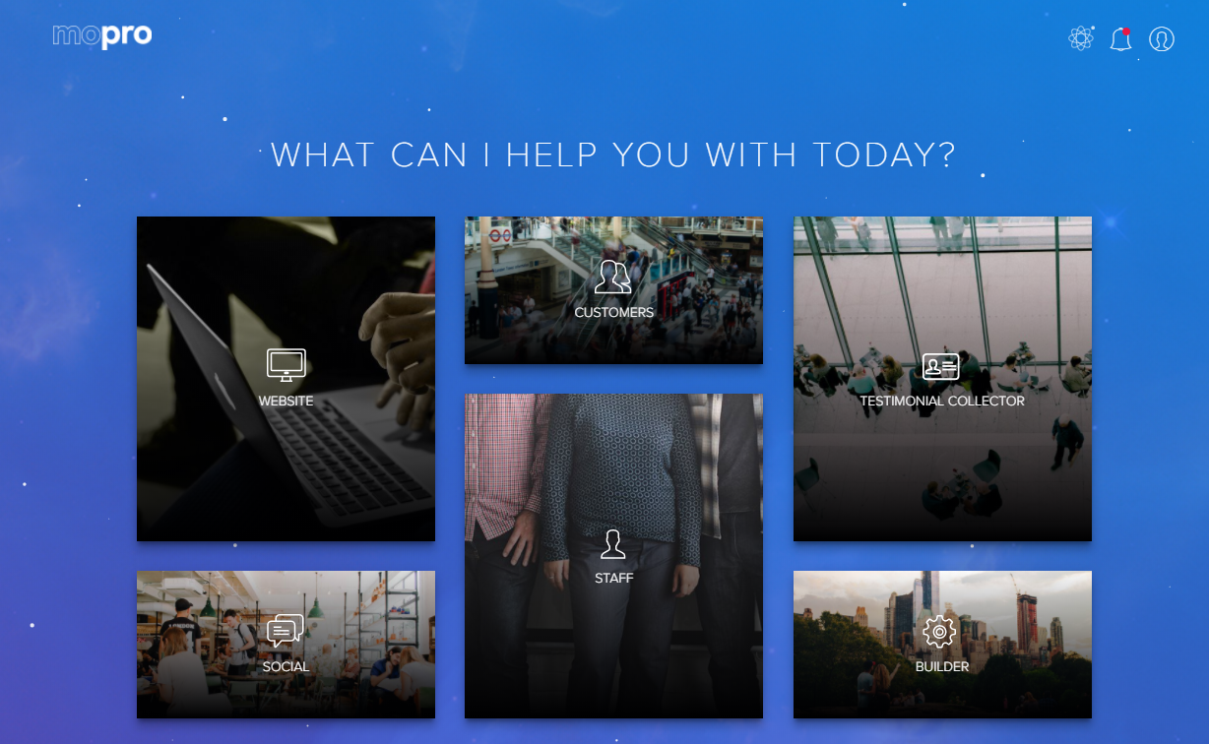 | 30 | •The prospect would have an idea of how a Mopro website looks like. | •The sales rep should:  - call the lead, according to the Spec Reveal schedule (if applicable as there are instances that the rep can have an ambush spec reveal)  - go through the Spec Site presentation.  •The sales rep should do appropriate product positioning:  • Website  • FSVB (If applicable)  • Competition Tracker  • Reputation Manager  • A.I. Editor  • Social Publisher  • Social 365 (If applicable)  • E-Commerce Add-on (If applicable)  • SEO Add-on (If applicable)
6 | •If the prospect asked questions regarding Mopro as a company, price, product and features | ~ | • The prospect would now have an idea of what Mopro is, the prices that it offers and the products and features. | •The Rep should be able to effectively address:  • Pricing-related question  • Feature-related question  • Trust-related question
7 | •The rep should be able to use appropriate sales techniques. | ~ | •The rep will be able to gain trust and make the prospect comfortable in stating his/ her needs and will be able to close the sale. | •The rep can use the following sales techniques:  • Rapport Building  • Competitor Technique  • Storytelling Technique  • Problem-Solution Technique  • Urgency Technique  • Trial Close/Assuming the Sale  • 3 Bucket Close  • One Call Close
8 | •If the prospect has an objection during the call the rep should be able to provide an effective rebuttal.  •If the rep is having a tough time in overcoming objections, he/she should request the sales manager to take over the call.  •If the prospect has concerns regarding cancellations or early termination, the rep should take any retention steps. | ~ | •The rep will have a chance to address the prospect's concerns or queries. | •The rep should at least provide 5 rebuttals for each query.  •The rep should maintain control of the call/ conversation.  •The sales manager should attempt to persuade the client to sign up.  •The sales manager can opt to close the deal or give it back to the rep.  •The rep should follow the prescribed retention talking points especially for those prospects that are leaning towards the $1 deal. The rep should NOT do any type of rescission sale/ communicate the following:  •Free Trial  •No agreement  •You only lose $1  •No commitment needed  •There are only 100 slots and if you try this out you will be 72  •You have nothing to lose  •It's just a $1  *Anything similar to the above mentioned
9 | •The rep should effectively deliver the different price points and the auto billing provision.  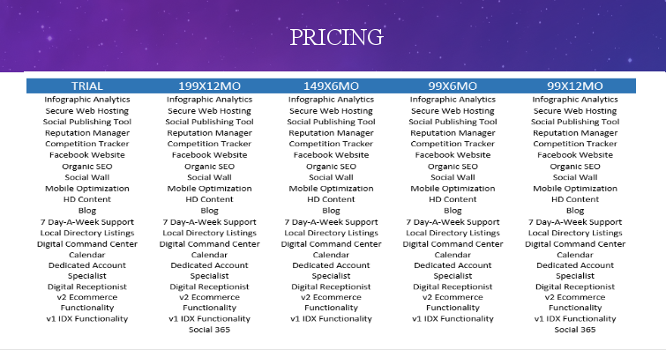 | 15 |  | •The rep could either give the prospect any of these price points:  For $1 deal  •$99/month minimum 12 months commitment  •$149/month minimum of 6 months  •$199/month  *The rep should inform the prospect that for $1 deals, after 30 days, the full payment and the term of the agreement automatically trigger*  For standard pricing:  •$99/ month minimum 6 months or 12 months commitment.  •$149/month minimum of 6 months.  •$199/month minimum of 12 months commitment  *for any price point that the prospect would want to sign up for with a minimum of 1-year commitment, the payment should be in full upon point of sale*  •For Auto billing provision, the rep should inform the prospect that for standard pricing deals, Mopro will debit their [Credit Card Provider] today and monthly on the anniversary date of sign up in the  amount of [Dollar Amount].
10 | •If the prospect is going to sign up with Mopro, the rep should fill out the checklist accurately and completely so that the website build process would be faster. | 15 |  | •The rep should fill out the checklist and pay attention to:  •3 value props which makes them stand out from their competitors  •3 online objectives based on the client's business website needs  •domain name info (if client has an existing domain)  *if client does not have an existing domain, the rep should set clear expectations set on Domain settings  •explain the importance of having an SSL certificate and ask the client if they already have one especially for E-COMM prospects.  •Business color  •General design.  •Requested functionalities and additional site pages needed.  •Preferred images and content if available  *if the prospect does not have images, the rep can give the prospect the option to temporarily use stock photos from our media repository.  •social media links especially if the client does not have an existing website so that the DAS and the builders can data mine those social media accounts for any content regarding the client's business.
11 | •The rep MUST read the Fine Print | 15 |  | •Fine Print - the Sales Rep MUST read the Fine Print Script verbatim and uninterrupted, BEFORE checking out the lead. If the lead interjects, the script MUST BE REPEATED FROM THE TOP.  •The rep should set the proper expectation on extent of assistance that can be provided by the DAS team.  •You will have a 30-minute call with your DAS on the selected date and time. Your DAS will gather valuable information and apply their expertise to your new website, then work with you to take it online, scheduling an additional call as necessary.  •The rep should also discuss the different ways that the client can contact the ProTeam:  •Direct Connect App  •Call  •Email  •The rep should set the proper expectation on SEO:  search engine results rely  on algorithms that are not public and the amount of competition in your market.  Mopro cannot guarantee specific results, nor can any other provider, but we’ll  certainly, apply best practices for SEO.  *if the client wants to have local SEO, the rep should inform the client that this would be an add-on at $59/month*  •For IDX clients, the rep should set the proper expectation on the geographic regions Mopro's IDX  functionality supports:  • CRMLS, which covers Southern California  • The MLS, which covers Southern California  • Metro list, which covers the Denver area  • ABOR, which covers the Austin area  • NTREIS, which covers the Dallas area  *** While the regions mentioned above are supported by the corresponding MLS board, Mopro won’t  be able to list properties outside of our supported MLS boards. However, we will be able to  manually add up to 100 of your current and sold properties, if necessary. If your current MLS  board is not supported; your DAS may be able to help you iframe your  MLS board. However, please note that it’s possible that Mopro could run into some limitations.  •For E-commerce clients, the rep should set the proper expectation on Mopro's E-commerce platform:  • All e-commerce sites, whether hosted by Mopro or elsewhere, require an SSL  certificate. An SSL certificate is a digital file that protects your site; this is what  allows for secure purchasing through your site.  • In the case that you don’t have an existing SSL certificate or we’re unable to  transfer an existing one, we’ll purchase and set up an SSL certificate for you and  bill you at-cost for $69/year.  • During your implementation period, you are entitled to an initial store set-up of up  to 100 items with your Digital Marketing Coordinator. After implementation, you  will have access to our Digital Concierge Team to add additional store items for  you. You can also add store items yourself with your Digital Command Center at  any time.  • Mopro’s e-commerce platform does not accommodate:  The charge of recurring subscription fees  • Gated content (which is when a user has to provide some information  to access a hidden page on your site)  • Food delivery  Mopro will debit your card today in the amount of [$28 –or– $69] for:  • [Basic] Up to 1,000 products. Please note, this does not include auto-calculation of tax  or customer and discount groups.  • [Unlimited] Unlimited products in your online store, including auto-calculation of tax,  and customer and discount groups.
12 | Rep should obtain the CC information and must fill out the checkout form.  *** Billing information must be acquired/provided from/by the customer. Rep must not assume the billing information  Allowed: is the billing address same as the business address and that sort | 10 |  | Checkout - this is where the lead is converted into a client, and the sales process is ended. To accomplish this, the Sales Rep must fill out the checkout form with the following:  •Business Name  •Website URL  •Items/add-ons  •Promo code  •Payment info  •Business info  •Billing address  •Contact Info  •Sales rep info  •Tick agree on the terms and conditions  •Signature  •Then click confirm
13 | Cancellation/ Escalation Request | 10 |  | •Sales Team are unable to create Client Care cases, we can only endorse cancellation escalations to Fulfillment. Please see options below:  • Client wants to cancel and is willing to stay on the line to speak to someone, WARM TRANSFER TO CLIENT CARE #3756 and leave a note in the Case tied up with the Opportunity. If there is no available Client Care rep, inform the client that they will receive a call back from the Billing team and leave a note in the Case mentioning the Case Owner, Carmela Carlobos, Levin Bendijo, Jerome & me.  • Client wants to cancel and is not willing to stay on the line to speak to someone, EMAIL the details to Sales Manager and Sales Analyst so they can take care of reaching out to Fulfillment.

