**Wilfredo Menorias Jr.**

30-G, 7th St., Guadalajara, Guadalupe, Cebu City ⚫ Phone: +639995151053 ⚫ [investwiser101@gmail.com](mailto:investwiser101@gmail.com)

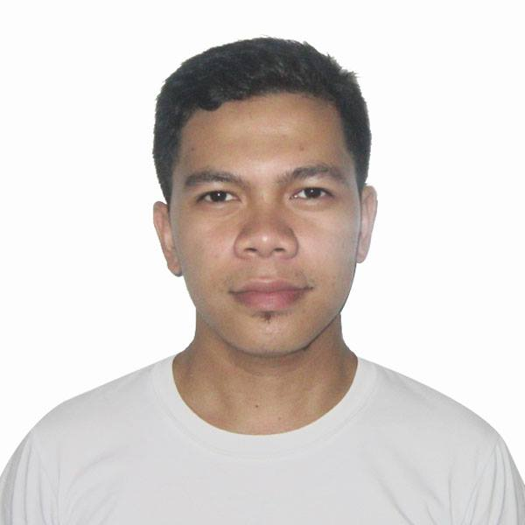

**Date of Birth : August 13, 1995**

**Place of Birth : Sogod, Southern Leyte**

**Age : 21**

**Citizenship : Filipino**

**Civil Status : Single**

**Gender : Male**

**Religion : Roman Catholic**

**Team Lead, Business Services Group**

* Respected leader of process knowledge and client project handling. Conceptualize and orchestrate standard operating procedures for newly hired associates that would enter the production floor.
* Expert in analysis of indicators that drives performance most specially in customer feedback and resolution of issues.

**Skills**

|  |  |
| --- | --- |
| * Corporate Communications * Creative Team Leadership * Computer Proficiency (Microsoft Applications) | * Troubleshooting of Local Internet Network * Effective facilitation of process updates |

|  |  |
| --- | --- |
| **Wilfredo Menorias Jr.** | Page 2 ⚫ Phone: +639995151053 |

**Trainings Undergone**

|  |
| --- |
| **Feedback and Coaching** *(Tech Mahindra),* 2016  **Quality Management Tools** *(Tech Mahindra),* 2016  **Dealing with Change (Management Policies)** *(Tech Mahindra),* 2016  **GROW Model Coaching** *(Tech Mahindra),* 2016  **Effective Facilitation, (Adult Learning)** *(Rotaract Club of Metro Cebu, Community Based),* 2016  **Project Management** *(Rotaract Club of Metro Cebu, Community Based),* 2016 |

**Professional Experience**

**VcUSTOMER pHILIPPINES (CEBU), INC., (a techmahindra company)**

A Multi-million dollar India-based Company than focuses on  BPO services across various industries including Telecom, Financial Services, Retail, Energy, Hospitality, Hi-Tech, Agriculture and Food and Beverage.

**Team Lead,** February 2015 to March 2017

Directly support and monitor a team of 13-16 technical support representatives attainment of client mandated performance targets. Generates reports on key performance indicators and behaviors that influence them. Inbound and outbound support for product recommendation for business and consumer clients to improve their experience in the telecommunication services the company provides.   
  
***Selected Accomplishments:***

* Pioneered the support team of the newly launched program. Help new associates manage customer calls.
* Selected as one of the first support team associates to move in a supervisory role.
* Chaired client project on long time open cases and ensuring the closure and customer updates.
* Led the analysis on open case repeat call within 24-48 hours after customer interaction.
* Created the Standard Operating Procedure for newly hired associates which includes performance targets and coaching frequency for improvement. Process has been used for more than 15 batches out of 31.
* Directly involved in tracking of product recommendations that associates offer to business and consumer accounts at which this project resulted in no less than 200.00% of quota attainment.

|  |  |
| --- | --- |
| **Wilfredo Menorias Jr.** | Page 2 ⚫ Phone: +639995151053 |

**CONVERGYS PHILIPPINES SERVICES CORP.**

A multi-billion US-Based Company that sells [customer management](https://en.wikipedia.org/wiki/Customer_management" \o "Customer management) and information management products, primarily to large corporations.

**Customer Service Associate,** July 2014 to January 2015

Directly reports to a supervisor, addresses customer calls in technical, billing and sales concerns.

**LEUTERIO REALTY**

The country’s fastest growing brand in real estate service. In less than five years since it’s inception, Leuterio Realty emerged as the most-sought after brand in real estate agency and brokerage firm because of it’s real assets - People.

**Real Estate Specialist**, May 2014 to Present

Rent, buy, or sell property for clients. Perform duties, such as study property listings, interview prospective clients, accompany clients, discuss conditions of sale, and draw up real estate contracts.

**Education**

**Saint joseph COLLEGE,** Maasin City, Southern Leyte

**Bachelor of Science in Accountancy,** June 2012 to March 2014

* Student Leader, Shepherds’ Voice Choir - Vice President
* 2 years in the course

**Character References**

Edsie Ann Alcoy

VcUSTOMER pHILIPPINES (CEBU), INC.,

(a techmahindra company)

Group Lead

+639294500552

Farrah Mae Herrera

VcUSTOMER pHILIPPINES (CEBU), INC.,

(a techmahindra company)

Group Lead

+639272263432