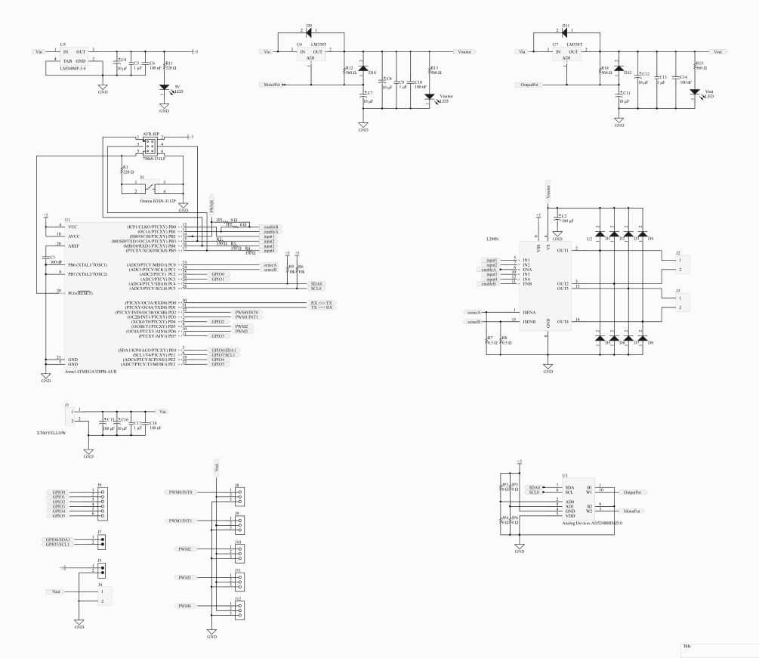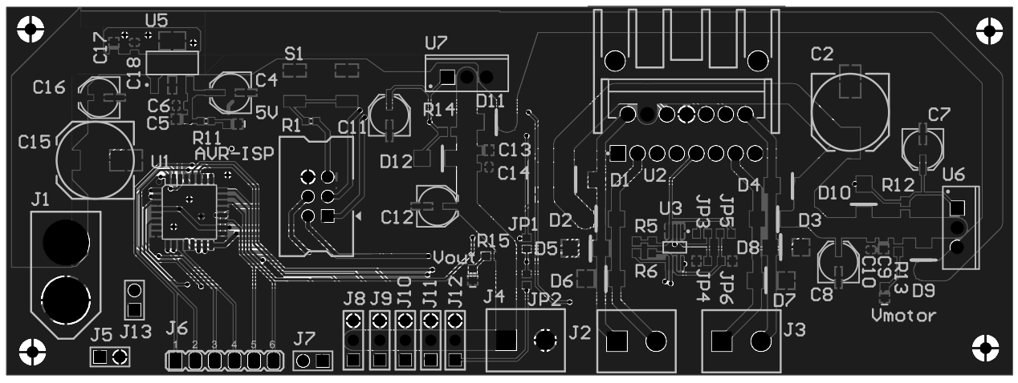

* Stepper and dual DC motor control.
* Dual digitally adjustable power supplies.
* RC, Pixhawk, and Ardupilot compatible.
* Integrate with Raspberry Pi and Arduino.

AVR-Based Robotics Controller

by

Justin Derickson

