# Supplemental Information for Appeal of Assessed Home Value

**Prepared By**

Justin & Rosa Deterding (Residents of 421Talbert Ct.)

Phone: 618-977-9796

Email: justin.l.deterding@outlook.com

**Address of Appealed Home Value**

421Talbert Ct.

Ballwin MO, 63021

## Executive Summary

We assert that the fair market value of our home is $261,000 which is the amount we purchased our home for in January of 2021. Furthermore, we show that the assessed value is drastically inflated due to the sale price of 432 Talbert Ct. (a comparable property listed on our Change of Assessment Notice). The analysis below shows that 432 Talbert Ct is a statistical outlier and should thus be excluded as a comparable home for the 2023 assessment.

## Supplemental Information

432 Talbert Ct. should not be used as a comparable home for the 2023 Assessment as the price of this home sale is a statistical outlier when compared to other comparable homes in the area. To show this the list of all homes sales was retrieved from the website of the [St Louis County Assessor’s Office](https://revenue.stlouisco.com/Assessment/Sales/Default.aspx?LocatorNum=24S640761). From the list of all returned home sales within a 1-mile radius, the following criteria was used to determine comparable homes.

1. Within $±$ 500 square ft of our “Total Living area”.
2. Within $+$ 0.2 and $- 0.1$ of our “Total Acres”.
3. Within $±$ 1 of our “Total Rooms” and “Half Baths”
4. “Architectural Type” and “Exterior Wall Type” were not filtered.
5. All else equal

The result of this filter returned 112 comparable homes. This search also returned all the comparable homes listed in the assessment notice, with the exception of 437 Melanie Meadows Ln, as this residence was not returned in the original data pulled from the assessor’s website. From the 112 comparable homes identified, the [Inner Quartile Range (IQR)](https://en.wikipedia.org/wiki/Interquartile_range) was computed using a trusted statistical and data analysis package [pandas](https://pandas.pydata.org/). The histogram below shows the distribution of the 112 home prices along with the upper bound of the IQR. The sale price of 432 Talbert Ct. exceeds the IQR by more than $25k (Figure 1).

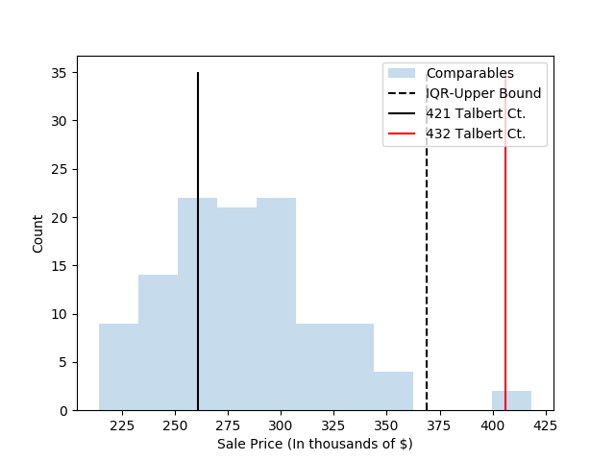

Given the small sample size the proposed assessment is based on (5 homes) the presence of such a statistical outlier would have an oversized effect on this assessment. From this we conclude that the sale price of 432 Talbert Ct. is not a reasonable comparison to our home and the appraised value computed is invalid. Instead we request the use of the recent sale price of our home to be used in it’s place on this assessment.

*Note: The script and data used to conduct this analysis are hosted on* [*GitHub*](https://github.com/jdeterding/StlCountyAssesment) *for your reference.*