Designing an Online Course Platform with Kubernetes and AWS

Justin DeKock
Information Systems | Saint Louis University
IS-5500: Advanced Software Development
Professor Greg Langston
February 8, 2026
Architecture Diagram
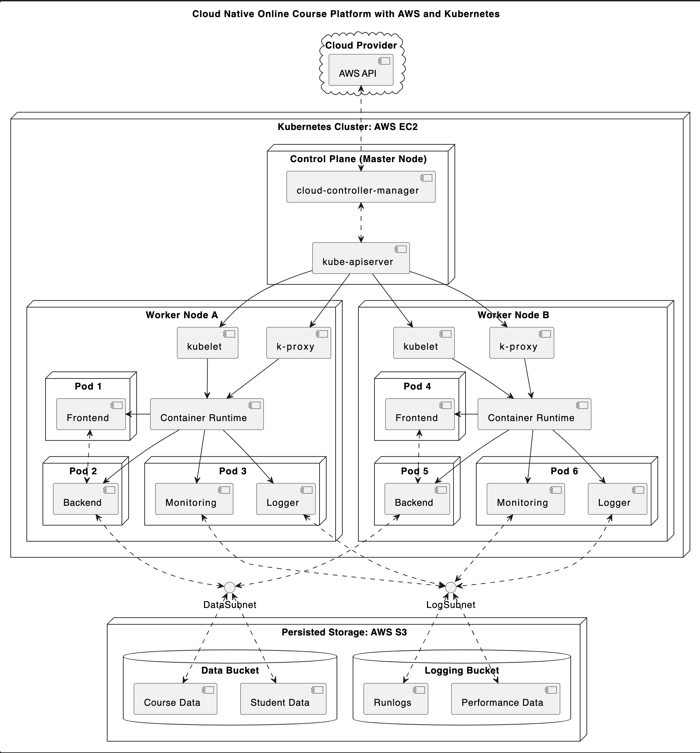

Introduction
This paper explores the planning and architectural design of a modern online course platform that is expected to be reliable and performant during periods of high traffic. Three primary technologies are used to achieve this: Amazon Web Services (AWS) Elastic Compute Cloud (EC2) for compute service, AWS Simple Storage Service (S3) for data storage, and Kubernetes (K8s) to efficiently deploy all components of the platform at scale.
Assumptions
An online course platform could take many different forms; this paper sets some baseline assumptions about the platform to provide direction. First, the hypothetical platform is assumed to be a web application where users can create and upload courses they would like to teach to other users, who can enroll in these courses during enrollment periods. It is assumed the platform will be used worldwide and will regularly encounter high traffic, especially during enrollment periods. These assumptions demand a scalable, highly available, and reliable architecture supported by a major cloud platform.
Architecture Overview
The platform utilizes AWS EC2 instances to deploy self-managed K8s clusters, each interacting with the platform’s shared AWS S3 persistent storage buckets. AWS services are highly available all over the world, satisfying the availability requirement. K8s enables the automated deployment, scaling, and management of containerized applications (Kubernetes, 2026); the platform’s backend application, frontend application, and logging/performance monitoring applications are all containerized and orchestrated into K8s clusters, with the ability to horizontally scale the platform to match the demand in each AWS region.
Security
Hosting servers with AWS and orchestrating the individual services with K8s brings added security benefits. Cloud providers invest significantly in ensuring their infrastructure is reliable and secure; AWS’ Shared Responsibility Model states that Amazon is responsible for securing cloud infrastructure (physical machines, underlying software, etc.) and the security of the services a customer hosts in the cloud is the responsibility of the customer (Amazon, 2026). K8s exposes robust networking features for communication between clusters and nodes; with proper configuration, these features will ensure the platform is internally secure.
Logging/Monitoring
The need for high availability makes logging and monitoring of systems an important aspect of the platform’s architecture. K8s provides robust logging for each node/pod, which are manually accessible through the Kubectl CLI tool. While this tool is convenient at times, the platform requires a dedicated application for collecting, aggregating, and storing the logs from each node/pod. There are several open-source services available for the aggregation of K8s logs, which can also be used to monitor health and performance of the system.
Tradeoffs/Conclusion
Managing tradeoffs is an integral and unavoidable aspect of software development and systems design; the primary tradeoff generally associated with a system architecture such as the one described in this paper is the added complexity that comes with containerizing the applications and orchestrating the work with Kubernetes. While there are certainly added complexities in comparison to alternative approaches, the added security benefits, reliability, and scalability provided by K8s outweigh the added complexity. Additionally, there are tradeoffs to deploying self-managed K8s clusters as opposed to a managed K8s service like AWS Elastic Kubernetes Service (EKS). This service would mitigate much of the complexities brought on by managing K8s, with a significant price tradeoff.
References
Amazon. (2026). Amazon EC2. Amazon Elastic Compute Service.
Amazon. (2026). Amazon EKS. Amazon Elastic Kubernetes Service.
Amazon. (2026). Amazon S3. Amazon Simple Storage Service.
AWS well-architected framework security pillar. Shared responsibility. (n.d.). https://docs.aws.amazon.com/pdfs/wellarchitected/latest/security-pillar/wellarchitected- security-pillar.pdf
Pressman, R. S., & Maxim, B. R. (2020). Chapters 9-10. In Software Engineering: A Practitioner’s Approach (9th ed., pp. 157–205). essay, McGraw Hill.
Production-grade container orchestration. Kubernetes. (2025, December 14). https://kubernetes.io/
Security. Kubernetes. (2025b, February 3). https://kubernetes.io/docs/concepts/security/

