Designing a CI/CD Pipeline

Justin DeKock
Information Systems | Saint Louis University
IS-5500: Advanced Software Development
Professor Greg Langston
March 1, 2026
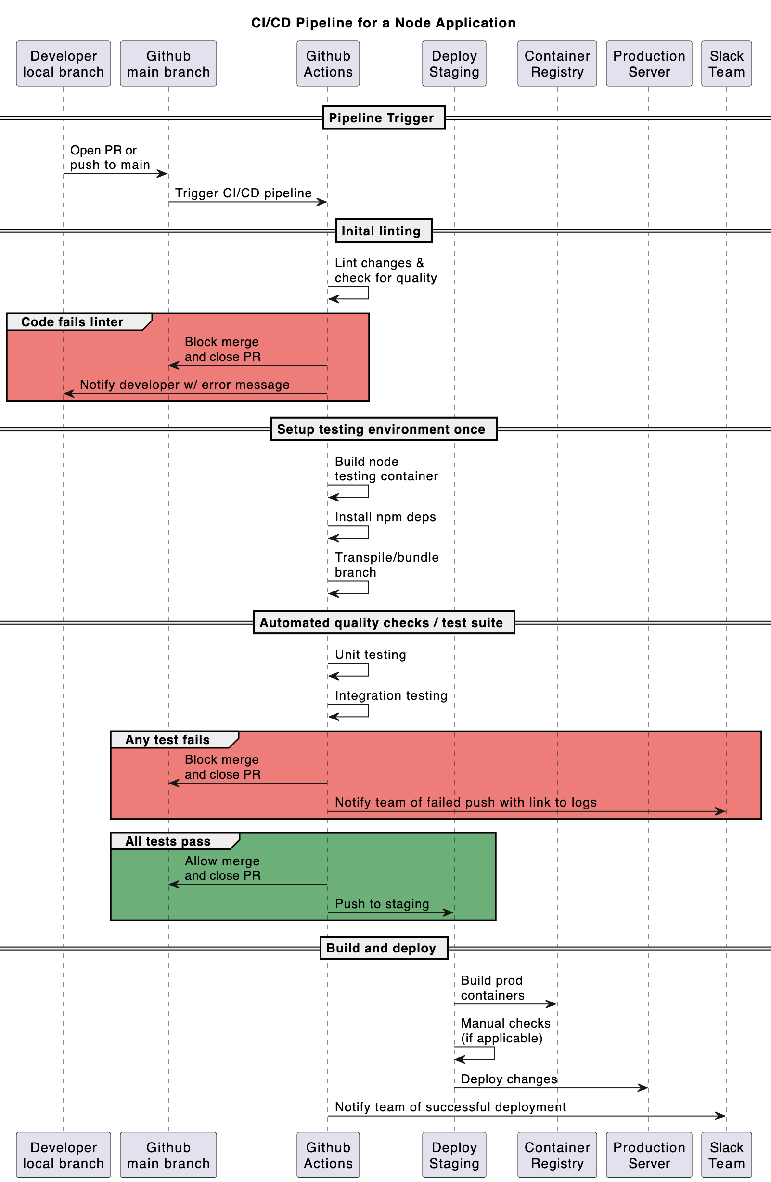
Sequence Diagram
Introduction
This case study discusses the design of an example continuous integration/continuous deployment (CI/CD) pipeline for a JavaScript/Node codebase. A high-level sequence diagram for the pipeline can be seen on the previous page.
Codebase Assumptions
The hypothetical codebase’s source of truth is its Github repository; this makes Github Actions the most convenient platform to host its CI/CD pipeline. The codebase follows the microservices architecture, with each component composed as a Docker container. New code is developed in TypeScript and transpiled to JavaScript. The Jest framework is utilized for testing.
Pipeline Overview
The CI/CD pipeline is triggered when a developer opens a pull-request (PR) or pushes changes from their local branch to the main Github branch. The linting process is run against the changes; if the linter fails, the changes are rejected. If linting is successful, the test environment is built, including building the test container, installing dependencies, and transpiling the TypeScript to JavaScript. The automated testing suite is started once the environment is built; unit tests and integration tests are run in parallel. If any test fails, the changes are rejected and an automated Slack message notifies the team of the rejected push/PR. If all tests pass, the staging process builds the codebase into production containers and stores them in the container registry. Manual tests can be performed at this point if applicable, before deploying the built artifacts to the production server. Finally, the automated Slack bot notifies the team of the successful deployment.
Automations
Automation is at the core of the CI/CD pipeline. All unit and integration tests are handled by the Jest framework as an automated Github Actions workflow. The build process automatically starts after the success of the test process, and stores the built artifacts to the container registry. The deployment process to the production server is also automated.
Optimizations
There are several steps that could be taken to optimize the performance of this pipeline. One step already taken was to run the lint process before building and running the entire test suite. This ensures that changes with unacceptable formatting are rejected early before resources are used to build and test them. Additionally, parallelization can be used to execute several operations at the same time. This is particularly useful for executing unit tests and integration tests in an efficient manor.
Tradeoffs
Like any engineering decision, it’s important to consider potential tradeoffs associated with this CI/CD design. Tradeoff between different CI/CD platforms must be weighed; this design warranted the use of Github Actions over other platforms like Gitlab due to its flexible nature and focus on third party resources, rather than Gitlab’s more extensive internal tooling. Given the broad nature of the hypothetical Node application, the flexibility from Github Actions is the most logical choice.

