0

Wordle

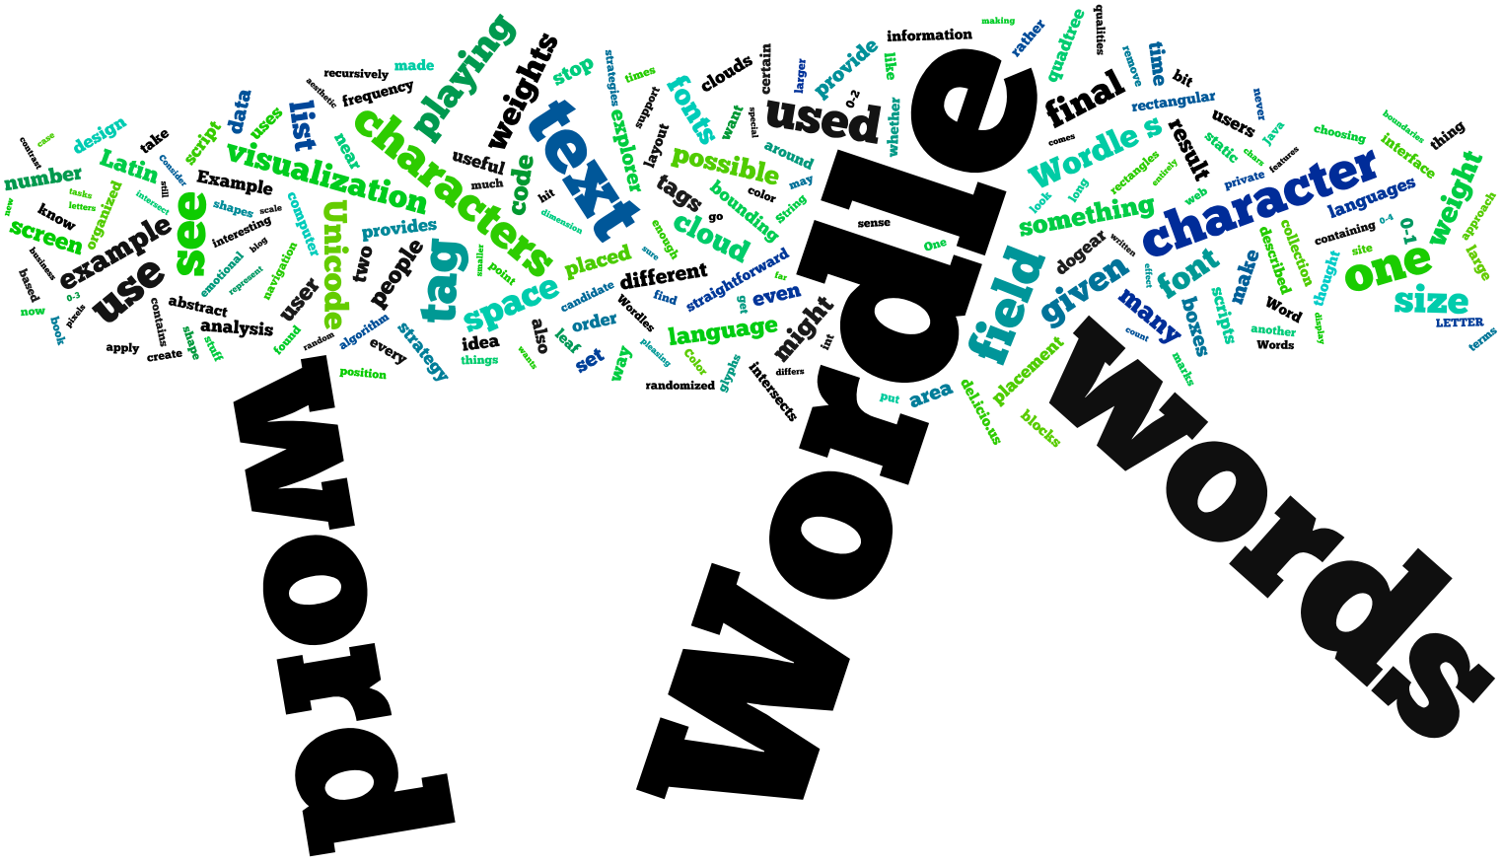
By now, even people who have never heard of “information visualization” are familiar with the colorful word collage known as Wordle, “the gateway drug to textual analysis”. Wordle is an example of aleatoric visualization, in which randomness plays an essential role in placing marks on the screen. It has its roots in the navigable tag clouds popularized by such sites as del.icio.us and Flickr, but emphasizes aesthetics over navigation. In this chapter, I’ll explain where Wordle comes from and describe how it works.

Where Wordle Comes From
In April of 2004, my colleague Bernard Kerr and I gave our research group an informal talk on the growing use of tags in social software. We were interested in the way that tagging—associating keywords with resources—made things (such as photos on Flickr and bookmarks on del.icio.us) more findable.
Bernard and I wound up making a social bookmarking application, which he named “dogear”. Any application that lets users tag content is bound to provide a tag cloud, a vaguely rectangular collection of clickable keywords. So, when we designed dogear, we made sure to feature a prominent tag cloud on every page.
I never found tag clouds to be particularly interesting or satisfying, visually. There’s also not much good evidence that they’re all that useful for navigation, or for other interaction tasks. But when blogger Matt Jones posted his del.icio.us tags as a beautiful, typographically lively image (see Figure 0-1), I was thrilled. I thought that there was no reason why a computer program couldn’t do something like that. At the very least, I wanted to end up with something that could—like Jones’s cloud—put the dot of a an “i” into the lower counter of a “g”, which was well beyond what tag clouds could do at the time.
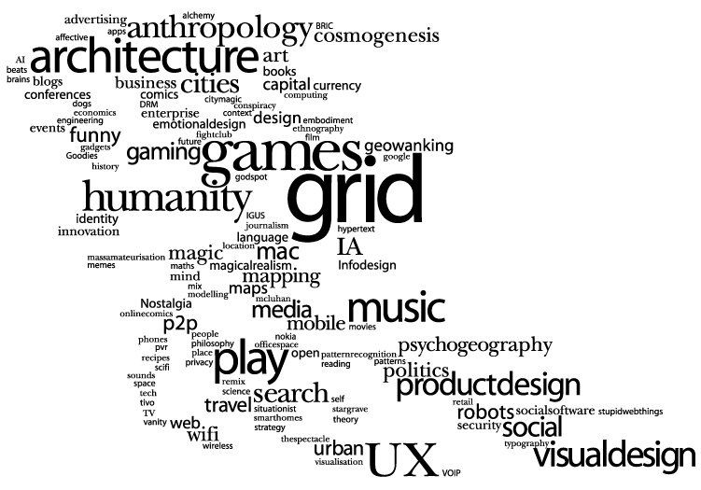
Figure 0-1. Matt Jones’s typographically-aware tag cloud
I spent a week or so creating the code for what I called the “tag explorer” (see Figure 0-2), a Java applet that permitted the user to navigate dogear by clicking on tags related to the current context.
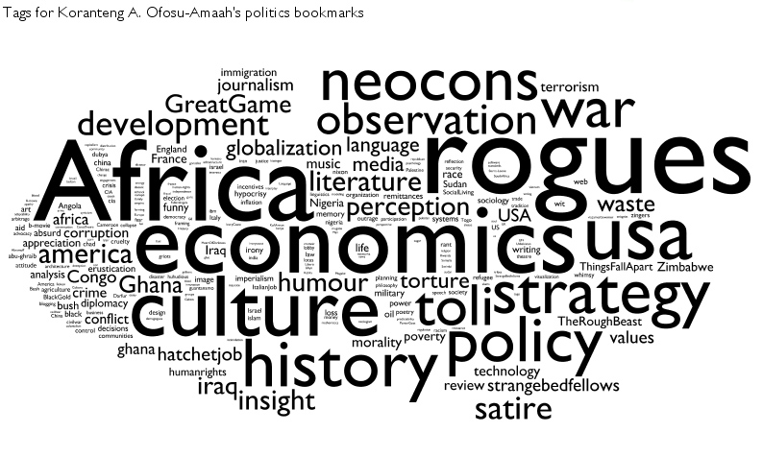
Figure 0-2. The dogear tag explorer
I liked the tag explorer, but never found it particularly useful for navigation. Instead, I thought that it was most interesting as a portrait of a person’s interests. And, long before Wordle existed, a number of my fellow IBMers used screen shots of the tag explorer to illustrate their résumés and email signatures (see Figure 0-3).

Figure 0-3. My 2006 work email signature
When dogear became an IBM product, the tag explorer did not go with it, and the code languished for a couple of years. In May of 2008, I re-found the tag explorer code, and thought that it was worth doing something with.
The original tag explorer was intimately tied to dogear, and to the idea of tag clouds in general. I thought it would be nice to find a way to decouple the word-cloud effect from the whole idea of “tags”, since the pleasing and amusing qualities of the word cloud seemed generally accessible, while “tags” were relatively arcane. This led to the idea of simply counting words. Once I had decided to build a system not for viewing tags, but for viewing text, it seemed superfluous to have the words do anything other than merely exist on the page. I decided that I would design something primarily for pleasure, in the spirit of Charles Eames’s remark, “Who would say that pleasure is not useful?” This decision, in turn, made it easy to decide which features to keep, which features to reject, and how to design the interface (shown in Figure 0-4).
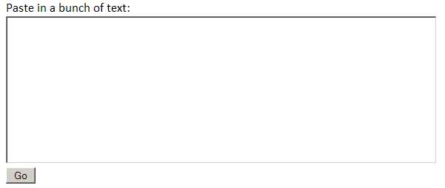
Figure 0-4. Wordle’s text-analytics user interface
Since Wordle (as it was now called) was meant to be pleasing, I had to give some thought to the expressive qualities of fonts and color palettes (see Figure 0-5).
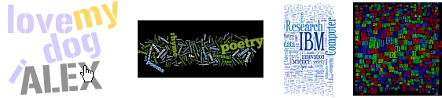
Figure 0-5. Wordle provides varied palettes, fonts, and layouts
I believe that my efforts to simplify Wordle, and to emphasize pleasure over business, have been paid for many times over. Wordle has been used in ways I’d never anticipated, by far more people than I’d dared to expect. Some of Wordle’s success is due, I believe, to the design of the web application itself, in its radical rejection of user accounts, and its one-paste/one-click instant gratification. However, to the extent that the design of the Wordle visualization itself has contributed to its ubiquity, it might be worth looking at what Wordle is not before we examine in detail what it is, and how it works.

Breaking Out of the Line
The typical word cloud is organized around lines of text. If one word on a line is larger than another, then the smaller word will get a disproportionate amount of white space overhead, which can look awkward (see Figure 0-6).
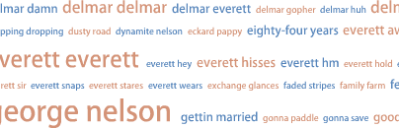
Figure 0-6. Lost in White Space
One way to mitigate the ragged white space caused by such extreme contrast in size is to squash different word weights into a small number of bins, as del.icio.us does. In Figure 0-7, the programming tag has been used 55 times, and scripting only once, but the font for the more frequently used word is only 50% larger. Notice, also, the use of font weight (boldness) to enhance the contrast between different word weights.
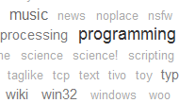
Figure 0-7. Squashing the scale of differences between word weights
In effect, del.icio.us is scaling the word weights—roughly—by logarithm. It’s sensible to scale weights this way—using logarithms or square roots—when the source data follows a power-law distribution, as tags seem to do.
Somewhere between these earnest, useful designs and the fanciful world that Wordle inhabits, there are other, more experimental interfaces. The WP-Cumulus blog plugin, for example, provides a rotating, three-dimensional sphere of tags (see Figure 0-8).
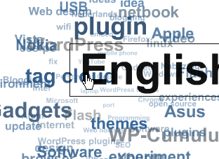
Figure 0-8. WP-Cumulus. Can’t… quite… click on “tag cloud”…
But once we are liberated from any pretense of “utility”, once we’re no longer providing navigation, then we can start to play with space.

Filling a Two-Dimensional Space
There are lots of computer science PhDs to be garnered in finding incremental improvements to so-called bin-packing problems. Having only a liberal arts degree, myself, I’ve got to find the dumbest possible way to do it. Luckily, the dumb way has a respectable name: a randomized greedy algorithm. Much of this chapter will be spent describing Wordle’s take on this strategy. But the main idea is: throw stuff on the screen somewhere near where you want the stuff to be. If the stuff intersects other stuff, then try again. Repeat.
Wordle’s specific character depends on a couple of constraints. First, we are given a list of words, with associated (presumably meaningful) weights. We can’t show any word more than once, and we don’t want to distort the shape of the word beyond choosing its font size. If we remove those constraints, then many other interesting and beautiful effects are possible.
For example, you can use a randomized greedy strategy to fill almost any region (not just a rectangle) as long as you have a set of words as a palette, from which you can arbitrarily choose any word, at any size, any number of times (see Figure 0-9).
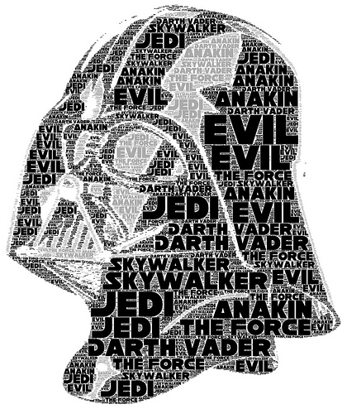
Figure 0-9. Do Not Underestimate the Power of the Randomized Greedy Algorithm
Consider Jared Tarbell’s exquisite Emotion Fractal (see Figure 0-10), which recursively subdivides a space into ever-smaller random rectangles, filling the space with ever-smaller words. This effect depends on a large set of candidate words, chosen at random, with arbitrary weights.
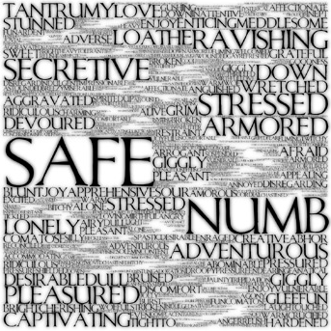
Figure 0-10. Jared Tarbell’s Emotion Fractal
If you don’t mind distorting your fonts by elongating or squashing the words as needed, other effects are possible. For example, Figure 0-11 shows a variation on the venerable treemap, which uses text, rather than rectangles, to fill space. Each word fills an area proportional to its frequency; each rectangular area contains words strongly associated with each other.
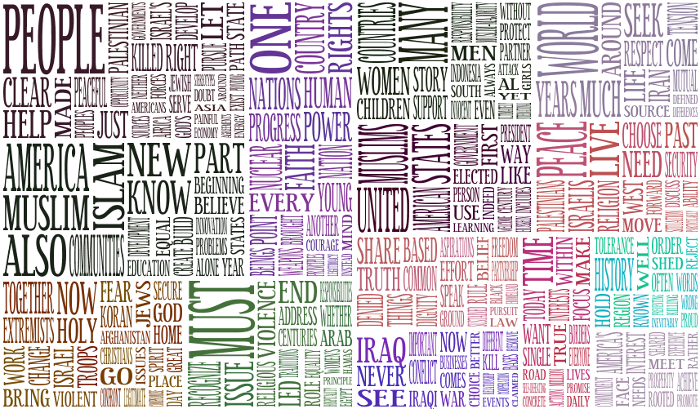
Figure 0-11. Word Treemap of an Obama Speech
Given this rather brief tour of the technical and aesthetic environment in which Wordle evolved, we’re now ready to look at Wordle’s technical and aesthetic choices in a bit more detail.

How Wordle Works
Wordle is implemented as a Java applet. Some of the technical details I provide here will be in terms of Java-specific features. Nothing described here is impossible in other languages, using other libraries and frameworks, but Java’s strong support for Unicode text processing and 2D graphics (via the Java2D API) makes those things pretty straightforward.

Text Analysis
Wordle is in the business of drawing pictures of words, each having some weight which determines its size. In this section, I’ll explain exactly what Wordle considers to be a word, and how it goes about assigning weights to the words.
While this kind of text analysis is relatively crude compared to what’s required for some natural-language processing, it can still be tedious to implement. If you work in Java, you might find my cue.language library useful for the kinds of tasks described in this section. It’s small enough, it’s fast enough, and it’s used by thousands each day as part of Wordle.

Finding Words
Natural-language analysis is as much craft as science, and, even given state-of-the-art computational tools, you have to apply judgment and taste. So it is with what might seem to be the straightforward task of scanning a text to extract a list of words.
Wordle builds a regular expression that recognizes what it considers to be words in a variety of scripts, and then iteratively applies that regex to the given text (see Example 0-1). The result is a list of words.
private static final String LETTER = "[@+\\p{javaLetter}\\p{javaDigit}]";
private static final String JOINER = "[-.:/'’\\p{M}\\u2032\\u00A0\\u200C\\u200D~]";
/*
A word is:
one or more “letters” followed by
zero or more sections of
one or more “joiners” followed by one or more “letters”
*/
private static final Pattern WORD =
Pattern.compile(LETTER + "+(" + JOINER + "+" + LETTER + "+)*");
Example 0-1. How to recognize “words”
The character classes javaLetter and javaDigit match any Unicode characters that satisfy the java predicates Character.isLetter(int codePoint) and Character.isDigit(int codePoint), respectively. The M class matches a variety of Unicode non-spacing and combining marks. Other joiners include pieces of punctuation commonly found in URLs (since Wordle users expect to see URLs preserved as “words”), the apostrophe, and several characters used as apostrophes in the wild (such as U+2032, the PRIME character).
know thy data
Unicode in a Nutshell
The Unicode standard provides a universal coded character set and a few specifications for representing its characters in computers (as sequences of bytes). Since Wordle understands text in Unicode terms, I’ll try to provide what you have to know in order to understand some of the terms and notations you’ll see here. This is a rather condensed and simplified view of Unicode!
A character is an abstract concept, meant to serve as an atom of written language. It is not the same thing as a “letter”—for example, some Unicode characters are only meaningful in combination with other characters, as in an accent, an umlaut, or a zero-width joiner. A character has a name (such as GREEK CAPITAL LETTER ALPHA) and a number of properties, such as whether it is a digit, whether it is an upper-case letter, whether it is rendered right-to-left, whether it is a diacritic, and so on.
A character set or character repertoire is another abstraction: it is an unordered collection of characters. A given character is either in, or not in, a character set. Unicode attempts to provide a universal character set, one that contains every character from every written language in current and historical use. The standard is constantly revised to bring it closer to that ideal.
A coded character set uniquely assigns an integer—a code point—to each character. Once you’ve assigned code points to the characters, you may then refer to those characters by their numbers. When referring to Unicode code points, one uses the convention of an upper-case U, a plus sign, and a hexadecimal number. For example, as mentioned in this chapter, the PRIME character has code point U+2032.
Coded characters are organized by the standard according to the script in which they appear, and scripts are further organized into blocks of strongly-related characters. For example, the Latin script (in which most European languages are written) is given in such blocks as Basic Latin (containing sufficient characters to represent Latin and English), Latin-1 Supplement (containing certain diacritics and combining controls), Latin Extended A , Latin Extended B, and so on.
When it comes time to actually put pixels onto a screen, a computer program interprets a sequence of characters and uses a font to generate glyphs in the order and location demanded by the context.

Determining Script
Having extracted a list of words (whatever we take “word” to mean), we need to know how to display those words to the viewer. We need to know what characters we’ll be expected to display, so that we can chose a font that supports those characters.
Wordle’s collection of fonts is organized in terms of what scripts each can support, where a script is what you might think of as an alphabet, a collection of glyphs that can be used to visually represent sequences of characters in one or more languages. A given script, in Unicode, is organized into one or more blocks. So, the task now is to determine which fonts the user might want to use by sniffing out which blocks are represented in the given text.
Java provides the static method UnicodeBlock.of(int codePoint) to determine which block a given code point belongs to. Wordle takes the most frequent words in a text and looks at the first character in each of those words. In the rather common case that the character is in the Latin block, we further check the rest of the word to see if it contains any Latin-1 Supplement characters (which would remove certain fonts from consideration) or any of the other Latin Extended blocks (which would bar even more fonts). The most frequently-seen block is the winner.
In order to keep Wordle responsive, and to limit its use of network resources, I designed Wordle to only permit the use of one font at a time. A more full-featured word cloud might choose different fonts for different words; this could provide another visual dimension to represent, for example, different source texts.
As of this writing, Wordle supports the Latin, Cyrillic, Devanagari, Hebrew, Arabic, and Greek scripts. By design, Wordle does not support the so-called CJKV scripts, the scripts containing Chinese, Japanese, Korean, and Vietnamese ideographs. CJKV fonts are quite large, and would take too long for the Wordle user to download (and would cost a great deal of “bandwidth”). Also, determining word breaks for ideographic languages requires sophisticated machine-learning algorithms, and large runtime data structures, which Wordle cannot afford.

Guessing the Language and Removing Stop Words
It would be neither interesting nor surprising to see that your text consists mostly of the words “the,” “it,” and “to”. In order to avoid a universe of boring Wordles, all alike, we want to remove such stop words for each language that we care to recognize. However, to know which list of stop words to remove, we have to guess what language a given text is in.
Knowing the script is not the same as knowing the language, since many languages might use the same script (e.g., French and Italian).
Wordle takes a straightforward approach to guessing a text’s language: it selects the 50 most frequent words from the text, and counts how many of them appear in each language’s list of stop words. Whichever stop word list has the highest hit count is considered to be the text’s language.
How do you create a list of stop words? As in the definition of a “word”, described above, this kind of thing is a matter of taste, not science. One typically starts by counting all of the words in a large corpus, and choosing the most frequently used words. But, as in the case of Wordle, you might find that certain high-frequency words add a desirable flavor to the output, while other, lower-frequency words just seem to add noise.
Many of Wordle’s stop word lists came from users who wanted better support for their own languages. Those kind folks are credited on the Wordle web site.
By default, Wordle strips the chosen language’s stop words from the word list before proceeding to the next steps, but the Wordle user can override this setting via a menu checkbox.

Assigning Weights to Words
Wordle is, once again, obstinately straightforward in assigning a numeric weight to each word. The formula is: weight = word count.

Weighted Words Into Shapes
Once you’ve analyzed your text, you’re left with a list of words, each of which has some numeric weight based on its frequency in a text. Wordle normalizes the weights to an arbitrary scale, which determines the magnitude of various “magical” constants that affect the resulting image (such as the minimum size of a hierarchical bounding box leaf, as described below). For each word, Wordle constructs a font with a point size equal to the word’s scaled weight, then uses the font to generate a shape, expressed as a collection of spline paths (see Example 0-2).
private static final FontRenderContext FRC
= new FontRenderContext(null, true, true);

public Shape generate(final Font font, final double weight, final String word,
final double orientation) {
final Font sizedFont = font.deriveFont((float) weight);
final char[] chars = word.toCharArray();
final int direction = Bidi.requiresBidi(chars, 0, chars.length) ?
Font.LAYOUT_RIGHT_TO_LEFT : Font.LAYOUT_LEFT_TO_RIGHT;
final GlyphVector gv =
sizedFont.layoutGlyphVector(FRC, chars, 0, chars.length, direction);
Shape result = gv.getOutline();
if (orientation != 0.0){
result = AffineTransform.getRotateInstance(orientation)
.createTransformedShape(result);
}
return result;
}
Example 0-2. How to turn a String into a Shape

The Playing Field
Wordle estimates the total area to be covered by the finished word cloud by examining the bounding box for each word, summing the areas, and adjusting the sum to account for the close-packing of smaller words in and near larger words. The resulting area is scaled to match the target aspect ratio (which is, in turn, given by the dimensions of the Wordle applet at the moment of layout).
The constants used to adjust the size of the “playing field”, the area in which Wordles are laid out, were determined by the time-honored tradition of futzing around with different numbers until things looked “good” and worked “well”. As it happens, the precise size of the playing field is rather important, because the field boundaries are used as constraints during layout. If your playing field is too small, then your placement will run slowly, and most words will fall outside the field, leaving you with a circle (because once a word can’t be placed on the field, Wordle relaxes that constraint, and you wind up with everything randomly distributed around some initial position); too large, and you’ll get an incoherent blob (because every non-intersecting position is acceptable).
One “gotcha” to look out for is an especially long word, which could have a dimension far larger than the calculated width or height based on area. You must make sure that your playing field is big enough to contain the largest word, at least.
I should emphasize that the playing field is an abstract space, a coordinate system not corresponding to pixels, inches, or any other unit of measurement. In this abstract space, we can lay out the word shapes and check for intersections. When it comes time to actually put pixels on screen, then we can do some scaling into useful units.

Placement
Having created a “place” to put words, it’s time to position the words in that space. The overall placement strategy is a randomized greedy algorithm in which words are placed, one at a time, on the playing field. Once a word is placed, its position does not change.
Wordle offers the user a choice of placement strategies. These strategies determine where a word “wants” to go. On the Wordle web site, the choices are center-line and alphabetical center-line. Both strategies place words near the horizontal center-line of the playing field (not necessarily upon it, but scattered away from it by a random distribution). The alphabetical strategy additionally sorts the words alphabetically, then distributes their preferred x coordinates across the playing field.
Interesting effects are possible through the use of smarter placement strategies. For example, given clustering data—information about which words tend to be used near each other—the placement strategy can make sure that each word wants to be near the last word from its cluster that was placed on the field (see Figure 0-12).
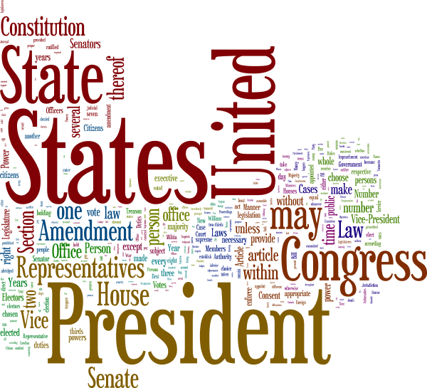
Figure 0-12. The result of a clustering placement strategy
The word shapes are sorted by their respective weights, descending. Layout proceeds as follows (and illustrated in Figure 0-13):
For each word w in sorted words:
placementStrategy.place(w)
while w intersects any previously placed words:
move w a little bit along a spiral path
Example 0-3. The secret Wordle algorithm revealed at last!
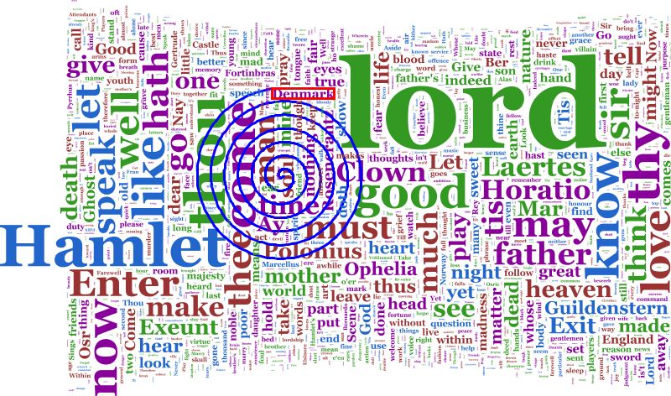
Figure 0-13. The path taken by the word “Denmark”
To make matters a bit more complicated, Wordle optionally tries to get the words to fit entirely within the rectangular boundaries of the playing field—this is why it’s important to guess how big the whole thing is going to be. If the rectangular constraint is turned on, then the intersection-handling routine looks like this:
while w intersects any previously placed words:
do {
move w a little bit along a spiral path
} while any part of w is outside the playing field and
the spiral radius is still smallish
Example 0-4. Constraining words to the playing field

Intersection Testing
The pseudocode, above, breezily suggests that you move a word “while it intersects other words,” but does not suggest how you go about determining such a thing. Testing spline-based shapes for intersection is expensive, and a naïve approach to choosing pairs for comparison is completely unaffordable. Here are the techniques that Wordle currently uses to make things fast enough.

Hierarchical Bounding Boxes
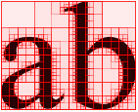
Figure 0-14. Hierarchical bounding boxes
The first step is to reduce the cost of testing two words for intersection. An obvious and cheap method for detecting misses is to compare the bounding boxes of two words. But it’s not uncommon for two such boxes to intersect when the word glyphs do not. Wordle exploits the cheapness of rectangle comparisons by recursively dividing a word’s bounding box into ever smaller boxes, creating a tree of rectangles whose leaf nodes contain chunks of the word shape (see Figure 0-14). Although it’s expensive to construct these hierarchical bounding boxes, the cost is recovered by an order of magnitude during the layout. It’s fairly straightforward to recursively descend into mutually intersecting boxes, terminating either when two leaf nodes intersect (a hit) or when all possible intersecting branches are excluded (a miss). By taking care with the minimum size of leaf rectangles, and by “swelling” the leaf boxes a bit, the layout gets a pleasing distance between words “for free.”

Broadphase Collision Detection
In choosing pairs of words to test for intersection, the simplest approach is to test the current candidate word against all of the already-placed words. This approach results in a hit test count around the order of N2, which is far too slow once you get up to 100 words or so. Therefore, Wordle does some extra work to avoid as much collision-testing as possible.

Caching
One very simple improvement stems from the observation that if a word A intersects some other word B, then it’s very likely that A will still intersect B after moving A slightly. Therefore Wordle caches a candidate word’s most recently intersected word, and tests it first.

Spatial Index
To further reduce the number of hit tests, Wordle borrows from computational geometry the “region quadtree”. Here, a quadtree serves as a spatial index to efficiently cull shapes from the list of words to be compared to some candidate shape. A quadtree recursively divides a two-dimensional space (in this case, the Wordle playing field) into four rectangular regions. Once a word is placed on the playing field, Wordle searches for the smallest quadtree node that entirely contains the word, and adds the word to that node. Then, when placing the next word, many already-placed words can be culled from collision testing by searching the quadtree for candidates.

Other Ideas
There’s an entire research field around efficient collision detection, much of which is very well summarized in Christer Ericson’s book, Real-Time Collision Detection. I recommend the book to anyone who wants to play with randomized graphics algorithms like Wordle’s. My own quadtree implementation is based on my understanding of the discussion in that book.

Is Wordle Good Information Visualization?
Wordle has been criticized for aspects of its design that may mislead or distract its users, when considering Wordle strictly as information visualization.

Word Count is a Poor Measure
Merely counting words does not tell you anything about how a particular text is distinct from other texts. Consider, for example, a blog post. It might be most revealing to emphasize how the post differs from other blog posts by the same author, or to show how it differs from posts on the same topic by other bloggers, or even to show how it differs from the language of newspaper reporting. I have seen Wordle used to summarize each of the books of the New Testament, leading to one page after another of “Lord,” which tells you nothing about how the chapters are distinct from each other.
There are plenty of statistical measures that one may apply to a text—the “specimen”—versus some other body of text—the “normative” corpus—to reveal the specific character of the specimen, with proper attention paid to whether some word-use is statistically significant. Given a more nuanced idea of word weight, beyond mere frequency, one could then apply the Wordle layout algorithm to display the results.
I explored this idea in an analysis of every presidential inaugural address, in which each speech is compared to the 5 speeches nearest to it in time, the 10 nearest speeches, and all other inaugural addresses. Such an analysis has the advantage of revealing the unexpected absence of certain words (See Figure 0-15).
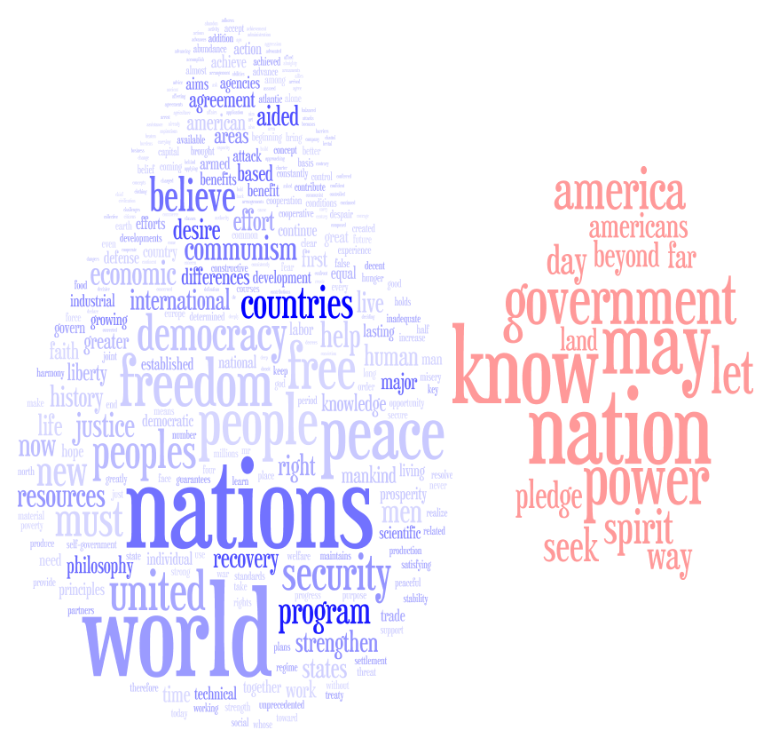
Figure 0-15. Truman looks outward, not inward, in 1948

Color is Wasted
In a medium—your computer screen—that provides precious few dimensions, Wordle is shockingly free with its use of color. Color means absolutely nothing in Wordle, and is used merely to provide contrast between word boundaries, and aesthetic appeal.
Color could be used to code various dimensions, such as clustering (indicating which words tend to be used near each other) or statistical significance (as in the inaugural address word clouds—see Figure 0-16). Wordle could also use color to let two or more different texts be represented in the same space.
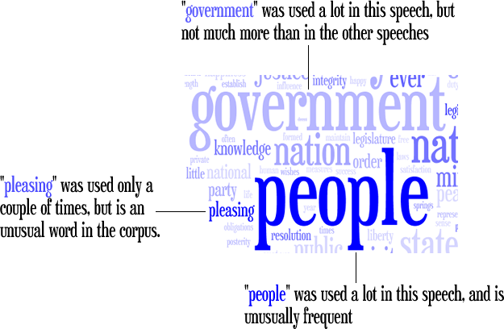
Figure 0-16. Using color to encode an abstract, statistical dimension
It should also be mentioned that Wordle makes no provision for colorblind users, although one can always create a custom palette via the applet’s Color menu.

Fonts are Fanciful
Many of Wordle’s fonts strongly favor aesthetics and expressiveness over legibility. Enough said.

Word Sizing is Naïve
Wordle does not take into account the length of a word, or the glyphs with which it’s drawn, when calculating its font size. The result is that, given two words used the same number of times, the word with more letters will take up more space on screen, which may lead to the impression of the longer word being more frequent. On the other hand, I don’t know of any studies that apply any rigor to the question of how relative word size corresponds to how people perceive relative weight.

How Wordle is Actually Used
Wordle was not designed for visualization experts, text analysis experts, or even experienced computer users. I tried to make Wordle as appliance-like as possible.
As of this writing, people have created and saved over 1,400,000 word clouds in the Wordle gallery. They have been used to summarize and decorate business presentations and PhD theses, to illustrate news articles and television news broadcasts, and to distill and abstract personal and painful memories for victims of abuse. Wordle has also found an enthusiastic community in teachers of all stripes, who use Wordles to present spelling lists, to summarize topics, and to engage preliterate youngsters in the enjoyment of text.
When people use Wordle, they tend to feel creative, as though they’re making something. Consider the survey result in Table 0-1.
Table 0-1. How people feel when they make a Wordle
 | Agree  % | Neutral  % | Disagree  %
I felt creative | 88 | 9 | 4
I felt an emotional reaction | 66 | 22 | 12
I learned something new about the text | 63 | 24 | 13
It confirmed my understanding of the text | 57 | 33 | 10
It jogged my memory | 50 | 35 | 15
The Wordle confused me | 5 | 9 | 86
So, by one traditional academic measure of a visualization’s efficacy—“I learned something new about the text”—Wordle can at least be considered moderately successful. But where Wordle shines is in the creation of communicative artifacts. People who use Wordle feel like they have made something, that the made thing succeeds in representing something meaningful, and that it accurately reflects or intensifies the source text. This sense of meaningfulness seems to be entirely intuitive: our survey revealed that many people do not realize that word size is related to word frequency (guessing, instead, that the size indicates “emotional importance” or even “word meaning”).
The special qualities of Wordle are due to the special qualities of text. Simply putting a single word on screen, in some font that either complements or contrasts with the sense of the word, immediately creates resonances in the viewer (and, indeed, there have been many thousands of single-word Wordles saved to the public gallery). When you juxtapose two or more words, you begin to exploit the tendency of a literate person to make sense of words in sequence. Wordle’s aleatoric word combinations create delight, surprise, and perhaps some of the same sense of recognition and insight that poetry evokes intentionally. A stacked area graph; a pie chart; a bubble chart: these have no inherent semantic or emotional hooks to engage the viewer.
Notwithstanding Wordle’s special emotional and communicative properties, the strictly analytic uses of information visualization are certainly available to the expert user. Even though Wordle was not intended for “serious” analytic tasks, there are many folks who want to use it as a visualization for their own weighted text, where the weights are not necessarily based on simple word frequency. Toward that end, I provide a so-called “advanced” interface, where one can enter tabular data containing arbitrarily weighted words or phrases, and where one can even specify colors. However, you do have to look for that interface; it’s not up front, where the simple “paste and go” interface lives. Still more advanced use, as in an analytic tool chain on the command line, is possible through the “IBM Word Cloud Generator”, available through IBM’s alphaWorks web site. The ManyEyes collaborative data visualization site also provides the Wordle as a text-visualization option beside its innovative Phrase Net and Word Tree visualizations (and a more traditional tag cloud, too).

Conclusion
I think that any discussion of Wordle as visualization has to permit the broadening of the very definition of “visualization”. To me, “visualization” connotes a certain strictness in the relationship between data and visual marks, whereas in Wordle, the data could best be described as an influence on the resulting marks. [TK ???]

Acknowledgements
I thank Martin Wattenberg and Irene Greif for making possible my participation in this book. Fernanda Viégas kindly provided excellent editorial advice. Please see http://www.wordle.net/credits for information about the many people who have helped me create and maintain Wordle.

http://www.profhacker.com/2009/10/21/wordles-or-the-gateway-drug-to-textual-analysis/
http://domino.watson.ibm.com/cambridge/research.nsf/pages/cue.html
http://www.flickr.com/
http://delicious.com/
Millen, D. R., Feinberg, J., and Kerr, B. 2006. Dogear: Social bookmarking in the enterprise. In Proceedings of the SIGCHI Conference on Human Factors in Computing Systems (Montréal, Québec, Canada, April 22 - 27, 2006). http://doi.acm.org/10.1145/1124772.1124792
http://doi.acm.org/10.1145/1240624.1240775
http://magicalnihilism.com/2004/07/04/my-delicious-tags-july-2004/
http://www.flickr.com/photos/koranteng/526642309/in/set-72157600300569893
http://www-01.ibm.com/software/lotus/products/connections/bookmarks.html
For a thorough survey of tag cloud designs, with thoughtful commentary, see http://www.smashingmagazine.com/2007/11/07/tag-clouds-gallery-examples-and-good-practices/
http://manyeyes.alphaworks.ibm.com/manyeyes/page/Tag_Cloud.html
http://www.citeulike.org/user/andreacapocci/article/1326856
http://wordpress.org/extend/plugins/wp-cumulus/
http://en.wikipedia.org/wiki/Bin_packing_problem
http://levitated.net/daily/levEmotionFractal.html
http://www.cs.umd.edu/hcil/treemap-history/
http://github.com/vcl/cue.language
For an illuminating demonstration of this craft, please see Peter Norvig’s chapter on natural language processing in the sister O’Reilly book, “Beautiful Data”.
http://unicode.org/
Ericson, Christer. Real-Time Collision Detection, Morgan Kaufmann, 2005
http://researchweb.watson.ibm.com/visual/inaugurals/
Fernanda B. Viégas, Martin Wattenberg, Jonathan Feinberg, "Participatory Visualization with Wordle," IEEE Transactions on Visualization and Computer Graphics, vol. 15, no. 6, pp. 1137-1144, Nov./Dec. 2009, doi:10.1109/TVCG.2009.171
http://www.alphaworks.ibm.com/tech/wordcloud
http://manyeyes.alphaworks.ibm.com/manyeyes/page/Visualization_Options.html

