VAST.AI usage instructions

- Login into vast.ai account
- In Search field select the Template PyTorch (Vast)
- Rent the GPU from the available devices and Click RENT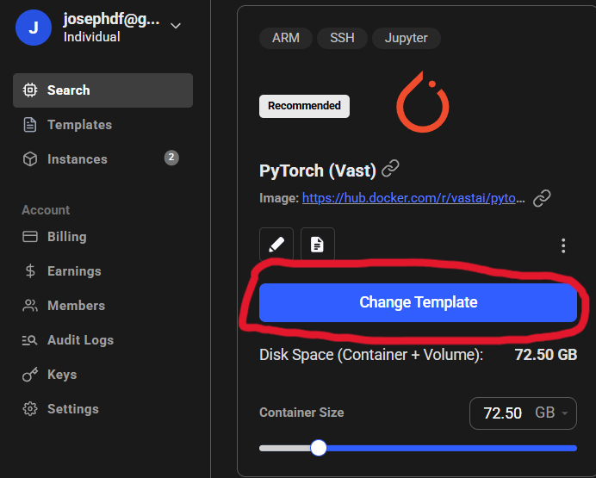
  - The 50 series GPUs are not supported for now
  - Move the Container Size slider to at least 800-900GB
  - You can now select a GPU that will automatically have more than 800-900GB of storage since you specified that in the container size slider
- In Instances field you can see the device 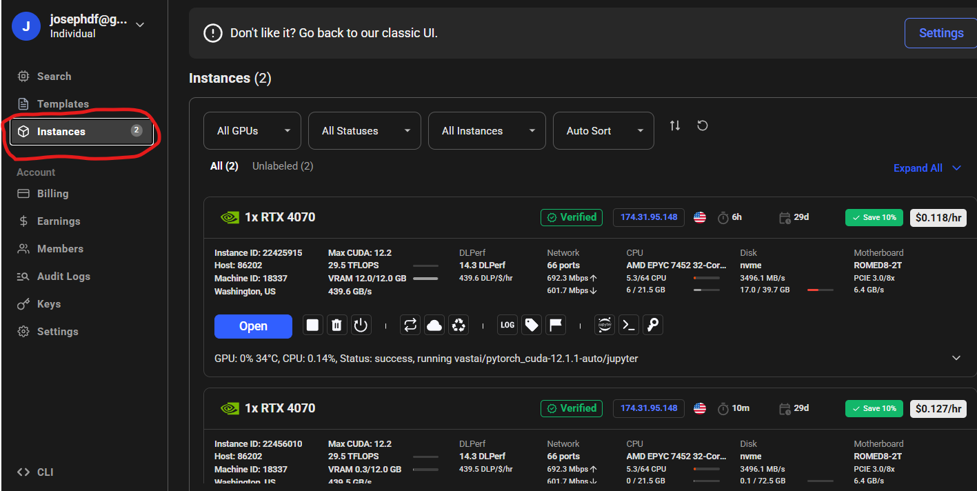
  - Wait until the GPU starts
  - Click the JUPYTER sign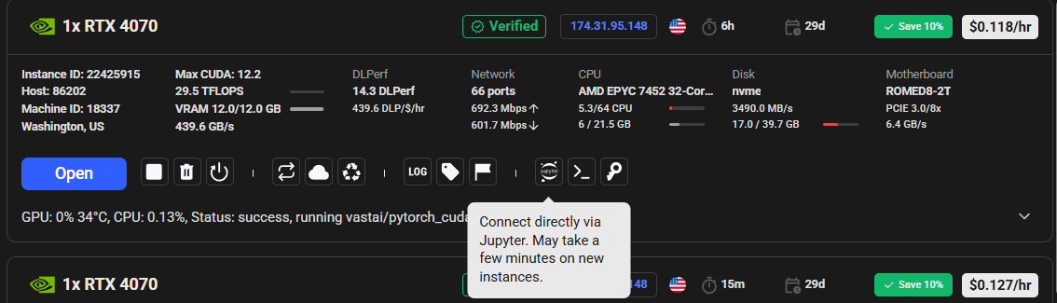
- You will be redirected into the JUPYTER NOTEBOOK instance.
  - Click Advanced
  - Agree with Unsafe login

  - Navigate to the folder workspace
  - Click UPLOAD to upload these files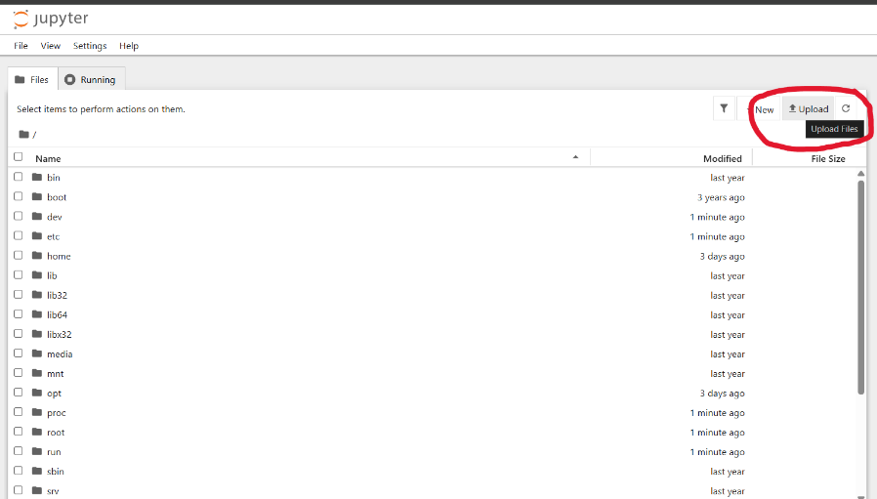
  - Import the files from google drive
https://drive.google.com/drive/folders/1FghZixpgH6_5KczDK-F7omwQyBveW3y8?usp=drive_link
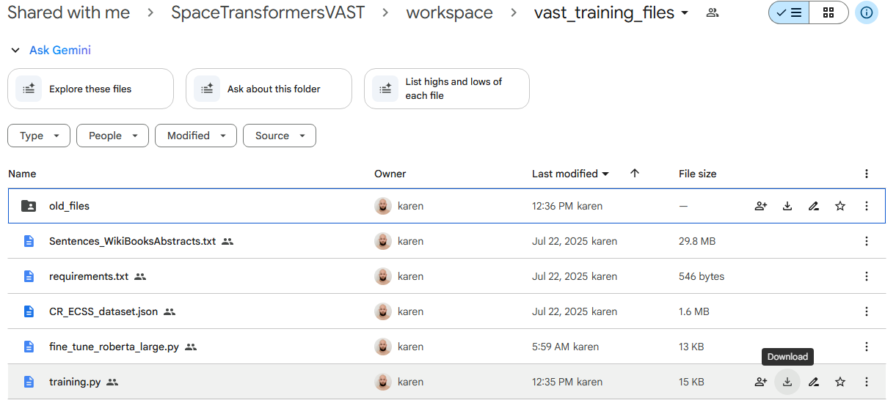

For Jupyter Notebook
- Open the pipeline.ipynb file
  - Change the kernel to System
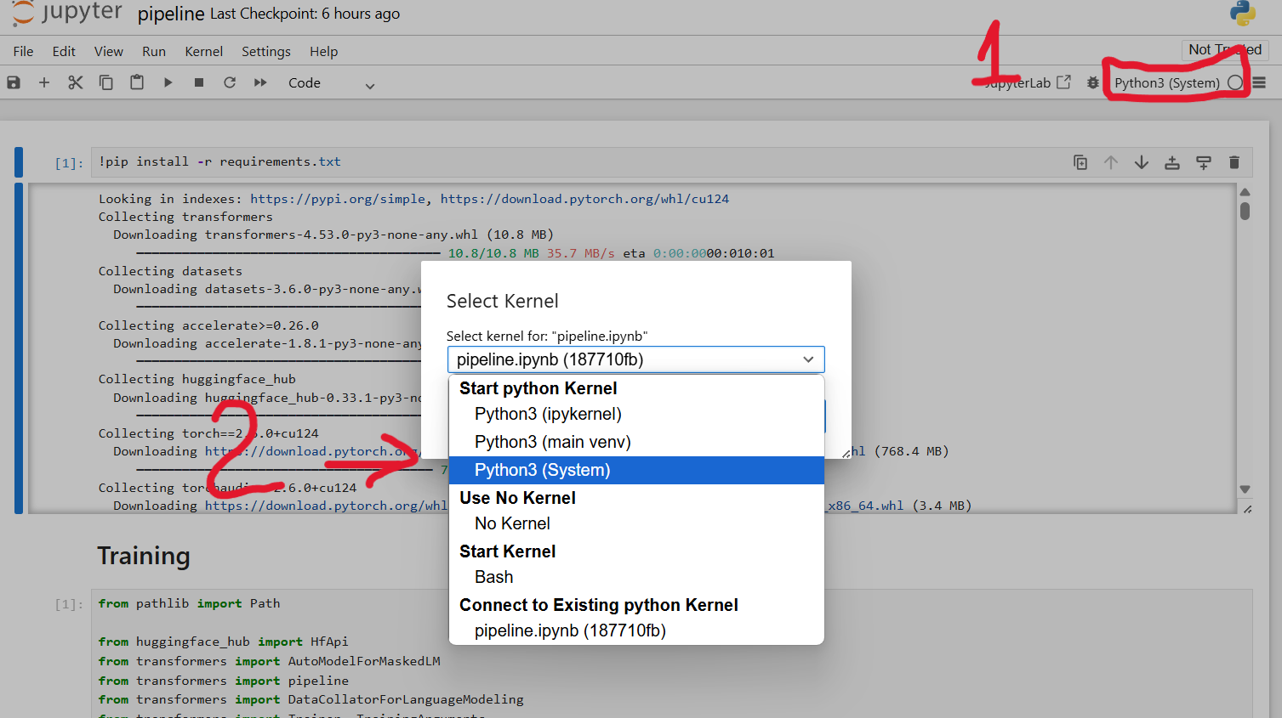
  - Start running all the cells

For Python file usage
- Open the Jupyter Command Line
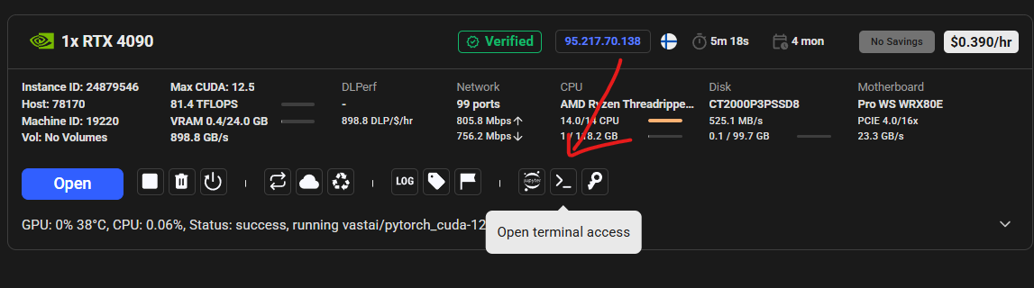
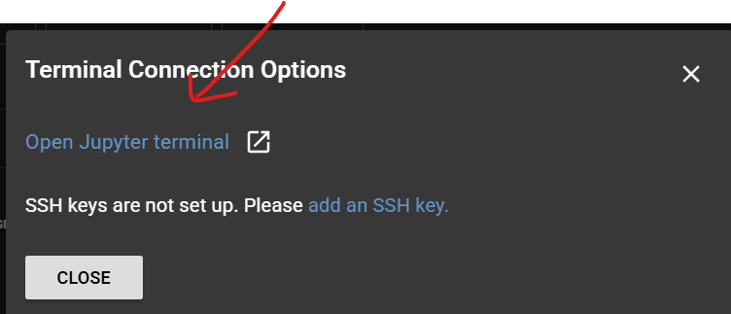
Run THIS in Terminal
Install REQUIREMENTS

Run pip install -r requirements.txt in command line

Model Presets
“Argument name” : “Model name in Hugging face”
- "bert-base-uncased": "bert-base-uncased"
- "bert-large-uncased": "bert-large-uncased"
- "roberta-base": "roberta-base"
- "roberta-large": "roberta-large"
- "modernbert-base": "answerdotai/ModernBERT-base"
- "modernbert-large": "answerdotai/ModernBERT-large"
- "deberta-v3-base": "microsoft/deberta-v3-base"
- "deberta-v3-large": "microsoft/deberta-v3-large"
- "bert-base-uncased":"bert-base-uncased"
- "bert-large-uncased": "bert-large-uncased"
- "scibert-uncased": "allenai/scibert_scivocab_uncased"
- "scibert-cased": "allenai/scibert_scivocab_cased"
Further Pre-Training
Arguments:
--preset
Default: deberta-v3-large
Type: choice (deberta-v3-large, deberta-v3-base, roberta-large, roberta-base, modernbert-large, modernbert-base, bert-base-uncased, bert-large-uncased, scibert-uncased, scibert-cased)
Description: Model preset to use.
--model-name (Not usable for our case)
Default: None
Type: string
Description: Hugging Face model ID. If set, overrides --preset (e.g., "microsoft/deberta-v3-large").
--train-epochs
Default: 10
Type: integer
Description: Number of training epochs.
--per-device-train-batch-size
Default: 8
Type: integer
Description: Batch size per GPU/CPU device.
--gradient-accumulation-steps
Default: 1
Type: integer
Description: Accumulate gradients over this many steps before an optimizer step (effective batch = per_device_batch_size × gradient_accumulation_steps × number_of_devices).

--max-length
Default: 512
Type: integer
Description: Max tokenized sequence length (pad/truncate to this).
--overwrite-run-dir
Default: (flag off)
Type: flag
Description: If set, remove existing run directory before starting a new run.
--resume-from (See resume instructions)
Default: auto
Type: string (choices: "auto", "none", or path)
Description: Resume from latest checkpoint in output dir ("auto"), start fresh ("none"), or resume from a specific checkpoint-* path.
--save-total-limit
Default: 3
Type: integer
Description: Max number of checkpoint-* folders to keep. With per-epoch saving, keeps the last N epoch checkpoints. Does not affect the separate best/ or final/ folders.
--data-file (Using Default value for our case)
Default: Sentences_WikiBooksAbstracts.txt
Type: string (path)
Description: Training text file (one sample per line).
--early-stop-patience
Default: 2
Type: integer
Description: Number of consecutive evaluation epochs allowed without improvement before training stops early. Set to 0 to disable early stopping.
--skip-final-save
Default: false
Type: flag
Description: If set, the script will not write a final/ snapshot at the end of training.
--val-ratio (Using Default value for our case)
Default: 0.1
Type: float (0.0–0.5)
Description: Fraction of data used for validation to monitor overfitting.

Option A: Training
For multiple GPU usage:
accelerate launch --multi_gpu --num_processes <NUM_GPUS> <script.py> -- --preset <PRESET> --train-epochs <EPOCHS> --per-device-train-batch-size <BATCH_SIZE> --gradient-accumulation-steps <GRAD_ACCUM_STEPS> --max-length <MAX_LEN> --save-total-limit <K> --early-stop-patie - nce <EARLY_STOP_PATIENCE> --skip-final-save --overwrite-run-dir
Full example:
accelerate launch --multi_gpu --num_processes 12 training_new.py -- --preset bert-base-uncased --train-epochs 10 --per-device-train-batch-size 4 --gradient-accumulation-steps 4 --max-length 256 --save-total-limit 3 --early-stop-patience 2 --skip-final-save --overwrite-run-dir

>> This is the initial training that goes for 10 epochs and saves the last 3 at any point in time
>> when fine tuning you should choose the best model and not a checkpoint
(best chooses the best of all of the runs)
model_path = "runs/preset/best" # folder containing your best model

For single GPU usage:
python <script.py> --preset <PRESET> --train-epochs <EPOCHS> --per-device-train-batch-size <BATCH_SIZE> --gradient-accumulation-steps <GRAD_ACCUM_STEPS> --max-length <MAX_LEN> --save-total-limit <K> --early-stop-patience <EARLY_STOP_PATIENCE> --skip-final-save --overwrite-run-dir

Full example:
python training_new.py --preset bert-base-uncased --train-epochs 10 --per-device-train-batch-size 4 --gradient-accumulation-steps 4 --max-length 256 --save-total-limit 3 --early-stop-patience 2 --skip-final-save --overwrite-run-dir

Option B: Resume Training
For multiple GPU usage:
accelerate launch --multi_gpu --num_processes <NUM_GPUS> <script.py> -- --preset <PRESET> --train-epochs <EPOCHS> --per-device-train-batch-size <BATCH_SIZE> --gradient-accumulation-steps <GRAD_ACCUM_STEPS> --max-length <MAX_LEN> --save-total-limit <K> --early-stop-patience <EARLY_STOP_PATIENCE> --skip-final-save --resume-from <auto|none|/path/to/checkpoint-XXXX>

Full Example:
accelerate launch --multi_gpu --num_processes 14 training_new.py -- --preset bert-base-uncased --train-epochs 20 --per-device-train-batch-size 4 --gradient-accumulation-steps 4 --max-length 256 --save-total-limit 3 --early-stop-patience 2 --skip-final-save --resume-from auto

--overwrite-run-dir -> --resume-from auto : Difference between the training from scratch and resuming

>> This moves the training forward another (20-10) = 10 epochs again saving the 3 epochs
>> when fine tuning you should choose the best model and not a checkpoint
(best chooses the best of all of the runs)
model_path = "runs/preset<model name>/best" # folder containing your best model

NOTE: OPTION auto will find the model checkpoint based on the –preset and it wont continue training based on the best model or final, only checkpoints, checkpoints are saving for last 3 epochs, we can change that value to 5.7.10 based on the space of the container.
OPTION: none will start the training from scratch
OPTION: PATH TO THE CHECKPOINT will run the checkpoint you specified
NOTE: The training epochs will count the total target, for example if the model is trained on 10 epochs, it won't train if the training epochs will be 10. For more 10 epochs the value should be 20

Keeping the progress of the last 3 epochs:
Total Epoch - 15:
1 2 3 4 5 6 7 8 9 10 11 12 13 14 15
Total Epochs - 17
1 2 3 4 5 6 7 8 9 10 11 12 13 14 15 16 17

Fine Tuning

Option C: Fine Tuning
Arguments:
--model-path
Default: runs/microsoft__deberta-v3-large/best
Type: string (path)
Description: Directory containing the pretrained weights and tokenizer to start from (e.g., the MLM best/ folder)
--data-file (Using Default value for our case)
Default: CR_ECSS_dataset.json
Type: string (path)
Description: JSON dataset with columns sentence_id, words (list of tokens per sentence), and labels (list of tags per sentence)
--epochs
Default: 1
Type: integer
Description: Number of fine-tuning epochs
--runs
Default: 1
Type: integer
Description: Number of repeated fine-tuning runs (useful for averaging results across multiple seeds/runs)
--batch-size
Default: 8
Type: integer
Description: Mini-batch size per step
--seed
Default: 42
Type: integer
Description: Random seed for reproducibility (affects shuffling, weight initialization, etc.)

For single/multiple GPU usage:
python <script.py> --model-path <PATH_TO_BEST> --data-file <PATH_TO_JSON> --epochs <EPOCHS> --runs <RUNS> --batch-size <BATCH> --seed <SEED>
Full example:
python fine_tune_new.py --model-path runs/bert-base-uncased/best --epochs 4 --runs 1 --batch-size 8 --seed 42
Option D: Direct Fine Tuning
Arguments
--model_key
Default: required
Type: string (choice from PRESETS)
Description: Which preset model to fine-tune. Must match a key defined in PRESETS
--epochs
Default: 1
Type: integer
Description: Number of fine-tuning epochs to run
--batch_size
Default: 8
Type: integer
Description: Batch size used during training
--seed
Default: 42
Type: integer
Description: Random seed for reproducibility
--data_file (Using Default value for our case)
Default: CR_ECSS_dataset.json
Type: string (path)
Description: Path to dataset JSON file. Should contain columns: sentence_id, words (list of tokens), and labels (list of tags)

For single/multiple GPU usage:
python <fine_tune_direct.py> --model_key <MODEL_PRESET_KEY> --epochs <EPOCHS> --batch_size <BATCH_SIZE> --seed <SEED> --data_file <PATH_TO_JSON>
Full example:
python fine_tune_direct.py --model_key bert-base-uncased --epochs 20 --batch_size 8 --seed 42

After running the fine tuning report.csv file will be saved with the training results
Note: In case the file will exist, new file will be generated without deleting the old opened
>> 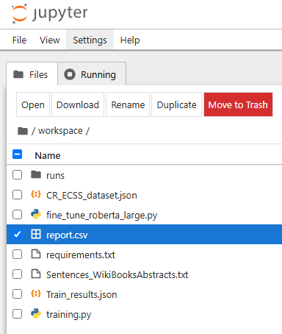

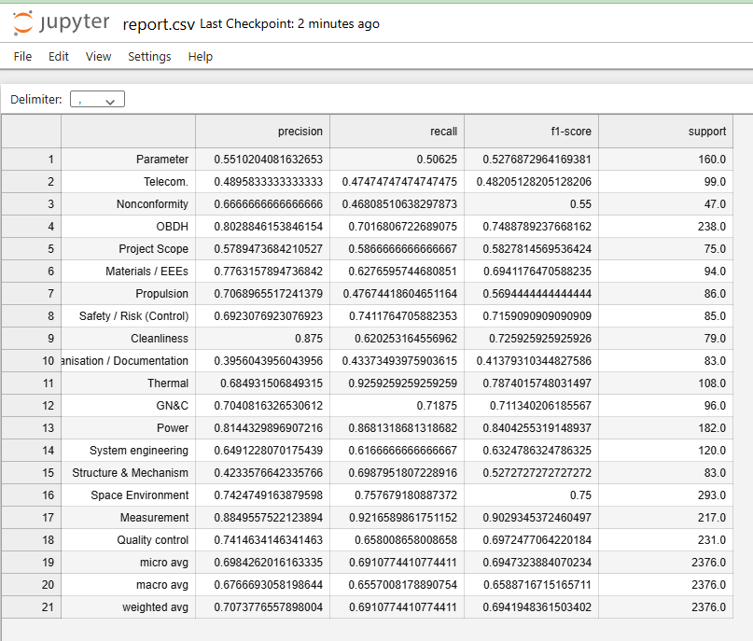

Direct Fine Tuning

