Calculating Network Statistics

Your Name Here

So far, we have focused on visualizing the network itself. This lesson will focus on calculating and visualizing statistics about the network.

## Network statistics

There are a lot of statistics that we might care about, and tidygraph and igraph have a number of functions to calculate them.

Let’s start with some simple graph-level measures, for our ffe_elite network.

G <- ffe_elite %>% as_tbl_graph()

Number of nodes:

G %>% gorder()

## [1] 28

Number of edges:

G %>% gsize()

## [1] 330

Number of mutual edges:

G %>% activate(edges) %>% filter(edge_is_mutual()) %>% gsize()

## [1] 160

Centralization:

G %>% centralization.degree()

## $res  
## [1] 11 41 34 8 16 15 33 29 21 25 31 8 28 27 27 26 25 24 29 4 32 21 17 26 35  
## [26] 27 37 3  
##   
## $centralization  
## [1] 0.3347051  
##   
## $theoretical_max  
## [1] 1458

### Exercise

Figure out how to calculate the betweenness centralization

## Your code here

## Identifying the most central nodes

We can also show the most central nodes in a table. We already know how to calculate centrality measures. After we calculate them, we have to take a step that’s a bit more complicated—basically, we take our node spreadsheet and temporarily convert it back to a “normal” R spreadsheet (a.k.a., tibble), and then manipulate the spreadsheet. That’s what the as_tibble() line below does.

After it’s in a spreadsheet, the select command is the list of columns we want to keep for our table, the arrange command sorts the table (the - before bw_centrality sorts it in reverse order, from highest to lowest). Finally, the head command shows the top N nodes.

G %>%  
 activate(nodes) %>%  
 mutate(bw_centrality = centrality_betweenness()) %>%  
 as_tibble() %>%  
 select(vertex.names, bw_centrality) %>%  
 arrange(-bw_centrality) %>%  
 head(10)

## # A tibble: 10 × 2  
## vertex.names bw_centrality  
## <chr> <dbl>  
## 1 E8 46.2   
## 2 E120 31.3   
## 3 E117 26.1   
## 4 E9 15.9   
## 5 E77 15.6   
## 6 E49 12.6   
## 7 E41 12.1   
## 8 E93 9.39  
## 9 E28 9.21  
## 10 E53 8.74

### Exercise

Calculate the closeness centrality and save it as close_centrality; add it to the table so that it shows both types of centrality, and sort by closeness centrality.

## Your code here

## Visualizing node or edge-level statistics

The other thing I want to show you how to do is to visualize attributes of the nodes or the edges. There are entire courses on visualizations, but I want to show you how to do a few.

### Histograms

We may want to visualize the distribution of attributes or network statistics.

We’ll use tibbles again, and then instead of using ggraph, we use ggplot, which is one of R’s general plotting packages.

geom_histogram tells it to create a histogram, in this case with the x axis mapped to the birthdate variable.

Finally, theme_minimal() adds the axes and tick marks to the graph (try it without that line to see what I mean).

G %>%  
 activate(nodes) %>%  
 as_tibble() %>%  
 ggplot() +  
 geom_histogram(aes(x=birthdate), binwidth=1) +   
 theme_minimal()

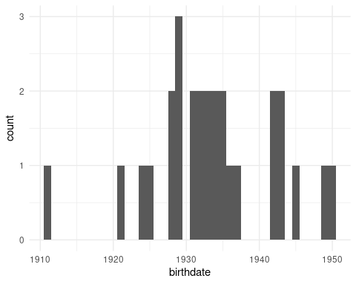

If we want to visualize how centralized a network is, a good way to do that is to show the distribution of degree (or betweenness or another centrality measure.) As we have done in a few previous labs, we’ll first need to create the column using mutate and then we’ll visualize it in the same way, using ggplot and geom_histogram.

Note: You’ll need to calculate networks statistics before calling as_tibble. R knows how to get the centrality of a node spreadsheet, but once it’s converted to a tibble, it doesn’t know what to do.

G %>%  
 activate(nodes) %>%  
 mutate(degree = centrality_degree(mode='all')) %>%   
 as_tibble() %>%  
 ggplot() +  
 geom_histogram(aes(x=degree)) +   
 theme_minimal()

## `stat_bin()` using `bins = 30`. Pick better value with `binwidth`.

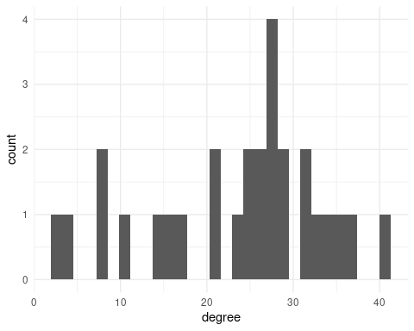

### Exercise

Visualize the betweenness centrality of the bkfrab dataset as a histogram.

Hint: You need to load the data using as_tbl_graph

# Your code here

### Challenge Exercise

Visualize the edge weight variable from bkfrab as a histogram.

Hint: Remember to activate the edges spreadsheet.

# Your code here

### Boxplots

The other thing we might want to do is compare the distributions of some network measure for different groups. There are lots of ways to do this, but the one I’ll show here is a “boxplot”. This shows where the “typical” values are for each group.

For example, this shows the degree distribution for each of the different religions in the ffe_elite dataset.

ffe_elite %>% as_tbl_graph() %>%  
 activate(nodes) %>%  
 mutate(degree = centrality_degree(mode='all')) %>%  
 mutate(religion = as_factor(religion)) %>% # Change religion to a factor  
 as_tibble() %>% # convert to a tibble  
 ggplot() +   
 geom_boxplot(aes(x=religion, fill=religion, y=degree)) + # `fill` changes the filled in color. Try changing this to `color` instead  
 theme_minimal()

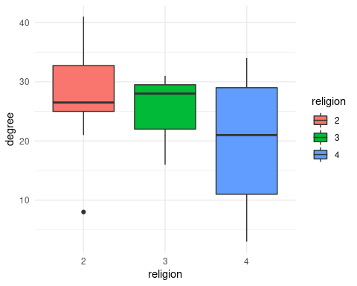

### Exercise

Visualize the betweenness centrality of the ffe_elite data by the university that people attended, as boxplots.

### Challenge exercise

Come up with something else that you want to visualize, either as a histogram or as boxplots and create a visualization below.

# Your code here