Materials needed:

- Print out everything on these pages and cut them out as needed
- “Laminate” the ACKS with tape

- Two pairs of scissors

- Two locks with two keys each

- A small box that can be locked
- Ideally, you can even have a to: and from: on the box

- 2 dry erase markers

- ~10 envelopes

You are a malfunctioning router – pass any packets that you get in the wrong direction

You are a malfunctioning router – throw any packets that you get on the floor (feel free to be dramatic)

You are a CIA-controlled router. Open up every packet that comes your way. As inconspicuously as possible, take notes about the sender, receiver, and what is in it.

You are a hacker. When you get a packet, replace the contents with the attached image

You are a user. Your goal is to send the attached image to Wikipedia. Here are the rules:

1. No talking
2. No bending or folding the image
3. You can only pass an envelope to a neighbor.

You are a user. Your goal is to send the attached image to Instagram. Here are the rules:

1. No talking
2. No bending or folding the image
3. You can only pass an envelope to a neighbor.
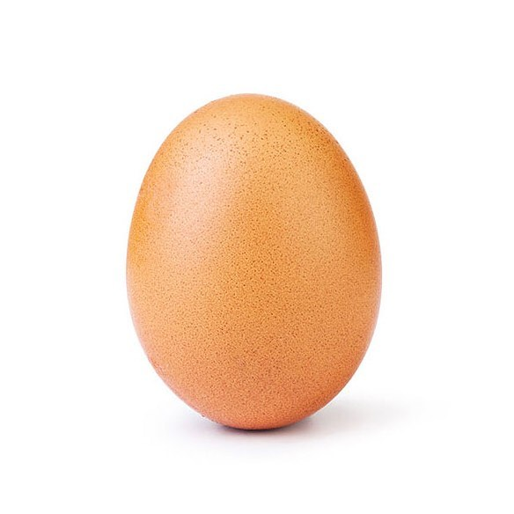

Most liked Instagram post
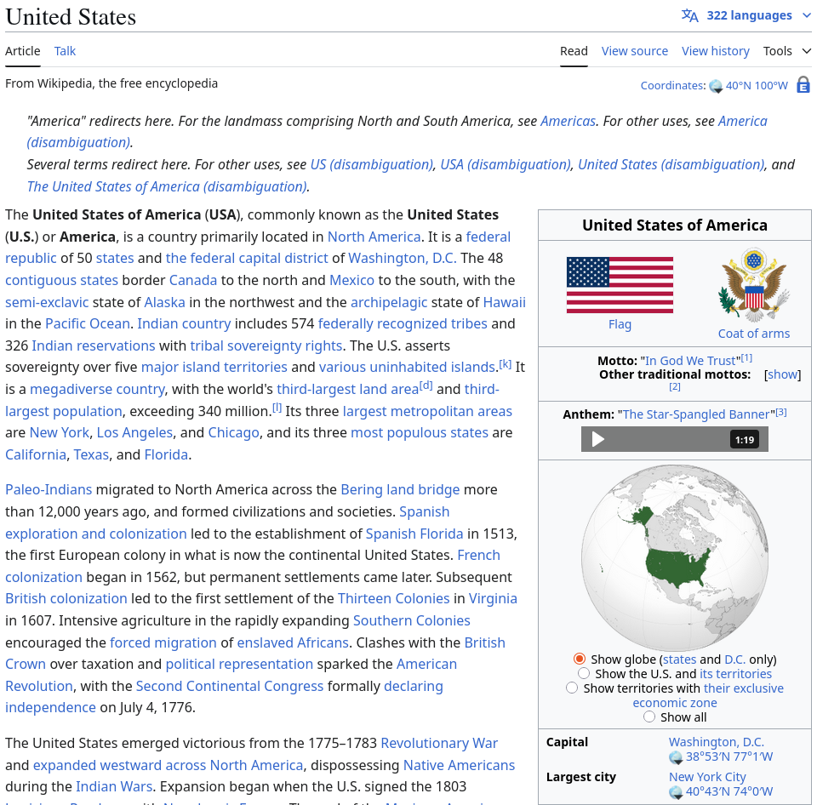

Most viewed Wikipedia page





ACK __ ACK __

ACK __ ACK __

ACK __ ACK __

