Urgent Care Expansion
Intelligence Demo
Synthetic public portfolio report
Boundary: All markets, organizations, metrics, and opportunities are fictional. Scoring is illustrative.

Executive Methodology
A compact public demonstration of the decision workflow:
Stage | Decision question
Market fundamentals | Is the synthetic market structurally attractive?
Demo Expansion Score | How do five transparent normalized components compare?
Entry opportunities | Is there an illustrative listed, off-market, or real-estate path?
Entry Feasibility | How strong is the best available demo path?
Near-Term Priority | Where should fictional diligence happen first?

Ranked Markets
Rank | Market | Metro | Near-Term | Expansion | Entry
1 | Alder Riverfront | Alder Bay | 82.1 | 78.4 | 86.0
2 | Lakehaven North | Lakehaven | 78.6 | 71.9 | 86.0
3 | Cedar Midtown | Cedar Junction | 75.4 | 75.8 | 75.0
Public model: demo_expansion_score_v1. This report does not reproduce production weights or opportunity logic.

1. Alder Riverfront
Alder Bay | Northland Demo | Synthetic market
Near-Term Priority | Demo Expansion Score | Entry Feasibility
82.1 | 78.4 | 86.0

Fictional market context

Market Overview
Indicator | Value
Population | 138,000
Population Growth | 5.8%
Competitors / 10k | 0.42 ++
Healthcare Access Gap | 74
Employment / Activity | 82

Competitors
Competitor | Rating | Reviews | Weekly hours | Operator / type
DemoCare 1 | 3.7 | 279 | 42 | urgent care
Northstar Clinic 2 | 3.8 | 330 | 47 | walk-in clinic
Civic Immediate Care 3 | 3.9 | 381 | 52 | occupational health

Entry Opportunities
Path | Illustrative opportunity | Score | Confidence
Listed acquisition | Illustrative clinic acquisition listing | 90 | High
Off-market target | Illustrative independent clinic target | 90 | High
Real estate | Illustrative medical office site | 68 | Medium

Metric Scoring
Metric | Normalized | Weight | Contribution
Population / Demand | 77.9 | 25% | 19.5
Population Growth | 90.7 | 20% | 18.1
Competitive Saturation | 72.2 | 25% | 18.1
Healthcare Access Gap | 74.0 | 15% | 11.1
Employment / Activity | 82.0 | 15% | 12.3
Source lineage: deterministic synthetic generator. No production source records are included.

2. Lakehaven North
Lakehaven | Northland Demo | Synthetic market
Near-Term Priority | Demo Expansion Score | Entry Feasibility
78.6 | 71.9 | 86.0
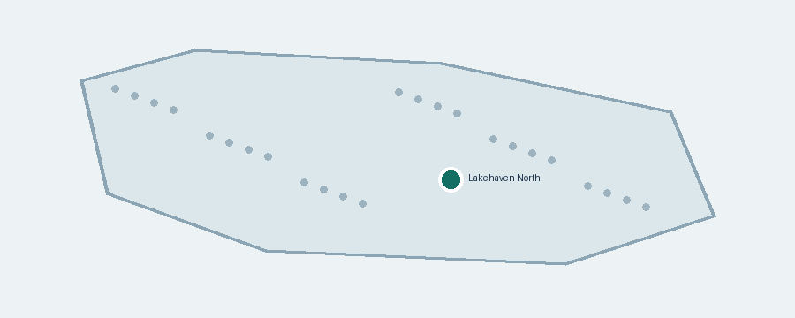
Fictional market context

Market Overview
Indicator | Value
Population | 87,000
Population Growth | 5.1%
Competitors / 10k | 0.36 ++
Healthcare Access Gap | 79
Employment / Activity | 63

Competitors
Competitor | Rating | Reviews | Weekly hours | Operator / type
DemoCare 1 | 4.2 | 534 | 67 | urgent care
Northstar Clinic 2 | 4.3 | 636 | 72 | walk-in clinic
Civic Immediate Care 3 | 4.4 | 738 | 77 | occupational health

Entry Opportunities
Path | Illustrative opportunity | Score | Confidence
Listed acquisition | Illustrative clinic acquisition listing | 90 | High
Off-market target | Illustrative independent clinic target | 80 | Medium

Metric Scoring
Metric | Normalized | Weight | Contribution
Population / Demand | 42.8 | 25% | 10.7
Population Growth | 81.3 | 20% | 16.3
Competitive Saturation | 77.6 | 25% | 19.4
Healthcare Access Gap | 79.0 | 15% | 11.9
Employment / Activity | 63.0 | 15% | 9.5
Source lineage: deterministic synthetic generator. No production source records are included.

3. Cedar Midtown
Cedar Junction | Southridge Demo | Synthetic market
Near-Term Priority | Demo Expansion Score | Entry Feasibility
75.4 | 75.8 | 75.0
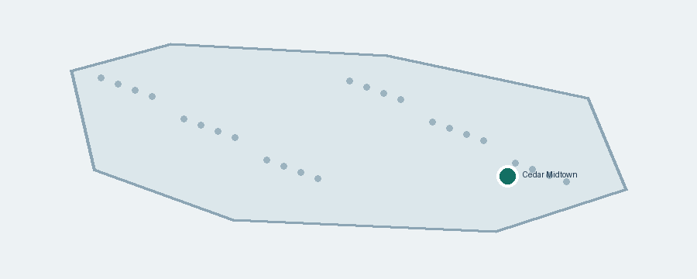
Fictional market context

Market Overview
Indicator | Value
Population | 168,000
Population Growth | 4.9%
Competitors / 10k | 0.47 ++
Healthcare Access Gap | 71
Employment / Activity | 91

Competitors
Competitor | Rating | Reviews | Weekly hours | Operator / type
DemoCare 1 | 4.3 | 687 | 47 | urgent care
Northstar Clinic 2 | 4.4 | 738 | 52 | walk-in clinic
Civic Immediate Care 3 | 4.5 | 789 | 57 | occupational health

Entry Opportunities
Path | Illustrative opportunity | Score | Confidence
Off-market target | Illustrative independent clinic target | 60 | Medium
Real estate | Illustrative medical office site | 72 | Medium

Metric Scoring
Metric | Normalized | Weight | Contribution
Population / Demand | 98.6 | 25% | 24.7
Population Growth | 78.7 | 20% | 15.7
Competitive Saturation | 67.7 | 25% | 16.9
Healthcare Access Gap | 71.0 | 15% | 10.7
Employment / Activity | 91.0 | 15% | 13.7
Source lineage: deterministic synthetic generator. No production source records are included.

