#### Homework 3 – Implementation of an advanced maintenance task in an unfamiliar Open Source Software (jEdit)

Template – The text in red represents a placeholder and provides additional instructions and should be removed from the final submission

# Software system and version: jEdit 5.4.0

# Change Request*:*

Add a new feature to jEdit which allows lines to be drawn beneath the text to simulate the look of a paper notepad. Also, there should be an option to allow the user to disable/enable this feature. The location of this control should be under “Utilities->Global Options…->jEdit->Text Area”.

# Detailed Development Environment Description*:*

TBD – Provide details about your development environment, including any tools you used for the entire assignment (e.g., Java JDK 1.8.0_144, Eclipse 4.6 on Windows 10, command line, git, Visual Studio Code, ant 1.10.2 etc.). This would be the type of information you could include in a bug report.

See [Slide 4](https://docs.google.com/presentation/d/1tTBrMlnMGO2eqo38HbRvHfJdTrQh7E5VOTimisB5wZM/edit?usp=sharing) for another example of a development environment.

# Description of Problems Encountered during Compiling/Building and Running:

TBD – Briefly describe any compilation/build and run issues you encountered and how you solved them. If you did not encounter any issues, briefly describe what steps you followed for a successful build and run.

**You should answer this question before working on the actual change request.**

# Screenshot of successful compilation:

TBD – Add a screenshot illustrating a successful compilation of the software. This screenshot can be either:

* a screenshots of an IDE (e.g., Eclipse, IntelliJ IDEA, etc.) which displays the software system without any build errors (see *Figure 1* for an example), or
* a screenshots of a terminal displaying the successful compilation of the software using a build system (e.g., Ant).

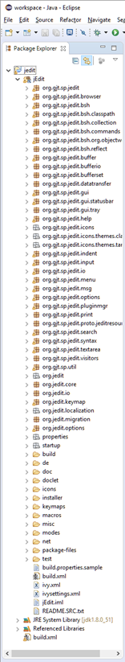

Figure 1 Screenshot of successful compilation of jEdit 5.4 in Eclipse 4.6 in Windows 10 (No compilation errors are highlighted in the Package Explorer)

# Identifying the Relevant Code (i.e., Concept Location):

TBD – Briefly explain what strategies/techniques you used to locate the parts of the code that needed to be modified. In other words, “what did you do” to discover the method that needed to be modified? Did you start by randomly opening files? Did you search for something? If yes, what was the search term? etc.

Aim to have around 1-2 paragraphs for this section.

# Successful Implementation Video:

TBD – Provide a link to a video capturing the implemented feature. The video:

* should be short (15-45 seconds)
* can be taken either with:
  + your phone camera or
  + through screen capture software such as OBS Studio (<https://obsproject.com/>)
* could be unlisted (e.g., only people with the link can see it), unless you want to make it public
* should be hosted on youtube, vimeo, google drive, or similar websites to facilitate viewing, and should not require flash installed on the client machine
* should capture the following scenario (e.g., steps to reproduce):

1. Launch jEdit (either through IDE or command line) with the notepad appearance option disabled.
2. After jEdit is open, start typing (or paste) a few lines of text.
3. Go to “Utilities->Global Options…->jEdit->Text Area” and enable the notepad-like style option.
4. (At this point, the notepad appearance should be visible in the editor).
5. Start editing and adding text in at least two random places within the file.

# Highlighted Source Code of the Implementation in a Side-by-Side readable format:

TBD – Highlight all the code snippets that were changed using a git diff visualizer (see *Figure 2* for an example) such as Visual Studio Code (<https://code.visualstudio.com/>), Source Tree (<https://www.sourcetreeapp.com/>), Eclipse, etc. NOTES:

* For each code snippet you highlight in this document, also include the file name containing this snippet.
* The text in the screenshot should be very clear and easy to read (i.e., it shouldn’t be very small and it shouldn’t be blurry)

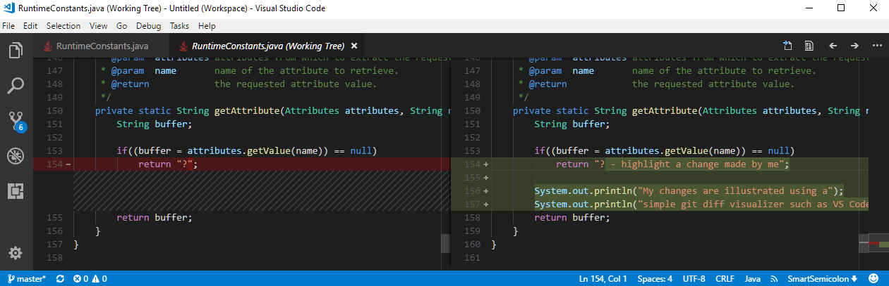

Figure 2 Sample git diff visualization using Visual Studio Code (<https://code.visualstudio.com/>).

# Time Required for Completing this Assignment:

|  |  |
| --- | --- |
| **Activity** | **Approximate Time Required (in minutes)** |
| How much time did it take you to figure out how to compile and run the software (i.e., total amount of time it took to read documentation, download the software, install Ant, etc.), **and NOT how much time it took the builder to build the software**. | *TBD* |
| How much time did it take you to understand the code that you need to modify, to implement the change request, and to test it? | *TBD* |