# Homework 5 – Testing

Part 1

# Overall coverage of all code blocks after running EMMA: 47%

# Screenshot of “EMMA Coverage Report”

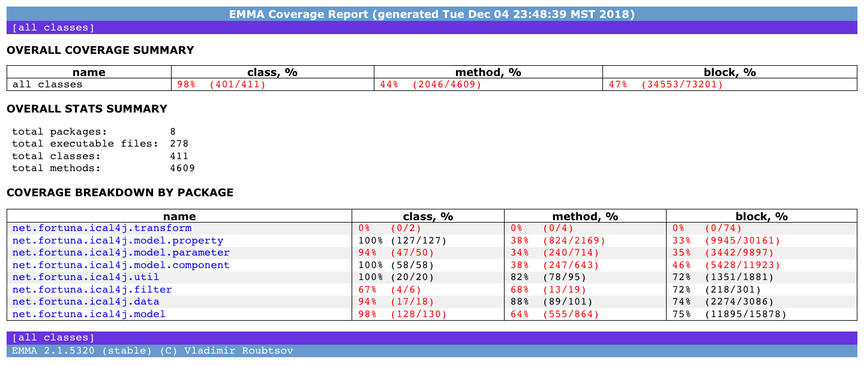

# Number of product lines of code: 16,262

# Number of test lines of code: 7,595

# Ratio of (Number of test lines of code) / (Number of product lines of code): .4670 or 46.70%

# Overall “Mutation Coverage”: 29%

# Screenshot of “Pit Test Coverage Report”

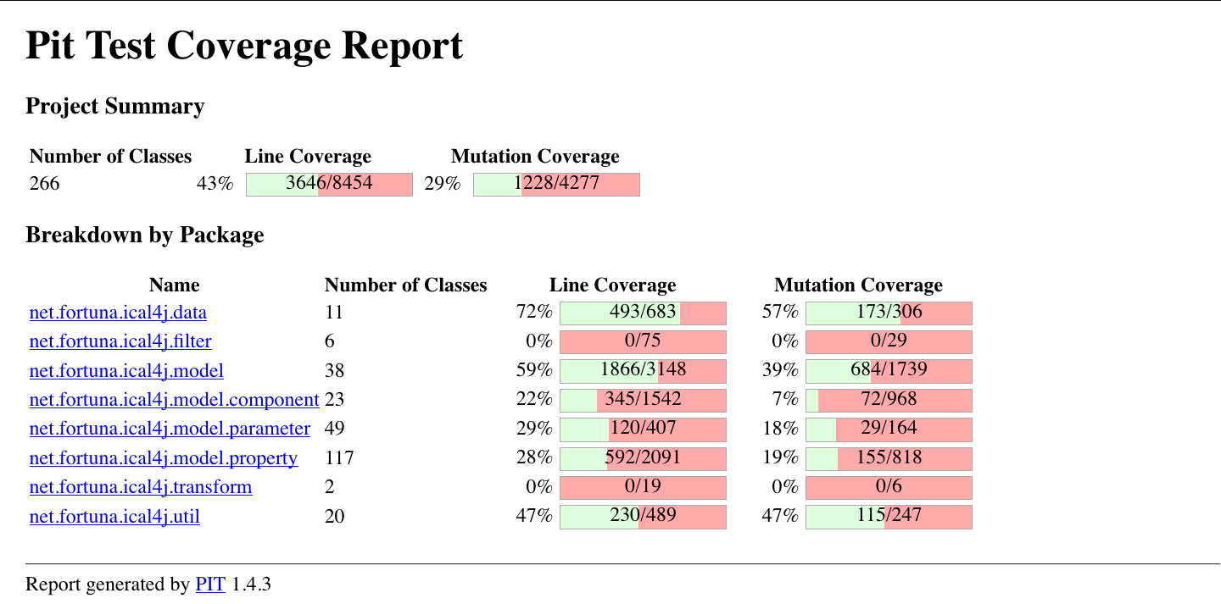

# Comparison of three instruments of the effectiveness of the test suite

It was very enjoyable getting to learn how to use all three of the methods here for testing a product, and definitely very educational when it comes to seeing how varied the methods can be when applied. However, it is worthy of note that while all three showed relatively the same coverage for the lines of code 43% to 47%, PIT showed that for randomly inserted defects (attempting to simulate new cases that the programmers may not have foreseen, as I understand it) the test suite was only able to cover 29%. This shows that the stochastic PIT may provide a better insight into how effective the testing suite is. This is because to me a random insertion of defects simulates a more realistic scenario of how a product may break down. While a programmer/engineer can brainstorm of possible ways a product may encounter an error/malfunction, often real errors and malfunctions present themselves at random. I do understand that there is so much any one engineer, or team of engineers, can do but by that same token, taking a look at the PIT results may provide to be much more insightful for testing a product than through EMMA or test-to-product ratios alone.

Part2

# In which order should the three software engineering activities be performed?

The coding activity should be followed by unit testing which is followed by static analysis, and finally the beta testing activity should be performed.

# What is the delivered defect density to the client if the development team uses the Defect Removal Model specified in Section 12?

Process:

30 defects / KLOC **=>** * .20 (20% Static Analysis effectiveness) = 24 defects / KLOC **=>** * .25 (25% Beta Test effectiveness) = 18 defects / KLOC **=>** * .30 (30% Unit Test effectiveness) = 12.60 defects / KLOC

Final: **12.60 defects / KLOC (~13 defects / KLOC)**