Designing Our Digital Past

Anchoring Digital-History Tool Development in the Historical Method Through Design-Based History Research
### anonym
### anonym
©. Published by De Gruyter in cooperation with the University of Luxembourg Centre for Contemporary and Digital History. This is an Open Access article distributed under the terms of the Creative Commons Attribution License CC-BY-NC-ND
Net.Create is funded through the EAGER program at the National Science Foundation under award #1848655 and the iTest program, and through the Lumina Foundation under award #(2104-1114262)[https://www.luminafoundation.org/grant/2104-1114262/]. Special thanks to the Center for Research on Learning and Technology and the RAPT Lab in IU Bloomington's School of Education; the team members at IU Bloomington's former Institute for Digital Arts and Humanities; the Department of History at IU Bloomington; and the developer team at Inquirium.
from IPython.display import Image, display
display(Image("./media/NetCreateCoverImage.png"))
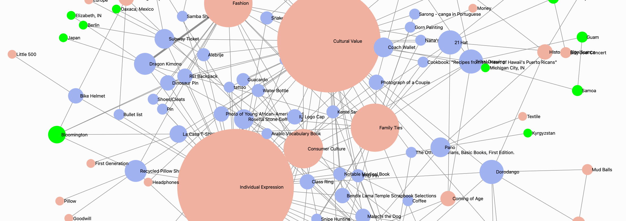
network analysis, network visualization, digital history tool design, capta, collaborative history, co-design, interdisciplinarity, representations, tacitus, design-based history research, design-based research
Many of the tools digital humanists use have come from a variety of disciplines outside of history. As a consequence, many digital-history methods sections focus on how a tool developed by non-historians might support, or need to be adapted for, particular historical questions. Few digital tools have been developed by and for historians with a specific eye to the methdological and theoretical explorations of design principles that are necessary to anchor digital-history-specific tool development in historiographic practices.
This article introduces Design-Based History Research (DBHR) as a methodological bridge between the practices of digital-history tool design, the use of digital methods to create historical argumentation, and social-science-inspired methodological innovation. Design-Based Research (DBR) is an educational-research approach to studying learning theory that supports theory building by integrating theory into the design of new tools and environments, in a manner that allows the designers to rigorously study the theory, and the relationship between the theory and the tools that embody it. In practice, this means that DBR focused on softare design incorporates theoretically motivated decisions about user interface features, user activities, and data-structure choices into an initial tool/software-package design and then studies the design package in use as a way of iteratively reifying the theoretical principles in each of the tool's design phases. DBHR is an adaptation of the DBR approach, with a theoretical approach grounded in the unique needs of historians and historiographic practices.
We aim to illustrate DBHR by describing the design and use of Net.Create, a user-focused network-analysis tool that prioritizes historiographic practices (evidence interpretation, citation preservation, and historiographic debate) in its feature development and user-interface choices. We document how the needs of digital historians shaped the current design of Net.Create, explore the connections between specific tool features and their operation, and delineate how those tool features support the digital-history needs we identified. As part of this iterative-design process, we will also address some of the human-computer-interaction observations, user-entered network data, and qualitative-network-analysis approaches that shaped each stage of our feature development around digital history practices.
Our DBHR process ultimately led us to prioritize the development of three features that support and encourage sustained historiographic debate at each phase of a network-analysis digital-history project:
- simultaneous entry and visualization of capta, data that is gathered and contested rather than downloaded or received, in order to support and encourage historiographic debate during the data-gathering phase and prior to a formal analysis phase
- easy-to-use revision of network taxonomy and network data, to support interpretation, reinterpretation and re-input of evidence and data by many collaborators simultaneously, synchronously or asynchronously, during the initial analysis phase
- data provenance features that expose the researchers' positionality and preserve the original citations for each network datapoint, to support the integration of close-reading analytical practices both by the research team and by other historians after the communication of results to a public audience
By documenting the historiographic roots of each of these features, we hope to offer a systematic articulation of digital history tool design not simply as software development but as a pathway to the concurrent and intertwined development of historical theory, digital-history tools, and collaborative historical methods.

Introduction: Archival Boxes and Historiographic Conversations
The conversation historians have about change and continuity over time in our research is most visible when we explore the riches that spill forth from a box of primary sources. We shape an argument around the stories archival documents tell about historical outliers and conformists alike. The historiography to which our arguments contribute, on the other hand, doesn't start with our primary sources in the archives. It starts in seminar rooms, conversation with colleagues in hallways at conferences, and in the footnotes of the vast literature that shapes how each of us approaches our archival work. Because digital historians draw on additional modes of analysis to find and articulate our contributions to our subfields' historiographies, we bring two extra layers of historiographic conversation to the table: the methods we use to transform unstructured historical evidence into structured data, and the tools that shape how our data analysis proceeds. This article introduces Design-Based History Research (DBHR) by addressing how the incorporation of the historiographic conversation into digital-history tool design can make that conversation clear and explicit for digital historians with tool-design ambitions. This clarity also paves a smoother path for digital-history practitioners whose goals are not to build tools but to use existing tools to serve their argumentative-history goals. Our intent in developing DBHR is not just to produce tools for historical analysis, but to use the production of those tools, and our observation of users working with digital-history tools, as a way of understanding the very nature of the relationship between such tools and the historical analyses they support.
To do so, we first position DBHR for an audience of historians who take on the task of developing digital-history tools. For these digital historians, DBHR offers a flexible collection of integrated theoretical principles and methodological affordances that redefine "digital history tools" at the nexus of software design and the activities that take place around the use of a particular software tool. Rather than a pure focus on network-analysis-software features, we theorize around the role of software's relationship to methods and researchers in a historical-research context. This focus on the context of a digital-history-tool development process also helps us address yet another limitation digital-history tool developers face: user-interface and feature-development theories and methodologies are dominated by software-engineering considerations, not by the theoretical motivations that shape the practices of working historians or by the actions of the historian that shape how we use our tools. By focusing on the definition of "digital-history tool" as encapsulating both the features of a digital-history software package and the activities teams engage in as they use a digital-history software package, we offer a novel approach to fostering historiographic conversations early in the digital-history research development process: at the data-entry stage. Our goal in fostering historiographic thinking in the data-entry process is twofold. First, beginning the formal practice of historiography in the data entry phase of a digital-history process is vital sustaining formal historiographic methods throughout the visualization and analysis process. Second, the transparency fostered by the acknowledgement that historiography is more than a post-publication conversation will better support the integration of digital-history methods into the discipline at large. In other words, DBHR's theoretical and methodological innnovations draw on social-science processes that address questions of feature development and usability tied, not to standard technology-driven measures of usability, but to features and usability driven by the conversations historians have, with our sources and with each other, at all stages of the research process.
Then, we position DBHR for an audience of digital-history practitioners who use other people's tools. For these digital historians, DBHR offers a start-to-finish evaluative process that can help digital historians understand how the digital tools they are adapting from other disciplines align with the disciplinary norms of history and use that evaluative process to encourage the incorporation and development of historiographic conversations in their data analysis phase. Digital historians already champion a certain transparency of method. As a consequence, digital-history methods sections are replete with descriptions of how data-gathering and digital techniques--mapping, network analysis, topic modeling, etc.--reshaped the scale, scope and structure for the historical argument being made. In some cases, that includes elucidation of the differences between the home discipline from which we are borrowing our methods and our own disciplinary goals. Rarely, however, do digital history practitioners extend that same analytical depth to the actual tool we are using to do our digital-methods analysis, or to how that tool's driving disciplinary concerns might impact the contents of our contributions to the historiographic conversation in which we participate.
We anchor the DBHR process we describe in this article in a specific software-and-activity-development example, by describing a series of small-scale design-and-use iterations of Net.Create, a user-focused network-analysis tool that prioritizes historiographic practices (evidence interpretation, citation preservation, and historiographic debate) in its feature-development and user-interface choices. Our team's development and use of Design-Based History Research (DBHR) offered a guide for the joint development of Net.Create as both software and the activities that scaffold its use of a software. As we developed software features alongside methods for the use of those features, we draw on three major design principles, outlined in section 36 below. Each of these design principles and user-interface choices can then be abstracted to offer a framework for the whole digital-history field to use as we: a) generalize our methods- and tool-design goals; b) evaluate in-development tool-and-activity systems; and c) adapt tools developed in other disciplines for use in historical research.

An introduction to Design-Based History Research (DBHR)

Design-Based Research and the Iterative Loop between Theory Development, Applied Methods, and Research Impact
Introducing DBHR requires us first to consider Design-Based Research (DBR) sans the "H". DBR is an approach to studying, modifying, and applying learning theory through design. Researchers seeking to understand how people learn use DBR first to integrate a motivating educational theory into a tool and/or activity design and then hypothesize, or "conjecture", about the learning outcomes that theory helps identify. They then implement their design and study how effective their conjectures were by comparing the learning processes and outcomes from that design to their hypotheses. Finally, they apply those processes and outcomes to a re-design that revises both their motivating theory and the design that aims to reify the theory. The educational researchers making use of DBR stress its value in assessing their assumptions about the development and design principles that reify, guide, inform, and improve theory, practice, and research in educational contexts. The applicable principles of DBR laid out below are done in the context of educational software. As such, these principles don't describe an educational software tool in isolation. Instead, DBR principles acknowledge that "technical objects define a framework of action together with the actors and the space in which they are supposed to act." The actions learners take in an activity system anchored by a software tool are mediated--changed and shaped--by the tool itself, by their relationship to other learners and to the instructor in a system, and by the other resources and instructions they are given as they engage in learning. DBR formalizes the relationships between actors in a system by exploring the relationship between the theory-driven development of software design and its accompanying activities. DBR then extends this formal analysis to the testing of a design and its activities in iterative stages, each of which provides additional evidence to inform the revision of the theory and the design in tandem, and the application of those revised theoretical principles with their practical design outcomes in other people's research and practice.
DBR Principle (adapted from ) | Practical Educational Research Outcome
Theory-driven development of educational design and methods | Situated in a real-world educational contextsFocused on the design and testing of a significant intervention
Applied iterative theory developed with practitioners | Testing of design and methods shapes revision of theory; Revised theory offers insight into design and methods revisionsEmphasizes mixed-methods and interdisciplinary approaches and collaboration
Should have impact in both research and practice | Develops research-driven design theory for use by other researchersProvides guidance for adoption by other practitioners
Adapting DBR to DBHR starts with the acknowledgement that the article "the" in "the historical method" isn't monolithic. The historical method governs not a singular approach to history--a single, well-articulated, unified "the"--but a wide variety of praxis, theory, and individual approaches to the study of the past that puts archival source material in conversation with other historical experts. Questions of scale, audience, sourcing, and presentation all shape these conversations, whether we put those questions in a methods section or not. The work of a microhistorian is shaped by the scale of the research, while public historians begin their work with questions of audience. Cultural and social historians differentiate their subfield methods by asking different questions and emphasizing the use of divergent types of documentary evidence to answer those questions. Public historians have developed methods to evaluate format, audience movement and public interaction as part of exhibit design for both in-person and digital public-history exhibits.
In our classrooms, historians communicate the interplay between researcher, method, primary sources and secondary sources, which aligns our field with the social-science approach that says defined methods should be included in published scholarship. In our research publications, on the other hand, historians tend away from explicit methods sections, where both qualitative and quantitative social scientists fully narrate the principles they used to gather data, and the hermeneutics and researcher positionality authors bring to their analysis. As a result, tool design in the context of a field that both relies on, and leans away from, documenting its own research methods can be something of a challenge even for those well-versed in the field.
Framing the iterative process of DBHR as a conversation about change and continuity over time roots digital-history tool design in historiography. Historians use citations to "talk" to each other in an ongoing conversation that is distributed across time and space. That is, historiography asks one historian to debate or agree with other historians' arguments using a crumbtrail of citations that lead to primary and secondary sources drawn from all over the world and across a very long timespan. Integrating DBHR into digital history as a guiding theoretical principle for design and methods sections renders both the tools, and the analysis based on those tools, transparent and approachable by other historians.

Adapting Design-Based Research Using Historiography as the Driving Theoretical Framework
DBR assumes that learning outcomes are the primary focal point for DBR analysis. Historical research requires a shift in priorities. If we adapt the primary principles of DBR to use historiography as a driving theoretical framework, we can reshape the principles of DBR into an adapted DBHR approach (table 2). In this new DBHR process, we can make several parallels. First, the process of historical analysis is the DBHR parallel to DBR's learning process. Second, the historical argument that puts analysis into conversation with other historians--the process of historiography--is the DBHR equivalent of DBR's educational outcomes (table 3). Finally, the classroom activity that is part of the DBR design process parallels the methods digital historians use to integrate software tools into their analysis.
DBR | becomes | DBHR
Theory-driven development of educational design and methods |  | Historiography-driven development of tools and methods to use those tools in order to answer questions about change and continuity over time
Applied iterative theory developed with practitioners |  | Refine and iterate design & methods based on resulting historical argument and how that argument fits into existing historiography
Impact in both research and practice |  | Impact in both argument-driven history and digital history and use by historians in both subfields
DBHR Principle | Practical Digital-History Design Research Outcome
Historiography-driven development of tools and methods to use those tools in order to answer questions about change and continuity over time | Situated in historiographyFocused on the gaps between historiographic need and existing design and method
Refine and iterate design & methods based on resulting historical argument and how that argument fits into existing historiography | Small-scale testing to evaluate how tool/method design shape historical inquiry and argumentRevised argument offers insight into design and methods revisionsEmphasizes mixed-methods approaches through proof-of-concept collaboration
Should have impact in both argument-driven history and digital history | Produces tools designed for and by other historiansArticulates methods that link tools to appropriate continuity-and-change questionsContributes to historiography through change/continuity-over-time arguments

Method-as-activity in DBHR: a Net.Create classroom-to-research DBHR pipeline
The governing principle of DBHR is that a concrete set of design choices rooted in historiographic principles can be iterated, tested, and redesigned to create a digital toolkit that doesn't just support, but encourages and furthers, historical analysis for users with a variety of historical experience. To illustrate that process, we now proceed to outline a series of design choices made over the course of 5 years during several iterations in the development of Net.Create, each of which takes a small-scale theory-driven approach to digital-history tool design. To begin that exploration, we first outline the initial experience a novice might have with the basic principles of network analysis before then moving to the historiographic principles on which Net.Create's development was based.
Networks are aggregate collections of individual relationships between actors in a system. Because networks offer a simultaneous view of the one-on-one relationship in its larger context, this relational structure offers a valuable lens through which to analyze and understand history. Aggregate network data can be mathematically parsed to identify well connected actors, outliers with few connections, and efficient paths of transfer for information, power, and money in a network. These mathematically driven analytical pathways to understanding relationship patterns offer digital historians many ways to understand historical significance. One "classic" digital history project, Mapping the Republic of Letters, uses network analysis to understand the transmission of ideas in letter networks, both intellectual and spatial, in the seventeenth and eighteenth century. A variety of other network-analysis projects explore history through the lens of connections, collaborations and interactions.
Network visualizations take this network data and present it in a graph. In network visualizations, the individual actors (nodes or vertices) usually appear as points or circles, and the connections they have (edges) are lines drawn between the points. In less technical terms, nodes are the subject and object in a sentence, and edges are the verbs that connect those nodes, creating a node-edge pair or dyad. Nodes that have the most interactions, or degrees, are represented as larger circles to represent their high connectedness, or high degree-centrality measurement. In representing them this way, network visualization tools can also calculate what is referred to as "gravity" for each node, using an approach force-directed display to move and re-arrange the nodes based on that gravity so that their import and impact on the network is even more salient to users. Below, for instance, we can see the nodes and edges that represent one version of the connections between members of the Julio-Claudian court describied in Tacitus' Annals, a second-century history of the late Roman Empire. This version of Tacitus' network was built by students sa part of an undergradaute course exercise in a process we'll address in section 42 in the hermeneutics layer. The two largest nodes in this network are labeled "Claudius" and "Agrippina". Emperor Claudius has 44 edges that link him to other nodes, for a degree-centrality measurement of 44; his fourth wife Agrippina's is 43, so the two nodes are similarly weighted, or demonstrate a significant role, in the historical events represented by this network. The "gravity" and "force" in this network can be seen in how the two large nodes push each other apart, while each also draws smaller nodes into their immediate area, helping viewers to infer their relative impact on each other, though that inference necessarily needs to be supported by a close reading of the text.
from IPython.display import IFrame
src='https://netcreate.org/SampleNetworks/Package/?dataset=2019-02-06_TacitusGender#/'
display(IFrame(src, width='100%', height='1000'))
<IPython.lib.display.IFrame at 0xffff902b2f90>
# pandas package needs to be added to the requirements.txt's file
import pandas as pd
df = pd.read_csv("script/Tacitus_StudentNodes_2019-10.csv")
df
Degrees Label Type \
0 1.0 Accusations leveled against Agrappina Event
1 1.0 Acerronia Woman
2 1.0 Acte Woman
3 3.0 Adultery Thing
4 3.0 Aedui Group
.. ... ... ...
114 1.0 Vipstanus Man
115 8.0 Vitellius Man
116 2.0 Xenophon Man
117 1.0 scipio Man
118 2.0 senate awards funds Event
Significance
0 A group of people leveled accusations against ...
1 Female slave of Agrippina
2 Freedwoman that Nero had an affair with.
3 a common thread
4 One of the prominent Gallic Tribes
.. ...
114 Consul
115 Censor
116 Claudius’ doctor
117 poppaea’s husband
118 money is awarded by the senate to those who ad...
[119 rows x 4 columns]
df = pd.read_csv("script/Tacitus_StudentEdges_2019-10.csv")
df
ID Size Source \
0 26 1 Valerius Asiaticus
1 162 1 Messalina
2 245 1 Claudius
3 259 1 Crispinus
4 310 1 Sosibius
.. ... ... ...
210 243 1 Herculeius
211 256 1 Obaritus
212 358 1 Murder of Agrippina
213 385 1 Agrippina
214 429 1 Tacitus
Type \
0 has martial or adversarial interaction with
1 has martial or adversarial interaction with
2 sends written communication to
3 has martial or adversarial interaction with
4 has peaceful, familial or conversational inter...
.. ...
210 has peaceful, familial or conversational inter...
211 has peaceful, familial or conversational inter...
212 participates in
213 participates in
214 has peaceful, familial or conversational inter...
Target Citation \
0 Poppaea 11.01
1 Valerius Asiaticus 11.01
2 Crispinus 11.01
3 Valerius Asiaticus 11.01
4 Britannicus 11.01
.. ... ...
210 Anicetus 14.08
211 Anicetus 14.8
212 Political Murder 14.9-11
213 Political Murder 14.9-11
214 Students in this class Self-evident
Signficance
0 former lover
1 successful imprisonment
2 sends to baiae
3 imprisons valerius
4 tutored
.. ...
210 Joins Anicetus to kill Agrippina
211 Accompanies Anicetus to kill Agrippina
212 Murders his politically ambitious mother, who ...
213 Murdered by Nero's men for her political ambit...
214 Learning
[215 rows x 7 columns]

Identifying DBHR Opportunities: An Environmental Scan of Network Analysis Software Feature Needs
With these network analysis basics in mind, we then turn to our design goal for Net.Create: the specific needs of historians working on network-analysis projects of varying levels, initially based on our own classroom and research experiences and then iteratively with a variety of historians working on research projects. DBHR shaped a process that leaned away from a tool built for networks at scale, such as the big-data networks that place individual social media interactions in a global-internet context, and toward very small focus-group-oriented iterations in controlled environments that allowed us to iterate the theory and activities/methods approaches alongside the software that anchored the activities. Our goal in working with this initial small user base was to conduct direct observation of network analysis practices in history-research and -teaching contexts so that we can better understand how a tool such as this reflects and informs historical theory and analysis and the future development of consumer-grade network-analysis tools (including a revised Net.Create with easy-install processes).
To that end, we articulated design "conjectures"--idealized behavioral goals driven by user-interface and activity-design choices--at each stage so that we could test our design choices and revisit them in later iterations. Over the course of a multi-year DBHR redesign-and-revision process--a process outlined in brief in tables 6 and 7 and fully described in the sections that follow--our team of historical and network-analysis methods experts and tool designers worked with and observed users to identify a number of emergent historical-thinking needs that had parallel data and visualization use patterns. We then mapped those design conjectures to user-interface and feature options in existing network-analysis software packages. There are a variety of network-analysis tools that range from free to very expenxive. In the free open-source network-analysis and visualization tools, we include: Gephi , Palladio , Cytoscape , Network Navigator and sigma.js . Tools with an initially low-cost or freemium approach to network analysis and visualization include: UCINET , NodeXL and nodegoat . Other platforms have initially high costs which are often aimed at bigger datasets, including Neo4j and Communalytic . We focused our attention on tools that appear in digital-humanities research, offer in-tool solutions for data entry, and align with the no-cost and open-source principles that drive many digital humanities tool developers. With these criteria in mind, Gephi and Cytoscape were the most helpful tools in identifying gaps that have historiographic implications for historians using network analysis.
In our early design iterations, we established simultaneous data entry, flexible taxonomy, and a clear provenance or citation requirement for each network data point drawn from a historical source as our highest-priority features. As we explored why these three features were so important for historians using network analysis, our inquiry process around emergent user patterns highlighted several other data features and network-visualization features that we felt were missing or not fully developed, from the perspective of the historical method, in other network analysis software packages. In table 6, we list the historiographic principles we worked from, each of which has several user-interface design choices and theoretical principles associated with it in Net.Create. The different user-interface and data-structure elements that support these design needs were added at various points in the tool design process. Some were driven by the research team's initial scan of network-analysis software package features that served historiographic principles less well, while others were driven by the research team's observation of how novice and expert historians interacted with the network graphs and data tables, connected the network data/graph to the original sources, and used the network and primary sources to craft historical arguments. The changing composition of both the research team and the pilot-test audience also shaped the tool's developing feature set; our small research team of historians added learning-science researchers and then agile software developers, and we worked with rounds of early-career history students and well-trained historians at the faculty and graduate student level in several cycles.
Over the long term, our design conjectures broke down into three basic categories. First, network analysis software packages are primarily designed for individual researchers working with large-scale scraped or pre-prepped datasets, not for historians extracting structured network data from unstructured sources through close-reading historical practices. This is especially true for network-analysis projects done in tandem with colleagues. Johanna Drucker calls this process of gathering, debating, and shaping humanities data capta. Because the labor-intensive nature of capta is often collaborative and conversational, we hypothesized that there's an unfilled need for research teams to simultaneously engage in data entry and respond to collaborators' data entry in real time. Second, we observed that humanities researchers and students simultaneously negotiated both the contents and the interaction taxonomy of their network capta as they explored historical sources. That is, our network analysts were engaged in a historiographic conversation about their network from the very beginning at both a very granular level, on the individual-data-point level and at the larger taxonomic node-and-edge-typology level. Many network analysis packages require researchers to determine the types of nodes and edges that will be collected from a network-data source and define how different node types will connect to each other before beginning to enter data. Our humanities-oriented network analysts debated both the network data and the taxonomy that network data fit into during every stage of their data entry process. Here, our conjecture suggested that we needed a design activity and software tool that accommodated a developing understanding of relationships at all stages of a network-analysis project, while still offering a way to communicate the need for more rigid relationships. Doing so would allow humanities-network-analysts the freedom to build an emergent taxonomy as their conversations about a network unfold, while also controlling the network data well enough to support eventual statistical analysis of the network data. Third, many network analysis packages are designed for self-contained datasets and as a result, don't automatically accommodate the citations or notes at the individual-data-point level that allow for data-entry-based historiographic conversations. Optional attribute fields can be added, but the optional nature of those attributes means that citations are often overlooked at the individual node-and-edge level. Our conjecture here was that requiring more citational scaffolding in the network-analysis dataset itself would not simply support but actually drive the historiographic conversation we wanted to encourage at all stages of the network data entry and analysis.
In our early design iterations, our conjectures focused on simultaneous data entry, flexible taxonomy, and a clear provenance or citation requirement for each network data point drawn from a historical source as our highest-priority features. As we explored whether and why these three features might be important for historians using network analysis, our inquiry process around emergent user patterns highlighted several other data features and network-visualization features that we felt were missing or not fully developed, from the perspective of the historical method, in other network analysis software packages. In table 6, we list the historiographic principles we worked from, each of which has several user-interface design choices and theoretical principles associated with it in Net.Create. The different user-interface and data-structure elements that support these design needs were added at various points in the tool design process. Some were driven by the research team's initial review of open-source network-analysis software package features that served historiographic principles less well. Other design elements were driven by the research team's observation of how novice and expert historians interacted with the network graphs and data tables, connected the network data/graph to the original sources, and used the network and primary sources to discuss data-entry questions or to craft historical arguments. The changing composition of both the research team and the pilot-test audience also shaped the tool's developing feature set; our small research team of historians added learning-science researchers and then agile software developers, and we worked with rounds of early-career history students and well-trained historians at the faculty and graduate student level over several iterative cycles.
In each of 6 rounds of redesign (table 7), we therefore addressed either a user-interface or data choice within the Net.Create tool or the specific instructions we used to scaffold use of the Net.Create tool by teams of historians (table 6). We then analyzed the resulting behaviors and datasets in order to establish a concrete list of current barriers to the historical method in existing network-analysis user interfaces, explore the possible user-interface or user-activity design principles that would reshape network analysis practices around the hisitorical method, and then enacted those design principles in case studies with practicing historians of all levels.
An overview of the theoretical and historiographic principles that underlie Net.Create design conjectures.
Net.Create Design Iteration | Design Need | Technical Implication | Historiographic Foundation
0.02, 1, 1.1, 1.2 | simultaneous entry and visualization of capta | data that is gathered and contested rather than downloaded or received | support and encourage historiographic debate during the data-gathering phase and prior to a formal analysis phase. Capta offers an operating principle for focusing capture of information through debate.
0.01, 0.02, 1, 1.2 | easy-to-use revision of network data and taxonomy | support interpretation, reinterpretation and re-input of evidence and data by many collaborators simultaneously, synchronously or asynchronously, during the initial analysis phase | revision and re-entry of capta that emphasizes the interpretive and conversational nature of historiographic debate
0.01, 0.03, 1.1, 1.2, 1.4 | data provenance on several levels (citation, revision tracking, researcher contributions) | support the integration of close-reading analytical practices both by the research team and by other historians after the communication of results to a public audience | data provenance features preserve links to citation and researcher as a path to transparency for our adiences and to emphasze the importansce of sourcing and expose the researchers' positionality and preserve the original citations for each network datapoint
A time-based and audience-based overview of Net.Create's DBHR-driven feature development.
Date | Version | Primary feature focus | Design/methods responsibilities | User-audience testing
2015 | 0.01 | Network data entry with citations | Craig responsible for solo coding, UI feature design, testing/user-activity design | Mid-sized classroom (75-100 students) with Craig as sole tool-builder and researcher
2016 | 0.02 | Simultaneous data entry | Craig
2017 | 0.03 | Customized notes and location fields | Craig | Addition of Danish and one graduate student to research and analysis team.
2018 | 1 | Live visualization, predictive text | Collaboration between Craig, Danish, Inquirium | Large undergraduate classrooms (100+) and history research teams both with and without Net.Create members
2020 | 1.1, 1.2 | Custom tags | Collaboration between Craig, Danish, Inquirium | Large undergraduate classrooms (100+) and history research teams both with and without Net.Create members
2022 | 1.2, 1.3 | Filtering, GUI-based node/edge type changes, import/export | Collaboration between Craig, Danish, Inquirium | Small history research teams, both with and without Net.Create members
2023-present | 2.0 | Comments layer, filtering refinement. End-user-friendly installation is in progress at time of publication | Collaboration between Craig, Danish, Inquirium, Digital Promise | Mid-size middle-school classrooms (25-30), undergraduate classrooms (25-100+), small independent digital-humanities and digital-history research teams with no connection to the Net.Create team

Software Versioning as Historiographic Practice: Tracing the Iterative DBHR Interventions in Net.Create's Feature Set
In our first two design rounds, our conjectures were primarily focused on two network-analysis projects that got their start in 2015 and 2016, the first in a history classroom and the second with team of historians working with archival sources. From the beginning, though, the theory-conjecture-design process we adapted from DBR guided our process. For clarity, though, we'll refer to the various network-analysis tools that came out of our development process as "Net.Create" and the growing team that designed and programmed Net.Create as "we".
As with the design team, our audiences and pilot-testers for Net.Create started with a single classroom and a few historians and grew with each round of design. Given our multiple overlapping commitments to teaching and research, we opted to implement some versions of Net.Create with history students, others with professional historian colleagues, and still others with both audiences. We were mindful of the limits of student expertise as historians, but two factors influenced our decision to work with both audiences. First, in-class activities were designed to parallel the way teams of professional historians work together during a collaborative activity focused on the creation of a joint network using a variety of archival sources. Classrooms, then, offered us a space in which to test at scale with real-world use of primary and secondary historical sources. Second, professional historians have expertise in working with archival sources, and in integrating those sources with other historians' work to craft arguments. We expected that professional historians would already have practices shaped by those norms, so our design was aimed at guiding students' activities more explicitly into alignment with those professional-practitioner norms. We hoped students' resulting behavior might partially mirror that of experts as a consequence of the activity and tool design, and thus produce similar outcomes while helping them to learn those processes and practices of the experts. Finally, despite their historical expertise, we anticipated many historians might be novices in the context of network creation and analysis, and thus felt that taking a pedgagogical approach to designing the system to be easily used would provide benefit to all of our planned users. It is important to note that we are not claiming that well-supported students act exactly as professionals. Rather, we believe that looking at how they interact with digital tools might provide insights into how the tools support target historiographical activities in ways that we can then take to professional historians and vice-versa. Our overarching claim, then, is that insights gained in each context can help us strengthen our designs in the other as we aim to make a tool that can support both novice and expert historians.

Design Round 1: Citation and Note-Taking as Early-Stage Practices to Support Networks in History (Version 0.01 in 2015)
Above, we established citation-based historiography as the core of the historical discipline. Historians drawing on network analysis to fit their own source interpretation into a historiographic debate need a network analysis tool that supports both their citation-surfing practices and exposes the interpretive debate that should ideally take place around each interaction in the network. In user interface terms, then, a functional digital-history network analysis tool needs to support a citation field and a notes or significance field that accompanies each piece of network data and can be contested. Prioritizing citations and a contestable significance field alongside node and edge data, in turn, requires a network-analysis tool that focuses on the data entry process itself and is calibrated to handle many people entering, and revising, data.
To that end, our first exploration into network tool design was focused on how the citation and significance fields might contribute, in usability terms, to a debate-oriented data-entry process undertaken in a large-scale collaborative environment. The two frameworks we drew on for this first round of design became foundations for the remainder of the design rounds. Activity theory--which we used to explore the ways in which a tool, and the activities designed for that tool use, would mediate engagement with the historiographic debate process--helped us identify a good pilot environment: a large classroom, where we could work with many students at one time, thus making it possible to vet the impact of many different users doing different kinds of things with the system at once. Activity theory assumes that the learners in a classroom (or subjects) and the teacher might have different goals or objectives. Students might want to memorize names, dates and faces in a history classroom, especially if that is what they predict will matter for a final exam, while history teachers might want students to use primary- and secondary-source evidence to support an argument about a historical narrative. Furthermore, the teacher might want the students to want to construct a meaningful argument about the historical context. Activity theory also aligns well with the technology-as-agent focus of Actor Network Theory. Activity theory posits that the elements that comprise a classroom--the mediating tools like software, sources, chalkboards, the way people are arranged in to groups, how a long text is divided into smaller excerpts, and the instructions people are given to transform notes about that text into network data--can be arranged and rearranged to help better realign the students' objective with the instructor's objective. Activity theory's explicit requirement that we outline how a tool changes behavior in a classroom allowed us to think about how student engagement with historiography and debate, as they considered concepts of interaction and centrality in network analysis, might better align with a goal of making an argument from the data.
We also needed to consider how the data depicted in the network was collected. As we considered the process students might use to transform their notes about historical sources into node-edge pairs describing the relatively significant interactions drawn from those sources, we identified Computer Supported Collaborative Learning (CSCL) and capta (see above) as additional theoretical frameworks to anchor our network-analysis and data entry needs. Broadly, CSCL is the study of how people learn and construct knowledge together, while working with or through computer software that is designed to support their learning process. CSCL and activity theory provided analytic lenses for exploring a range of collaborative classroom activities that were mediated not only by the tools we provided, but also by historical norms.
Students in the third unit of a Fall 2015 course on social and cultural reactions to outbreaks of bubonic plague taught by Craig were studying an outbreak of bubonic plague in Honolulu, HI. Plague and Fire contains a detailed account of a bubonic plague outbreak in Honolulu that began in late 1899, peaked in an out-of-control fire set by a white-settler-dominated board of health in downtown Honolulu in early 1900, and resulted in the quarantine and displacement of native Hawaiians, Chinese and Japanese immigrants in the year that followed. Students in previous version of the course struggled to identify and trace the interactions of the many figures involved in this outbreak and its aftermath. We hypothesized that assigning a small excerpt from Plague and Fire and asking students to take notes on their assigned excerpt in the context of a larger network dataset, would help focus students on a small digestible portion of the reading. A visualization that showed historical agents interacting in the monograph drawn from that data would allow students to explore historical significance in the monograph's narrative. That would, in turn, allow students to better understand who had agency in this plague outbreak, who didn't, and how plague affected different social, racial, and ethnic groups in Honolulu. Beyond the classroom context, this would also allow us to better undertand how our tool wouuld support (novice) historians in making sense of the multitude of relationships incorporoated in a text such as this.
Students in the third unit of a Fall 2015 course on social and cultural reactions to outbreaks of bubonic plague taught by Craig were studying an outbreak of bubonic plague in Honolulu, HI. Plague and Fire contains a detailed account of a bubonic plague outbreak in Honolulu that began in late 1899, peaked in an out-of-control fire set by a white-settler-dominated board of health in downtown Honolulu in early 1900, and resulted in the quarantine and displacement of native Hawaiians, Chinese and Japanese immigrants in the year that followed. Students in previous version of the course struggled to identify and trace the interactions of the many figures involved in this outbreak and its aftermath. We hypothesized that assigning a small excerpt from Plague and Fire and asking students to take notes on their assigned excerpt in the context of a larger network dataset, would help focus students on a small digestible portion of the reading. A visualization that showed historical agents interacting in the monograph drawn from that data would allow students to explore historical significance in the monograph's narrative. That would, in turn, allow students to better understand who had agency in this plague outbreak, who didn't, and how plague affected different social, racial, and ethnic groups in Honolulu. Beyond the classroom context, this would also allow us to better undertand how our tool wouuld support (novice) historians in making sense of the multitude of relationships incorporoated in a text such as this.
We identified several user-interface features we would need in a tool to support this historical sensemaking effort. First, we wanted a tool that would easily represent many relationships in an approachable manner. In order to extract capta in the form of interactions from a text and share those for debate, as either a set of classroom-generated notes or a network, we needed two additional things. First, we needed a central place to collect this network data. Each interaction would be comprised of a source node and a target node so that we could track people, groups, places and things as they interacted with each other. Each network data point--the source node, target node, and interaction edge--would also need to be justified with a citation and a notes field that supported revision and debate about the inclusion and form of that network edge. With limited resources at hand, Craig took an activity-design, rather than a software-engineering, route to build this first network. Rather than develop a new network visualization tool, she piloted this approach using pre-existing tools. specifically, she built a Google form with simply labeled field names mapped to both historical data and network data (see figure 2). She then gave students a clear sense of the historical interactions they should attend to. The resulting spreadsheet (table 8) was offered to students as a table-based reading guide sortable by citation page number or network actor. The instructor also cleaned and transformed the data into a visualization using Gephi (figure 3), offering a quick overview of degree centrality so that students' first step in assessing historical significance in Plague and Fire was with the visible representation of nodes with many interactions as large circles.
from IPython.display import HTML
src='script/PlagueAndFire_StudentSurvey_2015-11.html'
display(HTML(src))
<IPython.core.display.HTML object>
df = pd.read_csv("script/PlagueAndFire_StudentEntries_2015-11.csv")
df
Timestamp Network Connection 1 Network Connection 2 \
0 11/16/2015 11:52:39 Emerson Day
1 11/16/2015 11:54:23 Emerson Day
2 11/16/2015 11:54:44 Li Khai Fai Kong Tai Heong
3 11/16/2015 11:54:47 NaN Emerson, Day, Wood
4 11/16/2015 11:54:53 Wood Garvin
.. ... ... ...
137 11/16/2015 12:20:42 Hawaiian Aid Society Refugees
138 11/16/2015 12:21:30 Saito Miki Emerson, Day, Wood
139 11/16/2015 12:22:33 Chinese citizen's conmittee Board of health
140 11/16/2015 12:23:29 Day Honolulu
141 11/16/2015 12:24:44 Wood US Board of Health
Connection Type Network Connection 1 Type Network Connection 2 Type \
0 Good Person Person
1 Good Person Person
2 Bad Person Person
3 Bad Group Place
4 Good Person Person
.. ... ... ...
137 Good Group Group
138 Bad Person Person
139 Bad Group Group
140 Bad Person Place
141 Good Person Group
Page no of connection
0 71
1 71
2 pg. #35
3 83
4 171
.. ...
137 140
138 116
139 Page 49 - didn't give right precautions to pro...
140 Plague outbreak
141 196
[142 rows x 7 columns]
from IPython.display import Image, display
display(Image("./media/2015PlagueAndFire.png"))
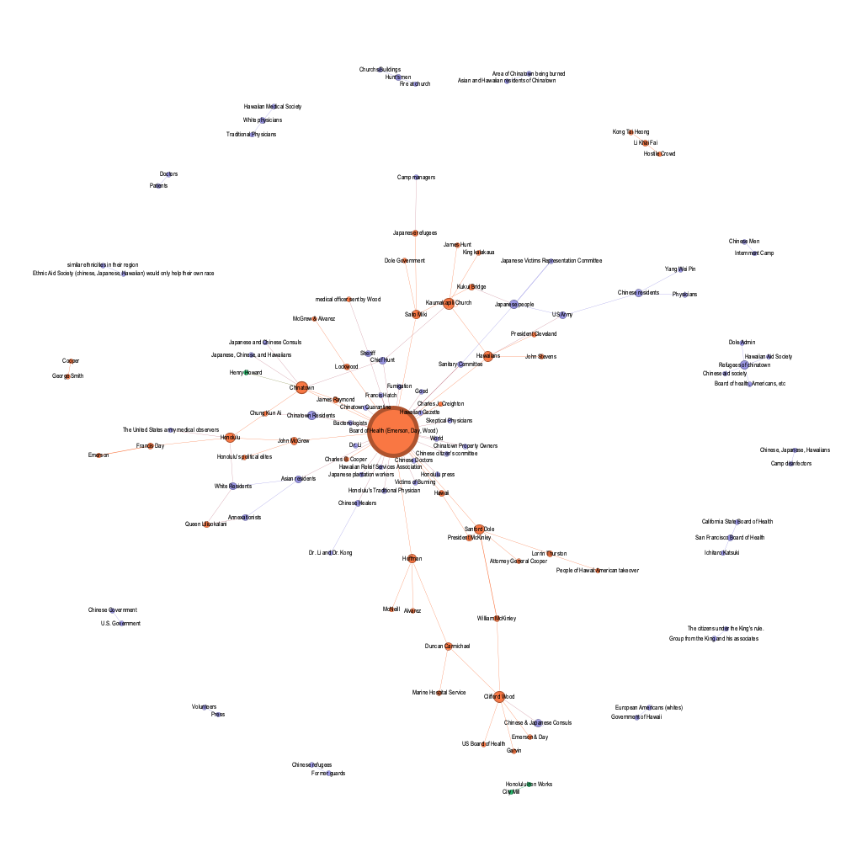
Evaluting student responses to the activity and data in the resulting network helped us see two outcomes. One, the capta process shaped by small-group debate exposed issues of network-data ambiguity. Some small-group teams chose to use verbatim references for node labels (e.g. "Dr. Wood"); others used a standardized reference regardless of how the page they were reading referred to a node (e.g. "Dr. Clifford Wood"). We expected this sort of data "messiness" but CSCL and capta helped us name it more directly: we needed programmatic disambiguation of node labels (a roster, in network terms) with notes. A roster, but flexible enough for real-time additions, would help small groups link their activity to the whole-class activity without reducing node and edge entries to a single (potentially incomplete) label. The second issue had to do with both historical and collaborative context. Google forms are easy to use for entry purposes but not everyone has equal facility using the spreadsheet created by the form. Because students could not immediately see their peers' data in an easily sorted form--or see the network visualization with labels and notes concurrently with their data entry--they struggled to understand initially how networks would help them understand historical significance. When we reviewed the mediators that were barriers to our hoped-for outcomes using activity theory, we identified the serendipitous prompting of new ways to understand historical details in their context that is a core feature of seminar discussions, an activity that was hampered by the Google-form data entry approach. Skilled historians engage in these sorts of debates at conferences and through footnotes in publications, and we wanted to support novice and skilled historians alike in this vital practice as they worked with network data.
Framing these outcomes in the structure of our three motivating theories shaped our feature list for the second round of Net.Create development. From an activity-theory perspective, we needed a platform that would mediate access to a shared set of controlled nodes that can be added to after a disambiguation process. In network terms, this means participants are free to use recall methods prompted by the historical source to build and augment a controlled roster of nodes, and then use that controlled roster to help disambiguate nodes without being restricted only to a preset roster. From a capta perspective, we needed to "store" the out-loud debate from small-group capta transformation in a typed notes field for each node and edge, so that the entire capta conversation from each small group would be visible to the other groups for use in evaluating individual nodes in the roster. From a CSCL perspectve, we needed the display of real-time contributions to, and feedback from, the whole dataset, so that small groups could see other small-group capta processes as they happened.

Design Rounds 2 and 3: Simultaneous Data Entry with Customizable Notes for Disambigution and to Emphasize Change over Time (Version 0.02 in 2016 and 0.03 in 2017)
Shortly after the first classroom experience with simultaneous network capta, a three-person research collaboration team working with Craig expressed the need to divide historical data drawn from 4 archival collections, work asynchronously in a shared environment to transform information in those collections into network data, and see it represented in a structured-text dataset that encouraged collaborative interpretation of each data point as it was entered. While the asynchronous nature of the research team's workflow did not directly match the simultaneous live-visualization needs of an in-person classroom, literature on asynchronous collaboration suggested that treating it as a real-time, but remote, problem-solving environment would provide the most flexible platform for fostering discussion and allow us to build on those prior experiences. Craig built a web app that allowed the research team to populate a shared menu of available nodes (or a "roster"), use the shared node list to create node-edge pairs, and to easily export data at any stage of the research process for provisional analysis in Gephi. In addition to more complex citation practices than the Google form allowed (Net.Create v0.01), Craig created specific notes fields that would allow for the disambiguation of historical figures with similar names (nickname, ISO-formatted date fields for birth and death, general notes field) and for the disambiguation of historical interactions (ISO-formatted interaction dates, and latitude/longitude data for spatial history purposes).
from IPython.display import Image, display
display(Image("./media/v0.02_2016_MainSearch.jpg"))
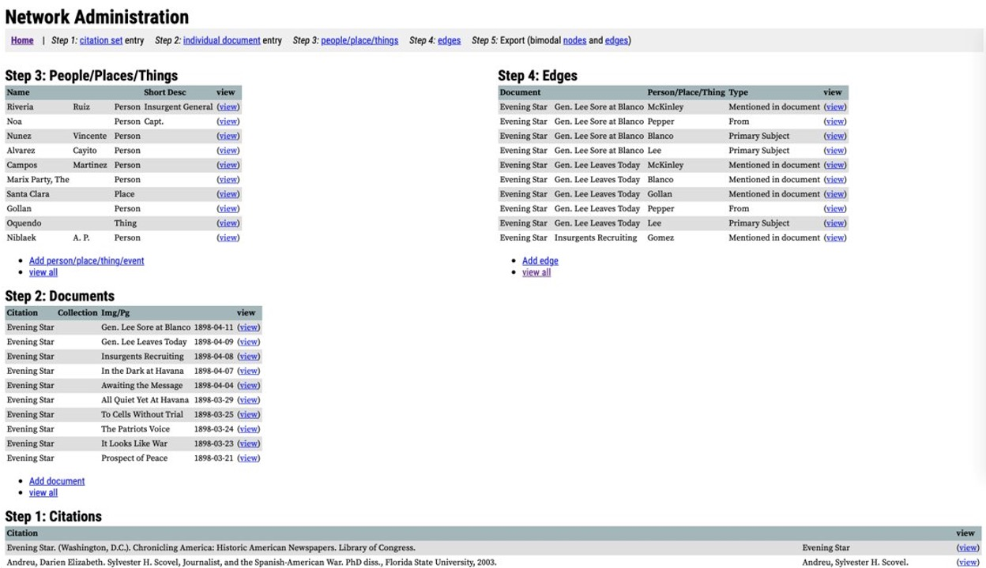
from IPython.display import Image, display
display(Image("./media/v0.02_2016_EdgeEntry.jpg"))
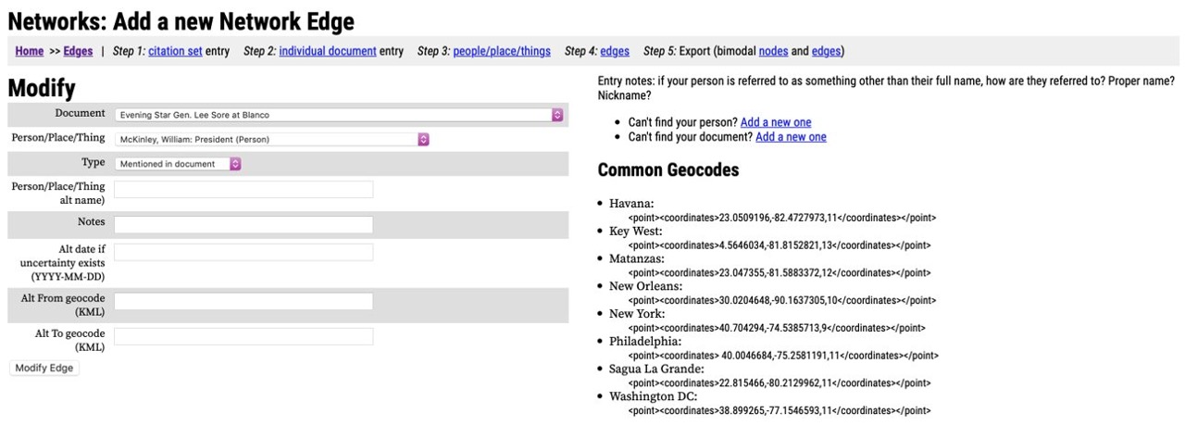
Two specific examples are representative of the shared historiographic debate that the Net.Create team wanted to prompt with its user-interface design choices, both drawn from a network done with a collaborator, Arlene Diaz. In one case Craig exported network data for visualization and analysis, from which Diaz identified a node of interest, a "Nichols", in a faction analysis. The team was easily able to use the PHP/SQL interface to explore the specific data for the "Nichols" node, use the citation data to identify which primary sources that node appeared in, interrogate the other historical agents with whom Nichols interacted, and establish Nichols as a point of further archival research. While Nichols was easily found in the textual representation of the network data, it was hard to identify Nichols as a node of interest without first visualizing the network in a separate tool like Gephi. Several of the history research team members asked if it was possible to have each node and edge added to a visualization as the data entry happened, to make the most recent additions more visible and salient for analysis purposes and to prompt further research. A second, less striking, but no less important, example from the same dataset highlighted the value of a shared set of notes fields. One historical figure had a nickname that rhymed with his real name: Jose Congosto, dubbed "langosta" or "the lobster" by Pinkerton representatives. Conversations about whether to make the nickname or the real name the canonical node reference between data-entry team members led to a more substantive conversation about why the nickname was so prevalent in the primary sources. That in turn prompted a research focus on interactions involving Congosto/langosta that helped shape several articles and a forthcoming monograph.
In 2017, two years after the original Google-form activity, the Net.Create team collected official user-experience data for the first time using an adapted version of this PHP/SQL interface. The remainder of the activity was identical to the 2015 Plague and Fire activity, and we engaged in a full educational-research study with cameras and microphones to better understand how students were using the new network capta activity and digital tool to understand the historical content of Plague and Fire. As we expected, based on feedback from the faculty research teams using the PHP/SQL tool, students drew heavily on the shared nodes and edges. One student even convinced their group members to "use the stuff that's already there" rather than engage in the presumably more laborious task of entering new data. Despite the initial indication that this student and their group were unwilling to engage fully with new information, they transformed interactions in their excerpt into several new node-edge pairs and had several substantive discussions about how to describe the interactions between those nodes as historically significant or not.
The network data from the resulting datasets were much easier to export for visualization, though they did not meet our simultaneous-visualization goals. As with the teams of faculty and graduate-student researchers who used this version of the netowrk capta tool, however, students who engaged in the same activity we did with Google Spreadsheets asked if the data they had entered could be added to the network graph as they worked. In network terms, our network-tool users wanted to situate the information drawn from their immediate data-entry tasks in real time, and in the context of the broader aggregate network. In historical-method terms, our historians wanted to immediately see, understand, and debate the significance of a new piece of historical evidence provided by their peers. The overlap in experience between professional colleagues and students also further justified the value in buildin our tool based on the experiences of both sets of users.

Design Round 4: Predictive Text and Simultaneous Data Visualization to Prioritize Historiographic Conversation (Version 1 in 2018)
The common experience that our research teams and students had with text-only version of Net.Create focused the Net.Create team on a major revision, both to the tool and to the team itself: simultaneous visualization of newly entered data. In our next revision, we brought in outside agile software developers (Inquirium, particularly Ben Loh and Sri Seah) whose expertise could support rapid prototyping based on the theoretical principles developed by the academic team. Our activity-theoretical framework was particularly valuable for communicating to the agile development team our goal to use visualizations to reshape user experiences in the existing Net.Create simultaneous capta system. Here, too, VNA and its emphasis on extracting visual patterns from network graphs helped us understand the function visualization might play in extending computer-supported collaboration between small-group or individual-user data entry and the whole-team dataset. Collaborative visualizations are more than just visualizations; they are, themselves, social spaces that can prompt substantive debate just as, or more readily, than the corresponding textual data anchoring a visualization. Our student and faculty data suggested that, while shared textual data could prompt users to more fully explore the interactions between historical agents as part of their capta process, the appearance of a node or edge in real time would be an even more immediate prompt.
Activity theory also framed our understanding of the need for textual cues, a question prompted by proximity and boundary-crossing practices in active-learning classroom spaces. For example, "Peripheral interactions" acknowledge the role physical proximity plays in classrooms, when a group responding to a prompt overhears a nearby group and uses the information from that overheard nearby conversation to shape their own conversation. If the visual prompt of a node appearing offered one opportunity to "see" what another group is doing, predictive text offered a text-based method of accessing--even eavesdropping on--other participants' real-time conversation and debate in a computer-supported-collaborative digital-tool space, and one that was more likely to happen exactly when the user could most benefit from it (i.e., when typing something similar).
These two features supported an activity revision to the Net.Create tool/activity cluster that we identified as a key principle of historiographic network analysis early in our design process: revision. In our original activity design, we focused on a formal capta entry process, but our Google Spreadsheet data did not easily support revisions. In the second round of our DBHR process, we used the menu-based node and edge lists to support revision, but the data-and-source corroboration of existing network data was purely textual in nature. Live visualization of the network, with node sizing and placement that changed as new data points were added, scaffolded both an informal revision process during the initial round of capta and a follow-up round of formal revision of network data after the first round of initial capta.
Net.Create prompted historiographic conversations in both the first round of capta transformation and in the second revision-oriented round of capta transformation. Visible here are the salient features of the user interface that made such a complex process possible. A predictive text search bar sits in the top left-hand corner, a prime screen-real-estate area for left-to-right language environments. That predictive-text search bar allows users to input only a few characters and see a drop-down menu of matching nodes. Users can select a pre-existing node to explore, which transfers that node's significance information and its edge connections to the left-hand node view and navigation panel; they can also type out the full label of a new node and use the "Add New Node" button to trigger the addition of a new node to the network roster, where they are prompted for significance and other historical detail. The "Add New Edge" button provides a similar user-interface experience. The active node is transferred to a "Source" field, and the Target field provides a predictive-text feature to match the main search field. Here, users are prompted to enter citation data along with other historical detail. The aggregate node and edge data is represented in two ways. Tables of node and edge data, sortable by label, source, target, citation, etc., are in what is commonly used as a drop-down navigation area in other web applications. In the center of the screen, a Force Atlas 2 planetary-gravity-model visualization offers yet a third way to find nodes and explore their edge data by clicking on a circle that represents a node, which loads that node into the information panel on the left for viewing and editing. Finally, the force-directed "gravity" of each node in the visualization allows users to pull on a node and see which other parts of the network follow it quickly--and are closely connected--and which parts of the network are held in place by the gravity of other nodes in the network.
from IPython.display import Image, display
display(Image("./media/NetCreateSimultaneousVisInterface.png"))
Simultaneous live visualization did not simply make the data easier to understand or make visual patterns in the existing data salient. The historiographic-conversation element of DBHR afforded the team a way to contribute to the pattern-exploration literature in VNA by suggesting that a visual feature that appears in real time for every participant has the potential to change the actual content in the network capta--and therefore the patterns that can be analyzed visually. Whether participants are working real-time in person, real-time remotely, or asynchronously, changes to the visualization triggered by other users brought attention to newly added nodes and edges, which in turn effected real-time changes in the historiographic conversation users had during their capta entry activity.

Design Rounds 5 and 6: Filtering and Nascent Tagging to Support the Development of Historical Argumentation Within Net.Create (Versions 1.2 and 1.3, 2020 to present)
Our current round of DBHR iteration is still in process, but like previous rounds of activity-and-tool design, it focuses on the role tools and activities play in building the historical method into digital-history projects. The end result of a historiographic debate is generally understood to be the creation of a historical argument. In data- and capta-oriented digital-history projects, the dataset itself can make a historical argument if it is structured properly and annotated. One way to argue for change or continuity over time is to categorize interactions and allow data filtering based on those categories. For instance, in the example from figure 6, Messalina (Roman Emperor Claudius' third wife) is targeted for "Political Murder", a concept so frequent in Tacitus that students created a node to represent it. In the most recent version of Net.Create, users have the option to create a "tag" field, which can then be used to filter out nodes and/or edges that meet that reqirement. In this case, we might assign "politics" to the Messalina->Political Murder edge, and to other political interactions, in order to reduce the network to the involvement of women in politics in the late Roman empire.
In a recent undergraduate-research project, a faculty member worked with students to explore several ancient Greek epigraphy networks. While the data for these networks is embargoed for privacy reasons, zoomed-out screen captures provide a sense of the filtering at work. The salient point here is that Net.Create allowed students working on seemingly disconnected epigraphic networks to work in a single, shared network-analysis environment. That shared environment helped prompt an argument about the interconnected giant component of 5 different epigraphic networks (figure 7). Filters based on tags allowed the reduction of the network to a single epigraphic network (figure 8, using the tag "women" to filter the original unfiltered network), demonstrating how sparsely connected the network of women's concerns was.
from IPython.display import Image, display
display(Image("./media/EpigraphyUnfiltered.png"))
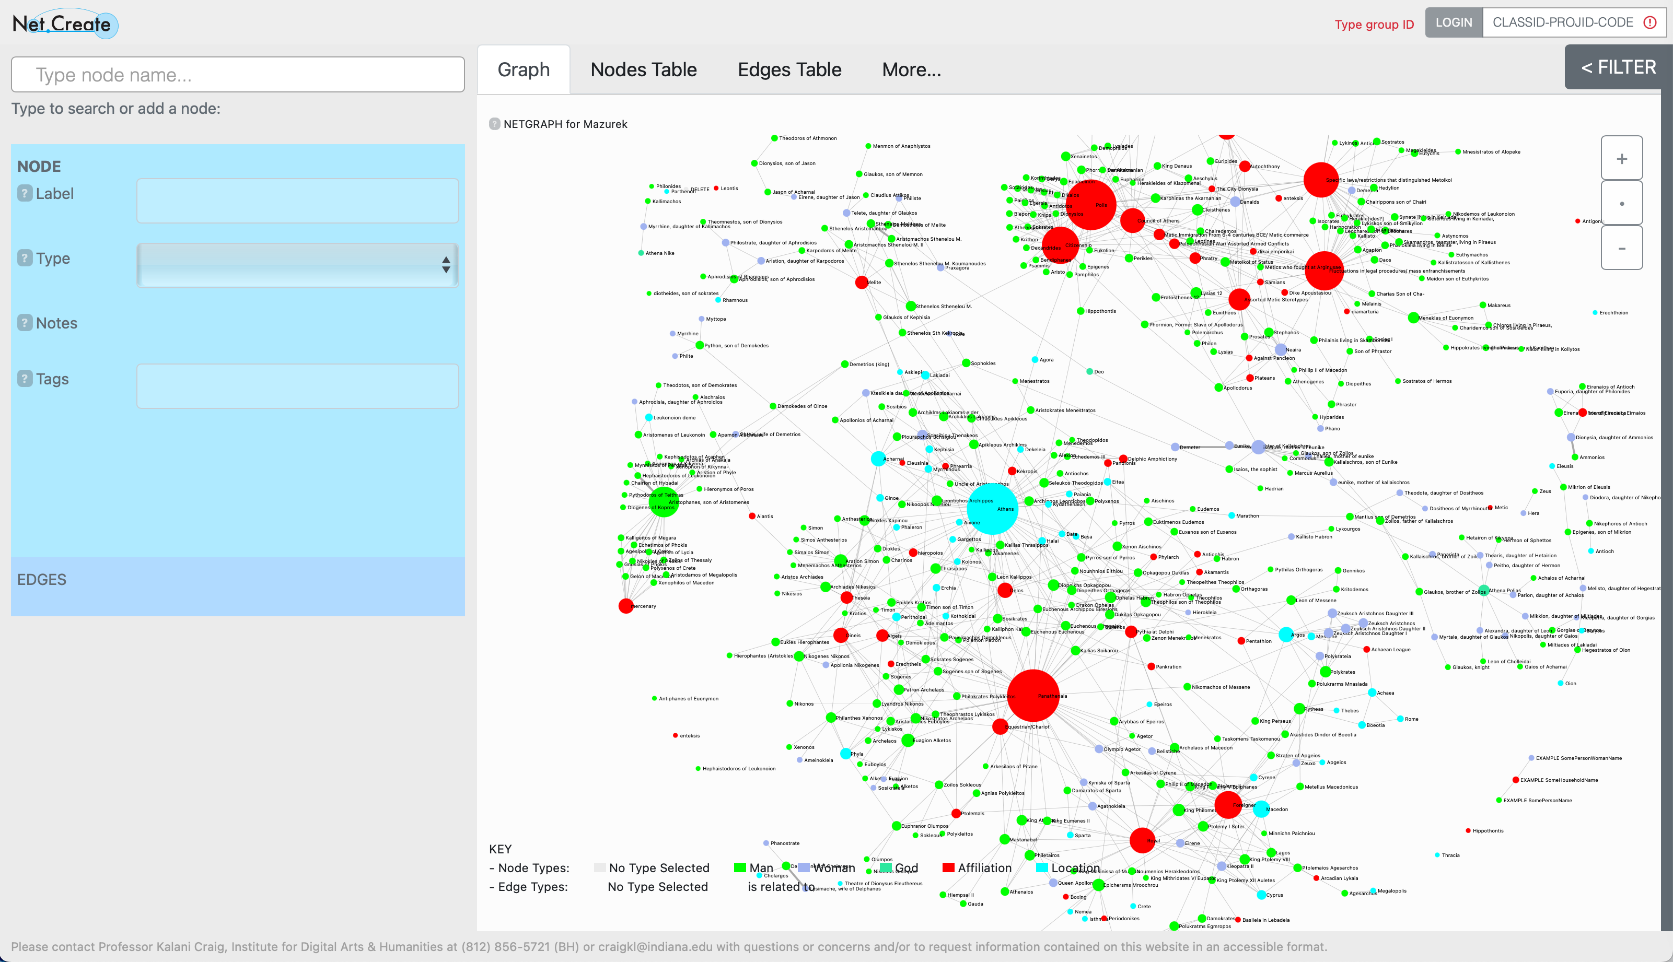
from IPython.display import Image, display
display(Image("./media/EpigraphyFiltered.png"))
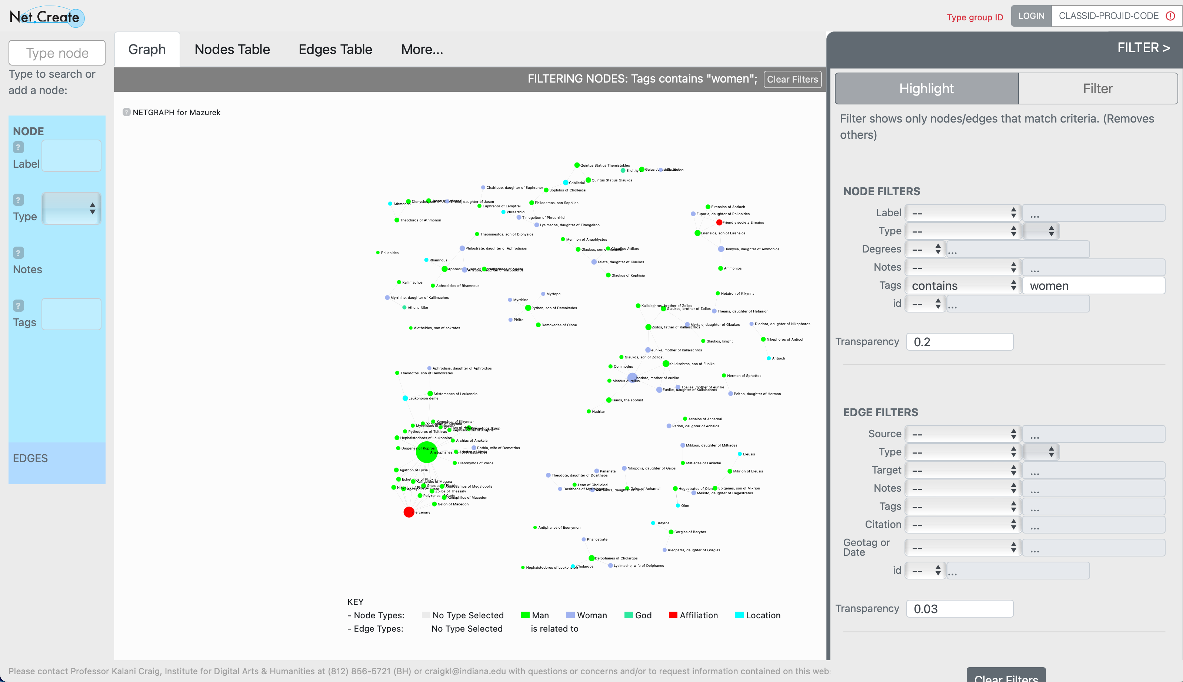
Concurrent with this round of design to support historical argument within the context of the Net.Create user interface, we are also taking Net.Create into middle-school classrooms. Our initial work with upper elementary and middle school students indicates that they were able to use networks to explore their interests, their community, and content of interest to them, while developing some early data literacy. While this setting seems far removed from the archives that historians frequent, but middle-school students documenting their own personally meaningful contexts--their connections to each other, to their own personal histories, and to their educational goals--parallels the exploration of interactions that historians trace in archival documents. These new endeavors with younger students will contribute to our developing understanding of how and when to make norms of historical capta more visible for all of our potential audiences in future versions of the tool.

Conclusion: Initial Principles for Design-Based History Research
We've detailed several theoretical and user-interface takeaways that are direct results of a structured Design-Based History Research process, but we want to conclude with several high-level DBHR principles that Net.Create helps illustrate. The first, driven by activity theory and its consideration of mediating tools, is that the design of digital tools for and by digital historians needs to include activity and methods design, not simply user-interface design or programming choices. The labor investment in digital-tool development is very high. Asking first what the desired historical-method activities are, then designing activities with features that support those goals and features that expose gaps or needs in existing tools can shorten the time to development. Using DBHR to evaluate tools in the existing digital-tool ecosystem and explicitly articulating changes to existing activities or methods practices around those tools is also a practical path for DBHR contributions to the discipline of history. Crucial to this process is how DBHR requires us to articulate our assumptions in advance, and then vet and revise them as we go - an additional step to theory building that is not present in traditioanl agile software development which is more goal oriented.
The second takeaway is that focus groups in any joint activity-and-tool-design endeavor are vital. Focus groups can take many forms, though. Many digital humanities practitioners value their classrooms as a site of public engagement research. By exploring the user-interface and activity-design choices that shape good historical thinking at the novice level, DBHR both acknowledges the importance of novice digital-humanities practitioners to the field and seeks to understand how novice practitioner needs can be a predictor for the needs of advanced practitioners.
Finally, and most importantly, the design of digital tools and the activities and methods that leverage those tools make abstract disciplinary norms concrete. The simplest of user-interface choices or activity requirements--a required citation field and the accompanying instruction to enter citations in an easily sortable format--operationalize the norms of history, and so our tool design and methods development should be driven by the needs and values of trained historians working in partnership with disciplinary experts drawn from the fields that shape digital humanities practices.
DBHR also offers a broader lesson for digital-tool developers outside of the digital humanities. Identifying the needs in table 6, and the the features mapped to those needs in table 7, took place over a sustained period of time as we explored the historical thinking principles we wanted to support, made design conjectures about the features and activities that would best support historians, and observed whether our design changes worked as predicted or not. This flexible, long-term development process points to two additional benefits of DBHR from the perspective of project sustainability. One, DBHR offers a flexible way to build expertise across interdisciplinary tool-design teams based on both short- and long-term project goals. Team composition can change, but the project's institutional memory not only for code but for new-feature assessment remains stable, because team members contribute to, and document their expertise as part of, the DBHR process. Two, DBHR's emphasis on theory offers a model for users to prioritize the features they need in a digital tool and for designers with limited development resources to differentiate their tools from other tools. Because DBHR-driven tools are accompanied by documentation of the theoretical and methodological principles around that tool's use, users and designers alike can navigate the inevitable end-of-support cycles that make tool development and tool adoption more difficult than it needs to be.

