# Ex.12: Sketch, design with popular tool and build a prototype and perform usability testing and identify improvements.

**Aim:**

The aim of this experiment is to design a user-friendly mobile app for

task management, create a prototype using a popular design tool, perform usability testing, and identify improvements to enhance the user experience.

# Algorithm /Procedure:

**Define Objectives and User Persona:**

Define the objectives of the task management app. Create a user persona to represent the target audience. **Sketch and Wireframe:**

Start with sketching the basic layout and functionality of the app on paper or

digitally. Create low-fidelity wireframes to visualize the app's structure and layout.

# Design with a Popular Tool:

Choose a popular design tool such as Adobe XD, Sketch, Figma, or InVision. Create high-fidelity designs with attention to visual elements, typography, and color schemes. Implement the user interface (UI) based on best practices and user persona's preferences.

# Prototype Creation:

Use the design tool to create interactive prototypes with clickable elements and transitions. Ensure that the prototype represents the app's core functionalities.

# Recruit Participants for Usability Testing:

Identify potential users or participants who match the user persona. Prepare a usability testing plan, including tasks to be performed within the prototype.

# Usability Testing:

Conduct usability testing sessions with participants.

Ask participants to perform specific tasks within the prototype. Observe and record their interactions and gather feedback on their experience.

# Analyze and Identify Improvements:

Analyze the usability testing data to identify pain points and areas of improvement. Look for common patterns and issues encountered by users. **Iterate on the Design:**

Implement the necessary design improvements based on the feedback received. Make changes to the prototype to address identified issues.

# Second Round of Usability Testing:

Conduct a second round of usability testing with new or the same participants to evaluate the impact of the design improvements. **Finalize the Prototype:**

Make any final adjustments based on the results of the second usability testing

round.

# Document Findings and Recommendations:

Document the findings from both rounds of usability testing.

Provide clear recommendations for further improvements or development.

# Conclusion:

Conclude the experiment by summarizing the improvements made to the prototype and how they enhance the user experience.

# Design:

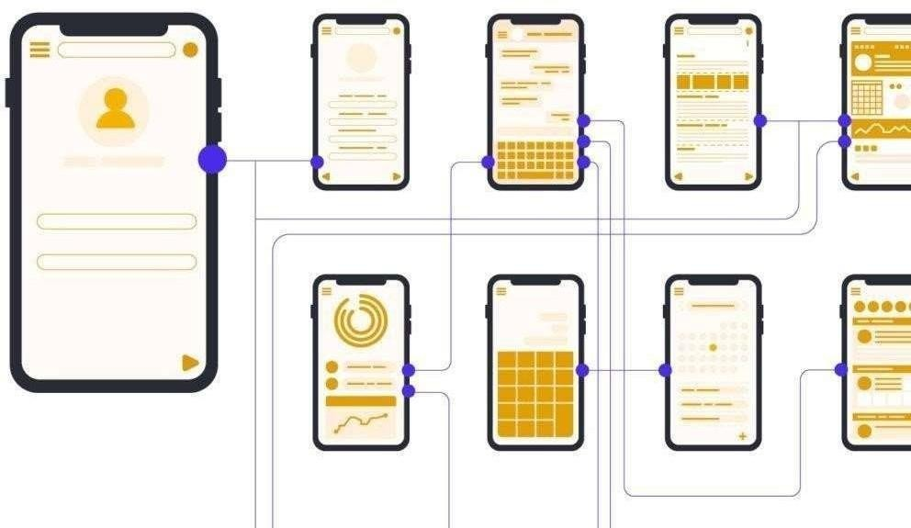

**Result:**

Thus, Sketching and build a prototype and perform usability testing and identify improvements has been learned and executed successfully.