# EX.02: Exploring various UI Interaction Patterns

**Aim:**

To explore various UI interaction patterns.

**Algorithm/Procedure:**

* Set objectives and understand user needs.
* Research and gather design inspiration.
* Create wireframes for layout and structure.
* Utilize Figma components and styles.
* Prototype interactions using Figma's features.
* Test the design with users for feedback.
* Iterate and refine based on feedback.
* Document the design decisions.

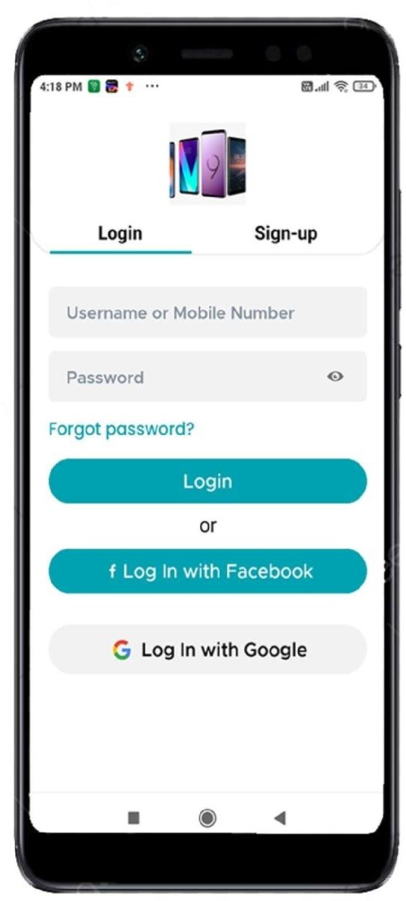

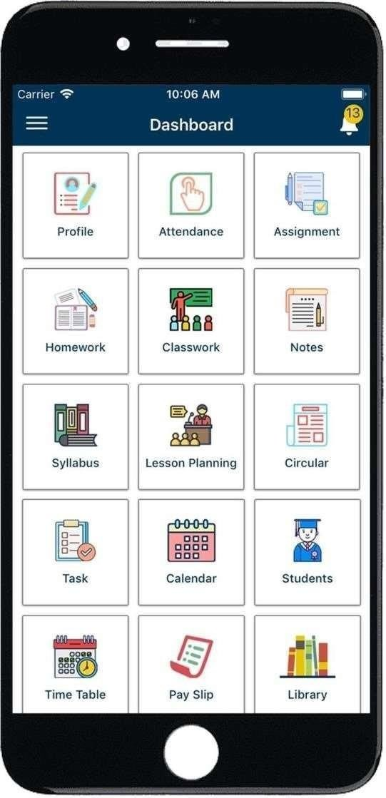



# Result:

Thus, exploring various UI interaction patterns has been performed successfully.