# Ex.03: Developing An Interface With Proper Ui Style Guides

**Aim:**

To develop an Interface with Proper Ui Style Guides.

**Algorithm/Procedure:**

* Define Goals and Audience: Understand the project's purpose and target users.
* Research and Inspiration: Gather industry insights and design inspiration.
* Create a Figma Project: Start a new Figma project.
* Workspace Setup: Organize Figma files and create sections for style guides and components.
* Brand Guidelines: Set color, typography, and brand-related guidelines.
* UI Components: Create component libraries for buttons, forms, icons, and navigation.
* Typography: Define font styles, sizes, and spacing.

**Icono**

* Graphy: Design and organize icons as components.
* Color System: Document primary, secondary, background, and text colors.
* Grids and Layouts: Establish grid systems for different devices.
* Accessibility Guidelines: Ensure WCAG-compliant contrast and text sizing.
* UI Elements: Document usage guidelines for various UI elements.
* Wireframes: Create wireframes and user flows for screen layout and interaction.
* Visual Design: Develop screens based on wireframes using components and styles.
* Interactive Prototyping: Build interactive prototypes for user testing and feedback.

# Figma Design:

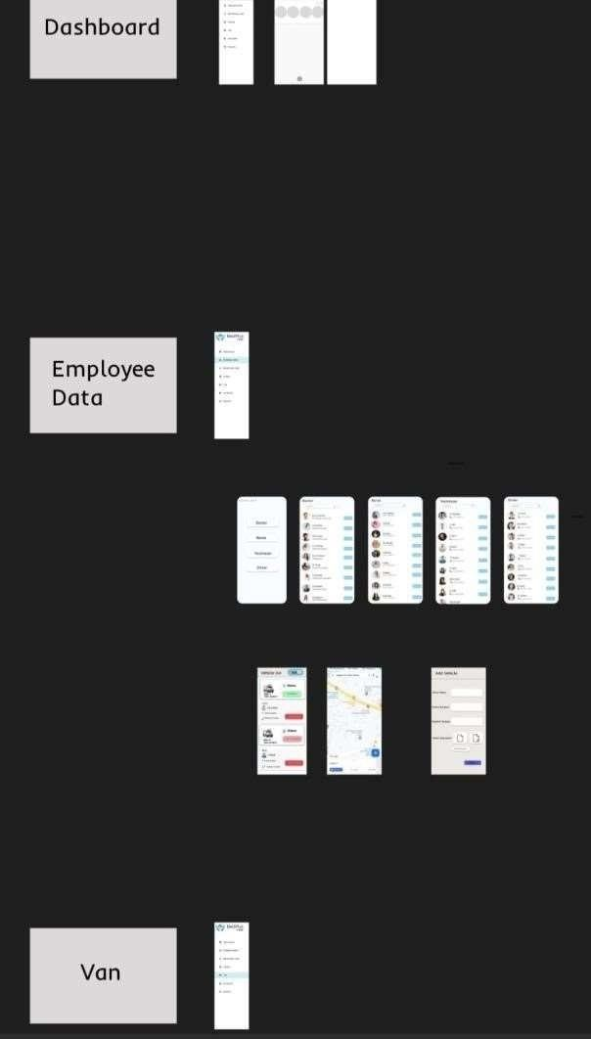



**Result:**

Thus, developing an Interface with Proper Ui Style Guides has been executed successfully.