# Ex.04: Developing Wireflow diagram for application using open-source software

**Aim:**

To develop Wireflow diagram for application using open-source

software

# Algorithm/Procedure:

1. **Define Purpose and Goals**: Determine the diagram's purpose and goals, focusing on user flows, navigation, and interactions.
2. **Identify User Personas**: If applicable, specify user personas for a usercentric approach.
3. **Gather Requirements**: Collect project information, including existing designs and functionality requirements.
4. **Select Software**: Choose open-source design software, such as Figma, for wireflow creation.
5. **Create a Project**: Begin a new project in chosen software and set up the canvas to match the project's needs.
6. **Wireframe Screens**: Develop wireframes for each application screen, focusing on visual structure.
7. **Define Interactions**: Add interaction notes or links to illustrate navigation and user interactions.
8. **Create User Flows**: Connect wireframes to illustrate user journeys, navigation paths, and interactions.
9. **Add Annotations**: Include descriptions to clarify elements and interactions in each wireframe.
10. **Collaborate and Share**: Utilize collaboration features to gather feedback from team members and stakeholders.
11. **Iterate and Refine**: Revise the wireflow diagram based on feedback, ensuring alignment with project goals.
12. **Finalize and Export**: Clean up the wireflow diagram and export it to a suitable format for sharing and documentation.
13. **Document the Wireflow**: Create a reference guide to explain the wireflow's purpose and key notes for stakeholders and developers.
14. **Maintain Consistency**: Keep the wireflow diagram in sync with the application's actual design, updating it as needed.

# Design:

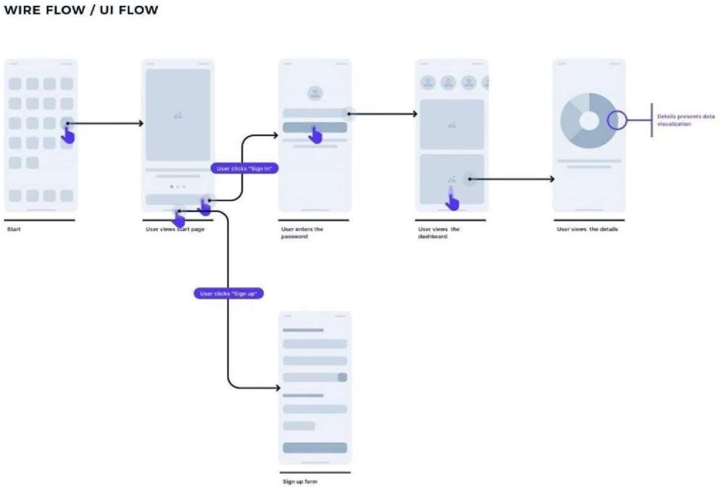

**Result:**

Thus, Developing Wireflow diagram for application using open-source software has been executed successfully.