# Ex.06: Hands on Design Thinking Process for a new product

**Aim:**

To apply the Design Thinking process for a new product.

# Algorithm/Procedure:

**Empathize:** Begin by conducting user research and interviews to gain insights into potential user needs and pain points related to smartphone usage.

**Define:** Analyze the gathered information to define a clear and specific problem statement. For example, "Users need a more efficient way to track their daily fitness activities."

**Ideate:** Organize brainstorming sessions with a diverse team to generate a wide range of creative solutions. Encourage free thinking and open collaboration.

**Prototype:** Create a low-fidelity prototype of the smartphone app. This can be a paper sketch or a digital wireframe that represents the app's basic functionality.

**Test:** Conduct user testing sessions with a small group of potential users. Observe how they interact with the prototype and gather feedback.

**Iterate:** Based on user feedback, refine the prototype and make necessary improvements to address user concerns or suggestions.

**Prototype (Again):** Create a more advanced prototype, closer to the final product. It should incorporate the changes and improvements identified during the initial testing phase.

**Test (Again):** Conduct another round of user testing, this time with a larger group of users. Gather data on usability, functionality, and overall user experience.

**Refine:** Analyze the results of the second testing phase and make further refinements to the app design and functionality.

**Implement:** Develop the final version of the smartphone app, incorporating all the changes and improvements identified during the design thinking process.

**Test (Final Testing):** Conduct thorough testing of the fully developed app to ensure it's bug-free and ready for launch.

**Launch:** Release the app to the target market, accompanied by marketing and promotion efforts.

# Example:

Let's say the team is designing a fitness tracking app. During the "Empathize" phase, they conduct interviews and surveys with potential users, discovering that users find it challenging to keep track of their daily physical activities. In the "Define" phase, they define the problem as "Users need a more efficient way to track their daily fitness activities."

In the "Ideate" phase, the team generates multiple ideas, including features like GPS tracking, step counting, and customizable fitness goals. They create a low-fidelity prototype that represents these features. In the first round of user testing, they observe that users have difficulty navigating the app.

After gathering feedback and identifying navigation issues, the team iterates by redesigning the user interface to improve user experience. They create an advanced prototype with a more intuitive interface and test it with a larger group of users in the second round of testing.

Based on this testing, the team further refines the app, making sure it's userfriendly, bug-free, and meets the needs of the target audience. Finally, they implement and launch the fitness tracking app to help users easily track their daily activities.

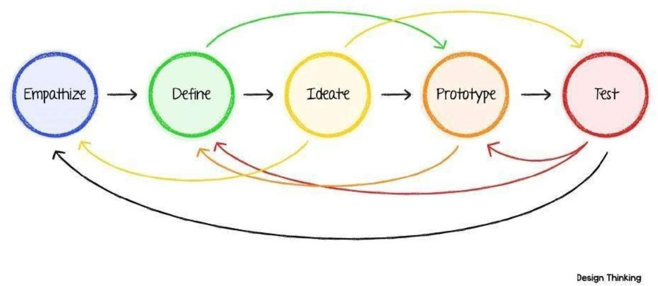

# Result:

Thus, apply the Design Thinking process for new product has been learned and understood successfully.