# Ex.07: Brainstorming feature for proposed product

**Aim:**

The aim of this process is to generate innovative and practical featureideas for a proposed product, ensuring that the final product meets user needs, addresses pain points, and has a competitive edge in the market.

# Algorithm/Procedure:

**Understand the Product Concept:**

Begin by thoroughly understanding the proposed product's concept, its target audience, and its unique selling points.

# Gather a Diverse Team:

Assemble a cross-functional team with members from various departments (e.g., product development, marketing, design) to bring different perspectives to the brainstorming session.

# Set Clear Objectives:

Define clear objectives for the brainstorming session. What problems should the new features solve? What goals should they achieve?

# Warm-Up and Icebreaker:

Start the session with a warm-up or icebreaker activity to encourage creative thinking and open communication within the team.

# Idea Generation:

Allow team members to freely brainstorm feature ideas. Encourage a "no idea is a bad idea" mindset. Use techniques like mind mapping, brainstorming software, or post-it notes on a whiteboard to record ideas.

# Categorize and Prioritize:

Group similar ideas together, and prioritize them based on factors like feasibility, potential impact, and alignment with the product concept.

# SWOT Analysis:

Conduct a SWOT (Strengths, Weaknesses, Opportunities, Threats) analysis for each feature idea to evaluate its potential in the market.

# Feasibility Assessment:

Assess the technical, financial, and resource feasibility of implementing the proposed features.

# Market Research:

Conduct market research to identify user preferences and gather insights that can inform feature development.

# Prototype and User Testing:

Create prototypes or mockups of the proposed features and conduct user testing to gather feedback and refine the ideas.

# Cost-Benefit Analysis:

Evaluate the expected cost of development against the projected benefits, such as increased user engagement, retention, or revenue.

# Risk Assessment:

Identify potential risks associated with each feature and develop mitigation strategies.

# Finalize Feature Set:

Based on the assessment, finalize the set of features to be included in the product. Ensure they align with the product's vision and goals.

# Documentation:

Document the chosen features, their objectives, and the rationale behind their selection. This document will guide the development team.

# Iterate as Needed:

Keep an open line of communication for ongoing feature refinements and iterations, especially as more data and insights become available.

# Example:

Suppose a software company is developing a new mobile messaging app. During the brainstorming session, the team generates a wide range of feature ideas, including:

**End-to-End Encryption:** To ensure user privacy and data security.

**Message Scheduling**: Allowing users to schedule messages to be sent at a specific time.

**Reaction Emojis**: A feature that lets users react to messages with emojis for more expressive communication.

**Dark Mode**: A night-friendly theme for the app.

**Polls and Surveys**: Integration of polls and surveys within the chat for easy decision-making.

**Auto-Translate**: Real-time language translation for international communication.

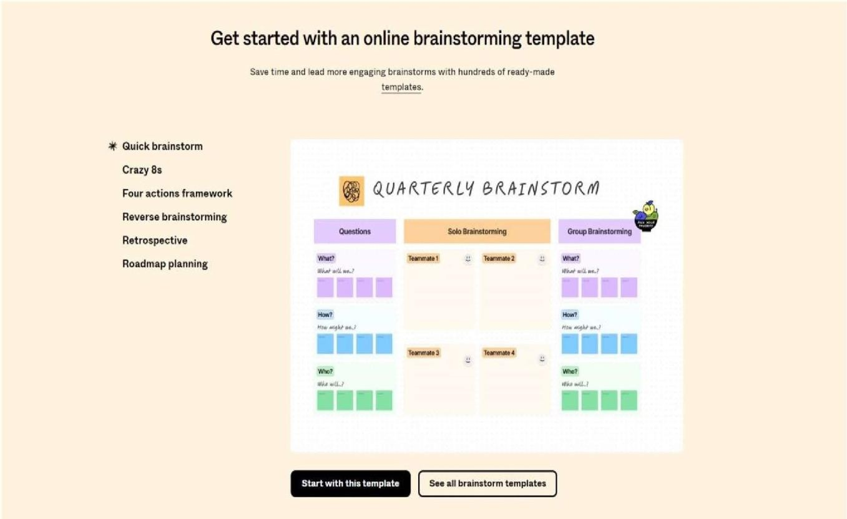

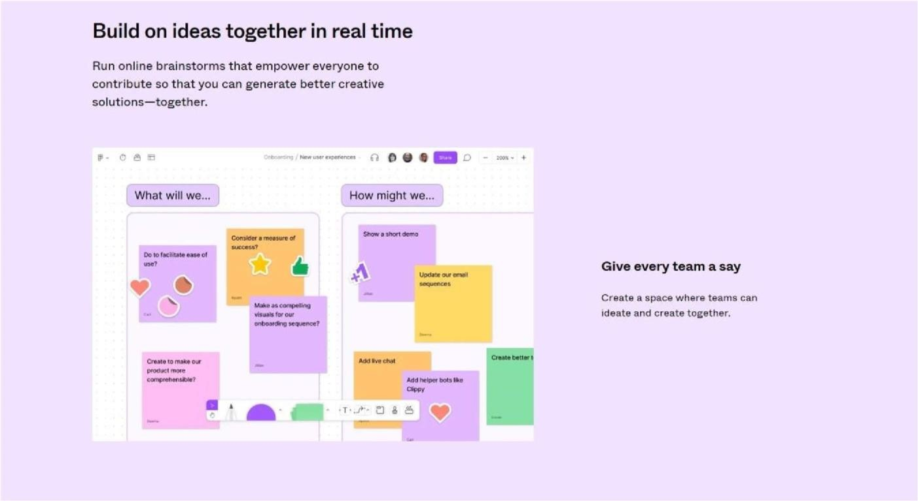

# Result:

Thus, apply the Brainstorming feature for proposed product has been learned, understood and executed successfully.