# Ex.08: Defining the Look and Feel of the new Project

**Aim:**

The aim is to establish the visual design and user experience for a new

project, ensuring it aligns with the project's goals and provides an appealing, intuitive, and cohesive interface for users.

# Algorithm/Procedure:

**Project Goal Assessment:**

Understand the project's objectives, target audience, and scope. This sets the foundation for design decisions.

# Research and Inspiration:

Gather inspiration from existing designs and industry trends. Create mood boards or design boards to collect visual references. **Define Design Principles:**

Determine the core design principles that will guide the project's look and feel.

These could include simplicity, consistency, accessibility, and branding.

# Wireframing and Prototyping:

Create wireframes or low-fidelity prototypes to plan the layout and structure of the user interface.

Use tools like Figma, Sketch, or Adobe XD for digital projects.

# Visual Design:

Develop a color palette, typography choices, and graphic elements (icons, images, logos) that reflect the project's identity.

Create high-fidelity designs using design software.

# User Interaction Design:

Define user interactions and behaviors, including animations, transitions, and micro-interactions.

Ensure a smooth and intuitive user experience.

# Responsive Design:

Adapt the design to various screen sizes and devices, focusing on mobile responsiveness.

# Accessibility and Usability Testing:

Evaluate the design for accessibility, ensuring it's usable by individuals with disabilities.

Conduct usability testing with potential users to gather feedback.

# Iteration and Feedback:

Refine the design based on feedback from users and stakeholders.

# Documentation:

Create design documentation that includes guidelines for developers to implement the design.

# Development Integration:

Collaborate with developers to ensure the design is implemented accurately in the project.

# User Testing:

Conduct user testing with real users to verify the design's effectiveness.

# Finalization:

Make necessary adjustments and finalize the design elements for deployment.

# Example:

Imagine you're tasked with defining the look and feel of a new e-commerce website. The following steps are:

**Assess the project's goal**: To create a user-friendly, visually appealing online store. Research e-commerce design trends and competitor websites.

# Define design principles:

Simplicity, trustworthiness, and a focus on the product. Create wireframes for key pages like the homepage, product listing, and product detail pages. Develop a color palette featuring subtle, trust-inducing colors.

Choose a clear and readable typography for product descriptions and headings. Plan user interactions like product image zoom and a streamlined checkout process.

Ensure that the design is responsive and mobile-friendly. Conduct accessibility testing to meet WCAG standards.

Iterate on the design based on usability testing feedback. Document the design guidelines for the development team. Collaborate closely with developers to bring the design to life. Conduct user testing to validate the design's effectiveness.

Make final adjustments and prepare for the website's launch.

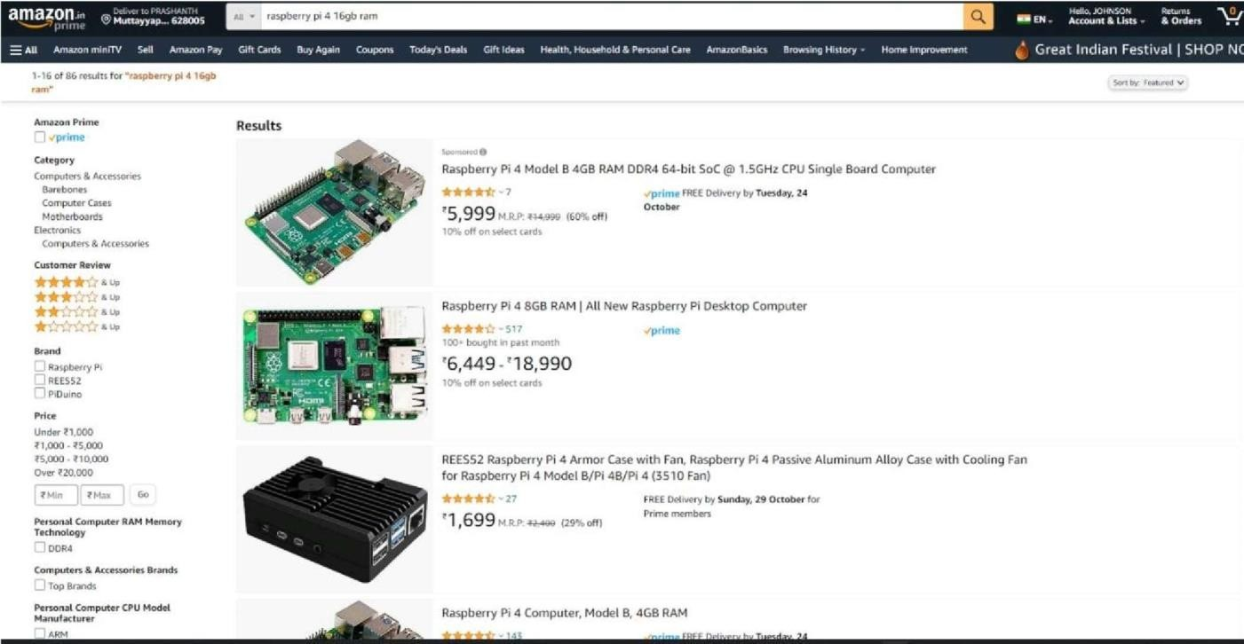

# Result:

Thus, Defining the Look and Feel of the new Project has been learned, understood and executed successfully.