# Ex.09: Create a Sample Pattern Library for that product (Mood board, Fonts, Colors based on UI principles)

**Aim**:

The aim of this project is to create a sample Pattern Library for a

product that includes mood boards, fonts, and color schemes based on UI (User Interface) principles. The Pattern Library will serve as a design reference for maintaining consistency and cohesion in the product's user interface.

# Algorithm/Procedure:

**Define the Scope:**

Identify the product for which you are creating the Pattern Library. Understand the product's target audience, brand identity, and design goals.

# Gather Inspiration:

Research existing UI designs, competitor products, and design trends to gather inspiration. This will help to create a mood board that captures the desired aesthetics.

# Create Mood Boards:

Using design software or tools like Adobe XD or Figma, create mood boards that reflect the desired visual style, mood, and tone of the product.Include images, colors, typography samples, and other visual elements that represent the brand and design principles.

# Choose Fonts:

Select fonts that align with the product's brand and design goals. Consider readability, hierarchy, and scalability. Choose a primary font for headings and body text, and possibly secondary fonts for accents.

# Define Color Palette:

Create a color palette that includes primary, secondary, and accent colors. Ensure the colors are harmonious and comply with accessibility guidelines.

Provide color codes (hex, RGB, or HSL) for each color.

# Document UI Principles:

Document the UI design principles that underpin the Pattern Library. This may include guidelines on spacing, layout, typography, and interaction behaviors. **Organize and Label:**

Organize the Pattern Library in a clear and accessible manner. Label each

component, color, and typography choice, and provide context or usage guidelines.

# Mockup Example Screens:

Create example screens or wireframes using the fonts,colors, and components defined in the Pattern Library. These screens should showcase the design principles in action.

# Test and Refine:

Share the Pattern Library with designers, stakeholders, or users for feedback. Make refinements based on the feedback to ensure it aligns with the project's goals.

**Maintenance and Version Control:** As the product evolves, maintain and update the Pattern Library to reflect any design changes. Use version control systems to keep track of changes and updates.

# Example:

Let's say you're creating a Pattern Library for a mobile app focused on wellness and meditation. The aim is to create a soothing and user-friendly design that promotes relaxation. Here's a simplified example:

**Mood Board:** Create a mood board with images of serene landscapes, calming color schemes (e.g., blues and greens), and sample UI elements that convey a sense of tranquility.

**Fonts:** Choose "Poppins" as the primary font for headings and "Roboto" for body text. These fonts are clean, readable, and complement the app's aesthetic.

**Color Palette:** Define a color palette that includes calming colors like "#3CBDBE" for primary elements, "#70C1B3" for secondary elements, and "#EFEFF0" for background. Ensure that these colors meet accessibility standards.

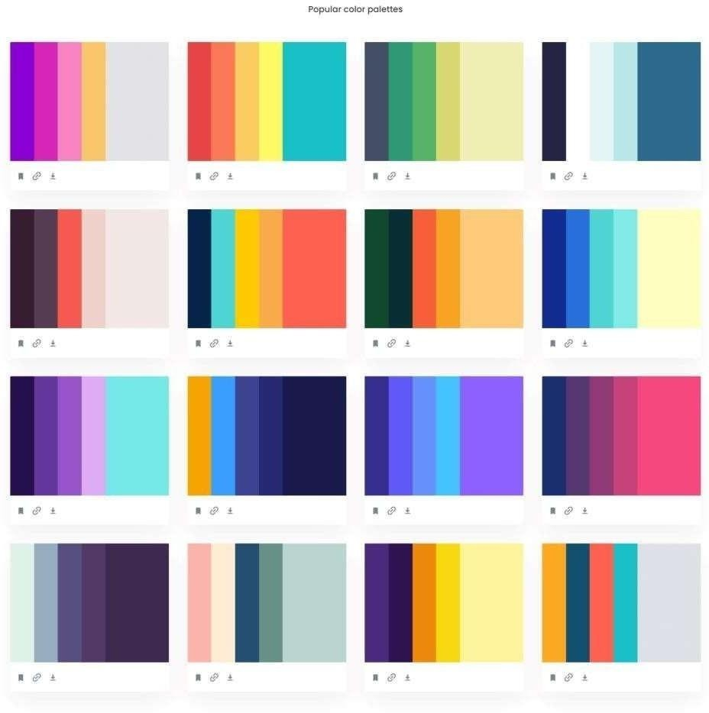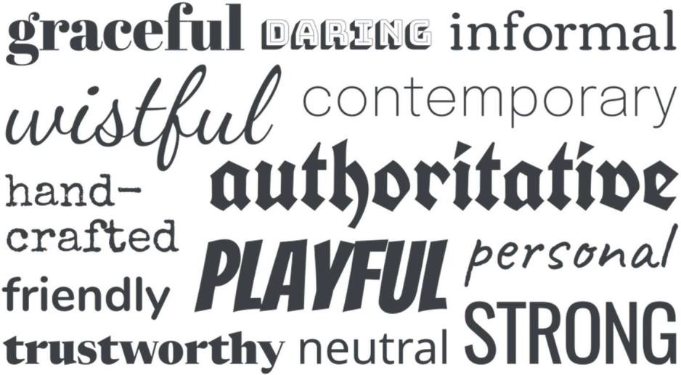

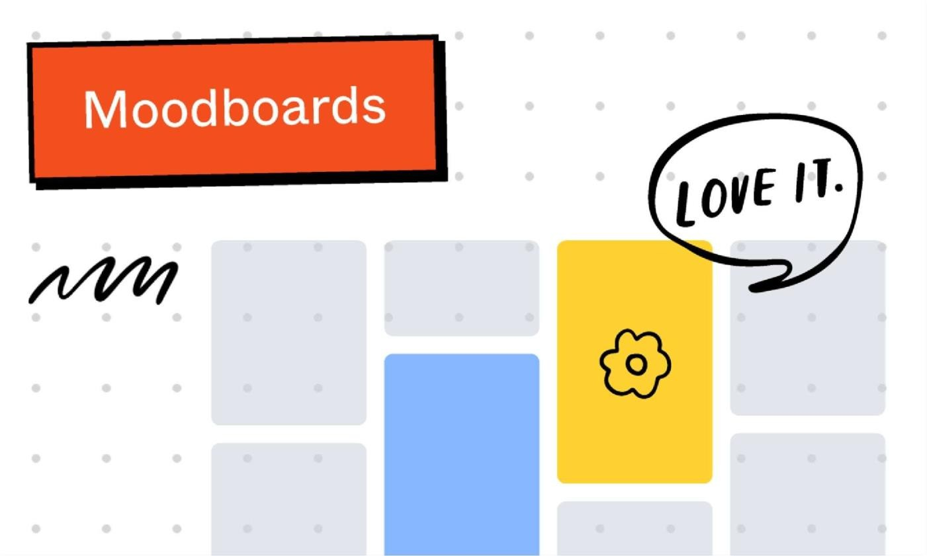

# Result:

Thus, creating a sample pattern library for a product learned, understood and executed successfully.