**Aim:**

To design a responsive layout for a societal application.

**Algorithm:**

1. **HTML and CSS Setup:**
   * Create an HTML5 document with character encoding and viewport settings.
   * Use internal CSS to style the layout components.
2. **Reset Default Styles:**
   * Reset margins, padding, and specify a font-family for better control.
3. **Style Header, Navigation, Content, and Footer:**
   * Apply background colors, text colors, and alignment to the header, navigation, and footer.
   * Style navigation links as inline elements with spacing.
   * Center-align text in header, navigation, and footer.
4. **Implement Responsive Design:**
   * Use a media query for screens up to 768px wide.
   * Adjust navigation for mobile display (block-level elements with margin).
5. **Add Content:**
   * Place application's content within the .container div.

**Program:**

<!DOCTYPE html>

<html lang="en">

<head>

<meta charset="UTF-8">

<meta name="viewport" content="width=device-width, initialscale=1.0">

<title>Societal Application</title>

<style>

/* Reset some default styles */ body, html { margin: 0; padding: 0;

font-family: Arial, sans-serif;

}

/* Header styles */ header {

background-color: #ff0000; color: #fff; padding: 10px; text-align: center;

}

/* Navigation styles */ nav { background-color:#47fff0; color:#fff;

text-align: center;

}

nav ul {

list-style: none; padding: 0;

}

nav li { display: inline; margin: 0 15px; }

/* Main content styles */ .container

{

max-width: 1200px; margin: 0 auto; padding: 20px;

}

/* Responsive design */ @Media (max-width: 768px)

{ nav {

display: block; text-align: center;

}

nav li {

display: block; margin: 10px 0;

}

}

/* Footer styles */ footer {

background-color: #0e00d1; color: #fff;

text-align: center; padding: 10px;

} </style>

</head>

<body>

<header>

<h1>Societal Application</h1>

</header>

<nav>

<ul>

<li><a href="#">Home</a></li>

<li><a href="#">Profile</a></li> <li><a href="#">Posts</a></li>

<li><a href="#">Friends</a></li>

<li><a href="#">Settings</a></li>

</ul>

</nav>

<div class="container">

<!-- Your content goes here -->

<h2>Welcome to our Societal Application! </h2>

<p>Lorem ipsum dolor sit amet, consectetur adipescent elite </p>

</div>

<footer>

&copy; 2023 Societal Application

</footer>

</body>

**OUTPUT:**

**DESKTOP VIEW:**

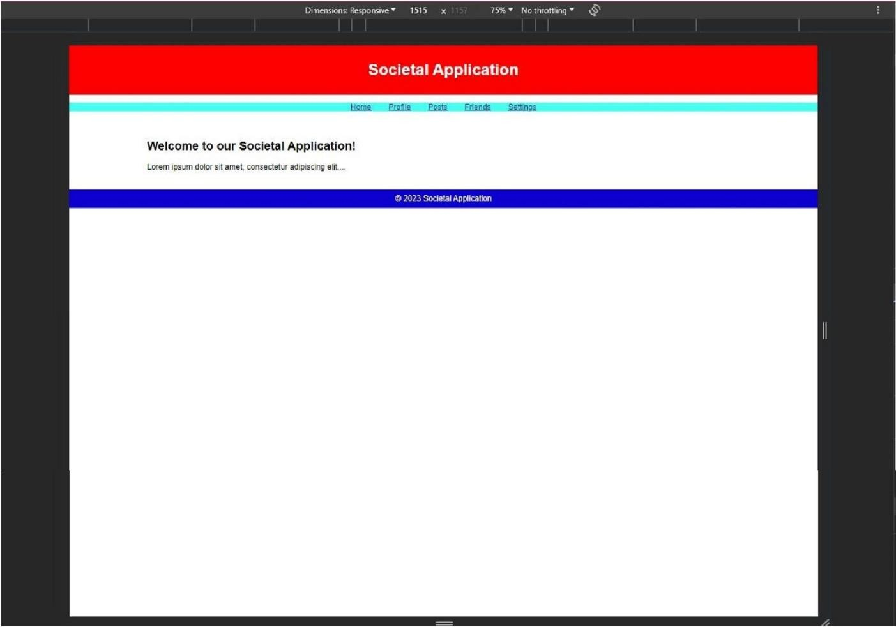

**TABLET VIEW:**

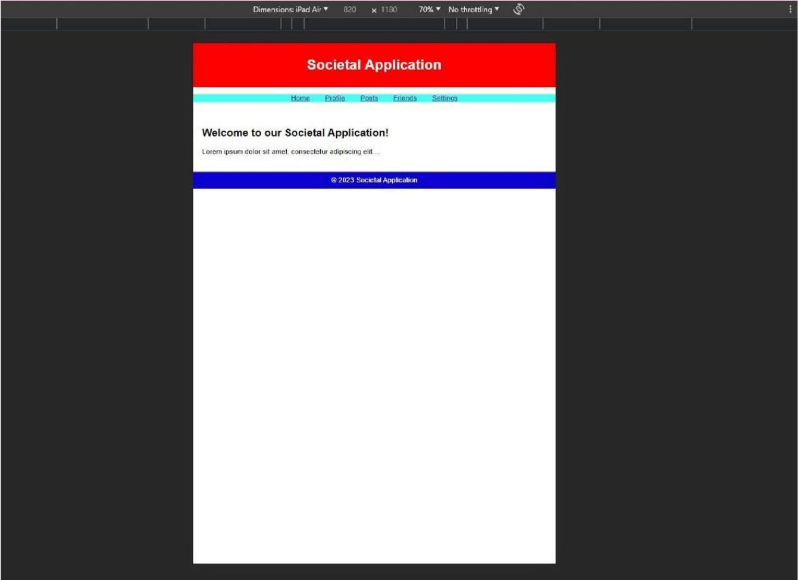

**PHONE VIEW:**

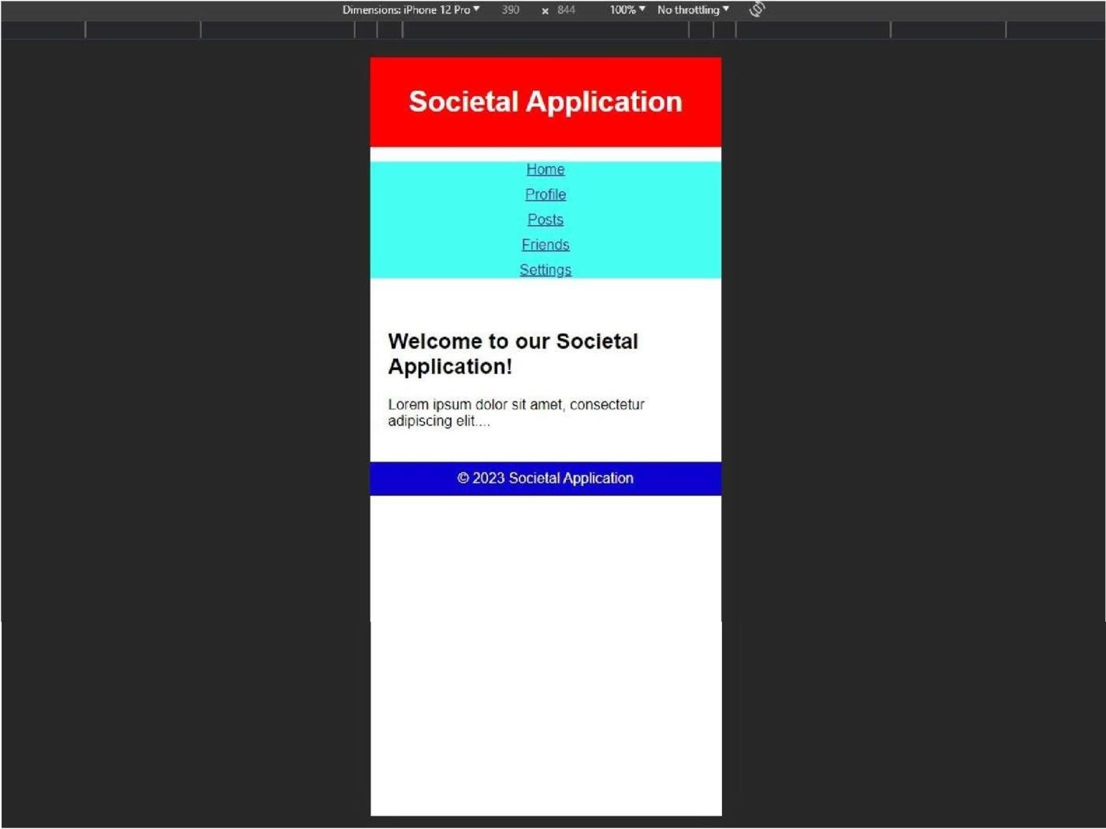

# Result:

Thus, designing of responsive layout for a societal application has been performed successfully.