3. **Visualize data using basic plotting techniques in Python.**

The pandas library makes it extremely easy to create basic data visualizations and provides built-in utilities

for all common data visualizations:

* **df.plot.bar(...)**, to create a bar plot (or add an **h** for **.barh** for a horizontal bar chart)
* **df.plot.line(...)**, to create a line plot
* **df.plot.scatter(...)**, to create a scatter plot
* **df.plot.hist(...)**, to create a histogram
* **df.plot.box(...)**, to create a box plot
* ...and **df.plot.pie**, **df.plot.hexbin**, and more.

### Selecting Columns for Visualizations

By default, each visualization will display **all** numeric columns of data -- which is often **A LOT** of data. For example, the [Illini Football Dataset](https://discovery.cs.illinois.edu/datasets/football/) contains four numeric columns: **Season** (ex: **2021**), **OpponentRank** (ex: **3**), **IlliniScore** (ex: **21**), and **OpponentScore** (ex: **14**).

This means a default visualization will display all four columns:

df = pd.read_csv("https://waf.cs.illinois.edu/discovery/football.csv")

df.plot.box()

df[ ["IlliniScore", "OpponentScore"] ]

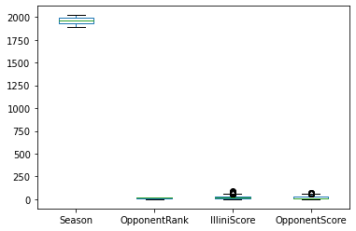

To create a DataFrame with only a subset of the columns, we need to select a **subset of columns**. The syntax required to do this will provide the list of column names as an index to the DataFrame as shown below:

Notice that **there are two sets of square brackets**!

* The first set tells us we're working within the **df**, as **df[ ... ]**.
* The second set is the **list** of column names where each column name is separated by a comma **["IlliniScore", "OpponentScore"]**.
* Together, they make the full command to select a subset of columns from our DataFrame.

A default box plot with only the two columns can now be created:

df = pd.read_csv("https://waf.cs.illinois.edu/discovery/football.csv")

df[ ["IlliniScore", "OpponentScore"] ].plot.box()

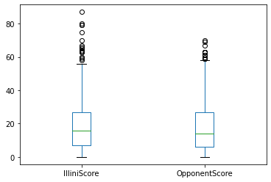

Box plot of only the **IlliniScore** and **OpponentScore** columns in the Illini Football Dataset.

By selecting a **subset of the columns**, we are able to focus on data with similar ranges.

Specifying x and y Column Values

Some visualizations require a single column to be plotted on the **x** or **y** axis. For example, **there is no default scatter plot** and Python informs us that both **x** and **y** are required:

df.plot.scatter()

TypeError: scatter() missing 2 required positional arguments: 'x' and 'y'

Python error message when **df.plot.scatter()** does not specify the columns names to be used

for **x** and **y** axes.

When Python informs us that we're missing "missing 2 required positional arguments",

we need to specify them in the function call. For all visualizations, the **x** and **y** values will be the **name of the column to be used**.

If we wanted to create a scatter plot of the **IlliniScore** verses the **OpponentScore**:

df = pd.read_csv("https://waf.cs.illinois.edu/discovery/football.csv")

df.plot.scatter(x="IlliniScore", y="OpponentScore")

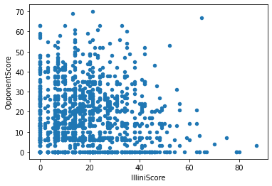

Scatter plot with the **IlliniScore** on the **x** axis and the **OpponentScore** on the **y** axis.

#### Chart-Specific Options

While this visualization is good, there's almost too much data for a scatter plot! Another plot, a **hexbin**,

provides a heat map for of density of each region of a scatter plot. Switching out the **.scatter**

for **.hexbin**, we get a completely different visualization:

df = pd.read_csv("https://waf.cs.illinois.edu/discovery/football.csv")

df.plot.hexbin(x="IlliniScore", y="OpponentScore")

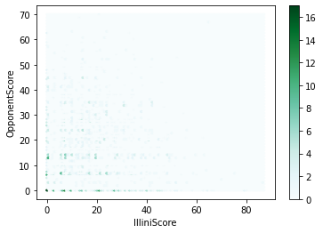

Hexbin plot with the **IlliniScore** on the **x** axis and the **OpponentScore** on the **y** axis.