Manuscript type: Perspective
Journal: EcoEvoRxiv
Running head: Technology convergence for landscape-scale conservation

Hierarchical Dendritic Forest Management: A Vision for Technology-Enabled Landscape Conservation
Justin Hart
Viridis LLC
*Corresponding author: viridisnorthllc@gmail.com
Word count: ~6,500 (excluding references)
ABSTRACT
Forest conservation faces a critical implementation gap. Despite decades of research demonstrating corridor networks' importance for biodiversity and climate adaptation, adoption remains minimal due to perceived complexity and cost. We present Hierarchical Dendritic Forest Management (HDFM)—a conceptual vision for addressing this gap through technology convergence: artificial intelligence, ubiquitous GPS positioning, and continuous satellite monitoring.
The framework's fundamental insight is replacing active corridor management with passive technological exclusion during the critical 30-50 year establishment phase, after which corridors become self-sustaining old-growth reserves clearly distinguishable from managed matrix. AI algorithms identify optimal dendritic corridor networks through entropy minimization and backwards optimization from multi-century climate projections, allocating 20-30% of landscape area to corridors with widths optimized for target species guilds (50-500m). GPS geofencing on logging equipment would provide automated waypoint warnings, allowing corridors to develop naturally while operations continue in the surrounding matrix. Satellite monitoring would enable verification without human oversight.
This perspective explores how converging technologies create unprecedented opportunities for implementing landscape-scale conservation at costs potentially orders of magnitude below traditional approaches. We articulate the conceptual foundation spanning local to planetary scales, discuss implementation pathways across temporal phases with specific design parameters, and identify critical research questions requiring empirical validation. While substantial development and testing remain necessary, the framework demonstrates how technology convergence could transform conservation from expensive aspiration to practical reality across the biosphere's arterial network.
Key words: conservation technology; corridor networks; dendritic systems; GPS geofencing; satellite monitoring; artificial intelligence; climate adaptation; landscape ecology; forest management; technology convergence.

INTRODUCTION
The Implementation Crisis in Forest Conservation
The biosphere maintains its resilience through living arterial networks that circulate genetic material, nutrients, and ecological processes across landscapes. Forest corridors function as these arteries, enabling gene flow that sustains population viability, facilitating species range shifts under climate change, and distributing disturbance responses throughout connected ecosystems. Yet anthropogenic fragmentation has severed these arteries, creating isolated habitat patches whose populations decline through genetic erosion and demographic stochasticity.
Forest management confronts a fundamental implementation crisis. Decades of research have established that corridor networks benefit biodiversity conservation, carbon storage, and landscape resilience (Haddad et al. 2015, Harvey et al. 2017). Yet adoption remains minimal. The barrier is not knowledge but implementation: traditional corridor establishment requires extensive planning, active management, boundary marking, and continuous monitoring—challenges that prove insurmountable for most landowners operating on constrained budgets (Newton et al. 2012, Lamb et al. 2018).
Climate change demands landscape-scale solutions implemented within years, not decades. Current approaches remain locked in planning while forests fragment and species distributions shift. We need fundamentally different pathways—methods that reduce rather than increase implementation complexity while positioning corridors to function across centuries of environmental change.
A Convergence of Technologies
Three technological advances now create unprecedented opportunity:
Artificial intelligence and optimization algorithms that can analyze massive spatial datasets to identify optimal corridor configurations using principles from information theory, network science, and landscape ecology (Urban et al. 2016, Dilts et al. 2016). Machine learning approaches increasingly enable automated pattern recognition and predictive modeling across complex landscapes.
Ubiquitous GPS positioning now standard on modern forestry equipment, achieving ±2-3m accuracy with Real-Time Kinematic (RTK) or Wide Area Augmentation System (WAAS) correction (Korten et al. 2022). Equipment operators routinely use GPS for navigation, harvest planning, and operational efficiency—creating infrastructure for geofencing without additional hardware investment.
Continuous satellite monitoring via Sentinel-2, Landsat, and commercial providers delivering 3-30m resolution imagery with daily to bi-weekly revisit times (Planet Team 2023). Open-access platforms and automated change detection algorithms make monitoring increasingly accessible and affordable.
Individually, each technology is powerful. Combined, they enable a paradigm shift: instead of actively managing corridors, we could simply exclude them from harvest through satellite-monitored geofencing during the critical establishment phase. Algorithms identify optimal locations. GPS prevents equipment entry through automated alarms. Satellites verify compliance without field visits. Corridors develop naturally into old-growth reserves—the biosphere's arterial infrastructure—while operations continue seamlessly in the matrix.
Building on TRIAD: From Static Zoning to Dynamic Networks
HDFM extends the TRIAD forest management paradigm (Seymour and Hunter 1999, Messier et al. 2003), which divides landscapes into conservation areas (no harvesting), extensively managed areas (ecosystem-based forestry), and intensively managed plantations (optimized production). While TRIAD addresses production-conservation tradeoffs through spatial segregation, it relies on static zones delineated through expert judgment and typically lacks explicit mechanisms ensuring connectivity between conservation patches.
HDFM proposes three key refinements. First, replace static conservation zones with dynamic corridor networks designed through backwards optimization from multi-century climate projections, ensuring protected areas remain functional across extended environmental change. Second, replace subjective zoning decisions with algorithmic optimization that explicitly addresses genetic connectivity and landscape entropy. Third, achieve protection through passive technological exclusion during establishment rather than perpetual active boundary management, dramatically reducing implementation barriers while allowing corridors to mature into self-sustaining features.
This evolution parallels the transition from manual drafting to computer-aided design: fundamental principles remain sound (spatial segregation, production-conservation balance), but computational tools enable precision, scalability, and adaptability previously unattainable. HDFM maintains TRIAD's core insight—concentrating intensive management in some areas enables conservation in others—while transforming implementation from static manual delineation to adaptive algorithm-optimized networks functioning across centuries.
Vision and Objectives
This perspective articulates a comprehensive vision for technology-enabled landscape conservation spanning local to planetary scales. We explore how converging AI, GPS, and satellite technologies could enable passive corridor establishment at unprecedented scales and minimal costs. We present conceptual foundations in information theory and network science, discuss implementation pathways across temporal phases with specific design parameters for corridor width and landscape allocation, explore scaling from landscape to biosphere, and identify critical research questions requiring empirical investigation.
Importantly, we present this as a vision requiring validation rather than a proven methodology. The framework offers immediate value for conservation planning and research design by articulating clear hypotheses, identifying critical uncertainties, and highlighting unprecedented opportunities created by technology convergence. Whether this vision translates to practice remains an empirical question worthy of serious investigation.
CONCEPTUAL FRAMEWORK
Three Integrated Components
HDFM integrates three technological components into a unified system (Figure 1): AI-driven optimization identifying optimal corridor configurations, GPS geofencing providing passive exclusion, and satellite monitoring enabling verification and adaptive management. Each builds on established technologies; their integration creates novel capabilities.
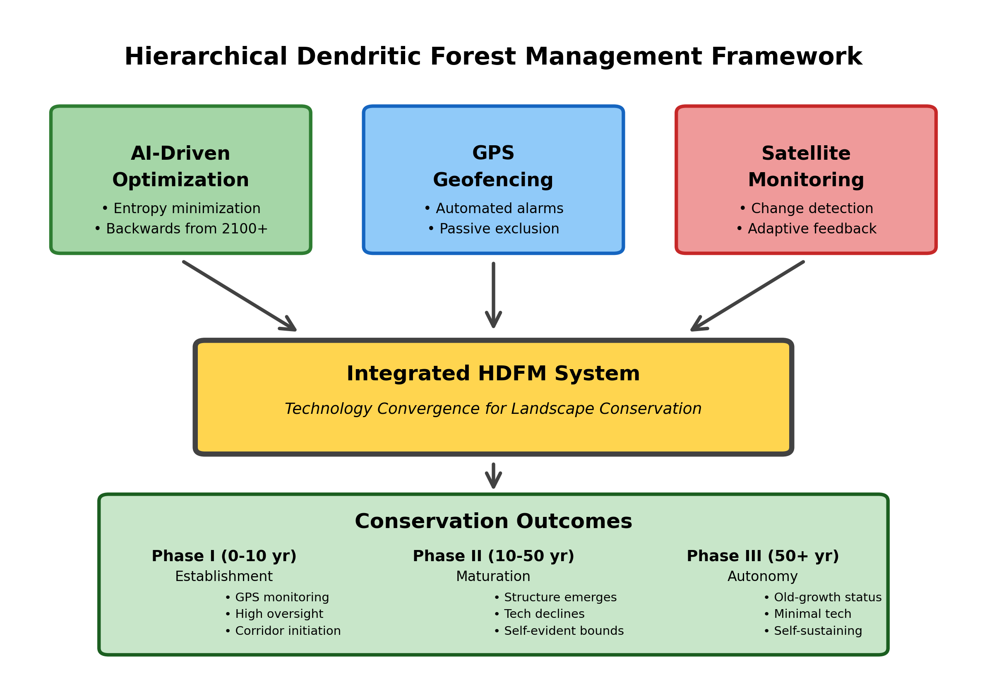
Figure 1. Hierarchical Dendritic Forest Management (HDFM) conceptual framework showing integration of three technological components into a unified system for landscape-scale conservation.
Information-Theoretic Foundation: Entropy Minimization
The framework applies information-theoretic principles to corridor design. Entropy in landscape ecology represents disorder, fragmentation, and inefficiency in ecological flows (Cushman 2015). High-entropy landscapes exhibit scattered habitat patches with poor connectivity, inefficient gene flow requiring complex movement paths, slow disturbance response due to information bottlenecks, and reduced resilience from lack of system-wide coordination.
Low-entropy dendritic networks minimize these inefficiencies by creating hierarchical branching structures that mirror optimal circulation patterns while maximizing connectivity with minimum total edge (Rodriguez-Iturbe and Rinaldo 1997, Bejan and Lorente 2008). Dendritic topology—characterized by tree-like branching without loops—provides theoretical advantages: minimum path redundancy reduces implementation costs, hierarchical structure enables efficient information flow, and branching patterns accommodate heterogeneous landscapes while maintaining connectivity.
An algorithmic approach could formulate corridor optimization as minimizing landscape entropy subject to connectivity constraints, dendritic structure requirements, and rapid disturbance response. This mathematical formulation would transform intuitive corridor planning into computational optimization with quantifiable objectives. However, developing such algorithms requires substantial research—defining appropriate entropy metrics, establishing connectivity thresholds, and validating that theoretical advantages translate to real landscapes.
Backwards Optimization: Designing for Multi-Century Resilience
Traditional corridor planning optimizes for current conditions, creating networks that may become obsolete as climate shifts species distributions. We propose a fundamental reorientation: work backwards from desired future states across multiple centuries to identify present implementation pathways (Figure 2).
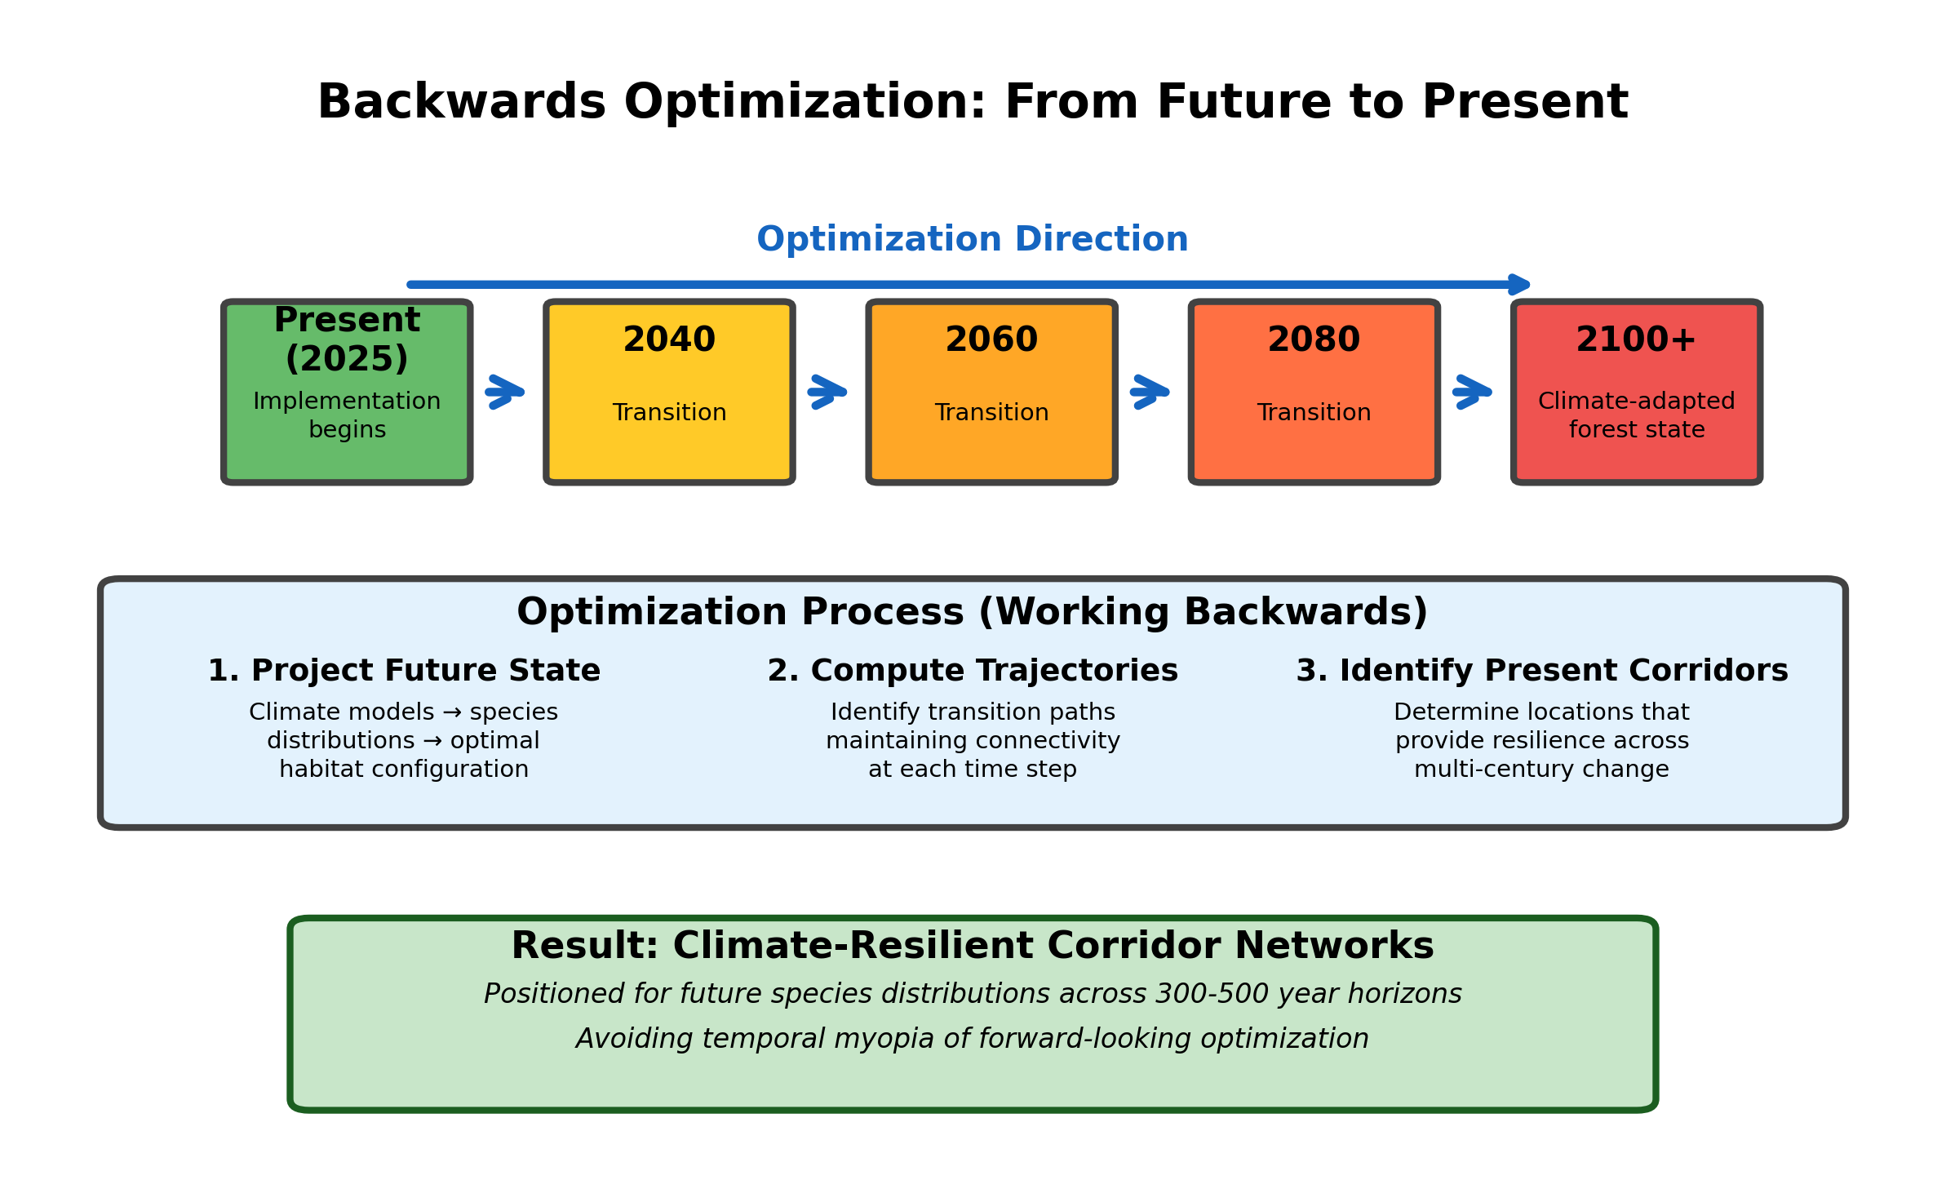
Figure 2. Backwards optimization workflow from 2100 climate projections to present implementation. The approach works backwards through time to identify corridors positioned for future species distributions rather than current conditions.
Rather than optimizing for 2100 as an endpoint, the framework envisions corridor networks functioning across multiple centuries of climate change, with 2100 representing merely the first major transition milestone. True rewilding—restoration of self-regulating ecological processes—requires corridor stabilization over 300-500 years as forest succession proceeds through young-growth → mature → old-growth → climax states. Genetic diversity maintenance requires demographic stability across these timescales. Climate adaptation through species migration operates on centennial to millennial scales.
By starting with multi-century climate-adapted forest projections and computing optimal transition trajectories in decadal increments, the approach could identify corridors positioned for future species distributions across extended timeframes, not just current or near-term conditions. This backwards design aims to create climate-resilient networks functional across coming centuries of environmental change, avoiding temporal myopia plaguing forward-looking approaches.
The conceptual advantages are clear. The implementation challenges are substantial. Climate projections carry inherent uncertainty that compounds across decades and centuries. Species distribution models have known limitations. The optimal corridor configuration for 2100 may prove suboptimal for transition periods. These challenges don't invalidate the approach—they identify research priorities for empirical investigation and adaptive management frameworks.
Passive Exclusion Through GPS Geofencing
Perhaps the framework's most transformative element is replacing active corridor management with passive technological exclusion during the establishment phase. Modern forestry equipment includes GPS guidance systems for operational efficiency. These existing systems could be configured with corridor boundary waypoints that trigger automated alarms when equipment approaches exclusion zones.
Implementation would be straightforward: upload corridor coordinates to equipment GPS systems, configure alarm thresholds (e.g., warning at 50m, alarm at 25m), establish protocols for alarm response, and verify configuration through initial field tests. Unlike physical barriers requiring construction and maintenance, GPS geofences need only one-time configuration with periodic coordinate updates as monitoring reveals necessary adjustments.
This approach faces socio-technical challenges. Equipment operators can override alarms. GPS signals may degrade under the canopy. System reliability depends on equipment maintenance and operator training. These are not insurmountable obstacles—they're implementation details requiring attention. The fundamental innovation is leveraging existing technology infrastructure for conservation purposes, transforming what foresters already use for efficiency into tools for landscape-scale corridor protection during the critical decades when corridors transition from exclusion zones to self-sustaining old-growth reserves.
Satellite-Based Verification and Adaptive Management
Satellite monitoring completes the system by enabling verification without continuous human oversight. Sentinel-2 provides 10m resolution imagery every 5 days. Landsat offers 30m resolution every 8 days. Commercial providers deliver even higher temporal and spatial resolution for critical areas. Open-source change detection algorithms can automatically flag potential corridor incursions, triggering field verification only when necessary.
This monitoring enables adaptive management. If satellite imagery reveals systematic corridor encroachment in specific areas, investigate causes and adjust accordingly. If certain corridor sections show low biological activity while others exhibit high use, consider boundary modifications. If climate-driven species shifts make originally-designated corridors suboptimal, update configurations based on emerging patterns.
The framework thus creates feedback loops between monitoring and management. Satellite observations inform algorithm refinements. Field validations improve predictive models. Biological monitoring reveals which corridor characteristics matter most. This iterative learning process would continuously improve system performance—if implemented and rigorously evaluated.

IMPLEMENTATION VISION AND EXPECTED ADVANTAGES
Dendritic Networks: Theoretical Advantages
Dendritic topology offers theoretical advantages over alternative corridor configurations (Figure 3). Compared to grid networks (requiring extensive corridor length), hub-and-spoke designs (creating central bottlenecks), or opportunistic ad-hoc corridors (exhibiting loops and redundancy), dendritic structures minimize total edge length while maintaining connectivity between all patches.
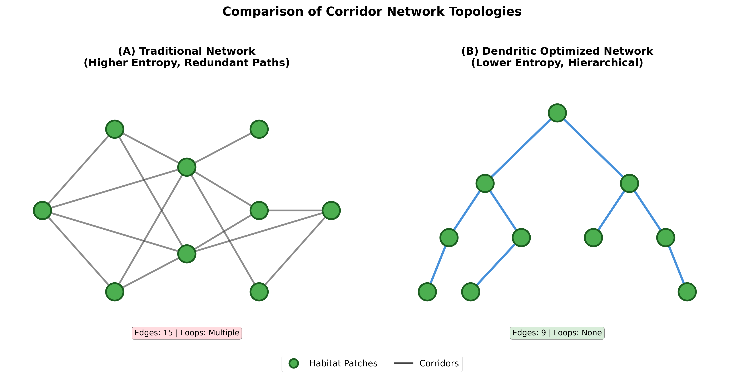
Figure 3. Conceptual comparison of corridor network topologies. (A) Traditional network with multiple loops, redundant paths, and higher entropy. (B) Dendritic optimized network with hierarchical branching, no loops, and lower entropy. Green circles represent habitat patches; lines represent corridors.
The theoretical efficiency translates to reduced implementation costs. Fewer corridor kilometers means less area removed from production, lower establishment costs, and reduced maintenance requirements. Hierarchical structure enables phased implementation—establish primary corridors first, add secondary branches as resources permit. Loop-free topology simplifies boundary delineation and GPS configuration.
Whether these theoretical advantages manifest in practice remains unknown. Real landscapes present complexities—ownership boundaries, topographic constraints, existing infrastructure, socio-economic factors—that may compromise pure dendritic optimization. Empirical studies across diverse landscapes would reveal when and where dendritic topology delivers promised benefits versus when alternative configurations prove more practical.
Corridor Design Parameters: Width and Landscape Allocation
Effective corridor implementation requires specific design parameters balancing ecological functionality with economic feasibility. We propose two fundamental constraints for HDFM optimization algorithms:
Landscape Allocation: 20-30% Target
Dendritic corridor networks should occupy 20-30% of total landscape area. This allocation range represents a conceptual optimum balancing multiple objectives. The lower bound (20%) ensures sufficient habitat area and connectivity for viable metapopulations while maintaining 80% of landscape in production, addressing landowner economic concerns. The upper bound (30%) provides enhanced resilience and redundancy without compromising landscape-scale timber production viability.
This range aligns with TRIAD principles, where approximately 20-30% of landscape typically receives conservation designation while 70-80% remains in varying intensities of production management. The dendritic optimization, however, ensures this allocation is configured for maximum connectivity efficiency rather than arbitrary spatial delineation. By minimizing corridor length through hierarchical branching while maintaining comprehensive patch connectivity, dendritic networks achieve greater conservation value per unit area compared to traditional approaches.
Site-specific optimization would determine exact allocation within this range based on landscape characteristics, ownership patterns, existing habitat patches, and target species requirements. Fragmented landscapes might require allocations toward the upper bound (30%) to achieve adequate connectivity, while landscapes with existing large patches might function effectively at the lower bound (20%).
Corridor Width: Species-Specific Optimization (50-500m)
Corridor widths should be optimized for target species guilds while maximizing flora and fauna reserves per unit area. Conservation biology literature suggests minimum effective widths vary substantially with species mobility, home range requirements, and edge sensitivity. We propose a conceptual framework spanning 50-500m corridor widths:
Narrow corridors (50-100m) function effectively for highly mobile species with small home ranges—songbirds, small mammals, pollinating insects. These widths provide adequate movement pathways while minimizing area removed from production. However, narrow corridors exhibit high edge-to-interior ratios, limiting suitability for edge-sensitive species and reducing capacity to maintain forest interior microclimates.
Moderate corridors (100-250m) accommodate broader species assemblages including medium-sized mammals (deer, coyotes), large raptors, and amphibians with moderate dispersal capabilities. These widths begin providing interior forest conditions, supporting edge-sensitive species and maintaining more stable microenvironments. The 100-250m range represents a practical compromise between ecological function and economic constraints for many temperate forest systems.
Wide corridors (250-500m) support large carnivores (bears, wolves), wide-ranging ungulates, and species requiring extensive interior habitat. These widths approach habitat patch functionality rather than merely providing movement pathways. Wide corridors maximize biodiversity conservation per unit area by supporting complete forest communities including old-growth specialists. However, the substantial area allocation may prove economically challenging in intensively managed landscapes.
Hierarchical corridor networks could implement variable-width strategies, with primary corridors connecting major habitat patches designed at 250-500m to support full species assemblages, while secondary and tertiary branches optimize at 100-250m for efficient connectivity with reduced area requirements. This approach maximizes conservation value within the 20-30% landscape allocation constraint while ensuring comprehensive network connectivity.
Critical research questions include: How do corridor width and landscape allocation interact to determine metapopulation viability? What width thresholds enable which ecosystem functions? How does corridor maturity (Phase I, II, III) affect functional width requirements? Can narrower corridors in early succession achieve equivalent function to wider corridors through enhanced structural complexity?
These parameters provide concrete starting points for algorithmic optimization while acknowledging substantial site-specific variation. Empirical validation across diverse landscapes, species assemblages, and management contexts will refine these ranges and identify conditions where departures from proposed values prove necessary.
Temporal Phases and Self-Sustaining Thresholds
The HDFM framework operates across three distinct temporal phases, each characterized by different management intensities, monitoring requirements, and corridor functional status:
Phase I: Intensive Establishment (Years 0-10)
The initial decade focuses on system implementation and refinement. GPS geofencing configurations are installed and tested across forestry equipment fleets. Satellite monitoring protocols are established with automated change detection algorithms calibrated for local forest types and seasonal variations. Corridor boundaries are precisely delineated based on algorithmic optimization outputs incorporating the 20-30% landscape allocation and species-specific width requirements. Early-successional vegetation establishes within corridor zones as harvest pressure is excluded.
This phase requires highest monitoring intensity. Weekly to bi-weekly satellite imagery review ensures GPS geofencing compliance. Field verification teams investigate flagged anomalies to distinguish between system false positives and actual boundary violations. Equipment operators receive training on alarm protocols and proper response procedures. Landowner engagement maintains commitment as economic opportunity costs become tangible.
Research during this phase addresses critical uncertainties: GPS accuracy under varying canopy densities, alarm configuration optimization to balance compliance and false alarms, satellite change detection algorithm refinement for diverse forest conditions, and economic performance against projections. Additionally, early monitoring establishes baseline data on how species colonize corridors of varying widths, informing adaptive management decisions.
Phase II: Corridor Maturation (Years 10-50)
This phase represents the critical transition period when corridors evolve from actively-protected exclusion zones into increasingly self-evident landscape features. Forest succession progresses through mid-successional stages. Canopy closure occurs. Structural complexity develops. Stand characteristics increasingly diverge from surrounding managed matrix.
Monitoring intensity decreases as corridors become visually distinguishable. Mid-successional corridors (20-30 years) exhibit sufficient structural difference from adjacent harvest areas that boundary violations become immediately obvious in satellite imagery. GPS geofencing transitions from primary enforcement mechanism to backup safeguard. Field verification frequency decreases from monthly to quarterly to annually as corridor stability increases.
By year 30-50, corridors approach early old-growth characteristics in temperate forests: large tree size, canopy complexity, coarse woody debris accumulation, and distinctive spectral signatures in satellite imagery. The harvest boundary naturally emerges through contrast—old-growth corridor structure versus managed production forest. GPS technology dependence declines as physical and visual boundaries become self-evident.
Economic dynamics shift during this phase. Initial opportunity costs (foregone harvest revenue from 20-30% landscape allocation) stabilize as landowners adapt management strategies around corridor networks. Carbon market revenues begin accruing as corridor biomass accumulates. Ecosystem service payments may commence as watershed protection and biodiversity values become demonstrable. Certification premiums (FSC, SFI) provide market differentiation.
Phase III: Autonomous Function (Years 50+)
Corridors achieve functional autonomy as self-sustaining old-growth reserves. GPS geofencing becomes largely obsolete except as legal documentation of permanent protection boundaries. Satellite monitoring transitions from compliance verification to ecological performance assessment: biodiversity indices, carbon stock monitoring, climate adaptation tracking, and evaluation of whether corridor width and allocation parameters achieve intended conservation outcomes.
Old-growth corridor characteristics (>100 years in temperate forests, >200 years in boreal systems) are unmistakable: large-diameter trees, complex vertical structure, extensive coarse woody debris, distinctive plant and animal communities. The boundary between corridor and matrix requires no technological enforcement—it exists as fundamental landscape structure, analogous to the distinction between river and upland.
Multi-century stabilization (200-500+ years) produces true old-growth characteristics optimized for genetic connectivity, climate refugia, and biodiversity conservation. The arterial network functions as permanent biosphere infrastructure, circulating genetic material and ecological processes across landscapes regardless of technological systems.
This temporal framework clarifies that HDFM's technological dependence is frontloaded during establishment, not perpetual. The 30-50 year geofencing phase represents a transition strategy—leveraging GPS technology during the vulnerable period when corridors lack physical distinction from surrounding matrix. Once structural differentiation emerges through succession, the corridors become self-evident, self-sustaining landscape features requiring minimal technological intervention.
Economic Considerations
Traditional corridor establishment costs $200-500 per hectare for planning, boundary marking, and active management infrastructure. HDFM could potentially reduce these costs by orders of magnitude: algorithmic design ($5-10 ha⁻¹ one-time), GPS configuration ($10-15 ha⁻¹ one-time), and satellite monitoring ($5-10 ha⁻¹ annually during Phase I, decreasing to $2-5 ha⁻¹ annually in Phase II, and $1-2 ha⁻¹ in Phase III). Total establishment cost might approach $30-45 ha⁻¹—an order of magnitude reduction.
The 20-30% landscape allocation to corridors represents foregone timber revenue offset by multiple benefit streams. At typical temperate forest productivity (3-5 m³ ha⁻¹ yr⁻¹) and stumpage values ($50-80 m³⁻¹), annual opportunity cost approximates $150-400 ha⁻¹ across the corridor network. However, carbon markets increasingly compensate for foregone harvest ($20-50 ha⁻¹ yr⁻¹ as biomass accumulates), ecosystem service payments may provide watershed and biodiversity premiums ($10-30 ha⁻¹ yr⁻¹), and certification differentials (5-10% price premiums on harvested timber) can offset significant portions of opportunity costs.
Ongoing costs decrease dramatically across temporal phases as monitoring intensity declines. Traditional corridors require perpetual boundary maintenance, field monitoring, and active management interventions. HDFM's satellite-based monitoring needs only periodic analyst review of automated change detection outputs in Phase I, decreasing frequency in Phase II, and transitioning to ecological performance monitoring in Phase III.
Revenue opportunities could offset implementation costs. Carbon markets increasingly value forest conservation, with revenue streams growing as corridor biomass accumulates through Phases II and III. Ecosystem service payments recognize watershed protection and biodiversity conservation. Green certification programs (FSC, SFI) provide market differentiation. Aggregated across large landscapes, these revenue streams could make corridor establishment economically attractive rather than merely acceptable.
These economic projections are speculative. They depend on technological maturity, carbon market stability, certification program evolution, regional stumpage values, and site productivity. The 20-30% allocation represents substantial area removed from production—economically viable only when offset payments and certification premiums prove reliable. Rigorous economic analysis across diverse contexts would reveal actual costs, identify economies of scale, clarify phase-dependent cost structures, and determine when and where the approach proves financially viable across the multi-decade implementation timeline.
RESEARCH PRIORITIES AND VALIDATION PATHWAYS
Algorithm Development and Testing
The framework requires substantial algorithm development before implementation. Priority research questions include: How should landscape entropy be mathematically defined for corridor optimization? What connectivity metrics best predict long-term genetic viability? How can backwards optimization handle compounding uncertainty in multi-century climate projections? How do algorithms incorporate the 20-30% landscape allocation constraint while optimizing corridor placement and width? Can existing tools (Marxan, Zonation, Circuitscape) be extended or must new algorithms be developed?
Initial development should occur on synthetic landscapes where 'ground truth' is known, enabling validation of algorithmic outputs. Testing should systematically vary corridor width (50-500m range) and landscape allocation (20-30% range) to identify optimal parameter combinations under different ecological scenarios. Subsequent testing on real landscapes with existing corridor networks would compare algorithmic recommendations to expert designs. Pilot implementations in diverse biomes would reveal how performance varies with landscape characteristics, species assemblages, and management contexts.
Corridor Effectiveness Research
Empirical validation must establish relationships between corridor design parameters and conservation outcomes. Critical questions include: What corridor widths support viable metapopulations for different species guilds? How does the 20-30% landscape allocation translate to actual species persistence and genetic connectivity? Do hierarchical networks with variable-width corridors (primary at 250-500m, secondary at 100-250m) achieve comparable effectiveness to uniformly wide networks? At what corridor width do edge effects diminish sufficiently to support interior forest specialists?
Long-term monitoring comparing different width configurations across matched landscapes would establish evidence-based design guidelines. Genetic analysis would assess population connectivity across corridors of varying widths. Movement ecology studies using GPS collars and automated telemetry would reveal how different species utilize corridors within the proposed width ranges. Biodiversity surveys would determine minimum corridor dimensions supporting target species assemblages across temporal phases.
GPS Geofencing Reliability
GPS-based corridor protection requires empirical validation across operational conditions and temporal phases. Critical questions include: What alarm configurations maximize compliance while minimizing false alarms during Phase I? How does GPS accuracy degrade under varying forest canopy densities as corridors mature? What training protocols ensure consistent operator response? How can systems detect and flag equipment with disabled GPS? At what point in Phase II does corridor structural differentiation reduce GPS dependency?
Controlled field trials should test GPS geofencing under realistic operational conditions, measuring alarm response rates, boundary accuracy, and failure modes. Long-term monitoring across all temporal phases would reveal how system reliability and necessity evolve with corridor maturation, equipment familiarity, seasonal variations, and changing landscape conditions.
Socio-Economic Viability
Even technologically feasible and ecologically effective approaches fail without socio-economic viability across the full implementation timeline. Research should examine: What factors influence landowner adoption decisions given the 20-30% landscape allocation requirement and multi-decade commitment? How do implementation costs and revenue offsets vary across regions with different stumpage values, carbon prices, and certification premiums? What policy mechanisms most effectively incentivize participation across the 30-50 year critical establishment period? How sensitive is economic viability to variations in corridor width and landscape allocation within proposed ranges?

DISCUSSION
Conceptual Contributions
HDFM makes several conceptual contributions beyond incremental improvements to existing approaches. First, applying information-theoretic principles to corridor design provides rigorous mathematical foundation applicable across biomes, scales, and objectives. Entropy minimization offers a quantifiable objective function that could replace subjective expert judgment—if properly developed and validated.
Second, backwards optimization from desired future states across multi-century timescales addresses temporal myopia inherent in traditional planning. By designing for 300-500 year functionality rather than just 2025-2100 trajectories, the approach aims to create climate-resilient networks positioned for centuries of environmental change—if climate projections prove sufficiently accurate across these extended timescales and if optimization algorithms can effectively handle compounding uncertainty.
Third, passive exclusion through technology during critical establishment phases represents a paradigm shift from perpetual active management to time-limited automated protection transitioning to self-sustaining landscape structure. By leveraging existing technology infrastructure (GPS on forestry equipment, satellite monitoring platforms, computational optimization tools) during the 30-50 year vulnerability window, the framework potentially eliminates primary adoption barriers while positioning corridors to function autonomously across centuries—if socio-technical integration proves reliable in practice and if corridors achieve predicted structural differentiation.
Fourth, explicit temporal phasing clarifies that technology dependence is frontloaded during establishment, not perpetual. The GPS geofencing phase represents a transition strategy enabling corridor development, not a permanent technological dependence. This temporal framework better aligns economic analyses, implementation planning, and realistic adoption pathways.
Fifth, specification of concrete design parameters—20-30% landscape allocation and 50-500m corridor widths—transforms HDFM from abstract concept to implementable framework. These ranges provide starting points for algorithmic optimization while acknowledging substantial site-specific variation requiring empirical validation.
Scaling Dimensions: From Landscape to Biosphere
While presented primarily at landscape scale, HDFM principles extend naturally to nested hierarchies spanning local to planetary scales. The dendritic topology that optimizes connectivity at individual ownership scales aggregates into regional networks, which themselves form dendritic branches within biome-scale arterial systems, ultimately constituting the biosphere's genetic and ecological circulation infrastructure.
This nested scaling enables a critical methodological inversion: rather than hoping local implementations fortuitously connect, a planetary-scale "terra-map" approach could work backwards from idealized global connectivity networks to identify priority nodes requiring protection and partnership. By simulating Earth's optimal ecological arterial system across diverse ecoregions, the framework could identify where specific corridors provide disproportionate planetary connectivity value, guiding resource allocation and partnership development with willing land stewards.
Such planetary-scale optimization would reveal which landscapes serve as critical hubs in global genetic flow networks, where climate refugia require enhanced connectivity, and which regions offer highest return-on-investment for biodiversity conservation. Local HDFM implementations would then function as nodes in explicitly-designed global networks rather than isolated projects hoping for emergent connectivity.
The 20-30% landscape allocation at local scales could aggregate into global targets. If implemented across Earth's forested biomes, this allocation would establish 4-6 million km² of corridor networks functioning as planetary arterial infrastructure—comparable in scale to existing protected area networks but explicitly designed for connectivity rather than static preservation.
This scaling vision requires substantial development. Planetary-scale optimization presents computational challenges orders of magnitude beyond landscape analysis. Data availability varies dramatically across regions. Climate projection uncertainty compounds across spatial scales and temporal horizons. Coordination mechanisms for international collaboration remain undeveloped.
Yet the scaling framework offers immediate value by positioning local implementations within global context, identifying where specific projects contribute disproportionately to planetary resilience, and articulating clear targets for international conservation partnerships. The biosphere's arterial network requires conscious design at planetary scale, not just local optimization hoping for emergent function.
Implementation Challenges and Limitations
The framework faces substantial implementation challenges across scales and temporal phases. Algorithm development requires expertise spanning landscape ecology, optimization theory, climate science, and software engineering. GPS geofencing depends on consistent operator compliance, reliable equipment maintenance, and effective training programs maintained across the critical 30-50 year establishment phase. Satellite monitoring needs automated change detection algorithms robust to varying atmospheric conditions, seasonal vegetation changes, and diverse forest types across succession stages. Planetary-scale coordination requires institutional mechanisms not yet developed.
Economic viability remains uncertain across temporal phases. The 20-30% landscape allocation represents substantial foregone timber revenue that must be offset through carbon markets, ecosystem service payments, and certification premiums. These offset mechanisms vary regionally and temporally. Carbon market prices fluctuate. Certification premiums vary by market. Timber opportunity costs during the multi-decade establishment phase depend on site productivity and stumpage values. What proves economically attractive in one context may fail in others. Revenue streams that appear viable initially may not sustain through full implementation timelines.
The proposed corridor width ranges (50-500m) require empirical validation across diverse taxa and ecosystems. Species with extensive home ranges may require widths exceeding 500m. Highly specialized or edge-sensitive species may require minimum widths toward the upper range. Conversely, some landscapes might achieve adequate connectivity with narrower corridors than proposed, reducing economic constraints.
Legal and regulatory frameworks may require adaptation. Property rights, liability concerns, verification requirements, and enforcement mechanisms vary across jurisdictions. Multi-decade commitment requirements face ownership transfer complications. International coordination for planetary-scale implementations encounters sovereignty and governance challenges. Successful implementation requires engaging legal and policy experts, building institutional capacity, and developing appropriate governance structures spanning local to global scales.
When Might the Framework Fail?
Identifying potential failure modes is essential for honest evaluation. The framework may prove ineffective when: algorithm assumptions don't match ecological reality across biomes; GPS technology proves insufficiently reliable during the critical 30-50 year establishment phase; satellite monitoring false positive rates overwhelm verification capacity; climate projections diverge substantially from actual trajectories across multi-century horizons; landowner adoption remains low despite reduced costs and clear temporal phases; the 20-30% landscape allocation proves insufficient for target species or economically infeasible in high-productivity forests; proposed corridor widths fail to support viable metapopulations; corridors fail to achieve predicted structural differentiation enabling autonomous function; ecological outcomes fail to justify implementation investments; or planetary-scale coordination proves institutionally intractable.
These potential failure modes don't invalidate the framework—they identify critical uncertainties requiring empirical investigation. Systematic evaluation would reveal which elements work across which contexts and scales, which need refinement, and which should be abandoned in favor of alternative approaches.
Relationship to Existing Approaches
HDFM complements rather than replaces existing conservation tools. Circuit theory, least-cost path analysis, and graph-theoretic approaches provide sophisticated connectivity modeling that could inform algorithmic optimization. Marxan and Zonation offer powerful systematic conservation planning frameworks potentially adaptable to entropy minimization objectives incorporating corridor width and allocation constraints. TRIAD provides proven conceptual foundation for production-conservation balance that HDFM refines rather than rejects—the 20-30% corridor allocation aligns with TRIAD's typical conservation zone proportions while ensuring these zones are configured for maximum connectivity.
HDFM's potential contribution lies in integrating these analytical approaches with emerging implementation technologies (GPS geofencing, satellite monitoring), novel optimization strategies (backwards planning across centuries, entropy minimization, explicit temporal phasing, nested scaling from landscape to biosphere), and concrete design parameters (corridor widths, landscape allocation targets) to create more practical deployment pathways spanning the critical establishment phase and extending into multi-century autonomous function.

CONCLUSION
Hierarchical Dendritic Forest Management presents a vision for addressing forest conservation's implementation crisis through technology convergence, temporal phase clarification, concrete design parameters, and nested scaling from landscape to biosphere. By combining AI-driven optimization constrained to 20-30% landscape allocation, GPS geofencing during the critical 30-50 year establishment phase, corridor widths optimized for target species (50-500m), and satellite monitoring enabling transition to autonomous function, the framework could potentially transform landscape-scale corridor establishment from expensive aspiration to practical reality within the biosphere's arterial network.
This vision requires validation. Every major component—entropy-minimization algorithms incorporating width and allocation constraints, backwards optimization across multi-century horizons, GPS-based passive exclusion through temporal phases, satellite-automated monitoring transitioning to ecological performance assessment, planetary-scale coordination mechanisms—needs substantial development and empirical testing before operational deployment. The gap between conceptual promise and practical implementation often proves larger than anticipated, particularly across the extended timescales this framework envisions.
Yet the framework offers immediate value. It articulates clear hypotheses testable through field studies across temporal phases and corridor width ranges. It identifies critical uncertainties requiring investigation at multiple scales. It provides conceptual foundation for algorithm development and refinement spanning landscape to planetary optimization. It clarifies temporal phases reducing perpetual technology dependence concerns. It specifies concrete design parameters (20-30% allocation, 50-500m widths) enabling practitioners to begin pilot implementations. It highlights unprecedented opportunities created by converging technologies for establishing self-sustaining old-growth corridor networks. It demonstrates how rethinking implementation pathways—not just ecological principles—could enable landscape-scale conservation functioning across centuries.
Climate change demands landscape-scale conservation solutions implemented within years, not decades, yet functioning across centuries, not just human lifetimes. Traditional approaches remain locked in planning stages while forests fragment and species distributions shift. New approaches merit serious consideration even when uncertainties remain substantial. The technologies exist. The conceptual foundations are sound. The temporal pathway from technology-dependent establishment to autonomous function is clarified. Design parameters provide implementable targets. What remains is collective willingness to develop, test, and refine novel frameworks through rigorous empirical investigation across the scales and timescales where Earth's arterial networks must function.
Conservation cannot continue business-as-usual while climate accelerates and habitats fragment. HDFM provides a roadmap—not proven methodology, but vision worthy of systematic exploration from landscape to planetary scales, across temporal phases from establishment through multi-century autonomous function, with concrete design parameters enabling immediate pilot testing. Whether this vision translates to practice depends on sustained research, careful implementation, honest evaluation, and adaptive refinement guided by evidence. The question is not whether the framework is ready for implementation, but whether it articulates a direction worth pursuing. We believe it does.
LITERATURE CITED
Bejan, A., and S. Lorente. 2008. Design with constructal theory. John Wiley & Sons, Hoboken, New Jersey, USA.
Cushman, S. A. 2015. Thermodynamics in landscape ecology: the importance of integrating measurement and modeling of landscape entropy. Landscape Ecology 30:7-10.
Dilts, T. E., P. J. Weisberg, P. Dencker, and J. C. Chambers. 2016. Functionally relevant climate variables for arid lands: a climatic water deficit approach for modelling desert shrub distributions. Journal of Biogeography 42:1986-1997.
Haddad, N. M., et al. 2015. Habitat fragmentation and its lasting impact on Earth's ecosystems. Science Advances 1:e1500052.
Harvey, C. A., et al. 2017. Climate-smart landscapes: opportunities and challenges for integrating adaptation and mitigation in tropical agriculture. Conservation Letters 10:77-88.
Korten, S., C. Kaul, and B. Talbot. 2022. Precision forestry: the path to increased mechanization and automation in forestry operations. Current Forestry Reports 8:45-61.
Lamb, D., P. D. Erskine, and J. A. Parrotta. 2018. Restoration of degraded tropical forest landscapes. Science 320:1458-1460.
Messier, C., M.-J. Fortin, F. Schmiegelow, K. P. Doyon, S. G. Cumming, J. P. Kimmins, B. Seely, C. Welham, and J. Nelson. 2003. Modeling tools to assess the sustainability of forest management scenarios. Pages 531-580 in P. J. Burton, C. Messier, D. W. Smith, and W. L. Adamowicz, editors. Towards sustainable management of the boreal forest. NRC Research Press, Ottawa, Ontario, Canada.
Newton, P., et al. 2012. Economic constraints to forest landscape restoration. Frontiers in Ecology and Environment 10:434-441.
Planet Team. 2023. Planet application program interface. San Francisco, CA. Available at: api.planet.com
Rodriguez-Iturbe, I., and A. Rinaldo. 1997. Fractal river basins: chance and self-organization. Cambridge University Press, Cambridge, UK.
Seymour, R. S., and M. L. Hunter Jr. 1999. Principles of ecological forestry. Pages 22-61 in M. L. Hunter Jr., editor. Maintaining biodiversity in forest ecosystems. Cambridge University Press, Cambridge, UK.
Urban, D. L., E. S. Minor, E. A. Treml, and R. S. Schick. 2016. Graph models of habitat mosaics. Ecology Letters 12:260-273.

