Title Goes Here

Jane Doe

September 29, 2025

Abstract

Text of abstract

Keywords: keyword 1; keyword 2; keyword 3

Highlights: These are the highlights.

library(DESeq2)  
library(ggplot2)  
library(ggrepel)  
library(gprofiler2)  
library(openxlsx)  
library(dplyr)  
  
set_base_url("https://biit.cs.ut.ee/gprofiler_archive3/e104_eg51_p15")  
  
volcano_plot <- function(exp, down_color, up_color, title){  
 colnames(exp)[grep(pattern = "log2FoldChange",x = colnames(exp))] <- "log2FoldChange"  
 colnames(exp)[grep(pattern = "padj",x = colnames(exp))] <- "padj"  
   
 exp$direction <- "No-significant"  
   
 exp$direction[which(exp$padj < 0.05 & exp$log2FoldChange > 0)] <- "Up-regulated"  
 exp$direction[which(exp$padj < 0.05 & exp$log2FoldChange < 0)] <- "Down-regulated"  
   
 exp <- exp[order(exp$padj),]  
   
 exp$threshold <- c(rep(TRUE,10),rep(FALSE,nrow(exp) - 10))  
 exp$direction <- as.factor(exp$direction)  
 result <- exp[which(!is.na(exp$padj)),]  
 result <- result[order(result$threshold,decreasing = TRUE),]  
   
 ggplot(result) +  
 geom_point(aes(x=log2FoldChange, y=-log10(padj),colour=direction)) +   
 scale_color_manual(values=c(down_color,"grey",up_color)) + ggtitle(title) +  
 geom_text_repel(data =result[c(1:10),],   
 mapping =aes(x= log2FoldChange, y = -log10(padj), label = result$name[c(1:10)] ), size = 1.5) +  
 xlab("log2 fold-change") +   
 ylab("-log10 adj. p-value") +  
 geom_hline(yintercept=-log10(0.05), linetype="dashed", color = "red") + theme_classic() + theme(legend.position = "none",   
 text = element_text(size = 8),  
 plot.title = element_text(size=6))   
   
}  
loc_val <- function(mean_FC,SD){  
 result <- c()  
 for(i in seq(length(mean_FC))){  
 if(SD[i] == 0){SD[i] <- min(SD[which(SD != 0)])}  
   
 if(mean_FC[i] < 0){  
 result <- c(result,mean_FC[i]-SD[i]-(min(SD[i])/2))  
 }  
 if(mean_FC[i] > 0){  
 result <- c(result,mean_FC[i]+SD[i]+(min(SD[i])/2))  
 }  
 if(mean_FC[i] == 0){  
 result <- c(result,NA)  
 }  
 }  
 return(result)  
}  
enrichment_profile = function(pathways, DEG, color_down, color_up, category){  
 # data is the dataframe containing only significant genes for a specific cell type  
 # pathway is a df of pathway ids/go ids that are statistically enriched from geneprofile  
   
 DEG$name <- rownames(DEG)  
   
 colnames(DEG)[grep(pattern = "log2fc",x = colnames(DEG))] <- "log2FoldChange"  
 colnames(DEG)[grep(pattern = "pvalue",x = colnames(DEG))] <- "padj"  
 colnames(DEG)[grep(pattern = "name",x = colnames(DEG))] <- "ensembl_gene_id"  
   
 to.plot <- data.frame()  
 for(i in 1:nrow(pathways)){  
 res = gost(query = pathways[i,"term_id"], organism = "hsapiens")  
 gene_set = res$meta$genes_metadata$query$query_1$ensgs  
   
 to.plot <- rbind(to.plot,  
 data.frame(  
 Name=pathways[i,"term_name"],  
 mean_FC=c(mean(DEG[DEG$ensembl_gene_id %in% gene_set,]$log2FoldChange[DEG[DEG$ensembl_gene_id %in% gene_set,]$log2FoldChange > 0]),  
 mean(DEG[DEG$ensembl_gene_id %in% gene_set,]$log2FoldChange[DEG[DEG$ensembl_gene_id %in% gene_set,]$log2FoldChange < 0])),  
 Type=c("up-regulated","down-regulated"),  
 Set_size = c(length(DEG[DEG$ensembl_gene_id %in% gene_set,]$log2FoldChange[DEG[DEG$ensembl_gene_id %in% gene_set,]$log2FoldChange > 0]),  
 length(DEG[DEG$ensembl_gene_id %in% gene_set,]$log2FoldChange[DEG[DEG$ensembl_gene_id %in% gene_set,]$log2FoldChange < 0])),  
 SD=c(sd(DEG[DEG$ensembl_gene_id %in% gene_set,]$log2FoldChange[DEG[DEG$ensembl_gene_id %in% gene_set,]$log2FoldChange > 0]),  
 sd(DEG[DEG$ensembl_gene_id %in% gene_set,]$log2FoldChange[DEG[DEG$ensembl_gene_id %in% gene_set,]$log2FoldChange < 0]))  
 ))  
 }  
   
 to.plot[is.nan(to.plot$mean_FC),"mean_FC"] <- 0  
 to.plot[is.na(to.plot$SD),"SD"] <- 0  
   
 to.plot$Name[which(to.plot$Name == "Regulation of Insulin-like Growth Factor (IGF) transport and uptake by Insulin-like Growth Factor Binding Proteins (IGFBPs)")] <- "Regulation of Insulin-like Growth Factor\n (IGF) transport and uptake by Insulin-like\n Growth Factor Binding Proteins (IGFBPs)"  
   
 to.plot$Name[which(to.plot$Name == "Assembly of collagen fibrils and other multimeric structures")] <- "Assembly of collagen fibrils\n and other multimeric structures"  
   
   
 p <- ggplot(to.plot, aes(x = mean_FC, y = reorder(Name, abs(mean_FC)), fill = Type, label = Set_size)) +   
 scale_fill_manual(name = "", values = c("down-regulated" = color_down, "up-regulated" = color_up)) +   
 ylab(category) + xlab("Mean logFC") +   
 theme(axis.line = element_blank(),  
 panel.grid.major = element_blank(),  
 panel.grid.minor = element_blank(),  
 panel.background = element_blank()) + theme(text = element_text(size = 6)) +   
 theme(legend.position = "none") +  
 geom_bar(stat = "identity") + geom_text(aes(label = Set_size, x = loc_val(mean_FC,SD) ),size = 1.5) +  
 geom_linerange(aes(xmin=ifelse(mean_FC < 0,mean_FC - SD, mean_FC), xmax=ifelse(mean_FC > 0,mean_FC + SD, mean_FC) ))  
   
 return(p)  
}  
  
raw_data <- "/workspaces/phd_dissertation/PIPE/analysis/data/raw_data/"  
first <- read.xlsx(paste0(raw_data,"231203_raw_data.xlsx"),sheet = 1)

# Mono-culture

## Endothelial 21% O2. Normal shear stress

counts <- first[,grep(pattern = 'raw_E21_BR|raw_DEN21_BR',x = colnames(first))]  
rownames(counts) <- first$id  
  
meta <- data.frame(experiment = as.factor(gsub(pattern = "\\_BR[1-3]",replacement = "",x = colnames(counts))))  
rownames(meta) <- colnames(counts)  
  
dds <- DESeqDataSetFromMatrix(countData = counts,  
 colData = meta,  
 design = ~experiment)  
  
keep <- rowSums(counts(dds)) >= 10  
dds <- dds[keep,]  
dds$experiment <- relevel(dds$experiment, ref = "raw_E21")  
dds <- DESeq(dds)  
resultsNames(dds)

[1] "Intercept" "experiment_raw_DEN21_vs_raw_E21"

resLFC <- lfcShrink(dds, coef=2, type="apeglm")  
resLFC <- as.data.frame(resLFC) %>% mutate(name = first$name[which(first$id %in% rownames(resLFC))], .before=1)  
cat("number of significant genes: ",nrow(resLFC[which(resLFC$padj < 0.05),]))

number of significant genes: 31

head(resLFC[order(resLFC$padj),])

name baseMean log2FoldChange lfcSE pvalue  
ENSG00000104267 CA2 25.81729 -3.561646 0.6135713 3.242714e-10  
ENSG00000165507 DEPP1 25.27896 -2.955909 0.5788937 1.405284e-08  
ENSG00000151012 SLC7A11 55.37205 2.342875 0.4686745 3.618823e-08  
ENSG00000020577 SAMD4A 34.05854 2.140450 0.4688876 2.399889e-07  
ENSG00000167861 HID1 31.14038 -2.563661 0.5771215 3.464114e-07  
ENSG00000189058 APOD 29.30900 -3.120242 0.8066631 3.843185e-06  
 padj  
ENSG00000104267 1.229961e-06  
ENSG00000165507 2.665121e-05  
ENSG00000151012 4.575398e-05  
ENSG00000020577 2.275695e-04  
ENSG00000167861 2.627877e-04  
ENSG00000189058 1.934964e-03

### Volcano plot

volcano_plot(exp = resLFC,down_color = "#FDE725FF",up_color = "#4AC16DFF", title="Endothelial oxygen")

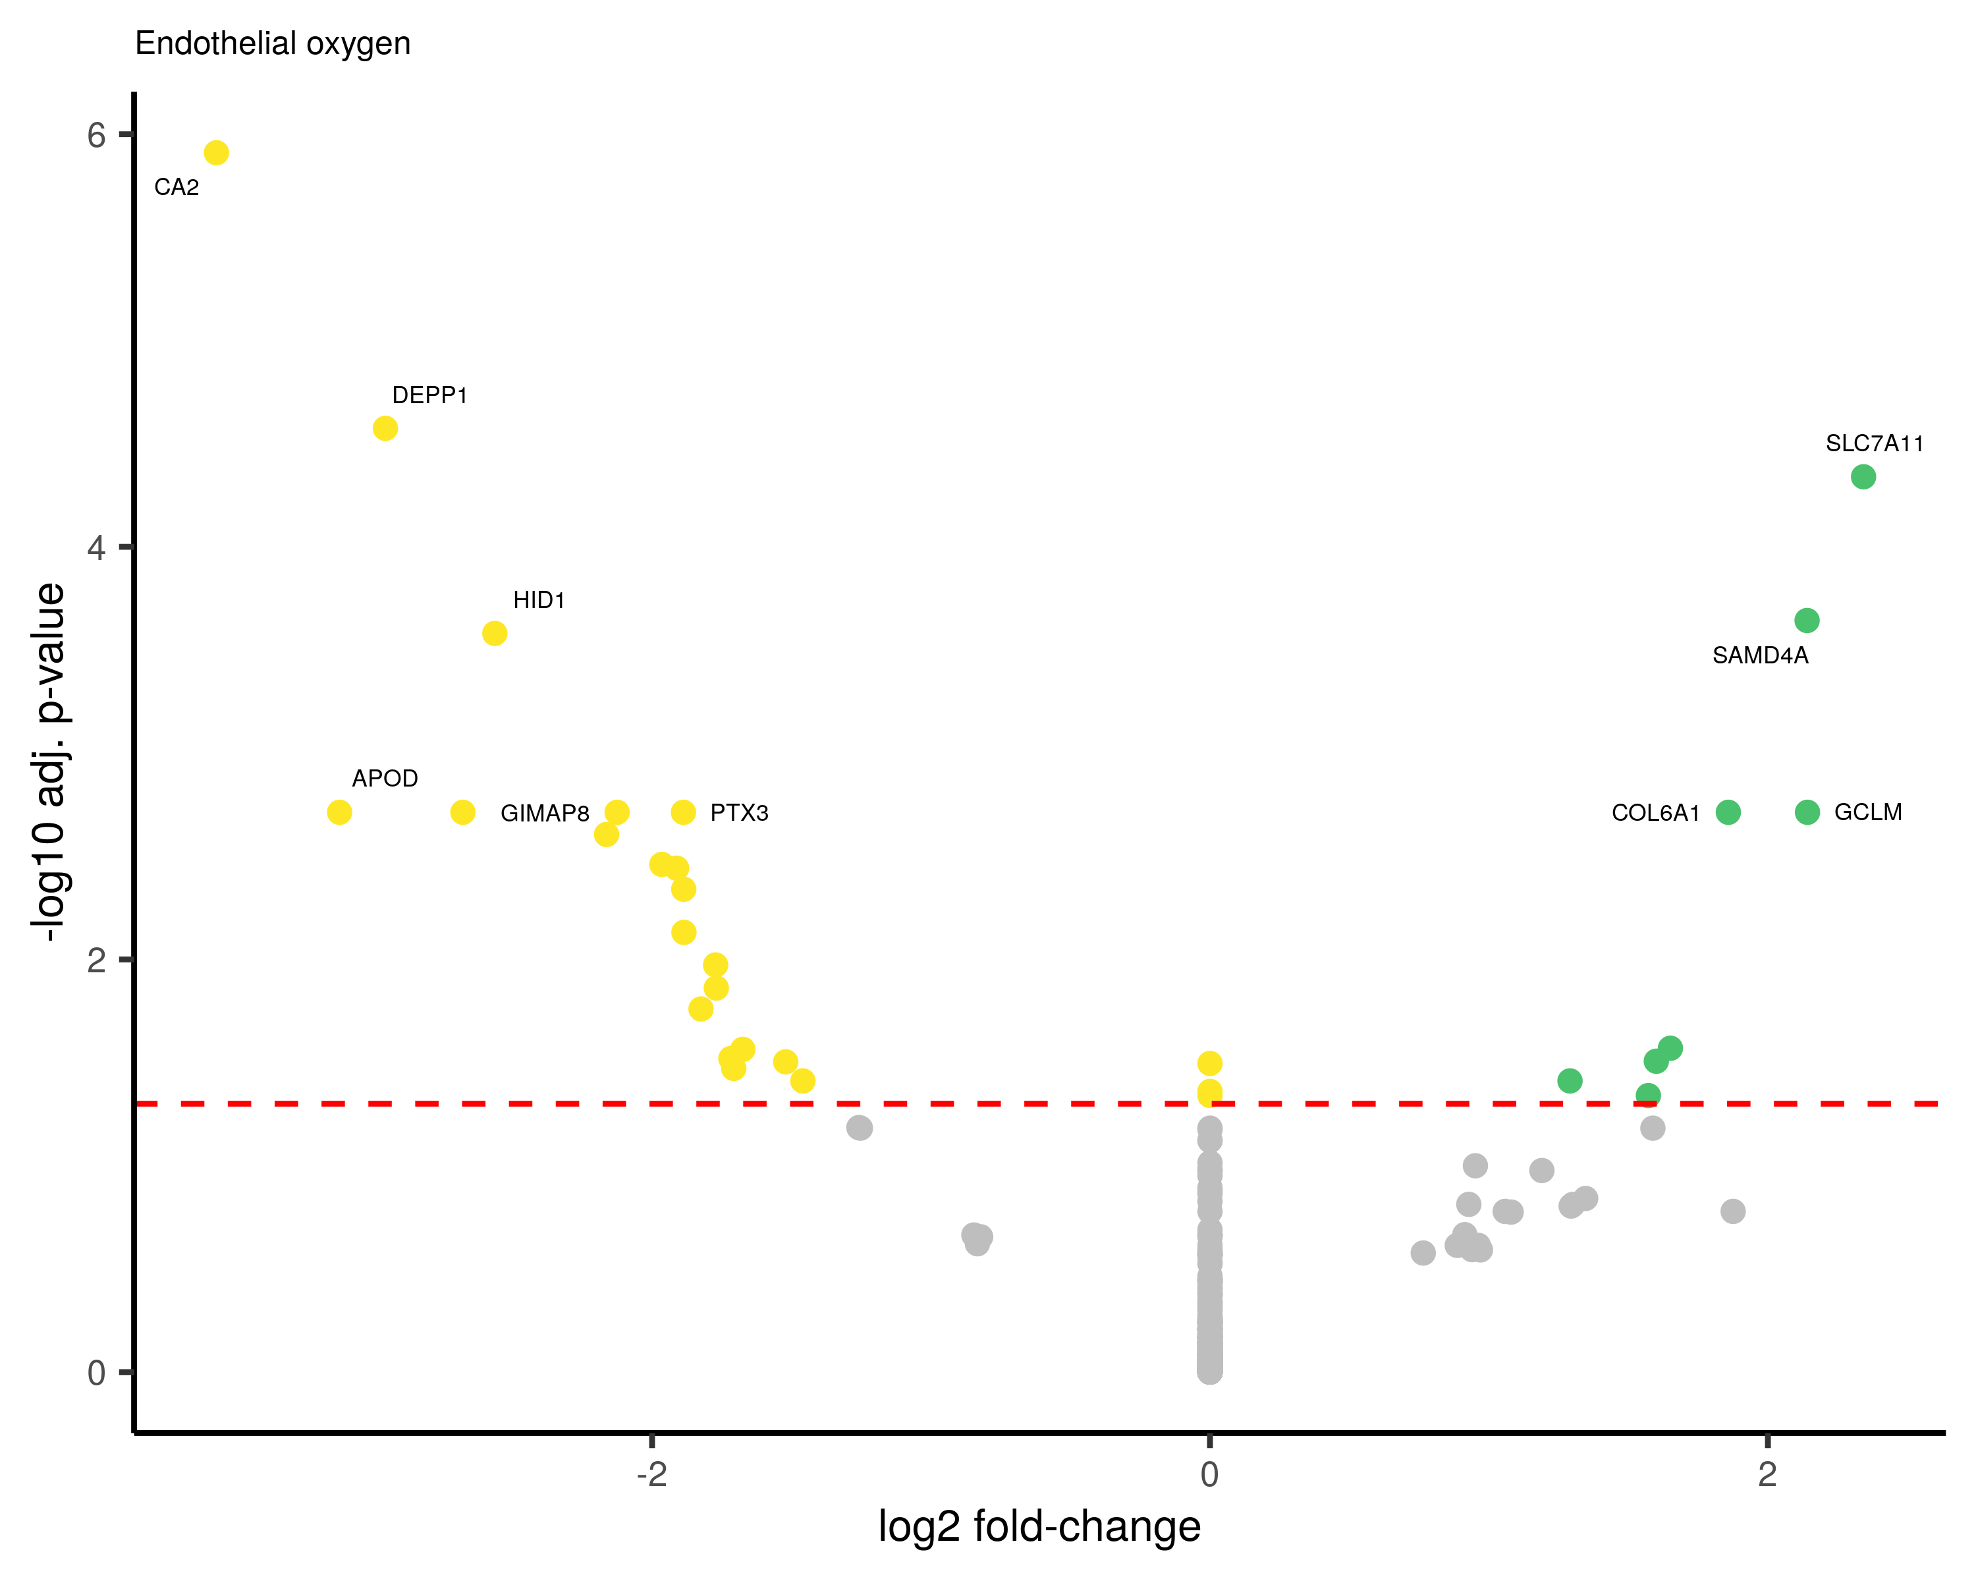

# Session info

sessionInfo()

R version 4.2.3 (2023-03-15)  
Platform: x86_64-pc-linux-gnu (64-bit)  
Running under: Ubuntu 22.04.4 LTS  
  
Matrix products: default  
BLAS: /usr/lib/x86_64-linux-gnu/openblas-pthread/libblas.so.3  
LAPACK: /usr/lib/x86_64-linux-gnu/openblas-pthread/libopenblasp-r0.3.20.so  
  
locale:  
 [1] LC_CTYPE=en_US.UTF-8 LC_NUMERIC=C   
 [3] LC_TIME=en_US.UTF-8 LC_COLLATE=en_US.UTF-8   
 [5] LC_MONETARY=en_US.UTF-8 LC_MESSAGES=en_US.UTF-8   
 [7] LC_PAPER=en_US.UTF-8 LC_NAME=C   
 [9] LC_ADDRESS=C LC_TELEPHONE=C   
[11] LC_MEASUREMENT=en_US.UTF-8 LC_IDENTIFICATION=C   
  
attached base packages:  
[1] stats4 stats graphics grDevices utils datasets methods   
[8] base   
  
other attached packages:  
 [1] dplyr_1.1.1 openxlsx_4.2.5.2   
 [3] gprofiler2_0.2.1 ggrepel_0.9.3   
 [5] ggplot2_3.4.2 DESeq2_1.36.0   
 [7] SummarizedExperiment_1.26.1 Biobase_2.56.0   
 [9] MatrixGenerics_1.8.1 matrixStats_0.63.0   
[11] GenomicRanges_1.48.0 GenomeInfoDb_1.32.4   
[13] IRanges_2.30.1 S4Vectors_0.34.0   
[15] BiocGenerics_0.42.0   
  
loaded via a namespace (and not attached):  
 [1] bitops_1.0-7 bit64_4.0.5 RColorBrewer_1.1-3   
 [4] httr_1.4.5 numDeriv_2016.8-1.1 tools_4.2.3   
 [7] utf8_1.2.3 R6_2.5.1 DBI_1.1.3   
[10] lazyeval_0.2.2 colorspace_2.1-0 apeglm_1.27.0   
[13] withr_2.5.0 tidyselect_1.2.0 bit_4.0.5   
[16] compiler_4.2.3 cli_3.6.1 DelayedArray_0.22.0   
[19] plotly_4.10.1 labeling_0.4.2 scales_1.2.1   
[22] mvtnorm_1.1-3 genefilter_1.78.0 digest_0.6.31   
[25] rmarkdown_2.21 XVector_0.36.0 pkgconfig_2.0.3   
[28] htmltools_0.5.5 fastmap_1.1.1 bbmle_1.0.25   
[31] htmlwidgets_1.6.2 rlang_1.1.0 RSQLite_2.3.1   
[34] generics_0.1.3 farver_2.1.1 jsonlite_1.8.4   
[37] BiocParallel_1.30.4 zip_2.3.0 RCurl_1.98-1.12   
[40] magrittr_2.0.3 GenomeInfoDbData_1.2.8 Matrix_1.5-4   
[43] Rcpp_1.0.10 munsell_0.5.0 fansi_1.0.4   
[46] lifecycle_1.0.3 stringi_1.7.12 yaml_2.3.7   
[49] MASS_7.3-58.3 zlibbioc_1.42.0 plyr_1.8.8   
[52] grid_4.2.3 blob_1.2.4 parallel_4.2.3   
[55] bdsmatrix_1.3-6 crayon_1.5.2 lattice_0.21-8   
[58] Biostrings_2.64.1 splines_4.2.3 annotate_1.74.0   
[61] KEGGREST_1.36.3 locfit_1.5-9.7 knitr_1.42   
[64] pillar_1.9.0 geneplotter_1.74.0 codetools_0.2-19   
[67] XML_3.99-0.14 glue_1.6.2 evaluate_0.20   
[70] data.table_1.14.8 png_0.1-8 vctrs_0.6.2   
[73] gtable_0.3.3 purrr_1.0.1 tidyr_1.3.0   
[76] cachem_1.0.7 emdbook_1.3.12 xfun_0.38   
[79] xtable_1.8-4 coda_0.19-4 survival_3.5-5   
[82] viridisLite_0.4.1 tibble_3.2.1 AnnotationDbi_1.58.0   
[85] memoise_2.0.1