Jack Hickey
20336645
Submitted 5 November 2025

GitHub repository: https://github.com/jdhickey/cisc327-library-management-a2-6645

- Stubbing vs. Mocking
Stubbing is creating small snippets of code which provide hard-coded values for the purpose of testing how a function behaves when interacting with external modules. In a stub, values are hard-coded to facilitate testing the interactions of other parts of the function. Mocking is more like a customized version of an external module. In a mock, specific behaviours can be specified/overridden for the purposes of testing without significantly impacting the overall behaviour of a module.

The functions that I stubbed were calculate_late_fees_for_book and get_book_by_id. These are both functions which the payment processing system interacts with from the main library_service.py file. But they both reference the book database which is not convenient to interact with for testing purposes. So it is more straightforward to substitute stubs for both to ensure consistent input for the parts of the payment functions which typically use database information.

The functions that I mocked were process_payment and refund_payment. These are both functions part of the gateway API. In order to properly test the internal logic of the gateway handler, functions which would normally connect to external services need to be substituted. Mocking these behaviours leaves the rest of the PaymentGateway logic unaffected, closely simulating actual runtime behaviour.

- Test Execution Instructions
python3 -m venv venv
source venc/bin/activate
pip install -r requirements.txt

export PYTHONPATH=$PYTHONPATH:$(pwd) (fixed error where pytest could not find files)

pytest tests/
pytest --cov=services --cov-report=term --cov-report=html tests/

- Test Cases Summary for New Tests
Function | Purpose | Stubs | Mocks | Verification
test_add_6 | Test book addition fails if author name too long | N/A | N/A | success==False
test_fees_6 | Test overdue book for less than 7 days | conn_execute_read | N/A | days_overdue, fee_amount, status
test_pay_late_fees_1 | Successful late fee payment | calculate_late_fee_for_book, get_book_by_id | PaymentGateway.process_payment | assert_called_once,, assert_called_with, success—True, transaction ID
test_pay_late_fees_2 | Payment declined by gateway | calculate_late_fee_for_book, get_book_by_id | PaymentGateway.process_payment | assert_called_once, success==False, txn==None, message contains “declined”
test_pay_late_fees_3 | Invalid Patron ID | calculate_late_fee_for_book, get_book_by_id | PaymentGateway | assert_not_called, success==False, message contains “invalid”
test_pay_late_fees_4 | No late fees to pay | calculate_late_fee_for_book, get_book_by_id | PaymentGateway | assert_not_called, success==False, txn==None, message contains “no late fees”
test_pay_late_fees_5 | Exception during payment processing | calculate_late_fee_for_book, get_book_by_id | PaymentGateway.process_payment | assert_not_called, success==False, message contains “error”
test_refund_late_fee_1 | Successful refund | N/A | PaymentGateway.refund_payment | assert_called_once_with, success==True, message contains “refund”
test_refund_late_fee_2 | Invalid transaction ID | N/A | PaymentGateway | assert_not_called, success==False, message contains “invalid”
test_refund_late_fee_3 | Invalid refund amount (negative) | N/A | PaymentGateway | assert_not_called, success==False, message contains “’greater”
test_refund_late_fee_4 | Invalid refund amount (exceeds maximum) | N/A | PaymentGateway | assert_not_called, success==False, message contains “exceeds”
test_refund_late_fee_5 | Exception during refund processing | N/A | PaymentGateway.refund_payment | assert_called_once_with, success==False, message contains “processing error”

- Coverage Analysis
The total coverage from before adding new tests for the payment_service module was 72%, which is a marginal decrease from the coverage rate of 93% I had from A2.
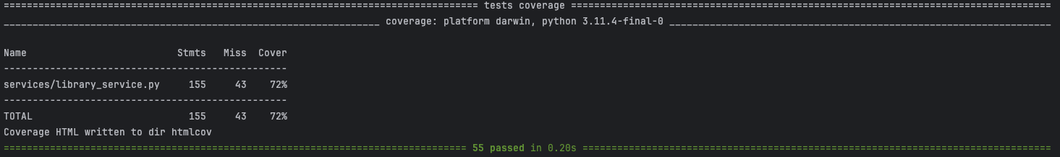

After adding tests for the new module, the total coverage was 80%.
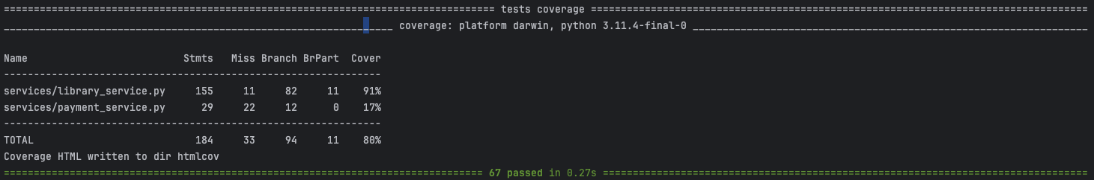
The reason for the decrease in coverage from A2 is that because payment_service is being mocked, almost none of it is actually being covered in testing.

The approximate statement coverage is 84%, and the approximate branch coverage is around 82%. The main code paths which were left uncovered correspond to errors which would normally be caused by database malfunctions or other information processing errors. Other than this, the few uncovered areas were input validation branches (e.g. rejecting an author with a name over 100 characters.

- Challenges and Solutions
During the development of unit tests for pay_late_fees and refund_late_fee_payment, I ran into several challenges. At first, I did not fully understand when the mock_gateway should be called or not, and what I should assert in specific cases. I had to carefully review the internal logic of the payment system to understand when it would reach the mock or not. I ran into similar issues with making assertions about result messages and raising exceptions for both functions. In particular, I dealt with a lot of subtle spelling mistakes, naming convention issues, and syntax errors which made it frustrating to repeatedly test. Luckily the content pipeline from A2 that we set up with GitHub made it so I did not have to manually run them every time I made a change to my code.

- Screenshots
