**Visual Basic Links**

**Savanah**

Don’t repeat code.

For example:

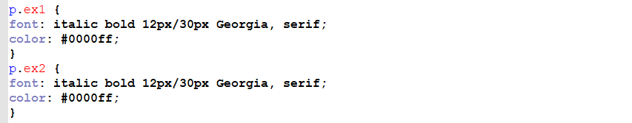

You will accomplish the very same outcome with this code:

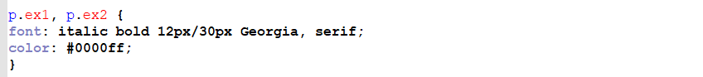

[**https://code.visualstudio.com/docs**](https://code.visualstudio.com/docs)

Watch the Introductory Videos on Visual Studio Code from Microsoft here:

[**https://code.visualstudio.com/docs/getstarted/introvideos**](https://code.visualstudio.com/docs/getstarted/introvideos)

Set up the appearance of Visual Studio Code the way you’d like it.

OPTIONAL RESOURCE – review this web page:

[**https://code.visualstudio.com/docs/getstarted/themes**](https://code.visualstudio.com/docs/getstarted/themes)

**CHALLENGE**

Write and execute a command-line command (console command) within Visual Studio Code from the Integrated Terminal.

RESOURCES:

I. Integrated Terminal in Visual Studio Code:

[**https://code.visualstudio.com/docs/editor/integrated-terminal**](https://code.visualstudio.com/docs/editor/integrated-terminal)

II. Command Line Interface (CLI)

[**https://code.visualstudio.com/docs/editor/command-line**](https://code.visualstudio.com/docs/editor/command-line)

**HTML IN VISUAL STUDIO CODE**

Review Microsoft’s documentation on using HTML in Visual Studio Code here:

[**https://code.visualstudio.com/docs/languages/html**](https://code.visualstudio.com/docs/languages/html)

**Command palette:** If you press “CTRL + P” at any time you will see a dropdown at the top of the page called the Command palette where you can type commands.

7. Open the terminal panel (click on “Terminal” and then New Terminal, or press CTRL + ` [this symbol is called a “backtick” and is to the left of “1” on most keyboards])

**LIVE SHARE**

Review Microsoft’s documentation on Live Share:

[**https://visualstudio.microsoft.com/services/live-share/**](https://visualstudio.microsoft.com/services/live-share/)

**GITHUB ASSIGNMENT**

1. Sign in to your personal GitHub account.

2. Download and install GitHub Desktop:

[**https://desktop.github.com/**](https://desktop.github.com/)

3. Visit The Tech Academy’s GitHub repository:

[**https://github.com/the-tech-academy/virtual_dr**](https://github.com/the-tech-academy/virtual_dr)

4. In the top right corner of the screen click on the “Fork” icon (if it has you sign in again, click on “Fork” again).

5. Click “Clone or download” and then click “Open in Desktop”.

6. Inside GitHub Desktop, click “Clone”.

7. Click “Open in Visual Studio Code”.

8. In the activity bar (left side of the screen), the project files are displayed. Click on the HTML file (virtual_dr.html).

9. Scroll down through the code and locate the <h3> tag that contains the statement “COMING SOON for the following mobile platforms!”. Change the statement to “AVAILABLE NOW for the following mobile platforms!”.

10. Save the file.

11. Return to GitHub Desktop, view your changes and click Commit to master, then click Push origin.

12. Return to The Tech Academy’s online GitHub repository (https://github.com/the-tech-academy/virtual_dr) and click “New pull request”. You’ll need to click the hyperlink to “compare across forks” (under the heading Compare changes).

13. Change the “Head Repository” to your fork of the repository (typically named yourusername/virtual_dr).

14. Add any comments needed and click the green button to create your pull request.

**VISIBILITY**

The CSS visibility property specifies whether or not an element is visible.

Values, such as visible and hidden, are used with it to direct the browser to display (or not display) the element to the user.

For example:

https://techacademystorage.blob.core.windows.net/htmlandcss/visibility.PNG

applied to an element will hide it from view. Whereas,

https://techacademystorage.blob.core.windows.net/htmlandcss/visibility2.PNG

will ensure it is displayed.

https://techacademystorage.blob.core.windows.net/htmlandcss/class_id2.PNG

We would display this using the z-index property as follows:

