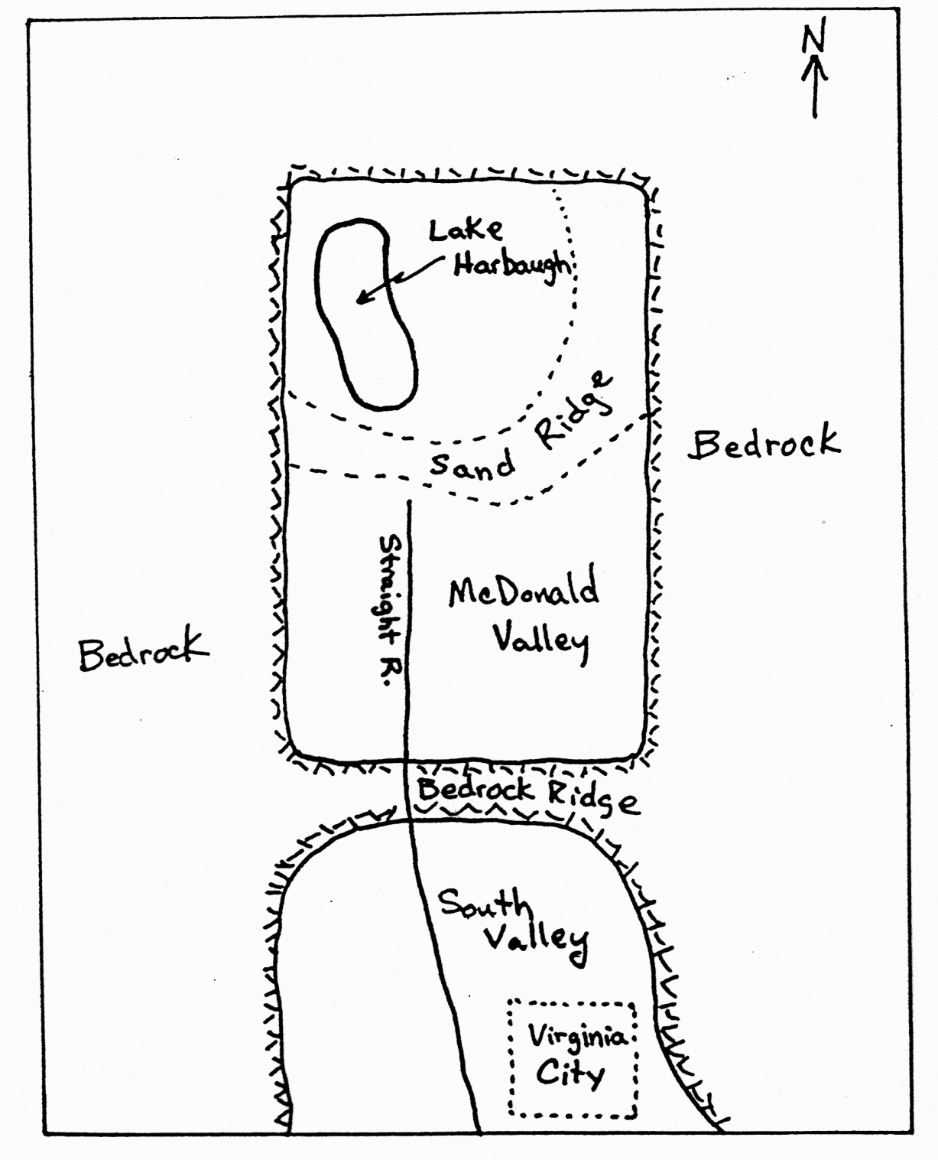

Figure 1 – Regional Map

Figure 2 – Topographic Map of McDonald Valley

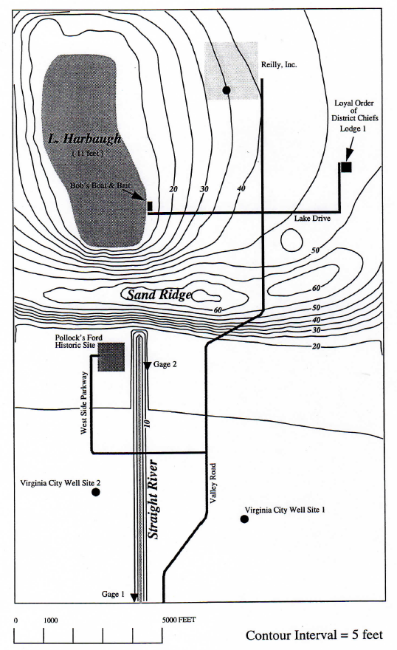

Lake

Harbaugh

L & H Lounge

