Problem Set 1

**Steady-State Flow with Constant Head Boundaries**

# Introduction

The flow system is in a valley which is 10,000 ft wide and 10,500 feet long. There is an unconfined upper sand aquifer and a lower sand aquifer which are separated by a fine-grained silt that acts as a confining layer for the lower aquifer. The flow system is bounded on all sides and its bottom by impermeable bedrock. At the eastern boundary there is a river, with a stage or 320 ft, which flows south. On the western boundary there is a canal, with a stage of 330 ft.

In the upper aquifer, the horizontal conductivity in both the x and y directions is 50 ft/d, the vertical conductivity is 10 ft/d. The bottom of the upper aquifer is at an elevation of 220 ft. The top is at land surface, which can be specified as 400 ft.

In the silt unit, the horizontal and vertical conductivity is 0.01 ft/d. The bottom of the silt layer is at 200 ft.

In the lower aquifer the horizontal conductivity in both the x and y directions is 200 ft/d, the vertical conductivity is 20 ft/d. The bottom of the lower layer is at 0 ft.

Simulate groundwater flow as a steady-state flow system. Use 3 layers, 21 rows and 20 columns with a uniform horizontal grid spacing of 500 feet in each direction. The upper aquifer is represented by layer 1, the silt is represented by layer 2, and the lower aquifer is represented by layer 3. The northern and southern boundaries and the bottom of aquifer 2 are no flow boundaries. The eastern and western boundaries will be constant head boundaries representing the river and the canal. The head in the river is 320 ft the head in the canal is 330 ft.

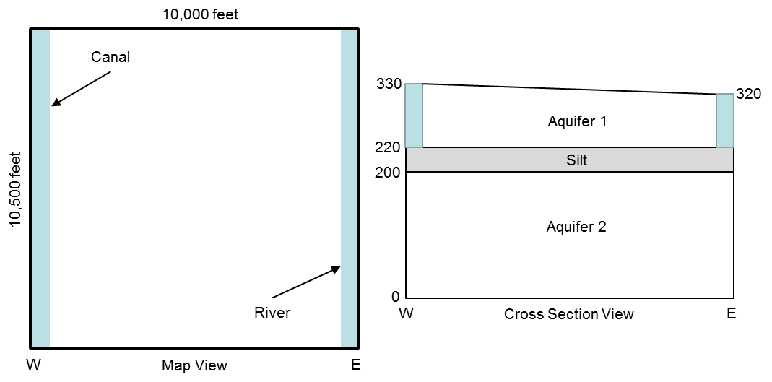

# Base Run – PS1A

Create the data files for the base run of this problem set in the directory PS1A that has been created for you. The following data files are needed for this problem:

* mfsim.nam – MODFLOW simulation name file
* ps1.nam – Groundwater flow process (GWF) name file
* ps1.dis – Spatial discretization package (DIS) file
* ps1.tdis – Time discretization (TDIS) package file
* ps1.ims – Iterative model solver (IMS) package file
* ps1.ic – Initial conditions (IC) package file
* ps1.chd – Constant head (CHD) package file
* ps1.npf – Node property flow (NPF) package file

We will work as a group to create this first dataset. When your dataset is complete, run MODFLOW and examine the output in the MODFLOW listing files, ps1.lst and mfsim.lst.

Before we go any further, we need to make some changes to the MODFLOW data to allow us to use a post-processing graphics display program, HeadViewer, to look at plots of the head output. We also will increase the precision of the head output in the MODFLOW listing files so that we can make some hand calculations of key flow terms in the model. Those changes require the addition of another data file, the output control file. We will discuss how to create the output control file as a group.

When you have created the output control file with the necessary input to save head and increase the head printout precision, run MODFLOW again use your output to answer the questions listed below. But, before we go on the exercises, we will use the output from your new run to look at how to use the HeadViewer post-processor to help examine the MODFLOW output.

Exercise 1:

Using the water budget summary in the MODFLOW listing file, what is the total volumetric rate of flow leaving the canal and the total volumetric rate of flow entering the river?

For comparison, use Darcy’s Law and the head output in the listing file to compute the total flow rate out of the canal and into the river. Calculate the flow from one canal cell and multiply by 21 rows to get the total flow. To simplify your calculations, use the average saturated thickness between columns 1 and 2 for the horizontal flow calculation. For the vertical flow calculation, assume that all of the head difference between the canal and the node in layer 2 occurs within the confining layer between the bottom of layer 1 and the node in layer 2. How do these flow rates compare with those determined from the MODFLOW water budget summary?

Exercise 2:

Between which two columns does the flow between layer 1 and layer 2 change from downward to upward?

Exercise 3:

What are the total volumetric rates of flow from column 10 to column 11 in each of the three model layers. Use Darcy’s Law and the head output from the MODFLOW listing file to make these calculations.

|  |  |  |  |  |  |
| --- | --- | --- | --- | --- | --- |
|  | h10 | h11 | h (h11 – h10) | b layer thickness | Q (all 21 rows) |
| Layer 1 |  |  |  |  |  |
| Layer 2 |  |  |  |  |  |
| Layer 3 |  |  |  |  |  |

Exercise 4:

What is the total volumetric rate of flow downward across the top of layer 3 for columns 1 through 10? What is the total volumetric rate for flow upward across the top of layer 3 for columns 11 through 20?

HINT: Use a simple water balance equation and the information from your answers to the previous exercises. Show your results on the schematic cross section below.

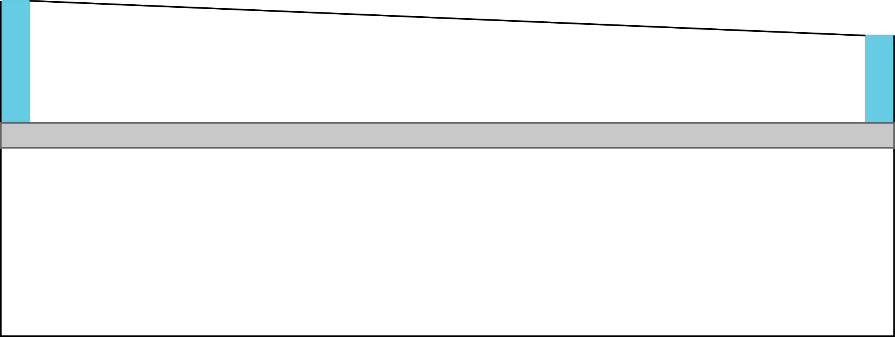

Explain how you could use Darcy’s law as an alternative approach for calculating the total downward and upward flow rates described above. You do not actually need to actually make the calculations, just describe how you would do it.

# Additional Runs – PS1B, PS1C, PS1D, and PS1E

Each of these runs is a modification of the base case dataset, PS1A. In each case, use the data files from problem set PS1A as the starting point by copying the files from directory PS1A into the sub-problem directories that have been created for you (PS1B, PS1C, PS1D, and PS1E).

PS1B

Copy all of the files from directory PS1A into directory PS1B and work in directory PS1B. Double all of the hydraulic conductivity values (vertical and horizontal) in both aquifers and the confining layer, and run the simulation again. How much water is leaving the canal? What is the effect on head distribution?

PS1C

Copy all of the files from directory PS1A into directory PS1C and work in directory PS1C. Reduce the vertical and horizontal hydraulic conductivity of the silt to 0.0001 ft/d. Run MODFLOW and observe the effect on the heads and flow rates in each layer? Calculate the rate of flow between column 10 and column 11 for layer 1 and layer 3.

PS1D

Copy all of the files from directory PS1A into directory PS1C and work in directory PS1D. Simulate a hole in the silt (layer 2) by setting the horizontal and vertical hydraulic conductivity for a rectangular block of cells in layer 2 extending from (row 9, column 5) to ( row 13, column 15) equal to the hydraulic conductivity values used for layer 1. Summarize the effect of the discontinuous silt on the groundwater flow pattern.

HINT: You will need to read arrays of horizontal and vertical hydraulic conductivity values for layer 2 instead of simple constant values.

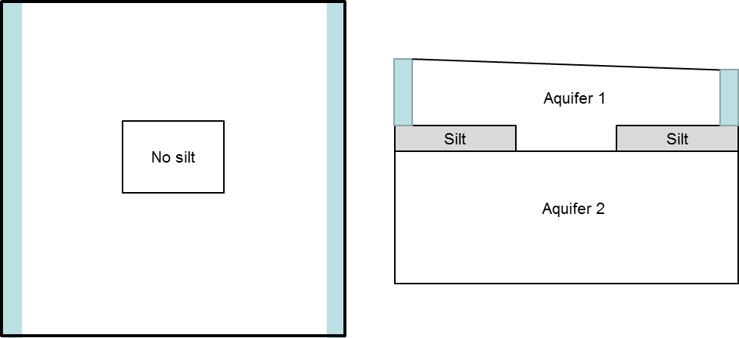

PS1E

Copy all of the files from directory PS1A into directory PS1E and work in directory PS1E. Simulate the hole in the silt a different way by using an IDOMAIN array for layer 2 to indicate that layer 2 is missing in the region of the hole. To do that, set IDOMAIN for layer 2 equal to -1 in the cells that correspond to the hole and equal to 1 elsewhere. Also change the bottom elevation for layer 1 so that the elevation is equal to 200 feet in the region of the hole, which corresponds to the top elevation of layer 3. Run the simulation and compare the results with those of problem PS1D.