**Problem Set 2**

**Introduction to Stress Packages**

This problem set introduces the use of stress package features. The groundwater flow system is similar to the base case in problem set 1 (PS1A), except the canal on the left side has been removed and areal recharge has been added to layer 1 as the new source of water for the system. The recharge rate is 0.005 foot/day.

The problem set consists of 5 major parts (A, B, C, D, and E). Part A introduces the use of the recharge package. Parts B, C, and D demonstrate the river, drain, general-head boundary, and well packages. Part E introduces transient flow simulation using multiple stress periods. This problem consists of a total of 7 MODFLOW runs. As with problem 1, each MODFLOW run requires a separate folder. The empty folder have been provided for you. Each run builds on a previous run.

Part A – The Recharge Package

1. Run PS2A builds off of run PS1A from problem 1. To be sure everyone starts with the same dataset, a completed copy of dataset PS1A is provided for you in the folder named “Initial”. Note that the dataset file names have been renamed with the “PS2” root name. To begin work on problem PS2A, copy all of the files in the “Initial” folder into the “PS2A” folder.
2. Be sure you are working on the files in the PS2A folder, then make whatever changes are required to remove the canal and add recharge.
3. Run MODFLOW by double-clicking the batch file named “runmf6.bat”. Examine the MODFLOW listing file, ps2.lst, to check the status of the run. Once you have a successful run, complete the exercises below.

Exercise 1:

Multiply the recharge rate you used by the model area. Does the recharge in the budget match the recharge that you thought that you had applied?

Exercise 2:

How much water is going into the river?

Exercise 3:

How is the head distribution in this simulation different from that in problem set 1? What causes the difference?

Exercise 4:

Between which two columns does the flow switch from downward across the bottom of layer 1 to upward across the bottom of layer 1?

Exercise 5:

For each of the three model layers, calculate the total volumetric rates of flow between the two columns you identified above in exercise 4. To simplify the computation for layer 1, use the arithmetic average of the heads in the left and right cells to compute the thickness (b) at the cell face. Round the computed values of Q to the nearest whole number.

|  |  |  |  |  |  |
| --- | --- | --- | --- | --- | --- |
|  | hleft | hright | h  hright - hleft | b  thickness | Q  (all 21 rows) |
| Layer 1 |  |  |  |  |  |
| Layer 2 |  |  |  |  |  |
| Layer 3 |  |  |  |  |  |

Exercise 6:

Copy all of the files from folder PS2A into folder PS2A1. Double all the vertical and horizontal hydraulic conductivity terms in all layers and then run MODFLOW. Describe the changes in the flow system.

Exercise 7:

Using the results from PS2A (the original run with the recharge package), do water budget calculations, for the 4 sub-regions in the idealized cross section shown below.

HINT: The horizontal boundaries between the zones are at the location where flow between layer 1 and layer 2 switches from downward to upward. So, the horizontal flows at those locations are the flows you calculated in exercise 5. You also know the recharge flows to zones 1 and 2 and the outflow to the river from the problem input. You could calculate the four vertical flows between model layers by summing up the Darcy’s law calculations for the individual cells corresponding to the zone boundaries. But, there is an easier way to estimate the vertical flows between layers by recognizing that the volumetric budget of each zone must balance. Start with zone 5 and estimate the flow down into zone 5 from zone 3. Then work your way through the other zones to estimate the remaining three vertical flows. When you are done, check the water balance for each of the 6 zones. The difference between the inflow and outflow for each zone should be very close to zero.

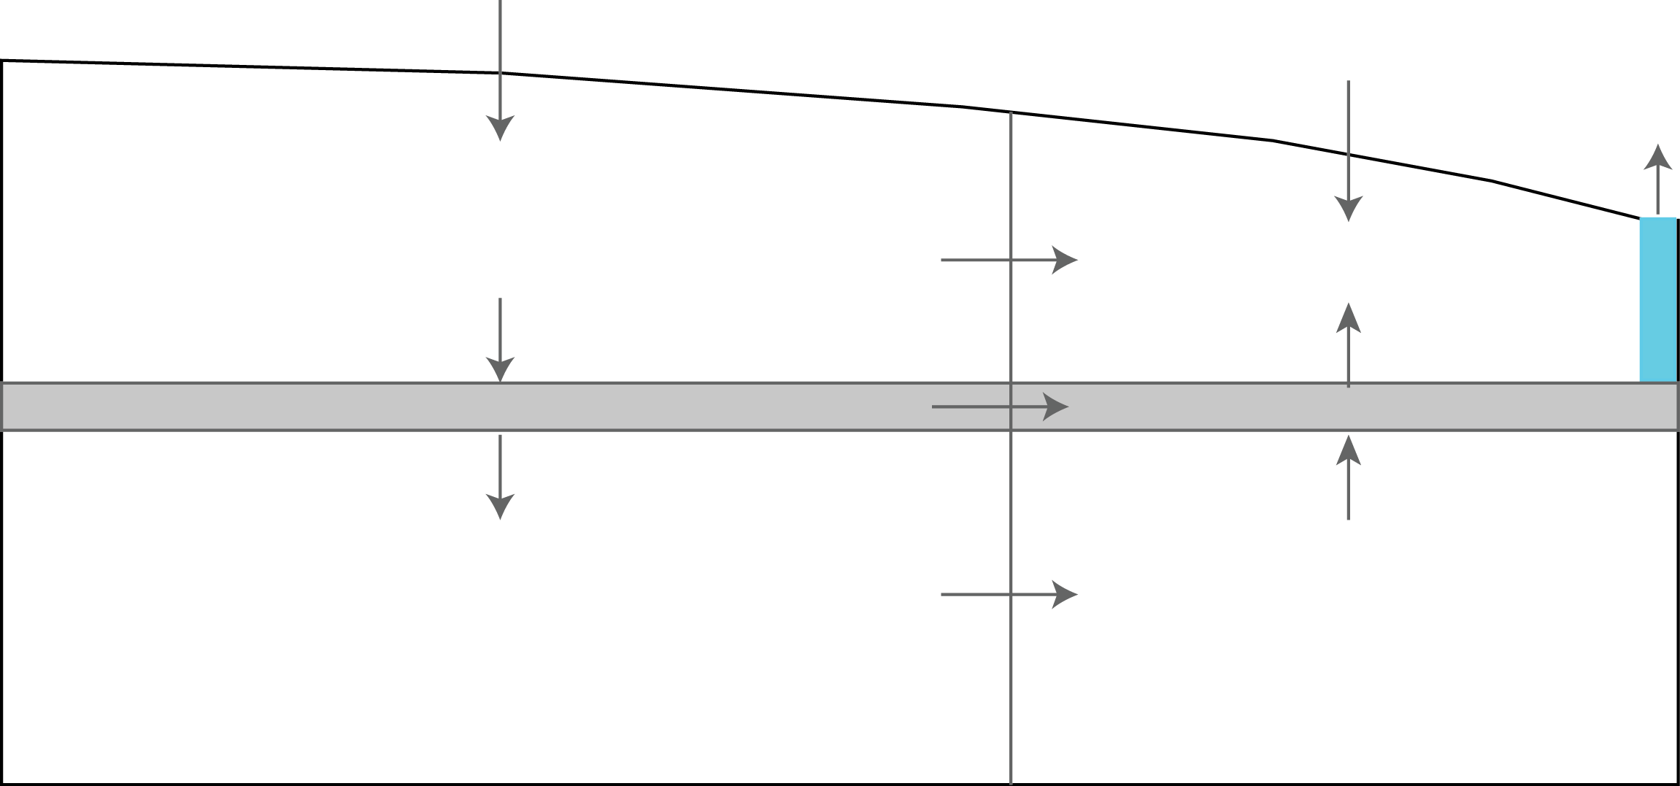

**Zone 1**

**Zone 3**

**Zone 5**

**Zone 2**

**Zone 4**

**Zone 6**

Exercise 8:

All of the water that enters the system comes from areal recharge. On the schematic cross section shown below, delineate the area at the water table in layer 1 that represents the source area for water that enters model layer 3.

**Hint**: Flow in the system is from left to right. The source area for layer 3 extends to the left edge of the system. You have enough water budget information to determine the width of the source area required to capture enough recharge to supply layer 3.

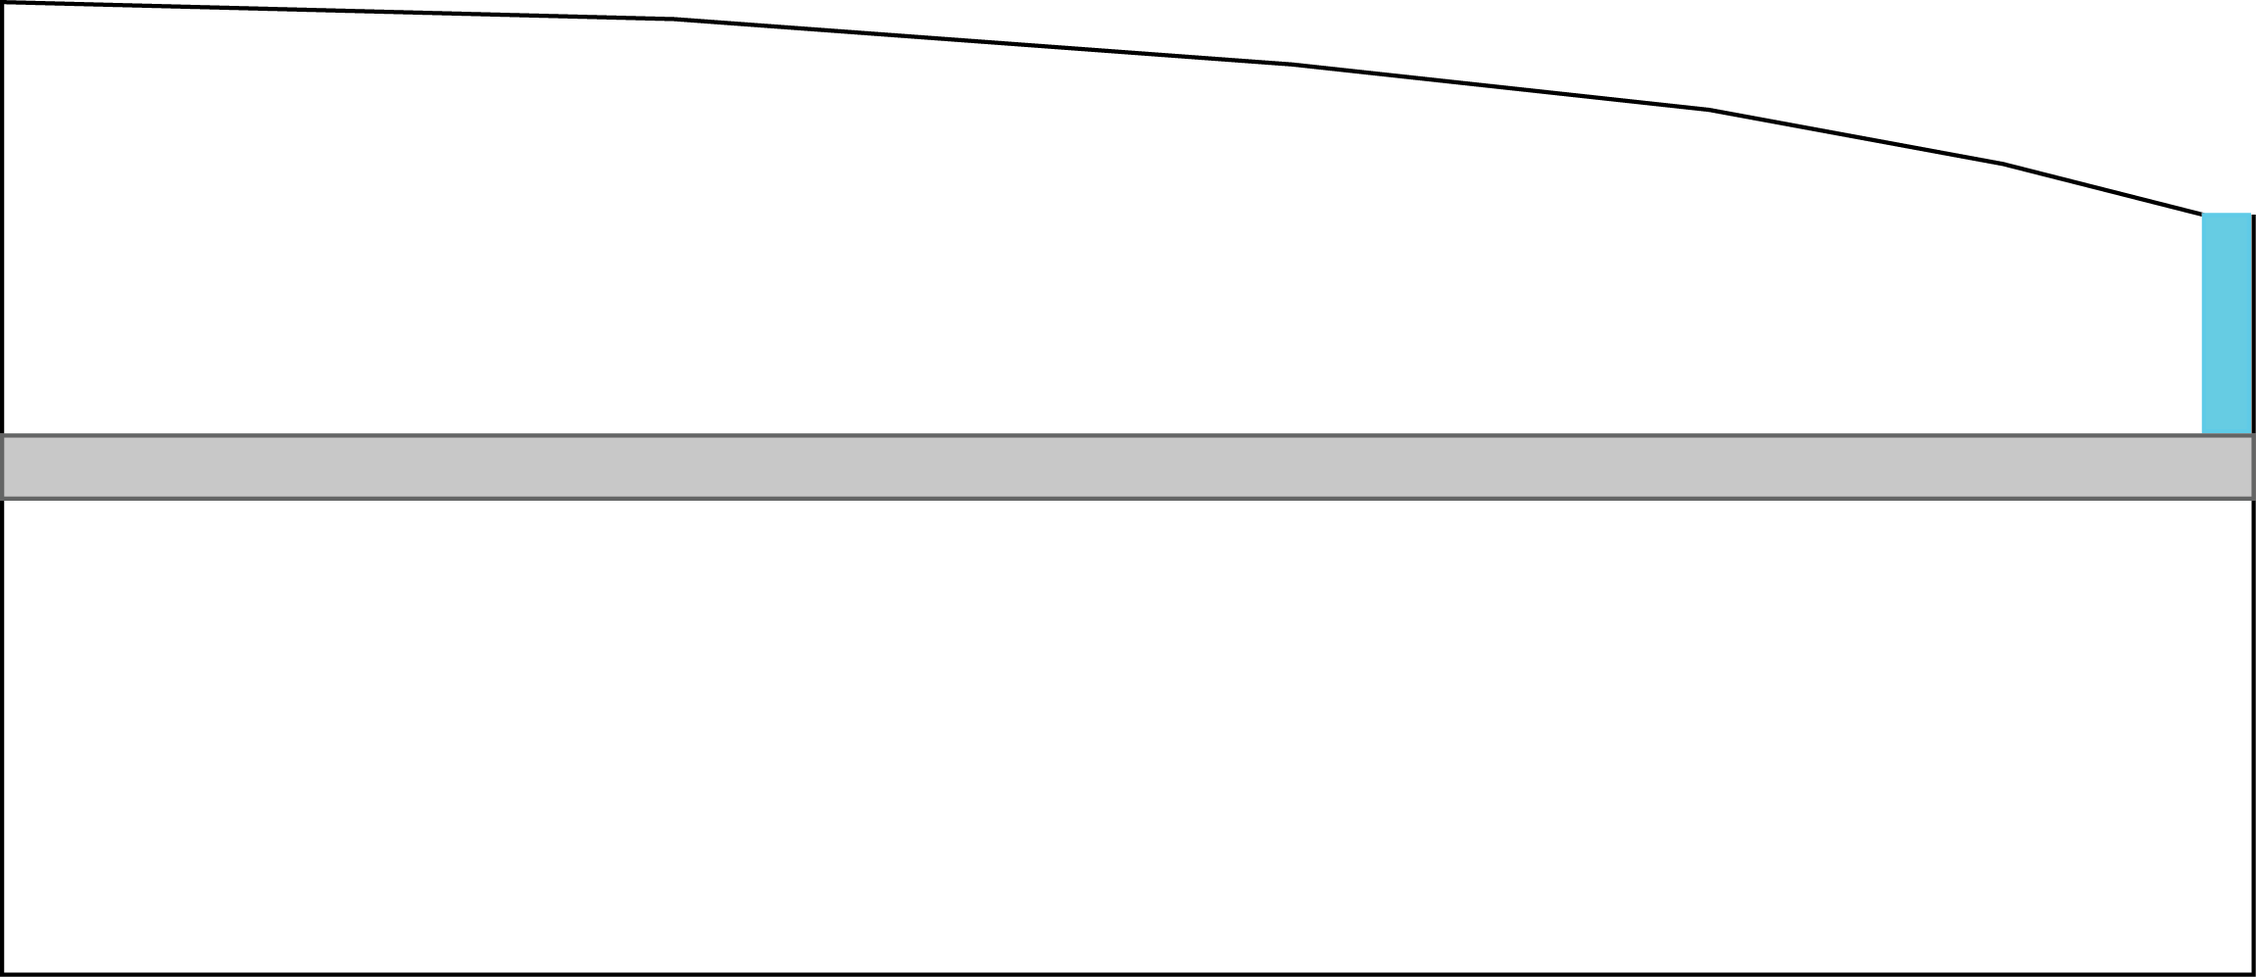

Part B – The River Package

This problem is the same as the problem PS2A except that the constant-head river on the east side of the grid is represented using the river package. The hydraulic conductivity of the river bed is 20 ft/d, and the width is 10 ft. The elevation of the river bed bottom is 317 ft. The riverbed is 1 ft thick. Follow these steps to make a simulation:

1. Use the original hydraulic properties from dataset PS2A. Copy all of the files in folder PS2A into folder PS2B.

2. Make whatever changes are required to simulate the river using the River Package.

3. Run MODFLOW.

Compare run PS2B with run PS2A and explain any differences.

Exercise 9:

Identify all of the inflow and outflow terms for cell 1, 1, 20 (layer, row, column). Compute the volumetric flow rate (Q) for each term and use them to calculate the water balance for the cell.

Part C – The Drain and General-Head Boundary Packages

This is the same as problem PS2B except that a buried drain tile,

simulated with the DRAIN package, is installed in row 15 in columns 10-20.

The conductance between the aquifer and the drain is 100,000 ft2/d, the

elevation of the drain is 322.5 ft. Follow these steps:

1.Start with problem PS2B and copy all of the files in folder PS2B into folder PS2C.

2.Make whatever changes are required to add the drain.

3.Run MODFLOW.

4.Examine the listing file to notice the impact that the drain has on water levels.

When you have a successful run, complete the following exercises:

Exercise 10:

Examine the drain discharge rates in the MODFLOW listing file (ps2.lst). Explain the difference in the drain discharge rate in cells (1, 15, 18) and (1, 15, 19)

Exercise 11:

Copy the files from PS2C into folder PS2C1. Make a new MODFLOW run in which you replace the drain with a general head boundary using the same head and conductance. Compare the drain and general head boundary discharge rates from the listing files for runs PS2C1 and PS2C. Explain any difference you observe.

Part D – The Well Package

This is the same as problem PS2C but with the addition of a well located in layer 1 at row 11, column 10. The discharge rate of the well is 75,000 ft3/d. Follow these steps:

1.Copy all of files from folder PS2C (which uses the drain package) into folder PS2D.

2.Make whatever changes are required to add the well.

3.Run the simulation

4.Examine the listing file to notice the impact that the well has on water levels.

When you have a successful run, complete the following exercise:

Exercise 12:

What is the change in the total volumetric rate of flow to the river in run PS2D compared with that of run PS2C? What is the change in the total volumetric rate of flow to the drain in run PS2D compared with that in run PS2C? Add the change in river discharge to the change in drain discharge and compare the sum to the well discharge rate. Record your results in the table below. Round the values to the nearest whole number.

|  |  |  |  |
| --- | --- | --- | --- |
| Flow Rate Out | PS2D | PS2C | PS2D – PS2C |
| River |  |  |  |
| Drain |  |  |  |
| Well | 75,000 | 0 | 75,000 |
|  |  |  | Sum = |

Part E – Transient Flow

Start with dataset PS2D, to create a new dataset named PS2E. We will convert the new dataset containing 3 stress periods. The first stress period is steady-state flow and is identical to the steady-state run for dataset PS2D. Stress period 2 is a transient stress period 36,500 days long. Stress period 2 contains an additional second pumping well in layer 3, row 13, column 5 that has a withdrawal rate of 100,000 ft3/d. Stress period 3 is another steady-state stress period that includes both wells pumping at the same rate as in stress period 2. Recharge rate and river stages stay the same throughout the entire simulation. Copy all of the files in folder PS2D to folder PS2E and make the following changes:

* Edit the time discretization package data file (TDIS) so that it has 3 stress periods with the following properties:  
    
  Period 1: length =300,000 days; 1 time step; multiplier = 1.0  
  Period 2: length = 36,500 days; 10 time steps; multiplier = 1.5  
  Period 3: length = 300,000 days; 1 time step, multiplier = 1.0
* Add the Storage package data file to the dataset. Storage properties were not needed for our previous steady-state simulation. Set specific yield = 0.1 and specific storage = 0.0001 for all cells. Set the ICONVERT property equal to 1 for all cells. Finally, set the steady-state/transient stress period style flags for each of the 3 stress periods.
* Edit the Well package data file to add the second pumping well to stress periods 2 and 3. Make any other changes that may be required for the Recharge and rRver package data files.

Exercise 13:

Examine the water budget print out in file PS2E.LST for each of the time steps in stress period 2. Describe how the (1) outflow to the river, (2) outflow to the drain, and (3) inflow from storage change from the first time step to the last time step in stress period 2. How are the changes in those three components over time related to one another?

Exercise 14:

How does the value of stress period length specified for steady-state stress periods 1 and 3 affect the results of the simulation?