**Class Information**

**GW2096 -- Modeling Groundwater Flow with MODFLOW**

**Dates: January 9-13, 2023**

Class starts 8:00 AM Monday and ends Friday, January 13 at 5:00 PM.

Please make sure to plan your travel appropriately.

**Classroom Location:**

San Diego State University (5500 Campanile Drive, San Diego CA 92182)

Chemical Science Laboratory Room 422 (CSL 422)

<http://www.myatlascms.com/map/index.php?id=801#!ct/12164,16202,16203,16235,16236,16748,17005,17006,12160>

<https://library.sdsu.edu/wayfinder/find.php>

**Lodging**:

Per Diem: $161 (hotel) $74 (meals)

A group rate has been reserved at:

[Best Western Plus Bayside Inn](https://www.bestwestern.com/en_US/book/san-diego/hotel-rooms/best-western-plus-bayside-inn/propertyCode.05362.html)

555 W Ash Street

San Diego, California 92101-3414

United States

***Please make your hotel reservation as soon as possible by clicking on the following link:

[USGS - BW Plus Bayside Inn reservation link](https://www.bestwestern.com/en_US/book/hotel-rooms.05362.html?groupId=B29TB5G7) (https://www.bestwestern.com/en_US/book/hotel-rooms.05362.html?groupId=B29TB5G7)

Click on the SELECT button in the window below:

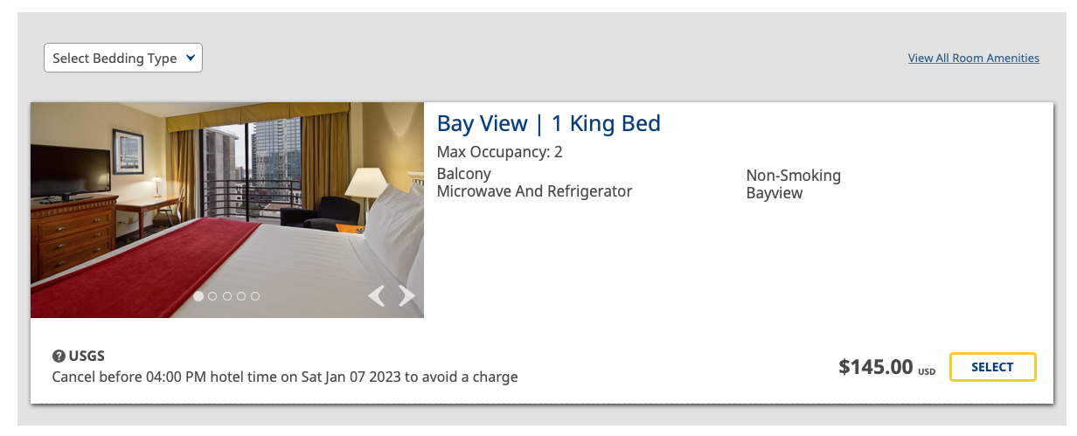

By default, the next page shows Saturday, January 07 to Saturday, January 14 as your stay duration.

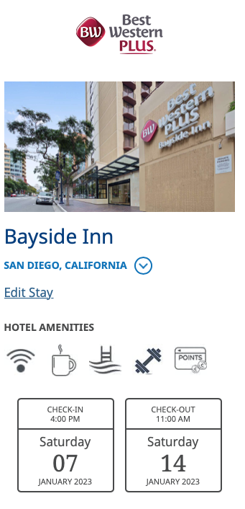

You will need to click “Edit Stay” to change the dates of your reservation. You will not be able to receive the group rate until Sunday, January 8. On the next page, after you click “Edit Stay”, you will need to manually change the check-in date to Sunday, January 8.

Continue filling out the form to complete your reservation.

**Transportation to and from hotel and classroom:** The hotel is the Best Western Plus Bayside in San Diego and is a few blocks from the trolley station. We’ve been told that the trolley ride is about 20 minutes to SDSU. The Little Italy Trolley Station is a few blocks from the Best Western Hotel. Take the blue/green line to SDSU.

