**GigaSpire Mesh Blast u4m Setup**

**Connect the Mesh BLAST u4m to your GigaSpire Router**

1. **Make sure that your existing GigaSpire Router is plugged in with active internet service.**
2. 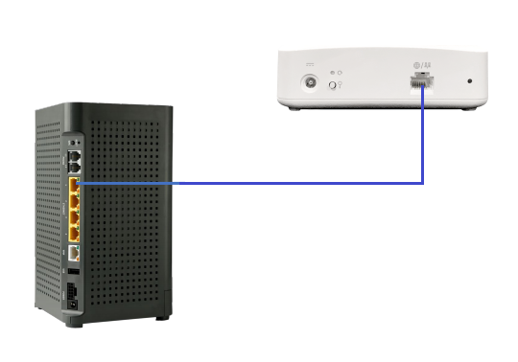**Plug one end of a cat5 cable into one of the yellow ethernet ports on the GigaSpire Router, and the other into the WAN port on the Mesh BLAST.**

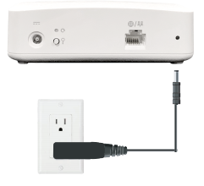

1. **Plug the Mesh BLAST to a power outlet.**
2. **Pairing will start automatically. This process can take up to 5 minutes. Pairing is complete when both units show a solid cyan color (light blue) light.**

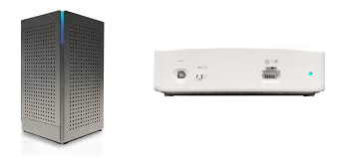

1. **Disconnect the Mesh BLAST from the GigaSpire and move it to a new location that is 1 to 2 rooms away.**
2. **Plug Mesh BLAST into power.**
3. 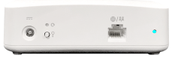**When the light on the back of the Mesh BLAST is solid blue again, the system is ready.**