**GigaSpire Initial Setup**

1. Connect computer to GigaSpire with default WiFi info on the bottom of the router or using an ethernet cable.
2. Open a web browser like Chrome, Edge, or Safari
3. Enter the IP Address **192.168.1.1** – This should take you to a Calix page asking for **Username & Password**
4. Enter the **User/Password** info from the bottom of the router and submit

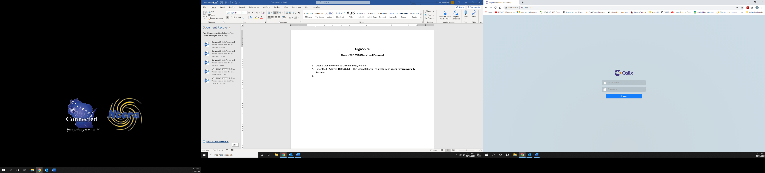

1. Verify Language and Time Zone are set and click Next

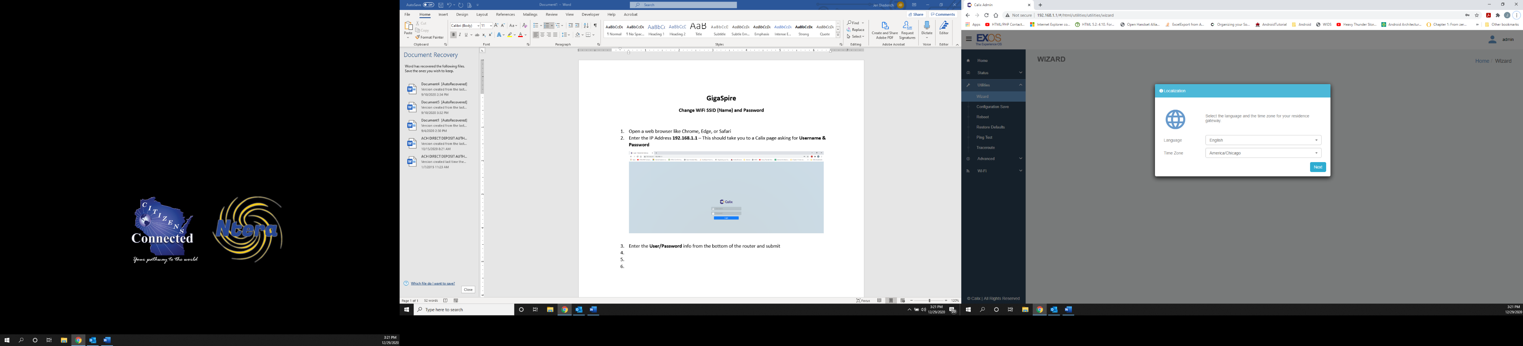

Change your **Admin Credentials**: You are changing the **User/Password** info from the bottom of the router that you used to login initially. You **MUST** change this info, so be sure to write it down somewhere safe.

1. Enter new admin **Password**
2. 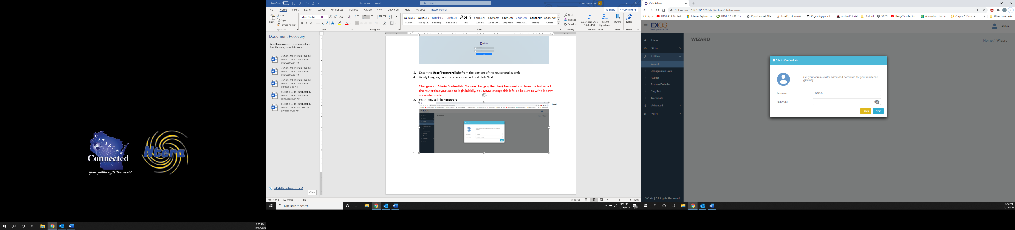Select **Next**
3. Make sure Wi-Fi is **ON**
4. **SSID Name:** Change this to whatever you want your network to be named. This is the name people will see when they connect to your WiFi
5. **Password:** Enter a new WiFi password
6. Click on **Next** to save changes.

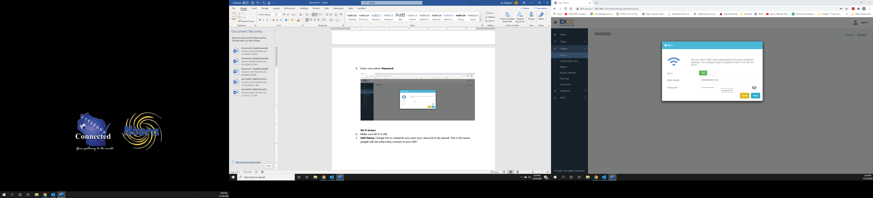

**If you were connected to your GigaSpire router wirelessly to begin with, you must reconnect using the new WiFi information you setup in the previous steps.**