Internet FAQ’s

# General Facts about Wi-Fi

**What is Wi-Fi?**

Wi-Fi, from the user's perspective, is just internet access from a wireless-capable device like a phone, tablet or laptop.

## **How does Wi-Fi Work?**

A Wi-Fi device is directly connected to an internet connection coming from outside the home or building via ethernet or coax cable. The Wi-Fi device then broadcasts a wireless signal using radio waves that other devices, like laptops, TV’s, and cell phones can connect to.

**Do you need a router to get internet?**

Yes and no. If you only want internet on one device, instead of using a router, you could connect directly to your service providers system device using an ethernet cable. In most cases however, that’s not going to be very useful. To enjoy the internet throughout the home and on multiple devices, a router or other Wi-Fi device is required.

**Does your router make a difference in your service?**

**YES!** At the center of traditional Wi-Fi networks is the **router or other Wi-Fi device**, which is the key piece of equipment that broadcasts the wireless signal. Router technology is changing as rapidly as the devices you connect to them, so what worked fine a year or two ago could now be suppressing your speed and coverage.

The type of router/Wi-Fi device also makes a difference. Older routers only use the 2.4 GHz radio frequency to send and receive data. This can be a problem as other electronics in your home also use that frequency. Microwaves, cordless home phones, wireless headsets, gaming devices, Bluetooth devices, and car alarms are just a few of the products that we use every day that utilize that same 2.4 GHz frequency. These devices cause congestion and can interfere with the Wi-Fi signal that your router sends out causing slow internet speeds and poor or dropped connections. Dual Band Routers use two frequencies to send and receive data: the 2.4 GHz and the 5 GHz bands. Having another frequency helps stop interference from other devices and helps alleviate a congested network.

The size of your home can also determine the effectiveness of your router. A traditional lower end single band router may not be strong enough to provide adequate coverage throughout your home. Higher end routers can send a stronger signal farther, and mesh systems provide multiple access points that can be placed throughout the home for greater coverage.

## Home Wi-Fi Devices:

There are two main types of home Wi-Fi devices. **Wireless routers** and **Mesh Systems**.

**Wireless routers** are a device that broadcast Wi-Fi signals from a single point and should be centralized in the home for best coverage.

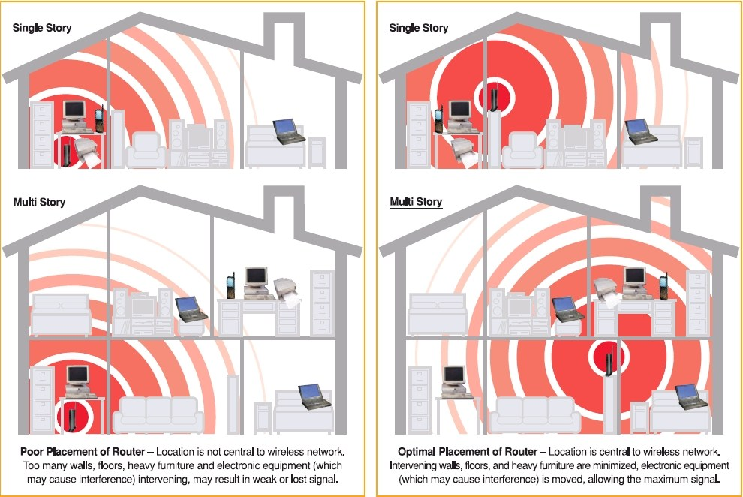

**Mesh Systems** have multiple access points, sometimes referred to as satellites or pucks, that are placed throughout the home to extend your Wi-Fi coverage.

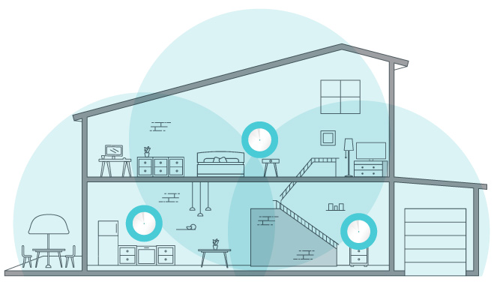

# Citizens Connected Routers

## Wi-Fi Router

TP-Link AC1200 Wireless Dual Band Gigabit Router – Archer C5 <https://service-provider.tp-link.com/wifi-router/archer-c5/#overview>

* + - * 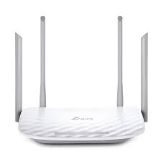Superfast dual band Wi-Fi, up to 1.2Gbps Wi-Fi speed, 300Mbps 2.4GHz, 867Mbps 5GHz
      * Easy Remote Management, TR-069 protocol enables an operator to remotely configure and manage end-user devices
      * 4 external antennas provide stable wireless connections and optimal coverage
      * Supports USB 2.0 port, easily share files & media with networked devices
      * Full Gigabit Ports, Support 1000Mbps WAN port and four 1000Mbps LAN port, for ultrafast data transfer speeds

Specifications

<https://service-provider.tp-link.com/wifi-router/archer-c5/#specifications>

## Mesh System (Whole home Wi-Fi System)

TP-Link AC1300 Home Wi-Fi System

<https://service-provider.tp-link.com/home-wifi-system/hc220-g1/#overview>

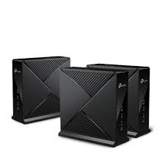

* Ultrafast Dual Band Wi-Fi
* Automatically Push Configuration
* Dynamic Self-Organizing Network
* Seamless Roaming
* AP Steering & Band Steering
* Easy Remote Management

Specifications

<https://service-provider.tp-link.com/home-wifi-system/hc220-g1/#specifications>

**What is upload vs download?**

Upload = Send

Download = Receive

In computer networks, download means to ***receive*** data from a remote system, typically a server such as a web server, an FTP server, an email server, or other similar systems. This contrasts with uploading, where data is ***sent*** to a remote server.

For example, looking at Facebook you are using download. The information you are looking at, you are ***receiving*** from Facebook. When you post a comment, upload a picture, or comment on someone else’s post, you are using upload. By hitting “Post”, you are ***sending*** that information to Facebook for others to see.

Anytime you use the internet to send information from your device, you are using upload. This could be things like backing up your pictures to cloud storage, using Wi-Fi calling, or sending an email.

When you use the internet to access information from another source, whether an app on your smartphone, YouTube.com, your banking website, etc., you are using download to receive that information.

**What is bandwidth?**

Internet bandwidth or network bandwidth is the maximum amount of data (measured in Kilobit, Megabit or even Gigabit) that can be transferred per second over a network link. Let’s say your internet package is 50 Mbps download. This means you have a bandwidth of 50Mbps which means 50 megabits of data can be downloaded in one second on your machine.

Everything you do using the internet uses your allotted bandwidth and can be measured in kilobits, megabits, gigabits, which is subtracted from your download and upload rates. Every video on YouTube you watch, every picture you upload to Facebook, every website you look at equals a certain amount of data and uses up the available bandwidth.

When your bandwidth is used up by all the devices connected at one time, your internet has issues; buffered video stream, disconnected internet, page not displayed and will remain this way until usage is reduced.

**Is there are a difference between internet speed and internet bandwidth?**

Yes, there is. Even though you will hear these words used in place of each other, they are different. Internet bandwidth is the maximum amount of data that can pass through a network link at any given time and internet speed is the actual data that passes through. It gets affected by various physical and software-related factors.

For example, if you start downloading a movie from Netflix and the download manager maxes out at 18 Mbps, then in this case, your actual bandwidth is 50 megabits per second, but the speed you’re getting is only 18 megabits per second. So even though you aren’t using your full bandwidth, your speed is limited due to other reasons.

**Factors that affect your internet speed:**

The type and age of your router.

The distance away from your router or mesh access point.

The device you are using to connect to the internet: Smart TV, Laptop, Xbox, PlayStation, Roku, etc.

The cabling inside your home.

The network cabling in the ground for your service provider (Fiber is currently the best)

The server that you are pulling content from: Netflix server, Hulu, local company’s website, etc.

And everything between you and where your content lives.

*All of these factors determine the speed at which your content is delivered to you.*