**Big Button Remote**

**Royal URC2060B0**

Please read through the directions entirely prior to programming your remote as the process is time sensitive.

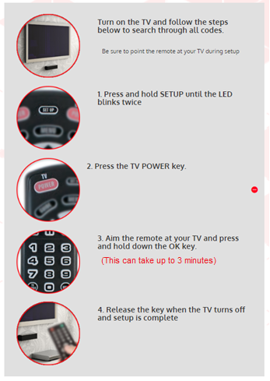

**PROGRAMMING YOUR SET TOP BOX**

1. Press and hold the SETUP button at the same time as the corresponding COLORED BUTTON, listed below, until the CABLE POWER button blinks twice.
2. Set up is now complete.

YELLOW (A): Legacy Amino (Amino 140)

BLUE (B): IS-5112SW (Innovative SML-5041W)

RED (C): ADB

GREEN (D): Entone/Amino

*NOTE: The model of your set top box can be found on label, typically located on the bottom of the box. If you are unable to locate the label, and are still unsure of the model, contact our support team at 715-237-2605. We would be happy to help you.