**Willow Remote Programming**

*Please read through the directions entirely prior to programming your remote as the process is time sensitive.*

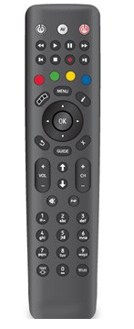– Please note this process may take up to 5 minutes to find your TV code.

1. Make sure your TV set is turned on. (The set-top box does not need to be turned on to perform this programming feature).
2. Press and hold both the number **1**and the number **3**buttons at the same time on the remote control for approximately 3 seconds until the **TV Standby**button remains lit. Release both buttons.
3. Point the remote control at the TV set and press and hold down the **MUTE**button on the remote control until you see the **MUTE** symbol on screen. This may take up to 5 minutes to happen.
4. Release the MUTE button.
5. Press and hold the **TEXT/SHIFT**button and then at the same time press the **STOP** button to finish setting up the TV control mode. The **TV Standby**button will go out. The TV control function is now programmed into the remote control.

* Should the TV brand be not successfully found by the remote control then the TV standby button will flash rapidly, and the remote control will revert to normal operation. No TV brand code will be stored. If Auto Search Method fails to successfully setup operation of the TV set, then the remote is unable to control that TV set.