**Overview:** In this tutorial we will create the MakeITHappen SQLite database and create 7 tables.

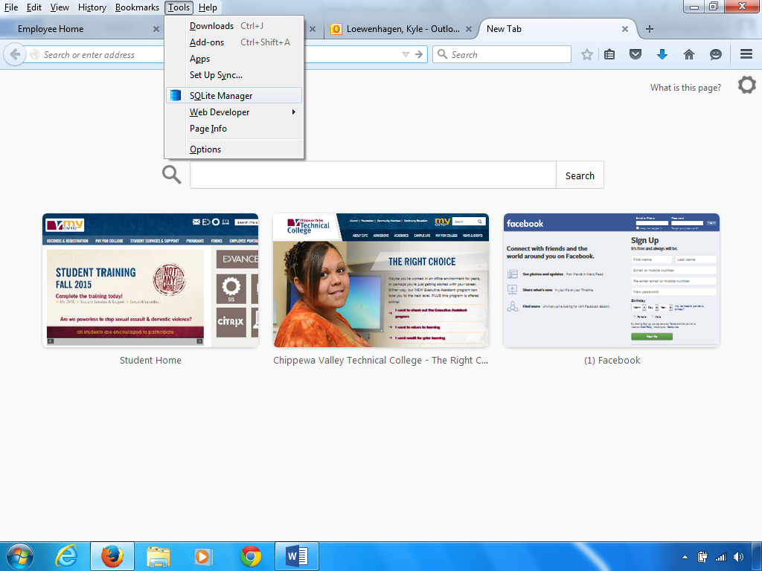

To begin with open the Firefox browser. Go to the Firefox toolbar – “Tools” menu – SQLite Manager. If you don’t see the toolbar, right click above the tabs and select “Menu bar”.

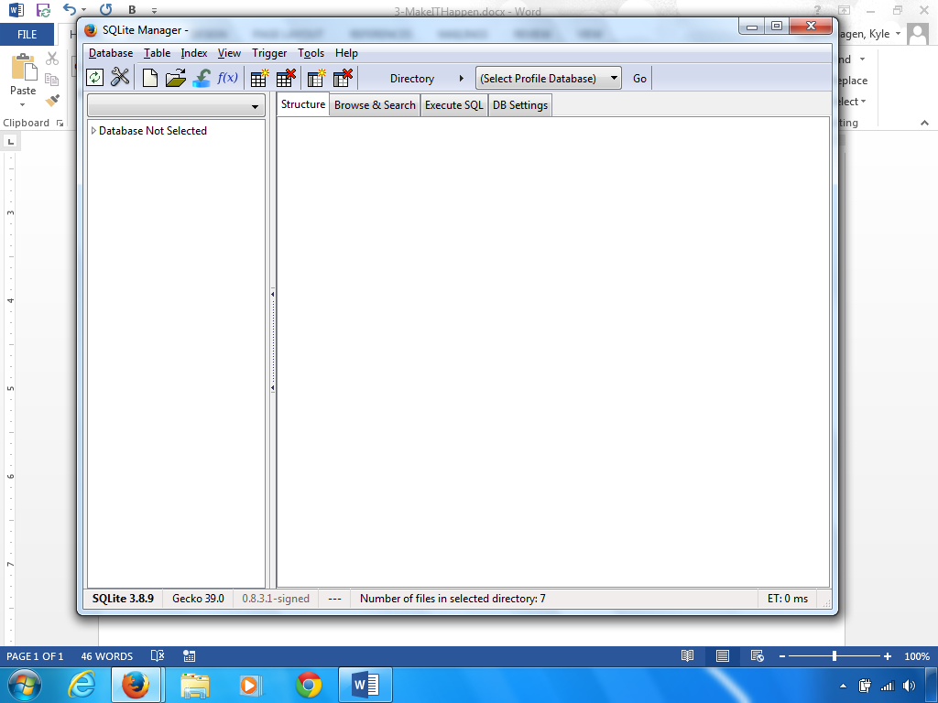

In SQLite Manager – Click on “Database” in the menu. Then select “New Database”.

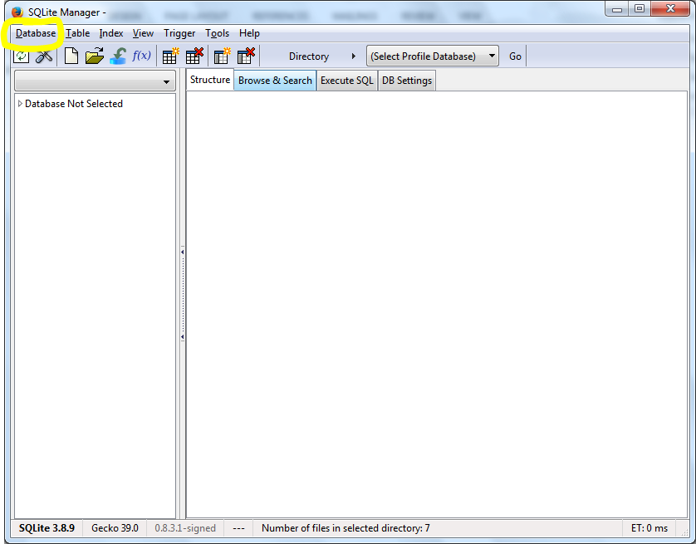

Type in “Make IT Happen” in the new database dialog box. Then click the “OK” button.

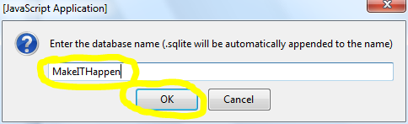

A “Save As” dialog form will appear.

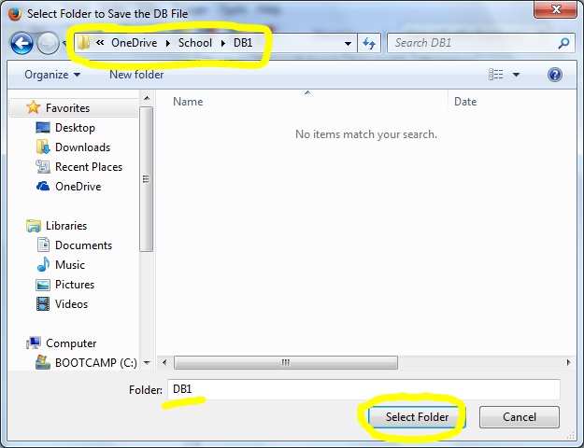

Change the path to an appropriate location for the database file and then click on the “Select Folder”.

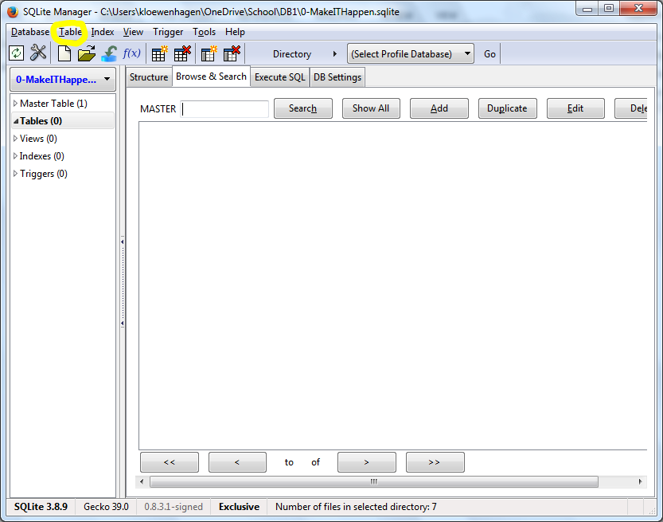

Your new database will appear. Click on “Table” in the menu bar – “Create Table” option.

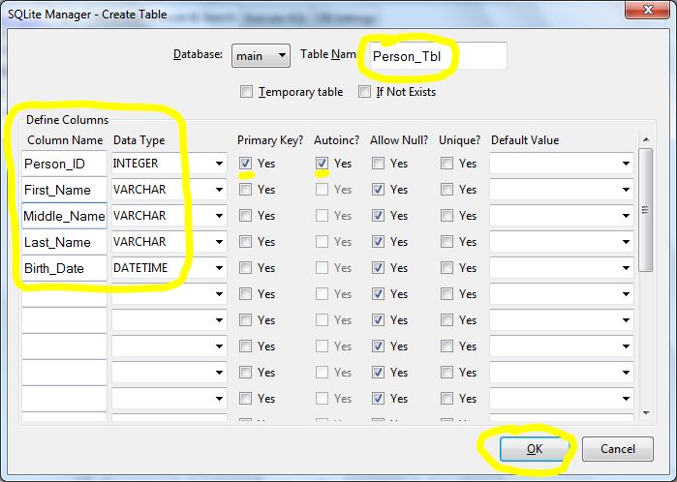

Type in “Person_Tbl” in the “Table Name” textbox. Type in the above “Column Name” and “Data Type”. Make sure you check the “Primary Key?” and the “Autoinc?” checkboxes on the “Person_ID”. Then click the “OK” button.

**Note:** Varchar is like a “TEXT” datatype found in MS Access. It is a variable character field. “Autoinc?” is autonumber. Autonumber is used when you want to increment a +1 value with each added record. Your student ID is an autonumber generated value.

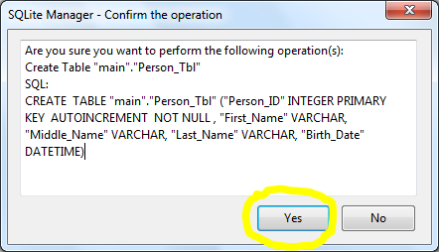

The next dialog box is the SQL confirmation screen. We will be covering SQL in future lessons. Click the “Yes” button.

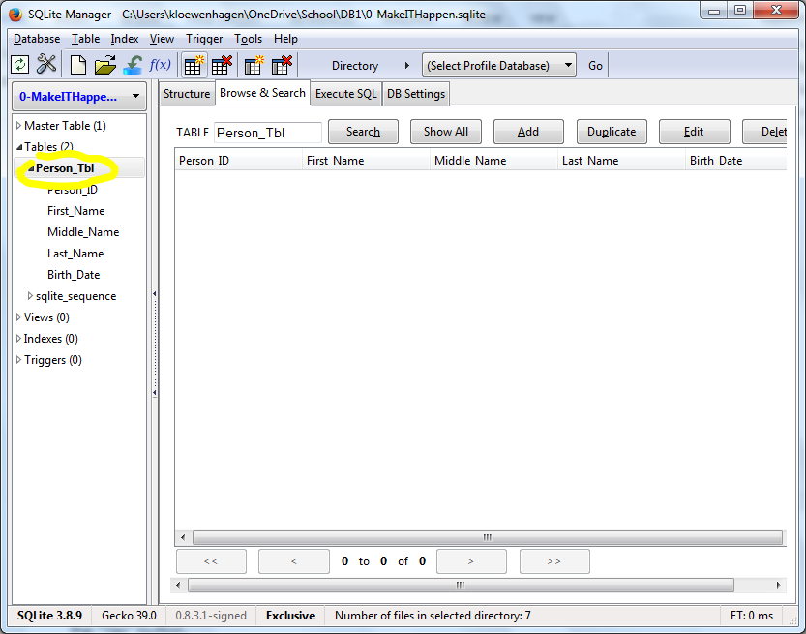

You will now see the “Person_Tbl” table in the left pane. Click on it to see the fields. Now let’s create the “Employee_Tbl”. Click on “Table” in the menu bar – “Create Table” option.

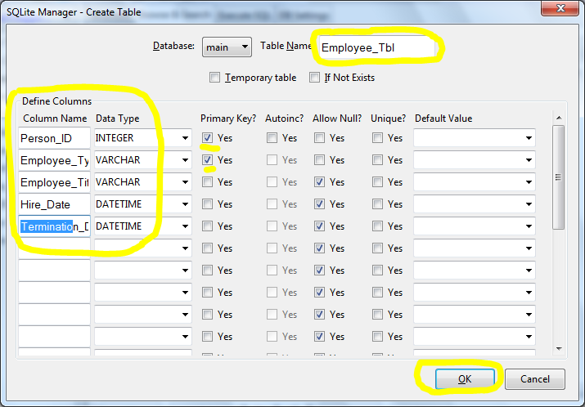

Type in “Employee_Tbl” in the “Table Name” textbox. Type in the following fields in order: Person_ID, Employee_Type, Employee_Title, Hire_Date, Termination_Date. Make sure you click on “Primary Key?” on the Person_ID and Employee_Type. Then click the “OK” button.

**Note:** You might wonder why we selected two fields for primary key. The rule of thumb is that you select one or more fields for the primary key until you have an aggregate unique key. Since there is a possibility that an employee could have more than one job, we need another field to specify each employee type. An example: Keith Stearns could be the Marketing Manager and teach a class in the evening as an Adjunct Instructor. You would not “AutoInc?” Person_ID in this table. Why? You only increment using an “AutoInc?” on the primary table. In this case, “Person_Tbl”. Any child or associated table will house the Person_ID that matches the Person_Tbl.

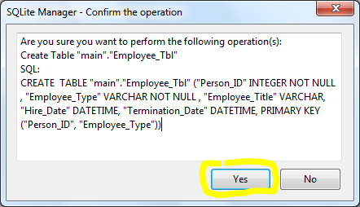

Click the “Yes” button on the SQL confirmation dialog box.

Now let’s create the “Employee_Type_Tbl”. Click on “Table” in the menu bar – “Create Table” option.

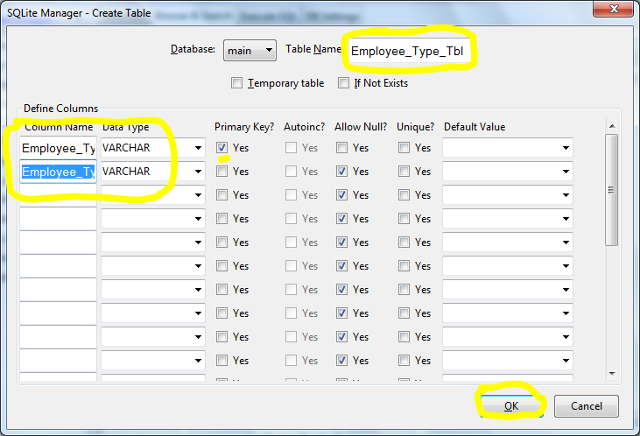

Type in “Employee_Type_Tbl” in the “Table Name” textbox. Type in the following fields in order: Employee_Type, Employee_Type_Descr. Make sure you click on “Primary Key?” on the Employee_Type. Then click the “OK” button.

**Note:** A DESCR field is a description field. A lot of time the formal name of the record is recorded in this field.

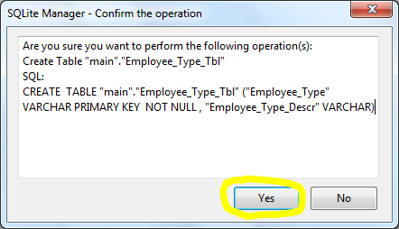

Click the “Yes” button on the SQL confirmation dialog box.

Now let’s create the “Student_Certificate_Tbl”. Click on “Table” in the menu bar – “Create Table” option.

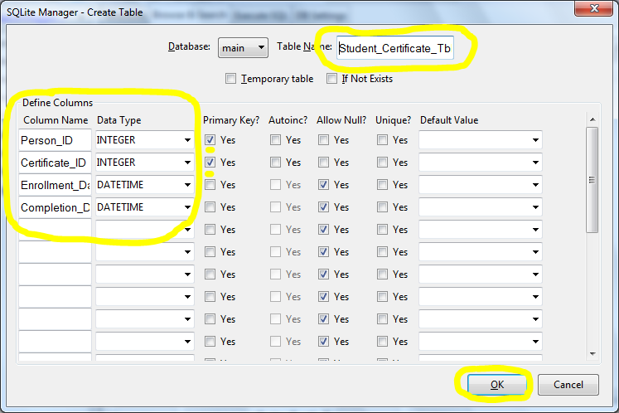

Type in “Student_Certificate_Tbl” in the “Table Name” textbox. Type in the following fields in order: Person_ID, Certificate_ID, Enrollment_Date, Completion_Date. Make sure you click on “Primary Key?” on the Person_ID and Certificate_ID. Then click the “OK” button.

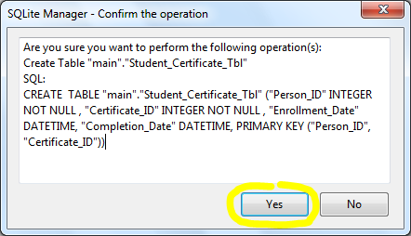

Click the “Yes” button on the SQL confirmation dialog box.

Now let’s create the “Certificate_Tbl”. Click on “Table” in the menu bar – “Create Table” option.

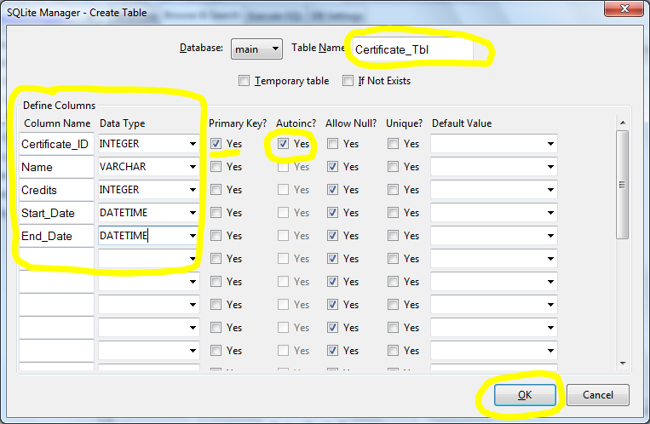

Type in “Certificate_Tbl” in the “Table Name” textbox. Type in the following fields in order: Certificate_ID, Name, Credits, Start_Date, and End_Date. Make sure you click on “Primary Key?” on the Certificate_ID. Don’t forget to click “Yes” on the Autoinc? For the Certificate_ID. Then click the “OK” button.

**Note:** Most INTERGER primary keys on parent tables use an Autoinc. As a database designer you have to ask yourself, do I want to have to come up with an unique key for every Certificate_ID? If so, don’t autoinc. If not, use autoinc.

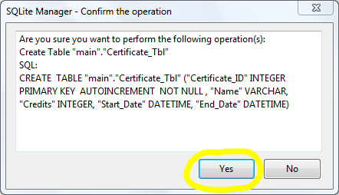

Click the “Yes” button on the SQL confirmation dialog box.

Ok, This was your idea! Now it is time for you to finish up the initial database creation. See the next Lesson items for instruction.