**Overview:** In this tutorial we will create the MakeITHappen SQLite database and create 5 additional tables and start populating some of the tables.

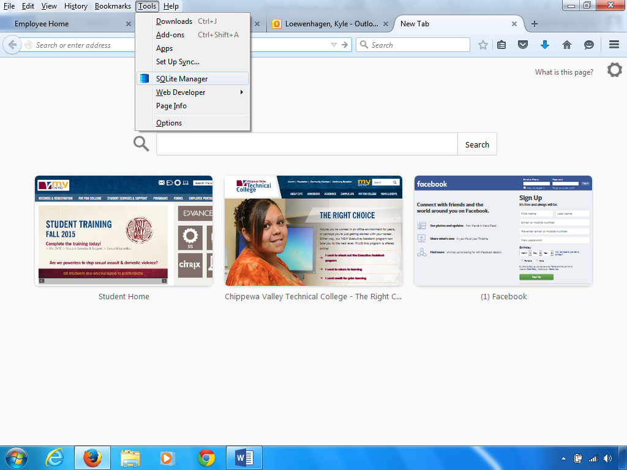

To begin with open the Firefox browser. Go to the Firefox toolbar – “Tools” menu – SQLite Manager. If you don’t see the toolbar, right click above the tabs and select “Menu bar”.

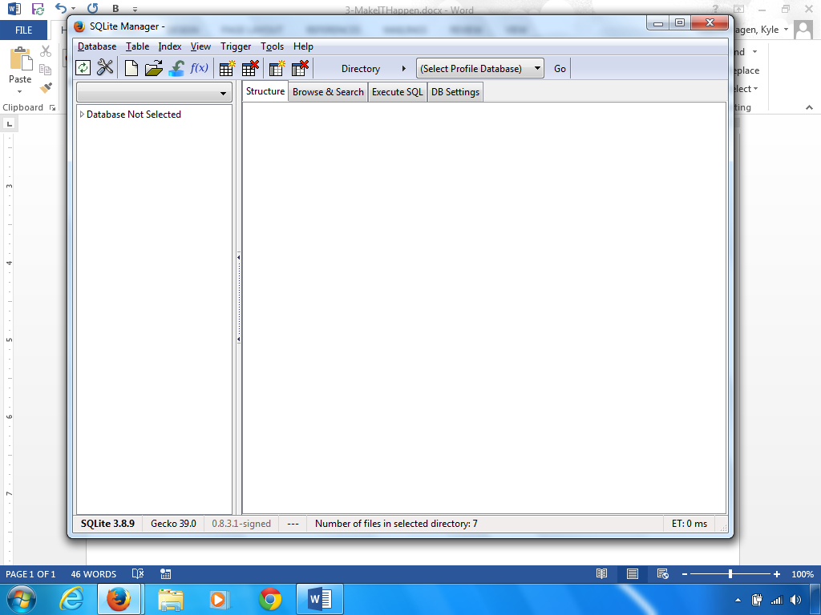

Your previous database should show up in SQLite Manager.

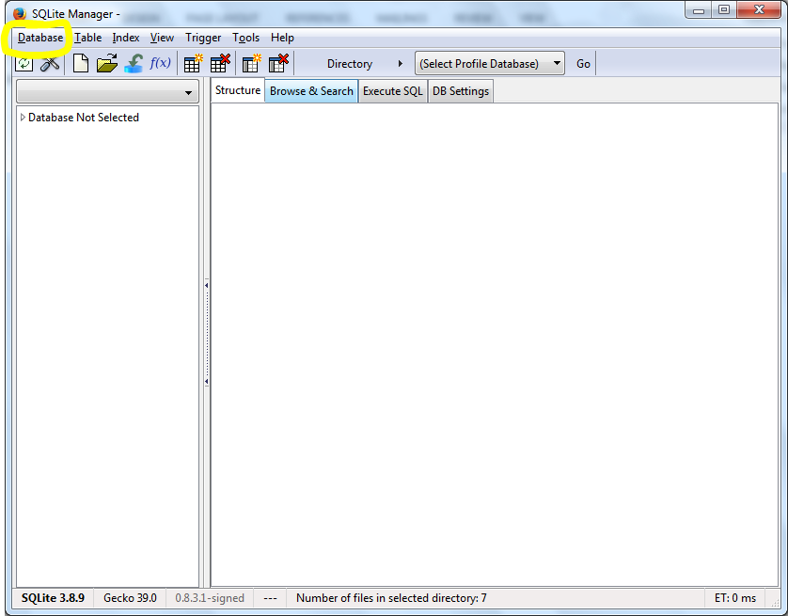

If the MakeITHappen database does not load, click on “Database” in the menu. Then select “Connect Database”.

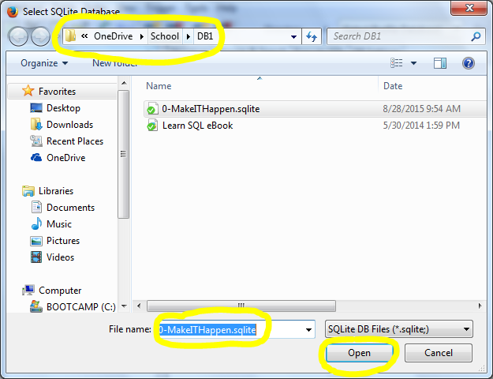

A dialog form will appear. Browse to where you saved the database, click on the .sqlite file. Then click the “Open” button.

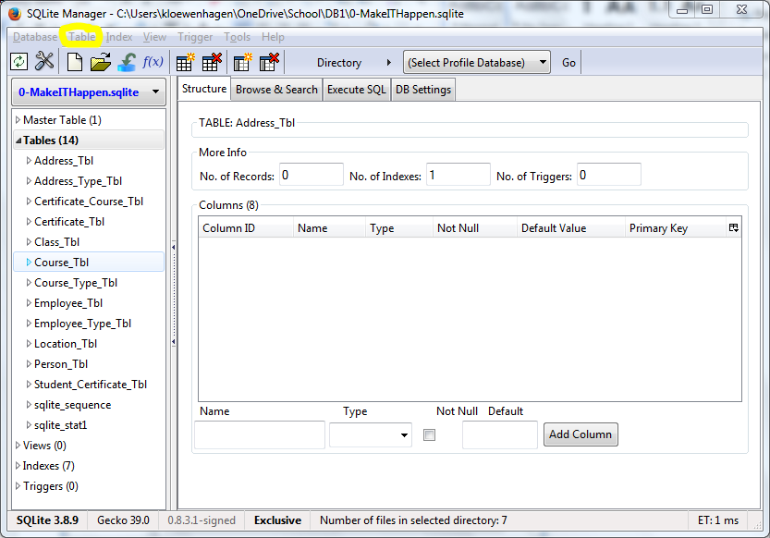

The MakeITHappen database will appear. Click on “Table” in the menu bar – “Create Table” option.

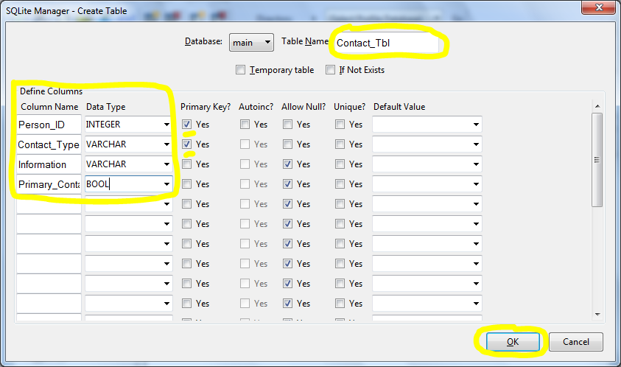

Type in “Contact_Tbl” in the “Table Name” textbox. Type in the following fields in order: Person_ID, Contact_Type, Information, Primary_Contact. Make sure you click on “Primary Key?” on the Person_ID and Contact_Type. Then click the “OK” button.

**Note:** The ‘Primary_Contact’ field will house a true or false; 1 or 0. This is called a Boolean. We will use this field to specify which record for a person is their primary way of communicating. IE: Home Email; Work Email, Cell Phone, etc.

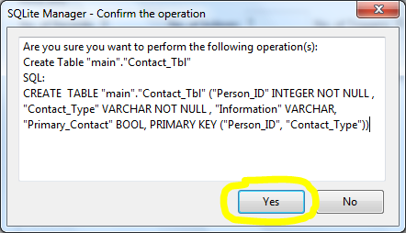

Click the “Yes” button on the SQL confirmation dialog box.

Now let’s create the “Contact_Type_Tbl”. Click on “Table” in the menu bar – “Create Table” option.

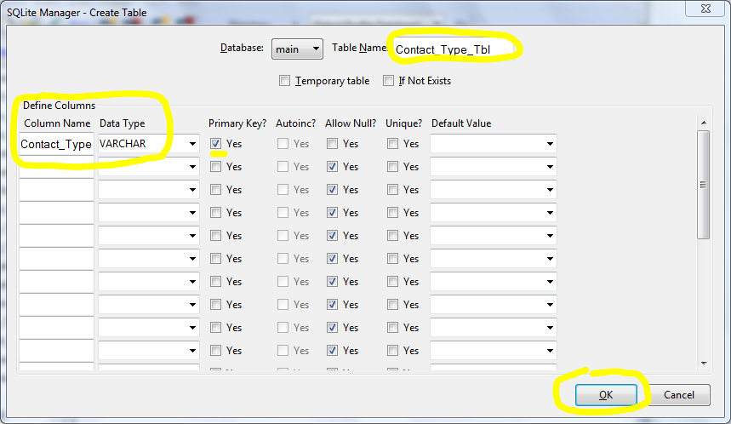

Type in “Contact_Type_Tbl” in the “Table Name” textbox. Type in the following fields in order: Contact_Type. Make sure you click on “Primary Key?” on the Contact_Type. Then click the “OK” button.

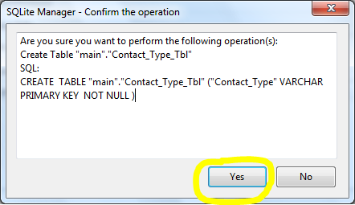

Click the “Yes” button on the SQL confirmation dialog box.

At this point you decide to populate the “Contact_Type_Tbl”. In the left navigation bar, click on the “Contact_Type_Tbl”. Then click on the “Add” button in the “Browse & Search” tab.

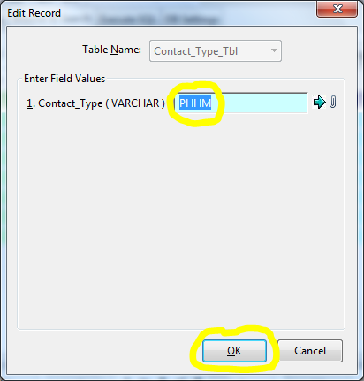

You type in ‘PHHM’ in the ‘Contact_type’ field for Phone - Home. Then click the “OK” button.

Click the “OK” button on the “Add New Record” dialog box.

Repeat this process for the following 7 more records:

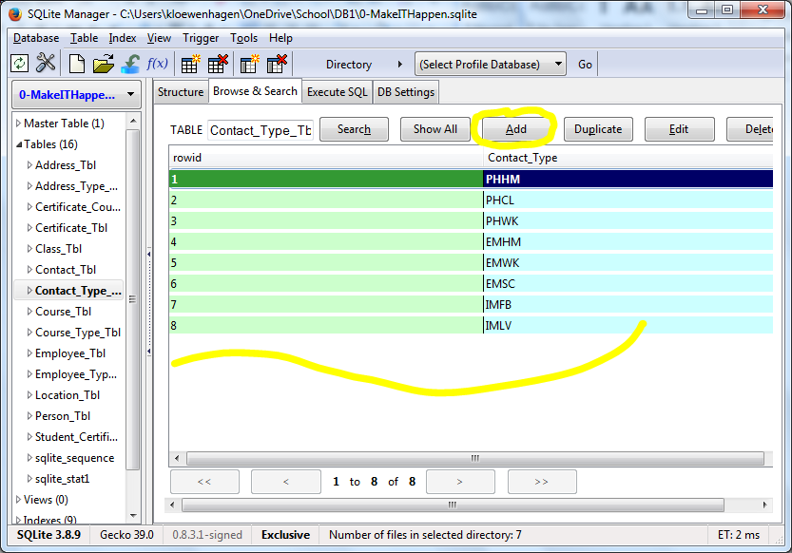

**Note:** If you make a mistake, right click on the record and select “Edit”.

Ok, This was your idea! Now it is time for you to finish up the modification of the database. See the next Lesson items for instruction.