**Web 2 – JavaScript Lesson5 jQuery Assignment**

Use the provided **Lesson5Assignment_startFiles.zip** folder to begin this assignment. You will have a web page called **fpwStage03.html** in the startFiles zipped folder that you should not need to change along with three folders (***css***, ***images***, and ***js***).

1. Note the change to our page in the lower-left corner with the **silhouette image** as shown below. This image and text is already in your provided .html and .css files so check them out.

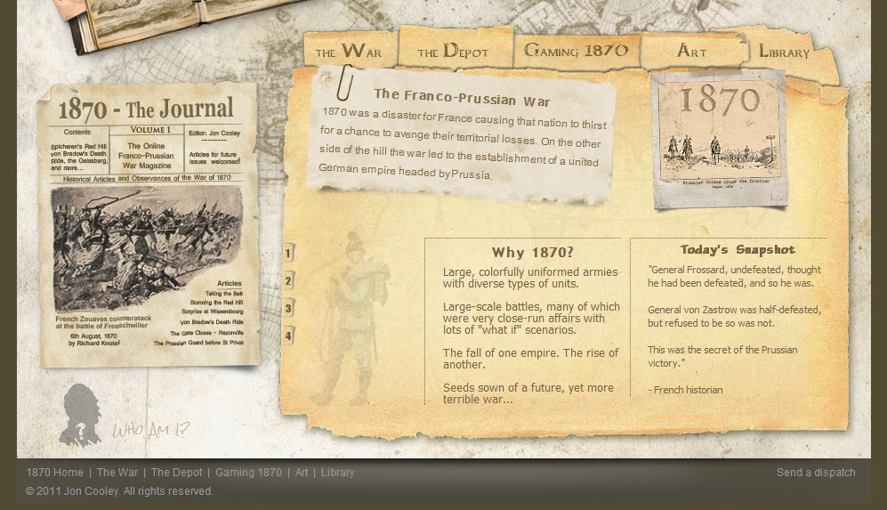

There have been three elements added to the ***.html*** file in **div#secondaryContainer** which are:

* An image whose id is “**whoAmI**”
* A paragraph whose id is “**whoAmIText**”
* A div whose id is” **mysteryPanel**”

Also, the CSS for these elements is already present in the ***.css*** file so look for how they are set up. It is always crucial to know the HTML structure and underlying CSS presentation you will need to work with when writing your JavaScript/jQuery code.

1. Create an external JavaScript file under the ***js*** folder named **whoAmI_yourname.js** (note: this naming convention will be graded to see if you are following the specs). In this JavaScript file you will use ***jQuery*** code to do the following:
2. Make sure the web page has finished loading with jQuery’s **ready() method**.
3. When the silhouette image at the bottom of the page is hovered over (jQuery’s **hover() method**), fade it and the accompanying text to full opacity (100%). When it is hovered off, fade the image and text back to 40%. Be sure any running animation is stopped (use jQuery’s **stop() method**) before doing your fading. Use jQuery’s **fadeTo() method** to do the above fading in/out.
4. When the "Who am I" silhouette image on page ***is clicked*** (select **img#whoAmI** and use jQuery’s **click() method**) toggle open/closed **div#mysteryPanel** depending on its current state. Check out jQuery’s **toggle() method** for this on **api.jquery.com**.

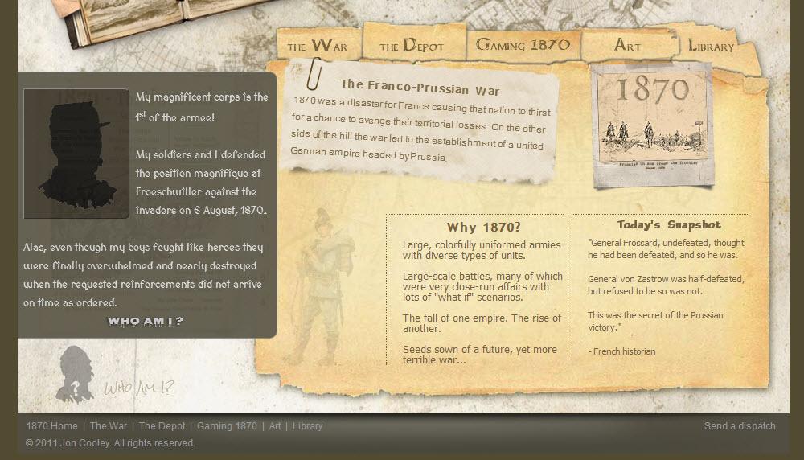

1. When the **"Who am I?" h3 text** is clicked, fade out the silhouette image and reveal the actual image underneath it by fading it in after a delay.

You will need to set up a click event on the h3 text (use jQuery’s **click() method**) and in the click’s handler function fade out the **img#silhouette** over 5 seconds (using jQuery’s **fadeout() method**).

At the same time below the fade out statement you just did, select **img#revealed** and use chaining of methods to first have a 3-second delay (use jQuery’s **delay() method**) and then fade the image in over 1 second using jQuery’s **fadeIn() method** (remember the values are in milliseconds – 1000 milliseconds = 1 second).

Change the **"Who am I?"** **text** (using jQuery’s **text() method**) to the name of the leader (“Marechal Patrice MacMahon”) and change the cursor back to default (using jQuery’s **css() method**). Important: do this change completely AFTER the fade in of img#revealed is finished.

Hint: use the **Callback parameter** of your **fadeIn() method** to call an anonymous function that calls the **text()** and **css()** methods to do this (fadeIn(1000, function() {call to text() and css() methods for the selected h3 using chaining here})).

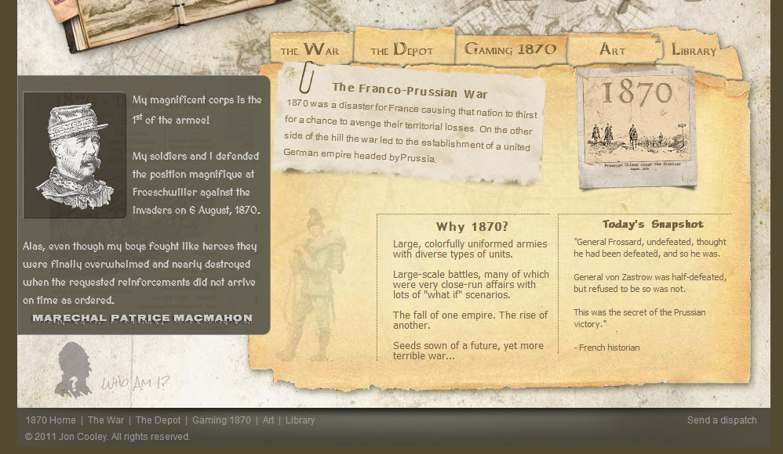

1. Check out the accompanying video in the E360 lesson for a visual tour of the effect.
2. Zip up your files into a zipped folder named **Lesson5Assignment_yourname.zip** and submit via the Dropbox for this assignment in E360.