Web 2 - Assessment 1 - JavaScript Coding Fundamentals (40 Points)

Using the below HTML code, screenshot, and starting files, fill in the JavaScript code (following the comments on the next page as a guide) to create an image gallery using two event handlers (older way) to rollover the existing large image to a large image corresponding to the thumbnail (small) image that was moused over. When the thumbnail is moused off of, change the large image back to the original large image.

Note: no jQuery code should be used in this assessment!

Thumbnail (small) images are in a folder named images/thumbs while the larger corresponding images are in a folder named images/bigPics.

Hint: you will need to use the id value of the moused-over thumbnail image as an index into the picArray array given below to determine which larger image should be displayed.

Use this HTML code snippet for your work (already in imageGallery.html and the CSS is already set up in css/assessment1.css):

<div id=”thumbnails”>
<img src=”images/thumbs/thumb1.jpg” id=”0”>
<img src=”images/thumbs/thumb2.jpg” id=”1”>
<img src=”images/thumbs/thumb3.jpg” id=”2”>
<img src=”images/thumbs/thumb4.jpg” id=”3”>
</div>

<div id=”container”>
<img src=”images/bigPics/initialPic.jpg” id=”bigPic”>
</div>

Screenshot:

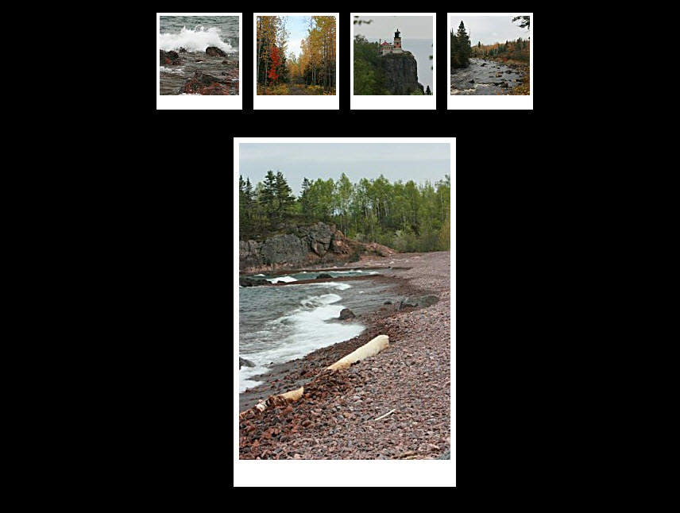
Use these comments to help with your JavaScript code:

var ImageGallery = {

init: function() {

picArray = ["1", "2", "3", "4"];

// Get reference to large image and store in variable named canvas

// Get reference to div#thumbnails and store in variable named
// thumbsDiv

// Set up nodelist, named thumbs, containing references to all
// <img> tags in div#thumbnails

// Add mouseover and mouseout event handlers to each thumbnail
// image using a for loop. Set them up to call a method of our // object called newPic on mouse over and a method called origPic
// on mouse off.

},

Mouse over Handler function name here: function() {

// Get the value of the moused over object's id attribute and // store it in a variable named imgNumber

// Build the path to the image we want to rollover to and store
// the path string in a variable named imgPath

// Rollover the large image to the moused over thumbnail's large
// image

},

Mouse off Handler function name here: function() {

// Rollover the large image back to its original image

}

};
Core.start(ImageGallery);

Save your JavaScript code in a file named assessment1_yourname.js in the provided js folder, zip up all the files in a folder named imageGallery_yourname, and submit it via the provided Dropbox under the Assessment1 Lesson in E360.

