Supplementary Material
Estimating Infectious Disease Importation Risk during the 2026 FIFA World Cup
Jose L. Herrera-Diestra
Kaiming Bi
Zeynep Ertem
Amera Al-Amery
Mallory Harris

Appendix A: Detailed Methods and Data Sources

Study setting
The 2026 FIFA World Cup will be hosted jointly by the United States, Mexico, and Canada, with matches scheduled from June 11 through July 19, 2026. The United States will host the majority of matches across eleven venues: MetLife Stadium (East Rutherford, NJ), SoFi Stadium (Inglewood, CA), AT&T Stadium (Arlington, TX), Mercedes-Benz Stadium (Atlanta, GA), NRG Stadium (Houston, TX), Arrowhead Stadium (Kansas City, MO), Lincoln Financial Field (Philadelphia, PA), Hard Rock Stadium (Miami Gardens, FL), Levi’s Stadium (Santa Clara, CA), Lumen Field (Seattle, WA), and Gillette Stadium (Foxborough, MA). Canada hosts two venues (BC Place, Vancouver; BMO Field, Toronto) and Mexico hosts three (Estadio Azteca, Mexico City; Estadio BBVA, Monterrey; Estadio Akron, Guadalajara). The geographic distribution of all 16 venues across the three co-host nations is shown in Figure [fig:venue_map]. All 48 qualified nations are listed in Appendix D.
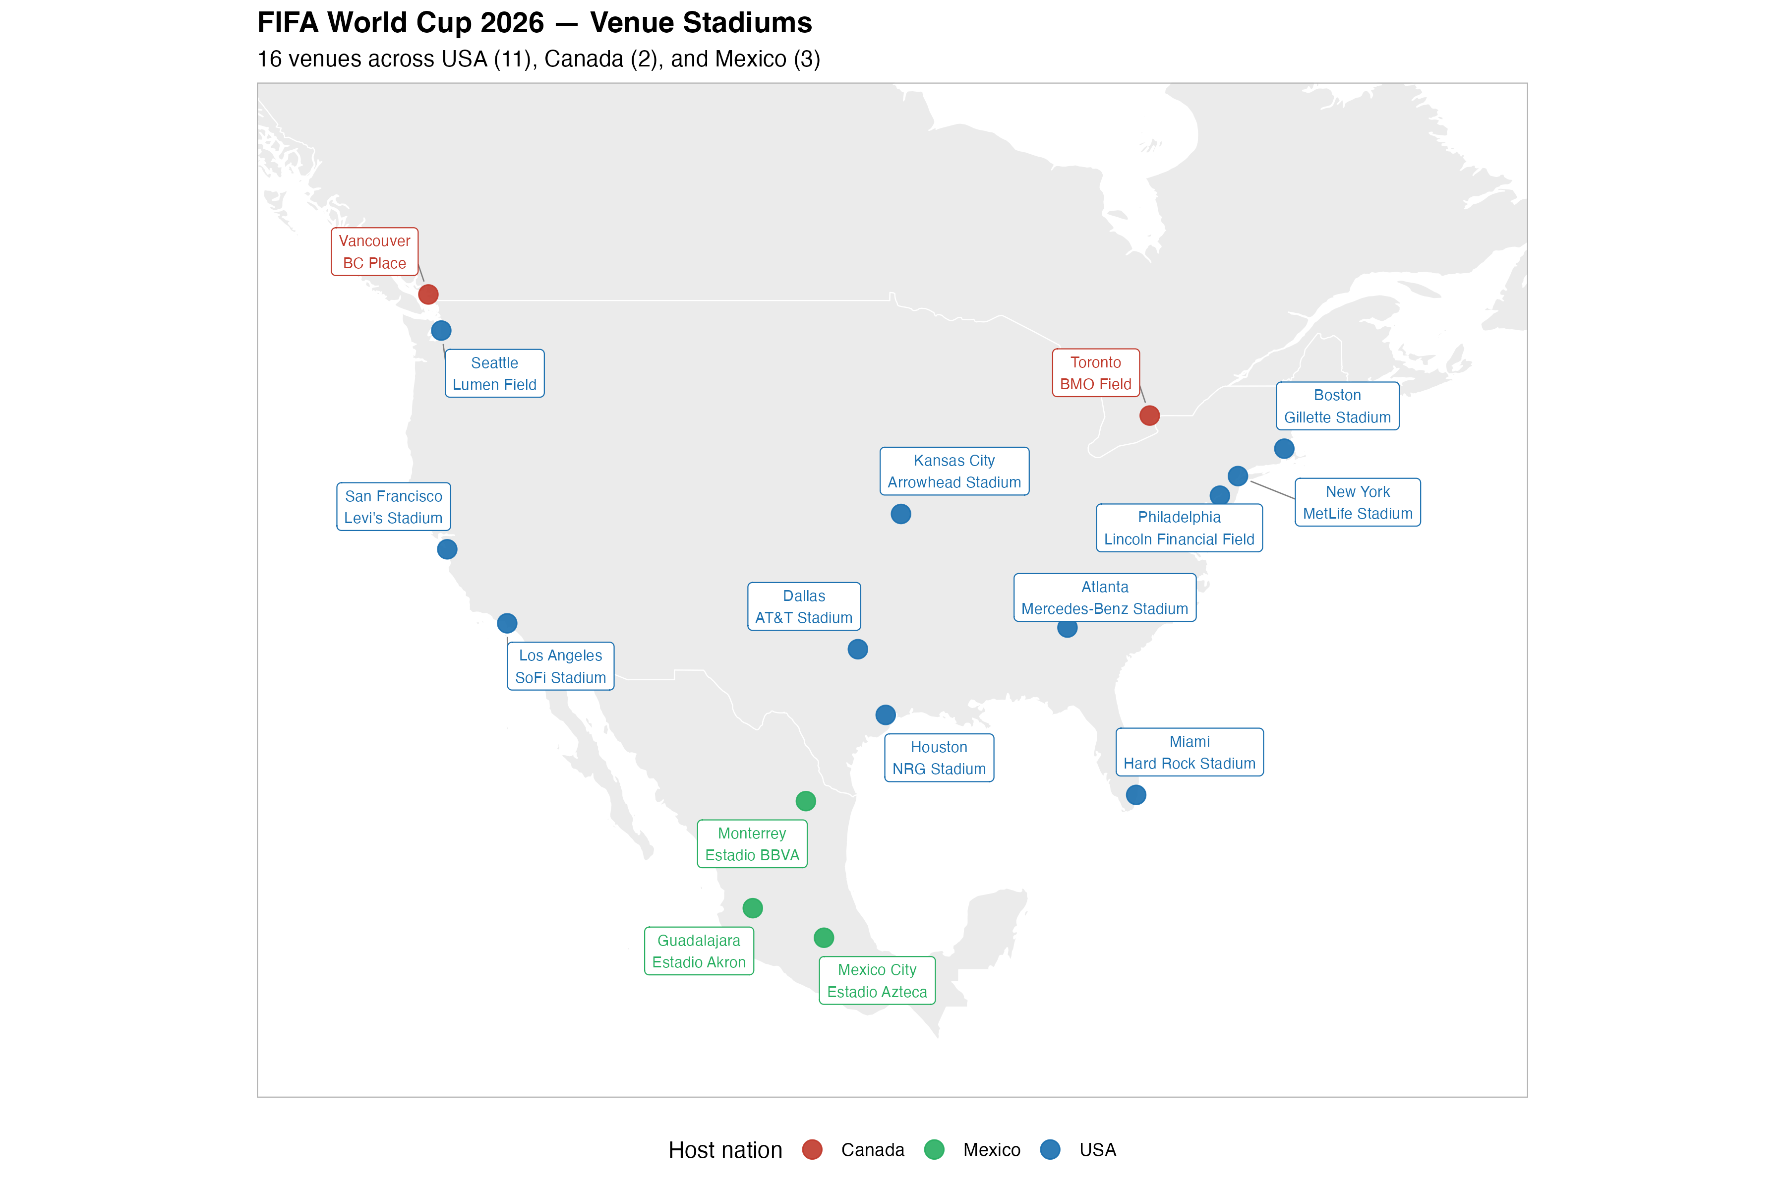
Geographic distribution of the 16 FIFA World Cup 2026 venue stadiums across the three co-host nations. Circles are colour-coded by host country: USA (blue, 11 venues), Canada (red, 2 venues), and Mexico (green, 3 venues). Suburb stadium locations are labelled by their metropolitan area to match the spatial aggregation used throughout the analysis (e.g. East Rutherford $→$ New York, Foxborough $→$ Boston).
We estimated the importation risk of five infectious diseases—dengue fever, influenza, malaria, measles, and pertussis—for each host city using three complementary models of increasing resolution: (1) a baseline model using COR June 2024 arrivals with BTS T-100 routing fractions and no World Cup growth adjustment; (2) a World Cup (WC)-adjusted model that scales volumes to country-level 2026 projections; and (3) a schedule-driven model that separates World Cup fan travel from background tourism and routes fans to the specific venue cities where their national team plays. The five diseases were selected because each is endemic in countries with strong football traditions, each has a plausible pathway for travel-associated importation into the United States, and each represents a distinct surveillance and public health response challenge. Influenza is included because June corresponds to the Southern Hemisphere winter peak, coinciding with the tournament window for WC-qualified nations in South America and Oceania.

Notation and variable definitions
The following indices and variables are used consistently throughout all three models. Where the range of an index differs between models, this is noted explicitly.
Indices
- $c$ — source country of international travelers (all three models).
- $v$ — destination venue city. In all three models, $v$ ranges over the eleven US WC venue cities (Table [tab:venues]). Model 3 additionally covers the five non-US host cities (Toronto, Vancouver, Guadalajara, Mexico City, Monterrey).
- $d$ — disease: $d∈\{\text{dengue}, \text{influenza}, \text{malaria}, \text{measles}, \text{pertussis}\}$.
- $y$ — calendar year, used when averaging over multiple June cross-sections ($y∈\{2023,2024,2025\}$ for T-100 routing fractions).
Travel and importation variables
- $N_{c,v}$ — expected number of travelers from source country $c$ arriving in city $v$ during June. Constructed differently in each model (see below).
- $Λ_{v,d}$ — importation intensity (Poisson rate): expected number of imported cases of disease $d$ arriving in city $v$ during June 2026.
- $λ_{c,v,d}$ — importation contribution from source country $c$ to city $v$ for disease $d$; Λv,d=c​λc,v,d.
Disease and parameter variables
- $I_{c,d}$ — per-traveler infection probability: probability that a randomly selected traveler from country $c$ is carrying disease $d$ during their trip. Defined as $I_{c,d}=ρ_{d}⋅C_{c,d}/P_{c}$.
- $C_{c,d}$ — reported cases of disease $d$ in source country $c$ during June (or annual figure divided by 12 for diseases with only annual reporting).
- $P_{c}$ — population of source country $c$.
- $ρ_{d}$ — reporting adjustment factor for disease $d$: corrects for under-reporting in routine surveillance and the fraction of reported cases that are actively infectious at any given time (Table [tab:params]).
- $p_{d}$ — travel-while-infectious probability: probability that a person infected with disease $d$ continues to travel internationally during the infectious window (Table [tab:params]).
Routing fractions and travel growth
- $f_{c,v}^{\text{T100}}$ — T-100 routing fraction: share of country $c$’s US-bound June arrivals that enter through city $v$, derived from BTS T-100 International Segment data averaged over June 2023–2025. Used in all three models.
- $ϕ_{c}$ — growth factor for country $c$: ratio of projected 2026 to observed 2024 annual visitor volume ($ϕ_{c}=V_{c,2026}/V_{c,2024}$). Derived from NTTO for Tier 1 countries; set to $ϕ_{\text{WC}}$ or $ϕ_{\text{base}}$ for all others.
- $ϕ_{\text{WC}}=1.174$ — aggregate WC growth factor (NTTO total: 85,017/72,390 thousand).
- $ϕ_{\text{base}}=1.077$ — baseline (non-WC) growth factor derived as the geometric mean annual growth rate over June 2023–2025, averaged across COR (1.062) and T-100 (1.092) data sources; applied to non-qualified countries.
- $N_{c}^{\text{WC}}$ — WC-fan travel increment: marginal arrivals attributed to the World Cup for country $c$.
- $N_{c}^{\text{bg}}$ — background arrivals: June 2026 travel that would have occurred without the WC.
- $ω_{c,v}$ — schedule routing fraction: share of WC fans from country $c$ attending matches in venue city $v$; defined as games played in $v$ divided by total known games for that team.
- $Q$ — set of WC-qualified countries with a known group-stage match schedule (TBD matches excluded).

Importation risk framework
We modelled disease importation as a Poisson process. This choice is standard for rare-event counting problems: when individual import events are independent and the per-traveller probability of infection is small, the number of imported cases in a fixed time window converges to a Poisson random variable. The Poisson framework is also analytically tractable and additive over source units, allowing country-level and stream-level contributions to be computed and summed independently. This framework is consistent with previously published importation risk analyses for large international sporting events (Herrera-Diestra et al. 2026). The core equations ($P(≥1)=1−e^{−Λ_{v,d}}$ and $λ_{c,v,d}=N_{c,v}⋅I_{c,d}⋅p_{d}$) are given in the main text; the three models differ only in how $N_{c,v}$ is constructed, as detailed below.

Baseline model: COR June 2024 travel volume with T-100 routing (no WC adjustment)

Baseline city-level arrivals
Baseline arrivals from country $c$ to venue city $v$ are:
$$N_{c,v}^{\text{baseline}}=N_{c,\text{June 2024}}^{\text{COR}}⋅f_{c,v}^{\text{T100}}$$
Countries with no T-100 routing data are excluded; their volumes are negligible in the aggregate.

Importation intensity (baseline)
$$λ_{c,v,d}=N_{c,v}^{\text{baseline}}⋅I_{c,d}⋅p_{d}$$
Λv,d=c​λc,v,d

BTS T-100 International Segment data: country-level city routing fractions

Motivation and data source
All three models require country-level city routing fractions that cover every US WC venue city. We use the Bureau of Transportation Statistics (BTS) T-100 International Segment (All Carriers) dataset (Bureau of Transportation Statistics 2026), which records nonstop international flight segments landing at US airports at the individual airport level. T-100 covers all US commercial airports and reports passengers by country of origin, making it possible to compute country-specific routing fractions for all eleven US venue cities. The T-100 data do not include an origin city field, only the originating country code for the international segment.

Data processing and routing fraction construction
Three full years of T-100 data were downloaded for 2023, 2024, and 2025, covering all months. Only June records (month = 6) were retained for each year, yielding three June cross-sections. This window was chosen to: (1) match the June travel period of the WC group stage; (2) use the three most recent complete pre-tournament June months; and (3) avoid the COVID-recovery period (2020–2022) during which route networks and traffic volumes were atypical.
Records were filtered to scheduled passenger service only (CLASS = "F"), excluding charter (N), all-cargo (L), and mixed cargo (P) service classes. Only segments with at least one passenger (PASSENGERS > 0) and landing in the United States (DEST_COUNTRY = "US") were retained. Destination airports were then mapped to the eleven US WC venue city groups using a predefined airport-to-city table (e.g., JFK, EWR, and LGA $→$ New York; MIA and FLL $→$ Miami; SFO, OAK, and SJC $→$ San Francisco). Any airport not associated with a WC venue city was excluded.
For each source country $c$, venue city $v$, and year $y$, the routing fraction is first computed within each June cross-section as:
$$f_{c,v,y}^{\text{T100}}=\frac{N_{c,h,y}^{\text{June}}}{N_{c,\text{US},y}^{\text{June}}}$$
where $N_{c,h,y}^{\text{June}}$ is the total T-100 passengers from country $c$ to the airport group serving venue city $v$ in June of year $y$, and $N_{c,\text{US},y}^{\text{June}}$ is the total T-100 passengers from country $c$ to all US airports in June of year $y$.
The mean routing fraction is then averaged across the three years:
fc,vT100=1|Y|y∈Y​fc,v,yT100
where $Y=\{2023,2024,2025\}$.

Important limitations of T-100 routing fractions
T-100 records the nonstop international segment only. A passenger travelling on a connecting itinerary (e.g., São Paulo $→$ Miami $→$ Kansas City) appears only in the Miami row, because Miami is the airport where the international segment terminates and US Customs is cleared. Kansas City correctly shows near-zero T-100 routing fractions for most countries; its WC-specific traffic is captured entirely by the schedule-driven WC-fan stream.
Country names in T-100 use ISO/ICAO conventions (e.g., “Korea, Republic of”, “Viet Nam”) while the CBP COR arrival data use informal short names (e.g., “South Korea”, “Vietnam”). A standardised recode table covering 26 known mismatches was applied before joining the two datasets.

World Cup–adjusted model: country-level travel volume (2026 projections)

Construction of 2026 travel volume
Country-level June 2026 visitor volumes to the United States were constructed from two complementary sources using a tiered approach.

Tier 1 — NTTO projections (top 12 source markets).
Official 2026 international visitor projections for twelve major source markets were obtained from the US National Travel and Tourism Office (NTTO) 2025 Forecast Report (National Travel and Tourism Office 2025). These projections—available for Australia, Brazil, Canada, China, France, Germany, India, Italy, Japan, Mexico, South Korea, and the United Kingdom—already incorporate the World Cup tourism effect. The 2024-to-2026 growth factor for each country was derived as $ϕ_{c}=V_{c,2026}/V_{c,2024}$, where $V_{c,y}$ is the projected annual visitor volume in year $y$ (Table [tab:ntto]).

Tier 2 — COR data scaled by global growth factors (remaining countries).
For all other countries, country-level June 2024 arrivals were extracted from the CBP I-94 Monthly Arrivals by Country of Residence dataset (US Customs and Border Protection 2026). A growth factor was then assigned based on World Cup qualification status:
- WC-qualified countries not in Tier 1: scaled by the overall NTTO 2024$→$2026 growth factor ($ϕ_{\text{WC}}=85,017/72,390=1.174$).
- Non-qualified countries: scaled by a data-driven baseline growth factor $ϕ_{\text{base}}$ estimated from observed trends in US inbound travel independent of the tournament. We derived $ϕ_{\text{base}}$ from two sources covering June 2023–2025: (i) CBP COR monthly arrivals and (ii) BTS T-100 total international passengers arriving in the US. For each source, the geometric mean annual growth rate over the two observed intervals is:
$$\overset{‾}{g}={\left(\frac{N_{\text{June},2025}}{N_{\text{June},2023}}\right)}^{1/2}=\sqrt{ \frac{N_{2024}}{N_{2023}}⋅\frac{N_{2025}}{N_{2024}}}$$
- and the two-year forward factor follows as $ϕ_{\text{base}}={\overset{‾}{g}}^{ 2}=N_{\text{June},2025}/N_{\text{June},2023}$. The COR estimate is $ϕ_{\text{base}}^{\text{COR}}=1.062$ and the T-100 estimate is $ϕ_{\text{base}}^{\text{T100}}=1.092$. Their arithmetic mean, $ϕ_{\text{base}}=1.077$, is used in the model.
The projected June 2026 arrivals for country $c$ are thus:
$$N_{c,\text{June 2026}}=N_{c,\text{June 2024}}^{\text{COR}}⋅ϕ_{c}$$
City-level arrival volumes are obtained by applying the T-100 routing fractions:
$$N_{c,v}^{2026}=N_{c,\text{June 2026}}⋅f_{c,v}^{\text{T100}}$$

Importation intensity (WC-adjusted)
$$λ_{c,v,d}=N_{c,v}^{2026}⋅I_{c,d}⋅p_{d}$$
Λv,d=c​λc,v,d

Schedule-driven venue routing model

Travel decomposition
For each source country $c$, total projected June 2026 arrivals are decomposed into two components:
- WC-fan stream: the marginal arrivals attributable to the World Cup:
$$N_{c}^{\text{WC}}=N_{c,\text{June 2024}}^{\text{COR}}⋅max​\left(0, ϕ_{c}−ϕ_{\text{base}}\right)$$
- Background stream: arrivals that would have occurred regardless of the World Cup:
$$N_{c}^{\text{bg}}=N_{c,\text{June 2026}}−N_{c}^{\text{WC}}$$
For a WC-qualified country assigned the global WC growth factor ($ϕ_{\text{WC}}=1.174$), the WC fan fraction is approximately $8.3\%$ of projected arrivals: $(1.174−1.077)/1.174≈0.083$.

Schedule-based WC fan routing
For each WC-qualified country $c$ with team $t_{c}$, a schedule routing fraction is defined as:
$$ω_{c,v}=\frac{g_{c,v}}{G_{c}}$$
where $g_{c,v}$ is the number of matches played by team $t_{c}$ at venue city $v$ and Gc=v​gc,v is the total number of known matches for that team. Matches with undetermined opponents (labelled “TBD”) are excluded. WC-fan arrivals at each venue city are then:
$$N_{c,v}^{\text{WC}}=N_{c}^{\text{WC}}⋅ω_{c,v}$$

Background stream routing via T-100 fractions
Background travellers are distributed across venue cities using T-100 fractions:
$$N_{c,v}^{\text{bg}}=N_{c}^{\text{bg}}⋅f_{c,v}^{\text{T100}}$$
England and Scotland are distinct World Cup participants but share a single country-of-residence entry (“United Kingdom”) in the COR arrivals data. Their combined matches are pooled and the routing fractions $ω_{\text{UK},v}$ are computed over the union of their games, with no double-counting of UK arrivals.
WC 2026 host venues and their canonical city names used in the schedule-driven model. Cities with T-100 background routing are marked with $†$.
Stadium | City (canonical) | Country | T-100 bg?
MetLife Stadium | New York$​^{†}$ | USA | Yes
SoFi Stadium | Los Angeles$​^{†}$ | USA | Yes
AT&T Stadium | Dallas$​^{†}$ | USA | Yes
Mercedes-Benz Stadium | Atlanta$​^{†}$ | USA | Yes
NRG Stadium | Houston$​^{†}$ | USA | Yes
Arrowhead Stadium | Kansas City$​^{†}$ | USA | Yes*
Lincoln Financial Field | Philadelphia$​^{†}$ | USA | Yes
Hard Rock Stadium | Miami$​^{†}$ | USA | Yes
Levi’s Stadium | San Francisco$​^{†}$ | USA | Yes
Lumen Field | Seattle$​^{†}$ | USA | Yes
Gillette Stadium | Boston$​^{†}$ | USA | Yes
BC Place | Vancouver | Canada | No
BMO Field | Toronto | Canada | No
Estadio Azteca | Mexico City | Mexico | No
Estadio BBVA | Monterrey | Mexico | No
Estadio Akron | Guadalajara | Mexico | No
Kansas City shows near-zero T-100 fractions for most countries,
reflecting its minimal direct international air service; its
WC-specific traffic is captured by the WC-fan stream.

Importation intensity (schedule-driven)
The total Poisson importation intensity for venue city $v$ is:
Λv,d=c∈Q​Nc,vWC⋅Ic,d⋅pd⏟WC-fan stream + c​Nc,vbg⋅Ic,d⋅pd⏟background stream

Disease data sources

Dengue
Monthly country-level dengue case counts were obtained from the WHO Global Dengue Surveillance dataset (World Health Organization 2025a). For all three models, the mean June case count per country over 2024–2025 was used directly, divided by national population to obtain a per-capita incidence.

Malaria
Country-level malaria incidence rates for 2024 (cases per 1,000 population) were obtained from the WHO Global Malaria Programme National Unit Data (World Health Organization 2024). Annual incidence was divided by 12 to obtain an approximate monthly rate.

Measles and pertussis
Annual country-level incidence rates (cases per 1,000,000 population) for measles and pertussis were obtained from the WHO Immunization Data portal (World Health Organization 2025b). Annual incidence was divided by 12 to obtain an approximate monthly rate.

Influenza
Weekly country-level positive specimen counts were obtained from the WHO FluNet / Global Influenza Surveillance and Response System (GISRS) (World Health Organization 2025b). June corresponds to ISO weeks 22–26. Mean June positive specimens per country were computed across 2023–2025 to produce a stable baseline signal.

Model parameters
Table [tab:params] summarises the disease-specific parameters used in all three models.
Disease-specific model parameters. The $ρ_{d}$ literature range is derived from published burden and under-reporting studies; the adopted value falls within or at the conservative end of that range. All $p_{d}$ values are supported by travel medicine literature.
Disease | $ρ_{d}$ range | $ρ_{d}$ | $p_{d}$ | Rationale for $p_{d}$ | Key ref. ($ρ_{d}$)
Dengue | 0.06–0.26 | 0.10 | 0.50 | Mild viraemic phase; $∼$40% viremic on arrival | (Bhatt et al. 2013; Undurraga et al. 2013)
Influenza | 0.033–0.20 | 0.10 | 0.50 | Moderate illness; many travel during early illness; SH winter peak in June | (World Health Organization 2025b)
Malaria | 0.10–0.35 | 0.20 | 0.30 | Severe illness; most febrile after return | (World Health Organization 2024)
Measles | 0.40–0.80 | 0.60 | 0.05 | Prostrating; ambulatory only in short pre-rash window | (Simons et al. 2012)
Pertussis | 0.01–0.10 | 0.10 | 0.70 | Catarrhal stage mimics common cold; unrecognised | (McLaughlin et al. 2016)

NTTO 2026 visitor projections for top 12 source markets
NTTO 2026 international visitor projections and derived growth factors used in the WC-adjusted model. Source: US National Travel and Tourism Office Forecast Report (March 2025).
Country | 2024 (000s) | 2026 (000s) | $ϕ_{c}$ | WC team?
Canada | 20,241 | 23,015 | 1.137 | Yes (host)
Mexico | 16,990 | 19,557 | 1.151 | Yes (host)
United Kingdom | 4,037 | 4,467 | 1.107 | Yes (England, Scotland)
Japan | 1,844 | 2,600 | 1.410 | Yes
China | 1,626 | 2,641 | 1.624 | No
Germany | 1,995 | 2,223 | 1.114 | Yes
Brazil | 1,910 | 2,341 | 1.226 | Yes
South Korea | 1,700 | 2,018 | 1.187 | Yes
India | 2,190 | 2,541 | 1.161 | No
France | 1,706 | 1,923 | 1.127 | Yes
Australia | 1,025 | 1,244 | 1.214 | Yes
Italy | 1,124 | 1,314 | 1.169 | No
Total international | 72,390 | 85,017 | 1.174

Software
All analyses were performed in R (version 4.5.2). The main importation pipeline (importationRisk_main_with_uncertainty.R) uses tidyverse for data wrangling and visualisation, readxl for Excel data ingestion, janitor for column-name standardisation, lubridate for date operations, and cowplot for multi-panel figure composition. Monte Carlo uncertainty propagation (5,000 Uniform draws on $ρ_{d}$ and $p_{d}$) is integrated directly into the main pipeline via the vectorised compute_mc_summary() helper. A dedicated data preparation script (t100_routing_prep.R) processes BTS T-100 data and must be run once before the main pipeline. FluNet influenza data are downloaded automatically from the WHO FluNet API on first run and cached locally. Code and data are available at:
https://github.com/jdiestra1977/FIFA_worldCup_2026_risk

Appendix B: Supplementary Results

Parameter uncertainty direction
Figure [fig:ci_asym] shows the directional asymmetry of Monte Carlo uncertainty for each disease across all venue cities. The axes compare the upside ratio ($Λ_{\text{hi}}/Λ_{\text{median}}$) against the downside ratio ($Λ_{\text{median}}/Λ_{\text{lo}}$). Points that fall above the dashed diagonal have CIs that extend further above the median than below it. Points below the diagonal carry CIs that compress below the median, indicating conservative upper bounds.
Dengue and influenza consistently fall above the diagonal because their central detection rates sit near the lower end of the literature range. Pertussis sits well below the diagonal: the central $ρ=0.10$ is the upper bound of its range, so the plausible space is almost entirely downward. Malaria and measles occupy intermediate, roughly symmetric positions.
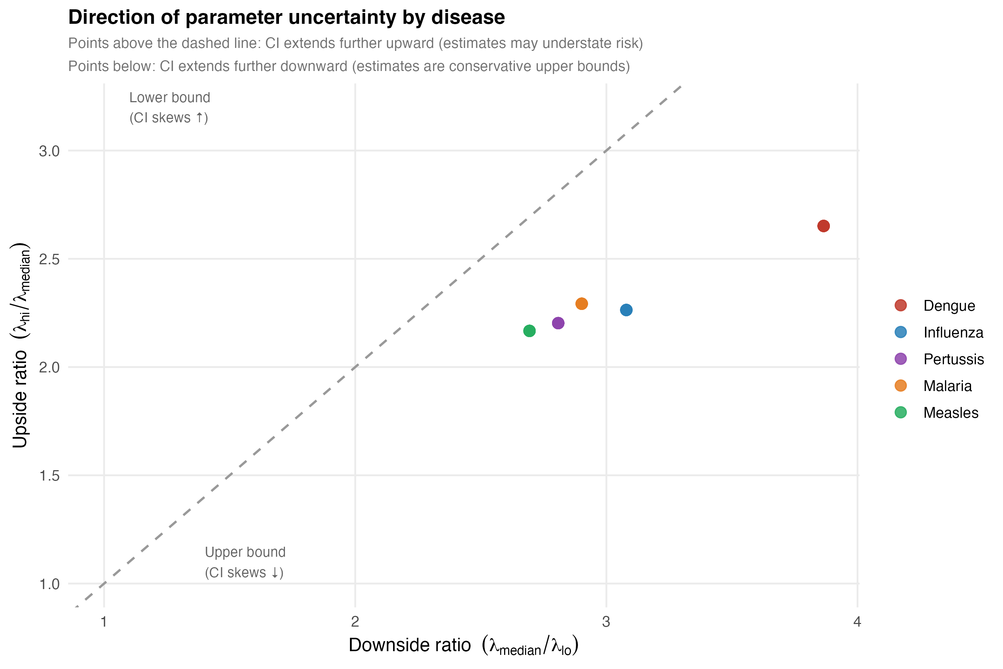
Direction of Monte Carlo parameter uncertainty by disease. Each point represents one disease–city pair under the schedule-driven model. Upside ratio $=Λ_{\text{hi}}/Λ_{\text{median}}$; downside ratio $=Λ_{\text{median}}/Λ_{\text{lo}}$. Points above the dashed diagonal: CI skews upward (central estimate near lower bound of plausible range). Points below: CI skews downward (central estimate near upper bound). Dengue and influenza may be underestimated; pertussis estimates are conservative upper bounds.

Importation risk overview: Baseline and WC-adjusted models
Figures [fig:heatmap_m1] and [fig:heatmap_m2] show the same $P(≥1)$ heatmap as Figure 1 in the main text, but for the Baseline (Model 1) and WC-adjusted (Model 2) tiers respectively. City and disease ordering are identical to Figure 1 to allow direct visual comparison across all three model tiers. Dengue importation probability is near-certain ($>0.99$) at the highest-risk cities under all three models, confirming that this finding is not an artefact of the schedule-driven travel assumptions.
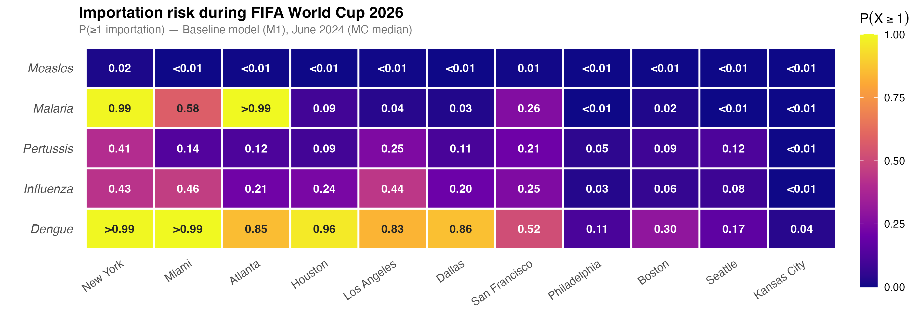
Importation risk overview under the Baseline model (Model 1): $P(≥1\text{ importation})$ using routine June 2024 COR arrivals with no World Cup growth adjustment (MC median, 5,000 draws). Same city and disease ordering as Figure 1 in the main text.
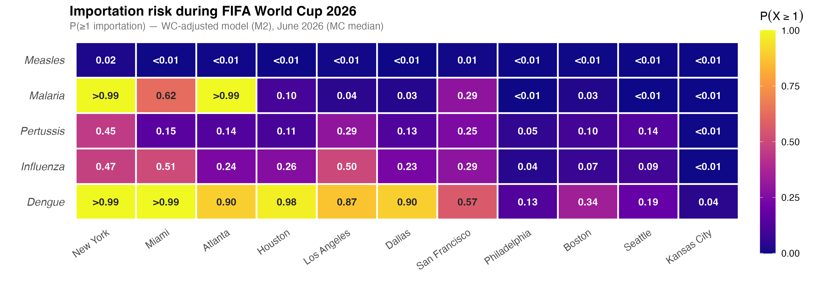
Importation risk overview under the WC-adjusted model (Model 2): $P(≥1\text{ importation})$ using June 2026 projected arrivals scaled by NTTO growth factors (MC median, 5,000 draws). Same city and disease ordering as Figure 1 in the main text.

Three-model comparison of importation intensity
Figure [fig:model_comparison] compares expected importation intensity ($Λ$, median and 95% MC uncertainty interval) across the three nested model tiers for the six highest-risk US cities. The near-uniform step-up from Model 1 to Model 2 reflects proportional amplification driven by the WC growth factor; the further step to Model 3 introduces modest city-specific divergence through schedule-based fan routing, without changing city or disease rankings.
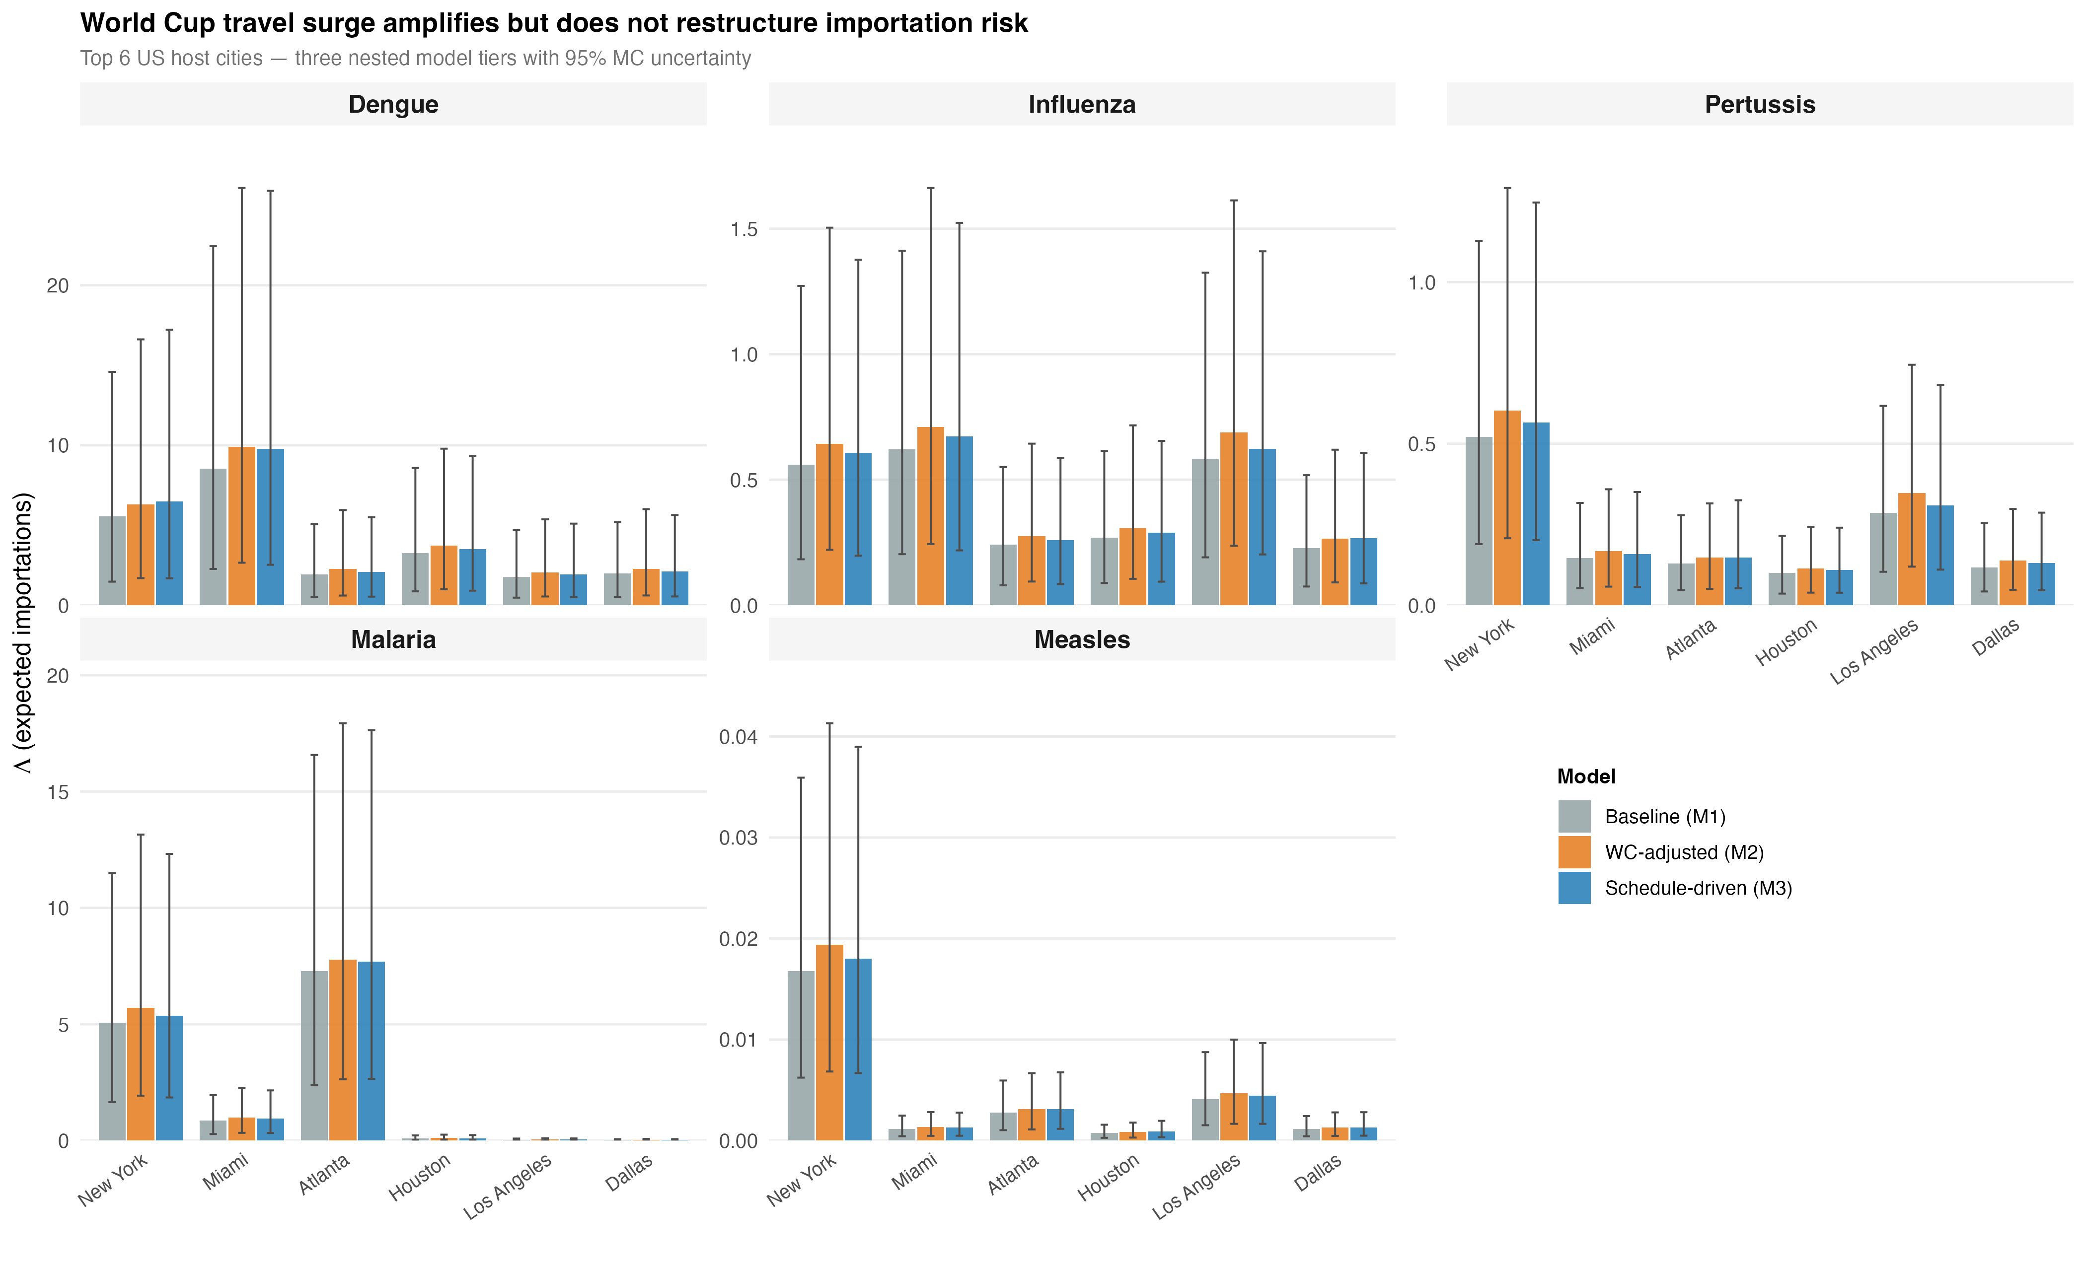
Three-model comparison of expected importations ($Λ$) for the six highest-risk US venue cities. Each panel shows one disease; bars are grouped by city and filled by model tier: Baseline (Model 1), WC-adjusted (Model 2), and Schedule-driven (Model 3). Bars show the MC median; whiskers span the 95% uncertainty interval. The WC surge amplifies risk proportionally; schedule-based routing introduces modest city-specific divergence but leaves rankings unchanged.

Dengue stream decomposition by source country
Figure [fig:stream_dengue] shows the dengue-specific travel stream decomposition for the top 20 source countries: background travel (blue) vs. WC fans (orange). The full five-disease stream panel is Figure [fig:stream_panel].
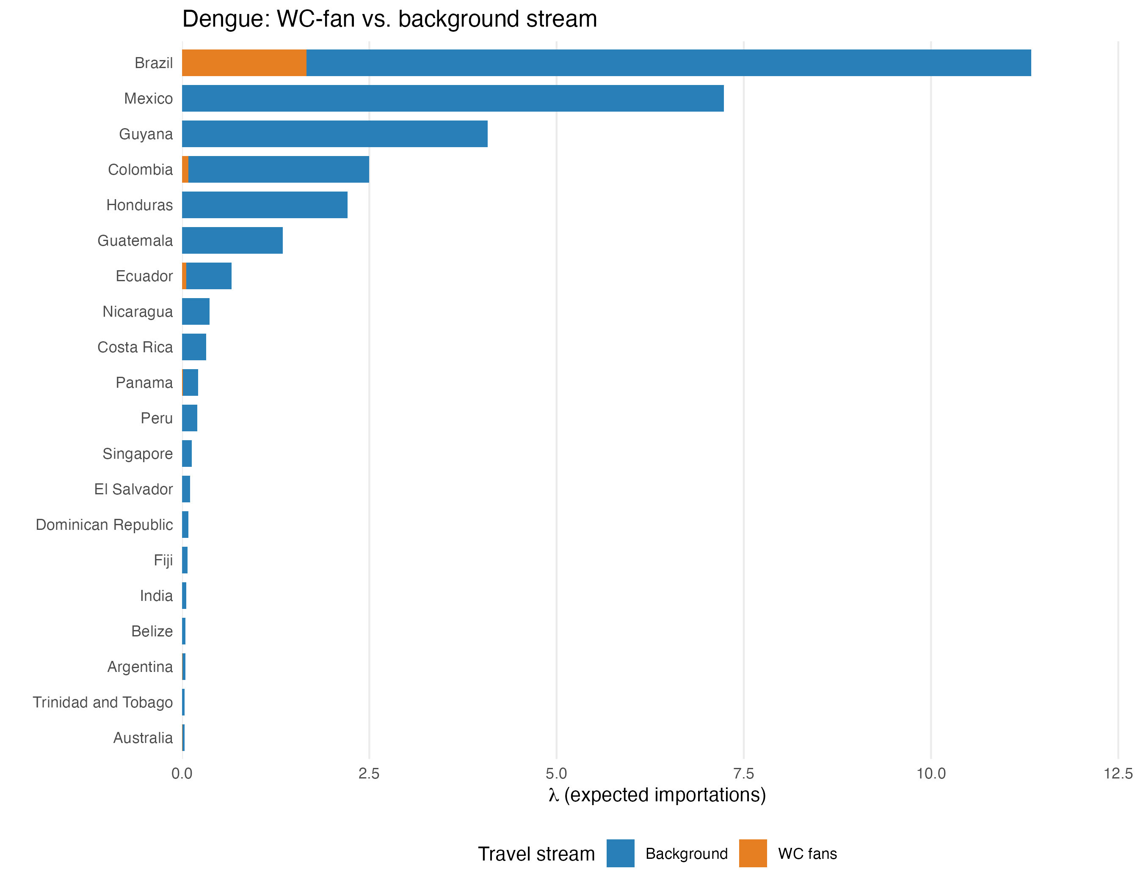
Dengue: importation intensity by travel stream for the top 20 source countries. Blue = background travel; orange = WC fans. Background dominates for all countries; the WC fan increment is largest for high-incidence WC-qualified nations (Brazil, Colombia, Ecuador).

WC-fan vs. background travel stream decomposition
Figure [fig:stream_panel] decomposes the top 20 contributing countries by travel stream (WC fans vs. background) for each of the five diseases. For WC-qualified countries, the WC-fan stream contributes a meaningful but typically minority share of the total importation intensity, consistent with the $≈8.3\%$ fan fraction. Non-qualified countries contribute exclusively through the background stream.
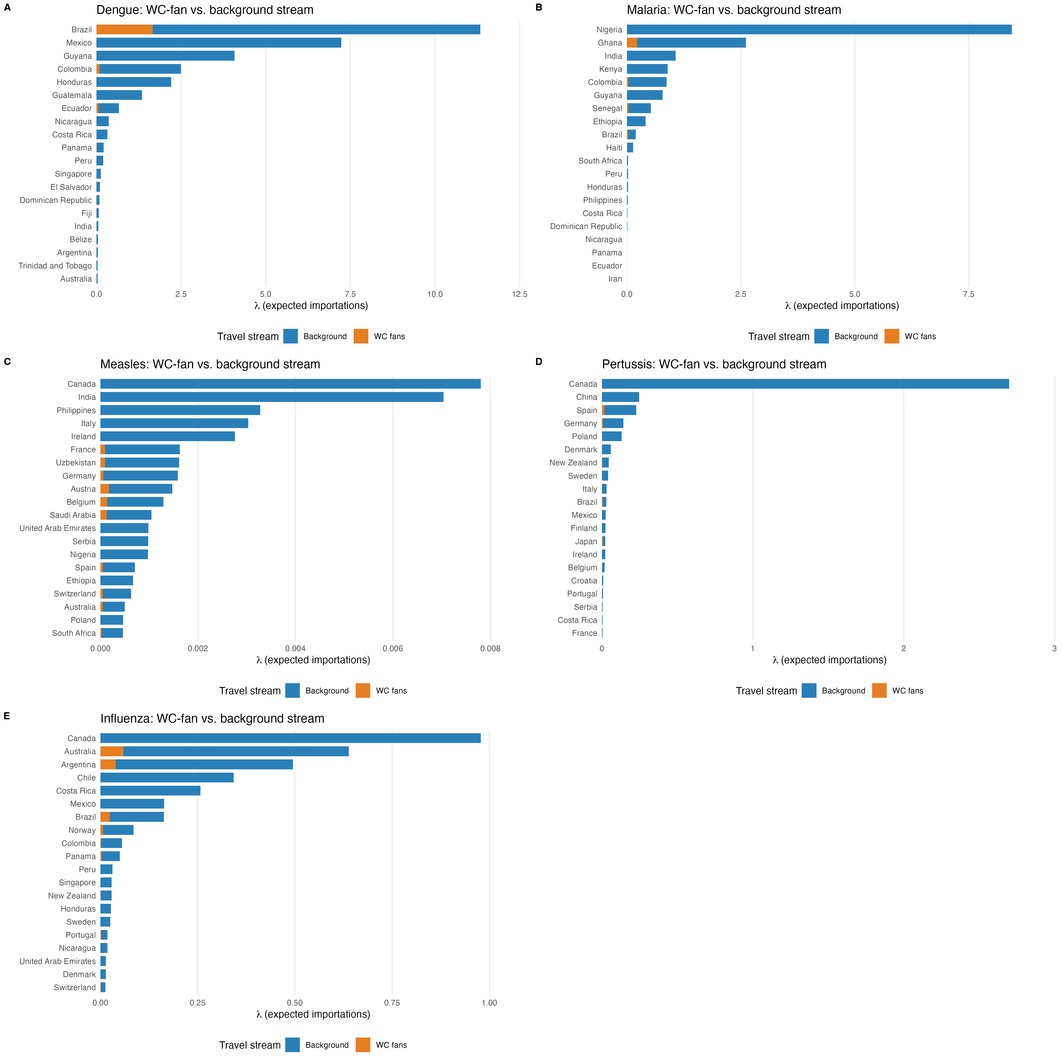
WC-fan vs. background travel stream decomposition for the top 20 source countries by total importation intensity, for each of the five diseases. Orange = WC fans; Blue = background. Countries with WC teams show a non-zero WC-fan component; non-qualified countries contribute only through background travel.

Country $×$ city importation heatmaps
Figures [fig:heatmap_dengue]–[fig:heatmap_influenza] present the country $×$ city importation matrix ($λ_{c,v,d}$) for each disease. WC-qualified countries from high-incidence regions show importation concentrated at the venue cities where their team plays, producing a block-diagonal structure aligned with the match schedule. Non-qualified countries show importation spread diffusely across cities in proportion to T-100 routing fractions.
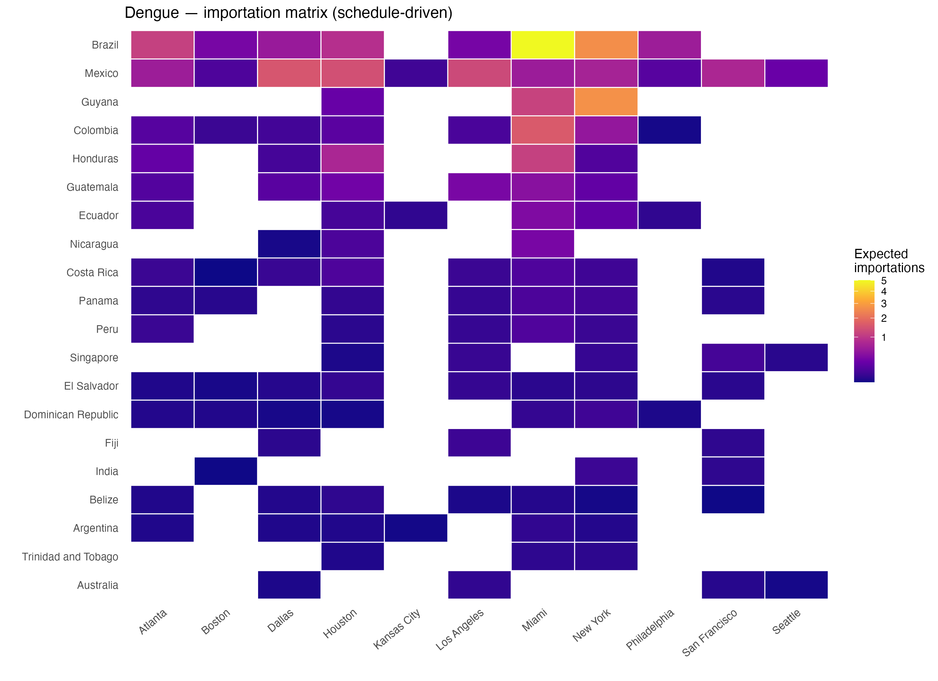
Dengue importation matrix: expected importations $λ_{c,v}$ by source country (rows) and destination city (columns) under the schedule-driven model.
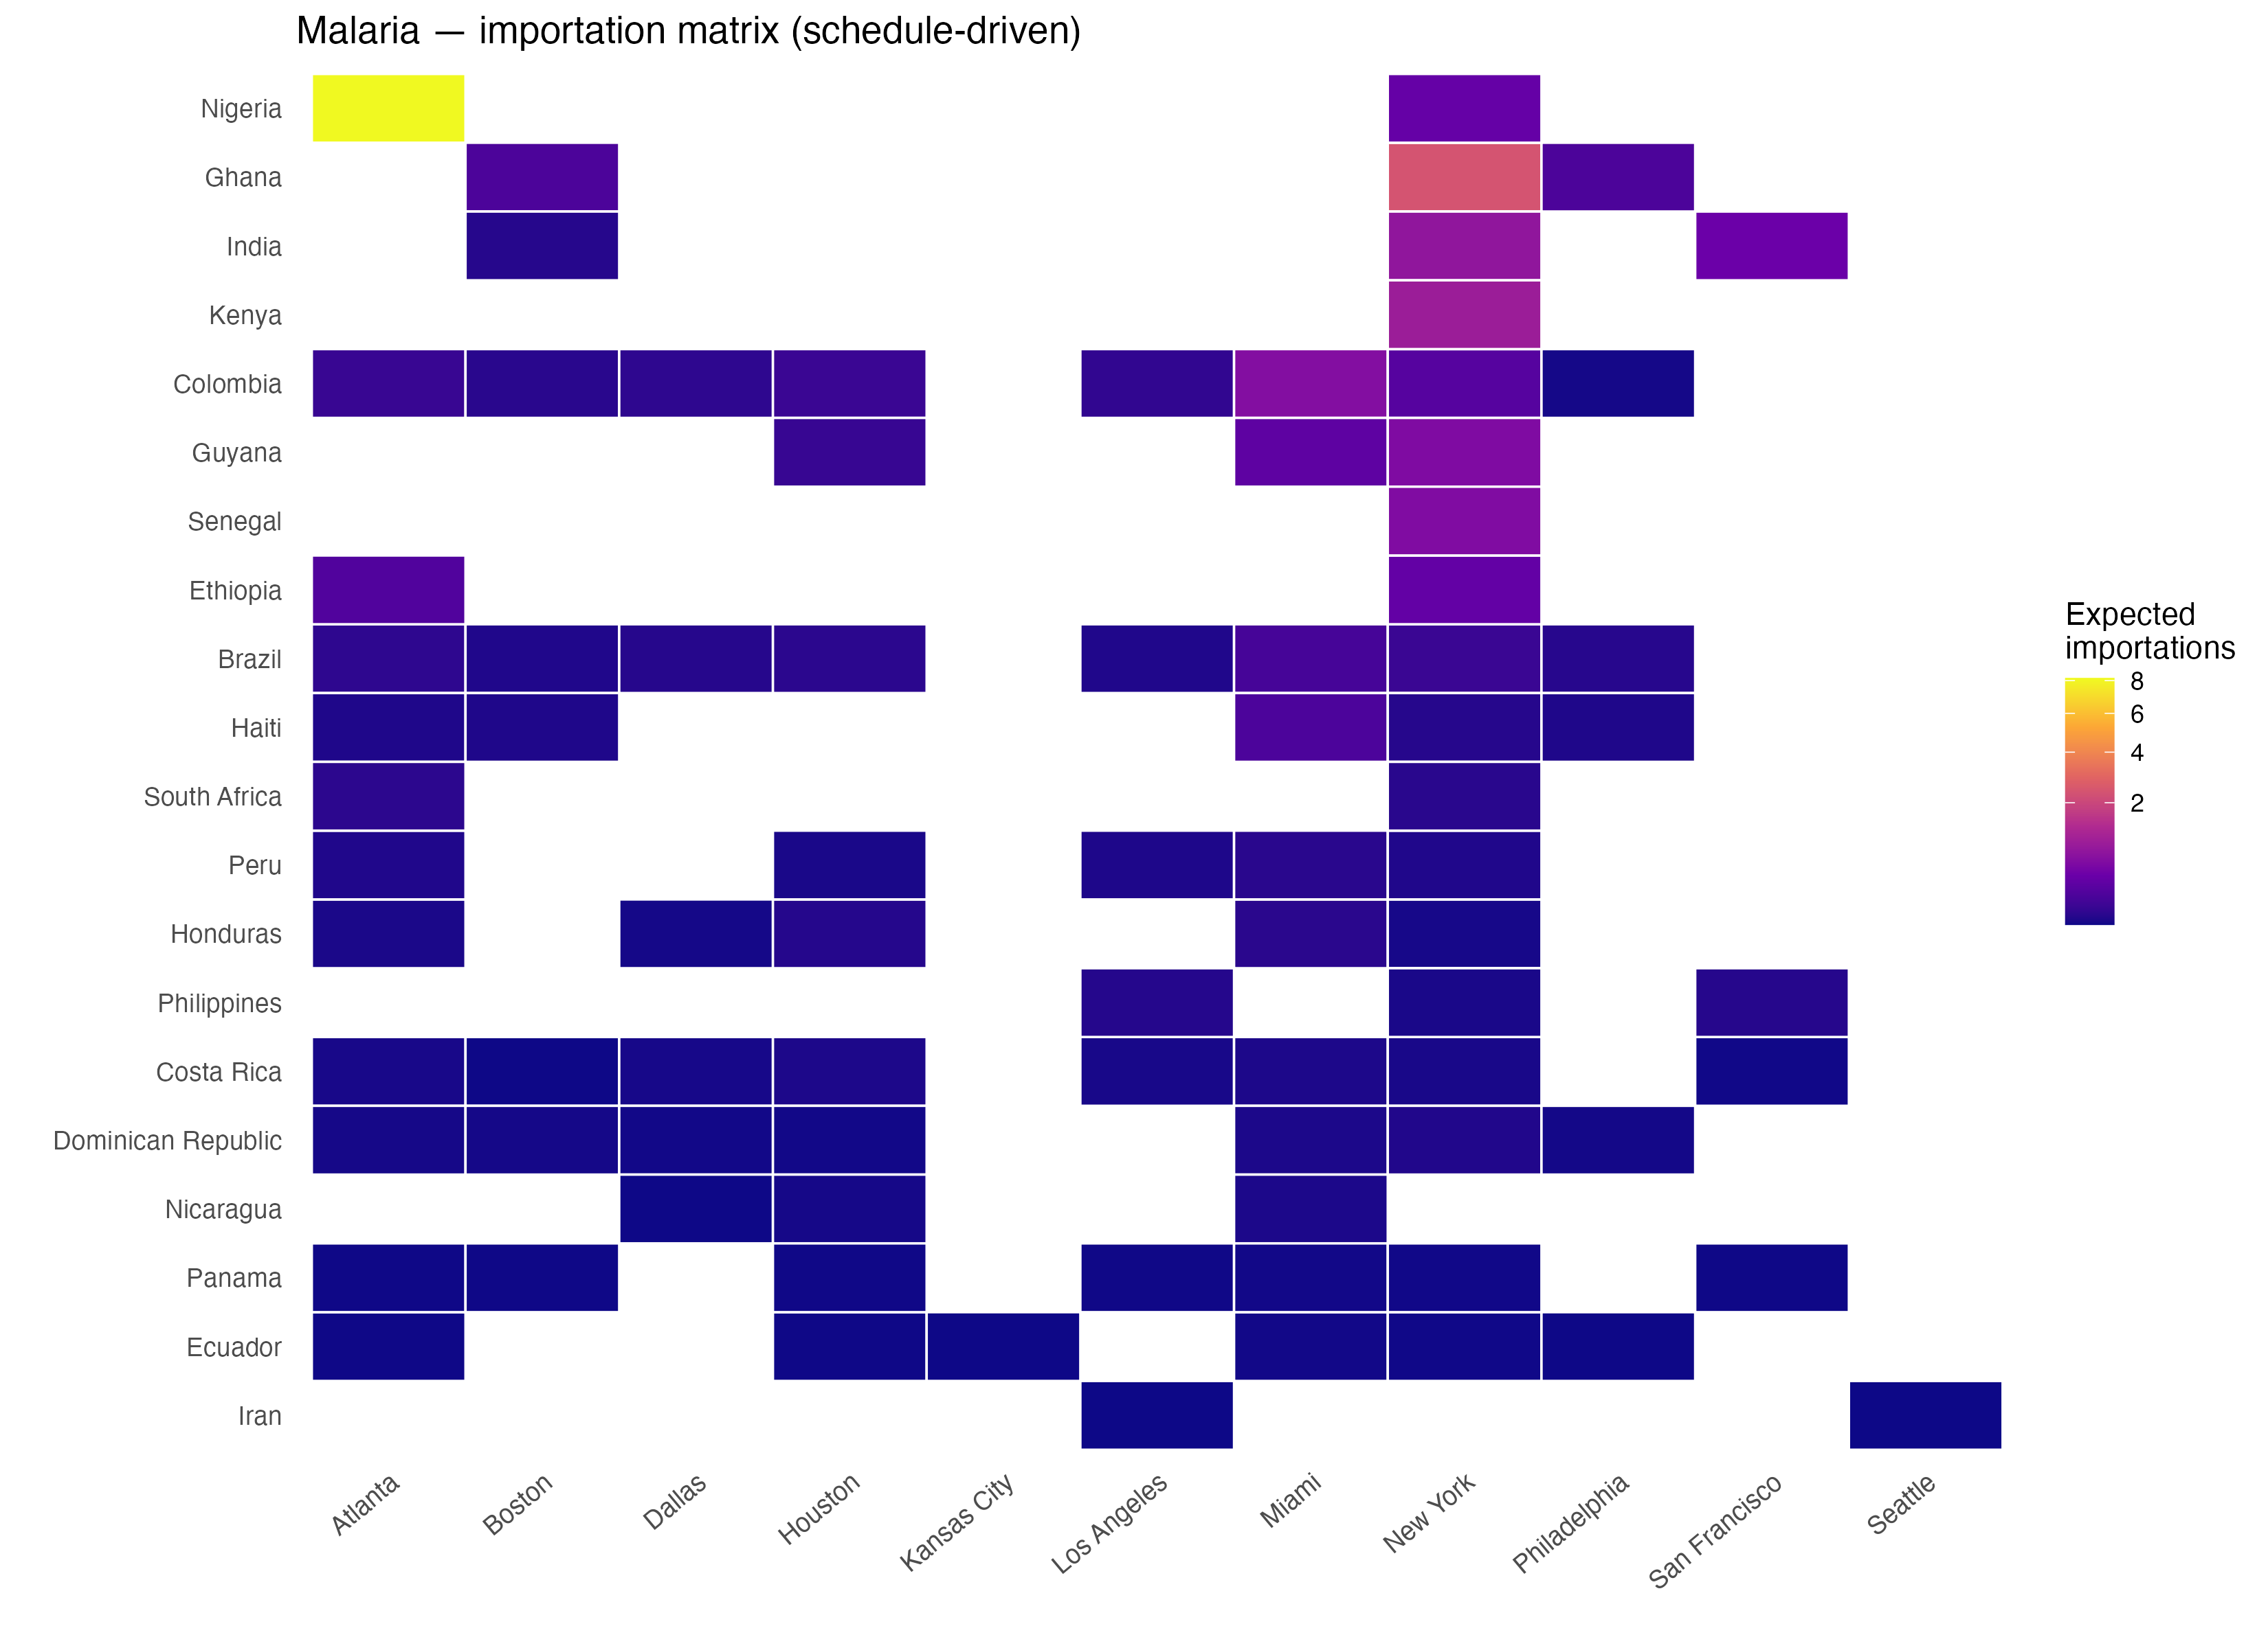
Malaria importation matrix. Risk is concentrated in West and Central African source countries.
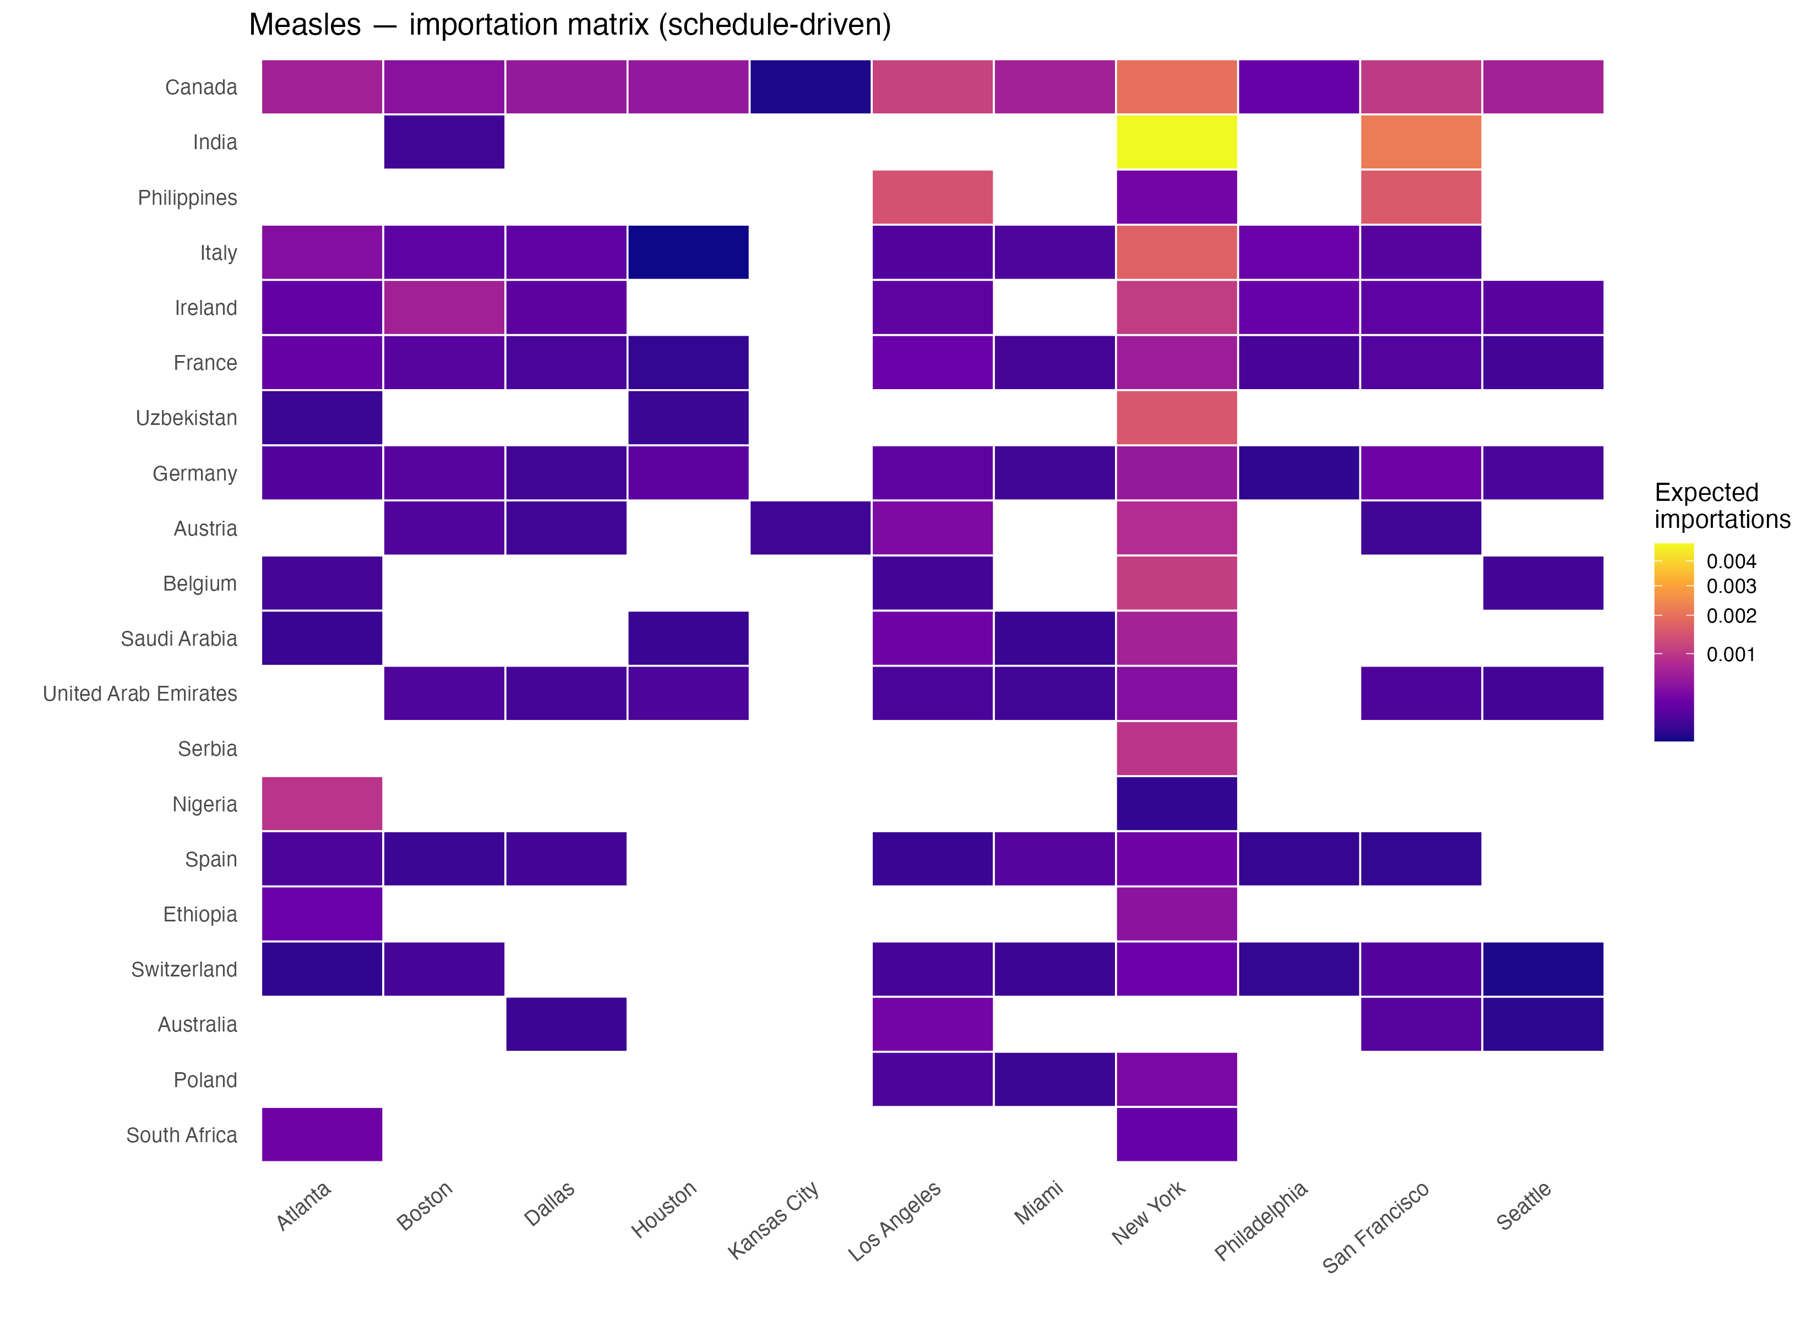
Measles importation matrix. Low absolute intensities across all cells reflect the low travel-while-infectious probability ($p=0.05$).
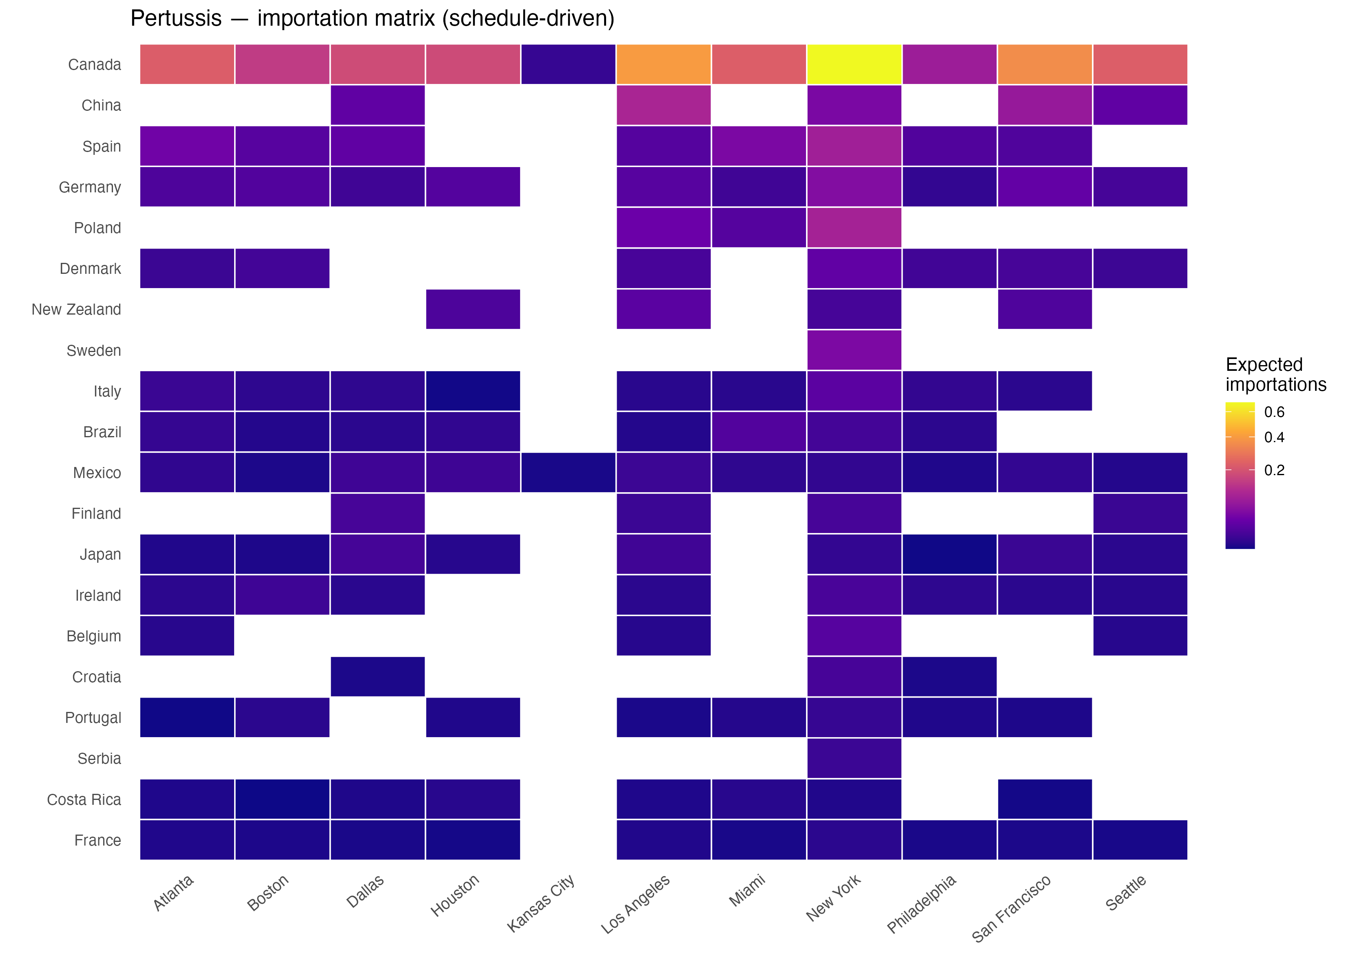
Pertussis importation matrix. The broad geographic spread reflects pertussis’s global endemicity and high travel-while-infectious probability ($p=0.70$).
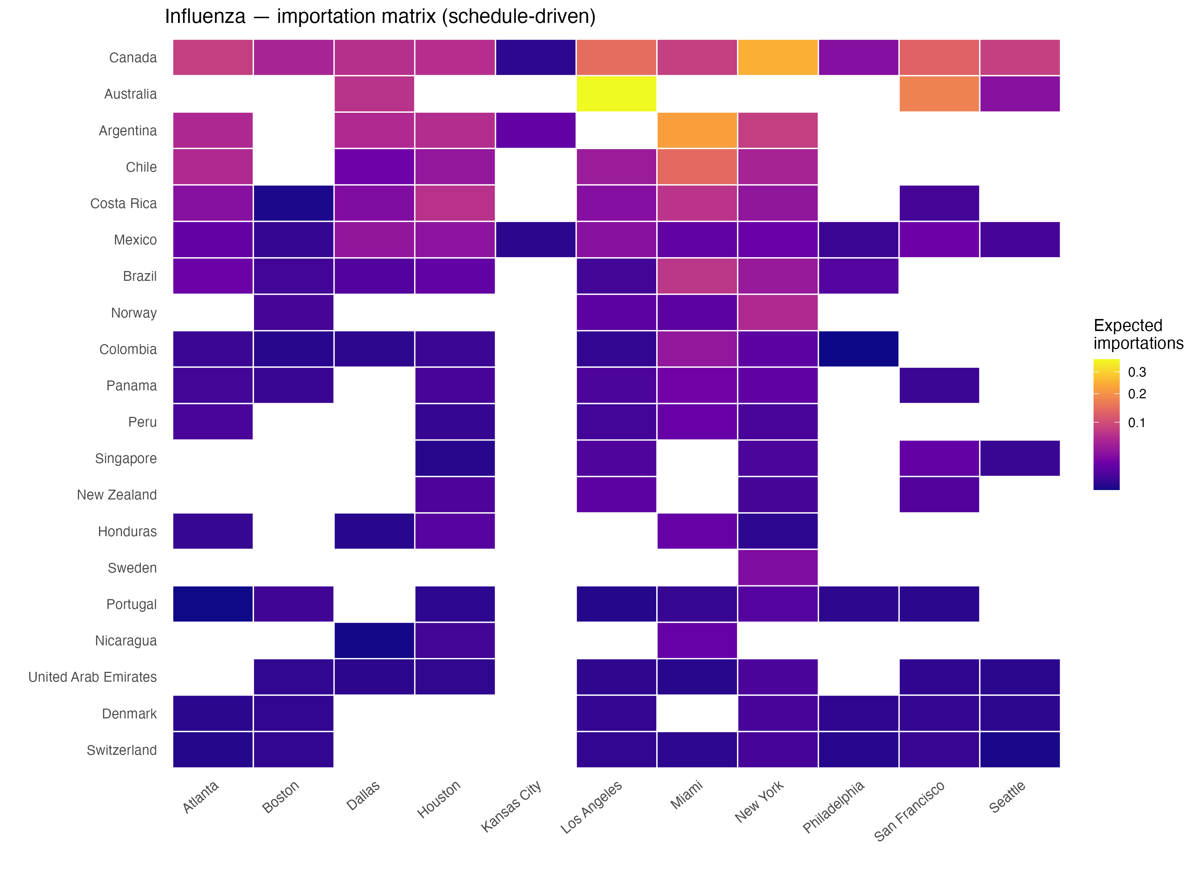
Influenza importation matrix. Risk is highest for Southern Hemisphere nations (Brazil, Argentina, Colombia) whose June peak transmission coincides with the tournament window.

Appendix C: Data Limitations and Improvement Opportunities

The role of non-public data in improving importation risk estimates
The framework presented here relies entirely on publicly available data sources — a deliberate choice that ensures reproducibility and allows the model to be updated by any public health team with internet access. However, several categories of proprietary and restricted-access data exist that would substantially improve the precision, timeliness, and scope of the estimates, and their absence represents the primary structural limitation of the current analysis.
The most valuable single dataset for this purpose would be airline booking and ticketing data. Companies such as OAG (Official Aviation Guide), Amadeus Travel Intelligence, and IATA’s PaxIS programme maintain origin-to-destination itinerary-level passenger records that cover not only the nonstop international segment (as T-100 does) but the full trip, including domestic connecting legs to non-gateway cities such as Kansas City and Seattle. These records are updated in near-real time and can be filtered to the specific June–July 2026 travel window rather than relying on historical routing fractions as a proxy for future behavior. Similarly, FIFA ticket sales records by country of purchase, while not publicly released, would replace the entire WC-fan travel decomposition framework with a direct, event-specific measure.
Beyond travel data, the precision of disease burden estimates is constrained by the reliance on WHO surveillance data, which is subject to reporting lags, inconsistent national case definitions, and known under-ascertainment. National or regional health ministry line-list or case-count data shared through WHO regional offices, the Pan American Health Organization (PAHO), or the European Centre for Disease Prevention and Control (ECDC) often contain more current and complete figures than what appears in the publicly indexed datasets used here. For measles and pertussis, age-stratified incidence and national vaccination coverage data at the subnational level would substantially improve the per-traveler infection probability $I_{c,d}$ by accounting for the fact that international travelers skew toward working-age adults.
Finally, the current model estimates importation risk but stops short of estimating local transmission risk after importation. Extending the framework in that direction would require local Aedes aegypti vector surveillance data from state and county health departments, hospital and public health capacity data by city and county, and aggregated mobility data from mobile device providers to calibrate the spatial spread of fans within and between cities. Establishing data-sharing agreements with the relevant agencies and commercial providers before the tournament begins would allow these estimates to be refined and operationalized in real time during June–July 2026.

Appendix D: Qualified Nations — 2026 FIFA World Cup
Country | Confederation | Host nation
Country | Confederation | Host nation
Continued on next page
Japan | AFC | No
Iran | AFC | No
South Korea | AFC | No
Australia | AFC | No
Qatar | AFC | No
Saudi Arabia | AFC | No
Uzbekistan | AFC | No
Jordan | AFC | No
Iraq | AFC | No
Morocco | CAF | No
Tunisia | CAF | No
Egypt | CAF | No
Algeria | CAF | No
Ghana | CAF | No
Cape Verde | CAF | No
Senegal | CAF | No
South Africa | CAF | No
Ivory Coast | CAF | No
DR Congo | CAF | No
Canada | CONCACAF | Yes
Mexico | CONCACAF | Yes
United States | CONCACAF | Yes
Panama | CONCACAF | No
Curaçao | CONCACAF | No
Haiti | CONCACAF | No
Argentina | CONMEBOL | No
Brazil | CONMEBOL | No
Ecuador | CONMEBOL | No
Paraguay | CONMEBOL | No
Uruguay | CONMEBOL | No
Colombia | CONMEBOL | No
England | UEFA | No
France | UEFA | No
Croatia | UEFA | No
Portugal | UEFA | No
Norway | UEFA | No
Germany | UEFA | No
Netherlands | UEFA | No
Switzerland | UEFA | No
Scotland | UEFA | No
Spain | UEFA | No
Austria | UEFA | No
Belgium | UEFA | No
Bosnia and Herzegovina | UEFA | No
Sweden | UEFA | No
Turkey | UEFA | No
Czech Republic | UEFA | No
New Zealand | OFC | No
Note: Confederation abbreviations — AFC: Asian Football Confederation; CAF: Confederation of African Football; CONCACAF: Confederation of North, Central America and Caribbean Association Football; CONMEBOL: South American Football Confederation; UEFA: Union of European Football Associations; OFC: Oceania Football Confederation.
Bhatt, Samir, Peter W Gething, Oliver J Brady, et al. 2013. “The Global Distribution and Burden of Dengue.” Nature 496: 504–7. https://doi.org/10.1038/nature12060.
Bureau of Transportation Statistics. 2026. T-100 International Segment (All Carriers) — Form 41 Traffic Data. Https://www.transtats.bts.gov/DL_SelectFields.aspx?gnoyr_VQ=FJE.
Herrera-Diestra, Jose Luis et al. 2026. “Importation Risk of Infectious Diseases During the FIFA World Cup 2026.” [Journal TBD].
McLaughlin, John M, David L Swerdlow, Sarah Isdale, et al. 2016. “Estimated Incidence of Pertussis in People Aged $<$50 Years in the United States.” Epidemiology & Infection 144 (13): 2676–84. https://doi.org/10.1017/S0950268816001126.
National Travel and Tourism Office. 2025. International Visitor Forecast: 2025–2029. Https://www.trade.gov/travel-and-tourism-forecasts.
Simons, Emily, Matthew Ferrari, John Fricks, et al. 2012. “Assessment of the 2010 Global Measles Mortality Reduction Goal: Results from a Model of Surveillance Data.” The Lancet 379 (9832): 2173–78. https://doi.org/10.1016/S0140-6736(12)60522-4.
Undurraga, Eduardo A, Yara A Halasa, and Donald S Shepard. 2013. “Use of Expansion Factors to Estimate the Burden of Dengue in Southeast Asia: A Systematic Analysis.” PLOS Neglected Tropical Diseases 7 (2): e2056. https://doi.org/10.1371/journal.pntd.0002056.
US Customs and Border Protection. 2026. Monthly Arrivals by Country of Residence (I-94 Data). Https://travel.trade.gov.
World Health Organization. 2024. World Malaria Report 2024. Https://www.who.int/teams/global-malaria-programme/reports/world-malaria-report-2024.
World Health Organization. 2025a. Global Dengue Surveillance Dataset. Https://www.who.int/data/gho.
World Health Organization. 2025b. Immunization Data: Reported Cases and Incidence. Https://immunizationdata.who.int.

