**Lab 7 Spatiotemporal Data and Real-time GIS**

**-Answers-**

**REMINDER: DO NOT CHANGE THE FORMAT OF THIS DOCUMENT. ALTER SPACING BETWEEN QUESTIONS AS NECESSARY.**

**/31**

**Name: Jacob Dietrich** **Date: 10/17/2021**

1. **Make a screenshot of your mobile phone showing one entry of your data you collected in the *ArcGIS* *Collector.****(2)*

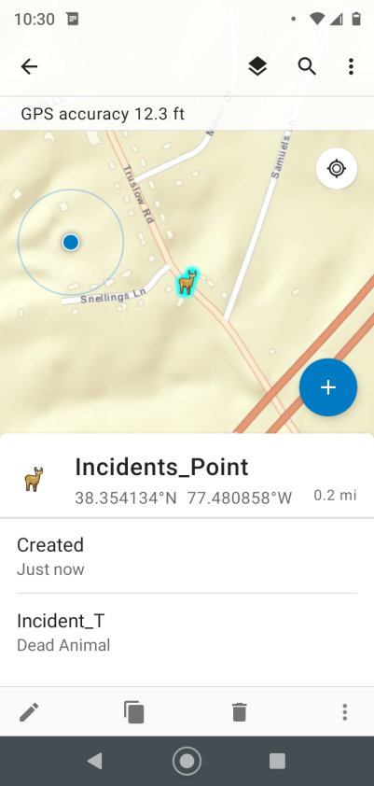

1. **Provide the URLs of both your Web map and dashboard app.** *(18)*

Web map - https://arcg.is/0PCOC51

Dashboard - https://arcg.is/yi4ae

1. **What are the spatial attributes (i.e., location) and temporal attribute (i.e. time), respectively, in the CSV file?** *(3)*

Location attributes in the file would be the X and Y columns. The Temporal data would consist of the Time column, as well as the Speed column in some cases.

1. **Provide the URL of your web app showing time series data** *(11)*

https://arcg.is/Cjmb4