**Lab 8 3D Web Scenes**

**-Answers-**

**REMINDER: DO NOT CHANGE THE FORMAT OF THIS DOCUMENT. ALTER SPACING BETWEEN QUESTIONS AS NECESSARY.**

**/40**

**Name: Jacob Dietrich**  **Date: 10/31/2021**

1. **Make a screenshot of your digitized points on top of your basemap in ArcGIS Pro. The locations of the digitized points should match those on your basemap.** *(6)*

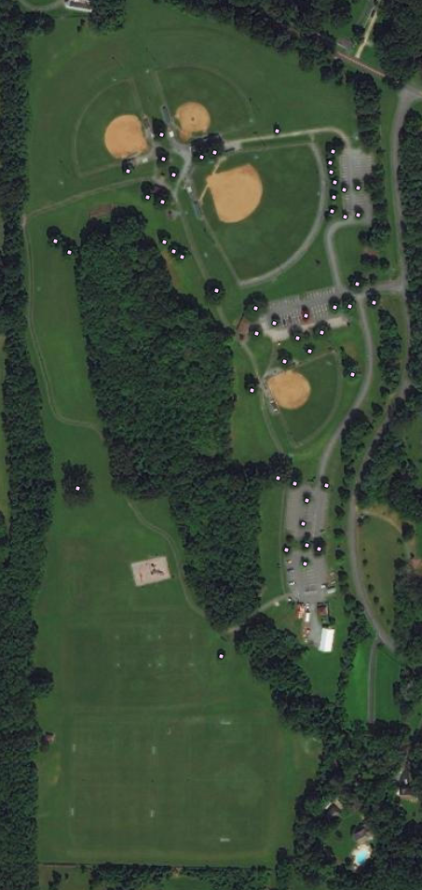

1. **Make a screenshot of the Attribute Table in ArcGIS Pro showing all attributes you entered for the digitized points** *(6)*

1. **Provide the URL of your hosted point feature layer.** *(2)*

https://services3.arcgis.com/eyU1lVcSnKSGItET/arcgis/rest/services/Trees_shp/FeatureServer

1. **Make a screenshot of your digitized buildings on top of your basemap in ArcGIS Pro. The locations and borders of the digitized buildings should match those on your basemap.** *(5)*

1. **Make a screenshot of your extruded buildings on top of your basemap in ArcGIS Pro.** *(3)*

1. **Provide the URL of your hosted scene layer.***(3)*

<https://services3.arcgis.com/eyU1lVcSnKSGItET/arcgis/rest/services/Willowmere_Park_POIs/SceneServer>

1. **Provide the URL of your web scene.** *(10, rubric as above)*
2. **Provide the URL of your web app.** *(5, rubric as above)*