**Lab 4 Mobile GIS**

**-Answers-**

**REMINDER: DO NOT CHANGE THE FORMAT OF THIS DOCUMENT. ALTER SPACING BETWEEN QUESTIONS AS NECESSARY.**

**/41**

**Name: Jacob Dietrich** **Date: 9/21/2021**

1. **Provide the URL of your survey for review. (14)**

https://arcg.is/1O5108

1. **Provide the URL of your survey results for review. Two entries should be shown. (1)**

**https://arcg.is/1yeHzD**

1. **Make a screenshot showing you are entering the entry through the survey web interface. At least the first three questions with input should be shown in your screenshot. (1)**

1. **Make a screenshot showing you are entering the entry through the *ArcGIS Survey123* app. At least the first three questions with answers should be shown in your screenshot. (1)**

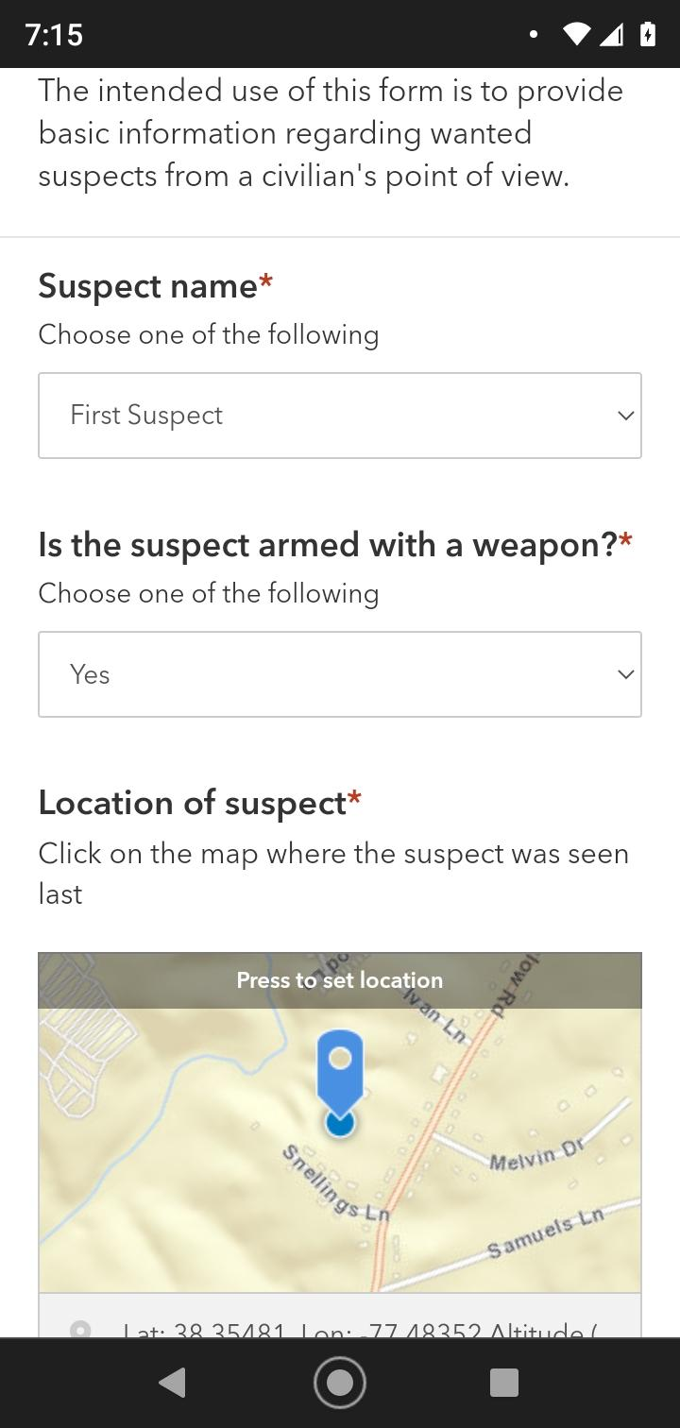

1. **By default, *can you edit your submission and resend it* through *ArcGIS Survey123 app on your phone?* (1)**

Yes, I can edit my submission and resend through the Survey123 app on my phone.

1. **Provide the URL of your *Web map* for review. All of the required features should have been created. (22)**

https://arcg.is/0GPS4O

1. **Make a screenshot of the *ArcGIS Collector app* on your phone showing the Editing page for a feature where all fields are filled and the location coordinates are determined*.* (1)**

