**Joe Monitor Instructions**

**Version 1.0**

Contents

Over View 3

Monitor Prerequisites 4

Example Code 5

Command AUTO (A) 6

Command Copy (C) 7

Command LIST (L) 8

Command Memory (Y) 9

Command NEW (N) 10

Command OLD (O) 10

Command Assemble Code (S) 11

Command Clear Sceen (z) 14

Command Help (?) 14

Command Go (G) 14

Command Erase Line (E) 14

Command Value (V) 15

Command Ascii (I) 16

Command User Command ( @ ) 17

Command Renumber (R) 17

Command Disassembler (D) 18

Command Mem Dump (M) 19

Command Trace (T) 20

Directives 21

.AS -/*string*/ 21

.AT -/*string*/ 21

.BS expression 22

.DA *expression* 22

.EQ expression 23

.OR *expression* 23

.TA expression 24

.DB expression 25

Numbers And Expressions 26

Decimal numbers 26

Hexadecimal numbers 26

Binary numbers 26

Positive ASCII 26

Negative ASCII 26

Current PC 27

# Over View

This is a 65C02 monitor developed for my 65C02 board. It contains a 65C02, 6551(ACIA), 6522(VIA) and the usual ROM (27C256), RAM decoding etc. It can be ported onto any 65C02 based computer with some minor modifications eg: KIM-1,Apple, C64,ViC20.

After searching the net I didn’t like many if not all the 6502 OS/Monitors. In my opinion I liked bits of them. So I decided to create my own. I began with little care about space, more functionality, but in the end, i was forced to keep it real tight.

My goal was for it to be a development machine/ bench top computer. Able to paste code to the terminal, compile it, dump, decode it, edit it etc. Some of this code had been inspired by many before me - the A1 Assembler by San Bergmans

<https://www.sbprojects.net/whoami/index.php>.

I liked the front editor but didn’t come with a dissembler. It’s 2 pass assembler and felt solid - but mostly written for an Apple.

With his permission i used his front end, but i ended up re-writing allot of it and certainly went over every line.

On the other hand The KRUSADER by Ken Wessen had the super-efficient disassembler that I’ve seen before (probably created by MOS and used by Apple) and it was tackling the additional 65C02 instructions. Didn’t like the editor no offence..

The old DOS debug command is how i wanted the console to feel, in other words, mistyping something means hitting the backspace not having to retype the whole line again as many of these monitors have you do – nuts.

So this is a full 2 pass assembler, with local and global labels, directives, the lot. I’ve also added a 65C02 disassembler, step by step debugging aka tracing, memory dump, ascii dump, fill, delete, block move, intel hex loader.

I’ve tested this on a real N65C02 computer. I’ve also included LCD 16x2 code - again also tested on real hardware.

Its currently takes just over 3.2KB

By Joe DiMeglio

# Monitor Prerequisites

This has been designed for the Rockwell 65C02 CPU and a terminal running ANSI screen codes, with serial 19200 baud N81

I’ve used RealTerm found here <https://sourceforge.net/projects/realterm/> to work best.

This was programmed in Michael Kowalski min version 1.3.2

# Example Code

The monitor is designed to be able to be copied & pasted from an external text application such as notepad and pasted, followed by compiling it (S key).

Copy & paste below {every between the lines}

AUTO

WRBYTE .EQ $FFDC

ECHO .EQ $FFEF

CR .EQ $0D

SP .EQ $20

;------------------------------

START JSR HELLO ;output to screen

JSR COUNT

RTS

;------------------------------

HELLO LDX #0

.1 LDA .3,X

BPL .2

JSR ECHO

INX

BNE .1

.2 ORA #1000.0000

JMP ECHO

.3

;------------------------------

.AT -/HELLO WORLD/

;------------------------------

COUNT JSR .2

LDX #0

.1 TXA

JSR WRBYTE

LDA #" "

JSR ECHO

INX

CPX #10

BCC .1

.2 LDA #CR

JMP ECHO

# Command AUTO (A)

#### AUTO linenum,increment

The command auto will auto number each line. The assembler uses line numbers to allow you to identify which line you like to delete, insert, renumber etc. Pressing **escape** on the last line will exit assembler editor.

Note: the default origin for source to is defined by the variable DEF_ORG which is $1000 and the incremental steps are DEF_INC defaulted to 10. Also the count is set by DEF_AUTO – which is 1000

See constants.65s

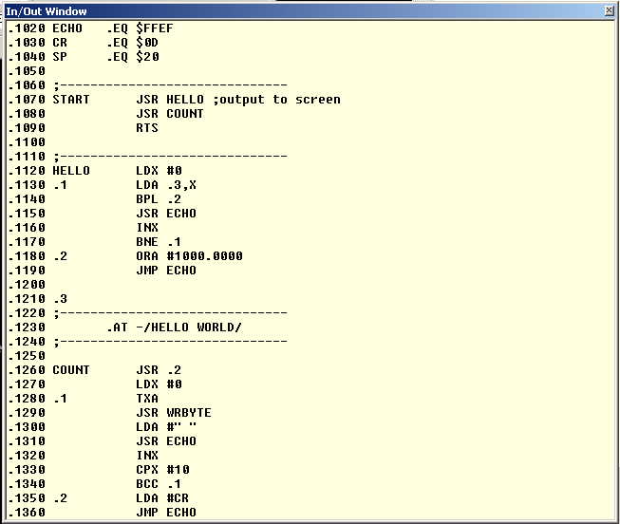

If no operands are given auto line numbering will start from the last entered line number + current increment. Or if no line has been entered before it will start from line number 1000, with an increment of 10.   
  
You may use *linenum* to start the auto line numbering from any specified number.   
You may use *increment* to change the default increment of 10.

AUTO Start numbering from last entered line number + increment

AUTO 2000 Start numbering from 2000 with unchanged increment

AUTO 4000,5 Start numbering from 4000 with 5 as increment

AUTO ,10 Start numbering from last entered line number + 5 as new increment

Pressing ESC will cancel auto line numbering and the current unfinished line. Simply hit ESC when you're done entering your source code or when you make some typing errors which you can't correct with the back space key. Typing AUTO again will generate the same line number you have just cancelled to allow you to start from scratch with this line.

It goes without saying that you do not have to use AUTO line numbering if you just want to enter one or two lines somewhere in your program. Simply type the appropriate line number after the prompt, followed by your source text.

The value of *increment* is limited to the range of 1 to 255. Higher values are truncated to the LSB value only, which could cause some unexpected increments. An *increment* of 0 will result in an increment of 1.

# Command Copy (C)

#### COPY source,destination,length

This command can be used to copy a part of memory to another destination. All three parameters are mandatory, you can't skip any of them.

It is possible that the destination block will eventually overwrite the source block. This means that the original block can be partially destroyed after the copy. However the copy will always be an exact copy of the original contents of the source block.

Warning! Be careful when the destination is in page 0. The COPY command uses 6 bytes there as temporary storage

Overwriting these values by random values will very likely crash your system.   
You should also be aware of the fact that the input buffer may partially overwrite your copied code if the destination is in the zero page.

There is absolutely no safeguard built into this command. You can make a copy anywhere in RAM, effectively destroying the data which is overwritten. This might even be your precious source text!

This command can be useful if you assembled a program with a different target address (See .TA directive). After assembling your code you can move the code to the desired destination.

# Command LIST (L)

#### LIST begin,end

This command lists your source to the screen. If no parameters are given the entire program is listed. The *begin* and *end* parameters can be used in the usual manner to control the range to be listed.

LIST list entire program

LIST 1000 list only line 1000

LIST 1000,2000 list lines 1000 until 2000

LIST 1000, list from line 1000 until the end of source

LIST ,2000 list from begin of source to line 2000

LIST D list dump the entire program

The ESC key aborts the listing.

The LIST command has one extra option. Typing LIST D will dump the entire program to the output without line numbers. This option can be used to transfer your source file to the PC over the RS232 connection. The resulting file on the PC can then be saved

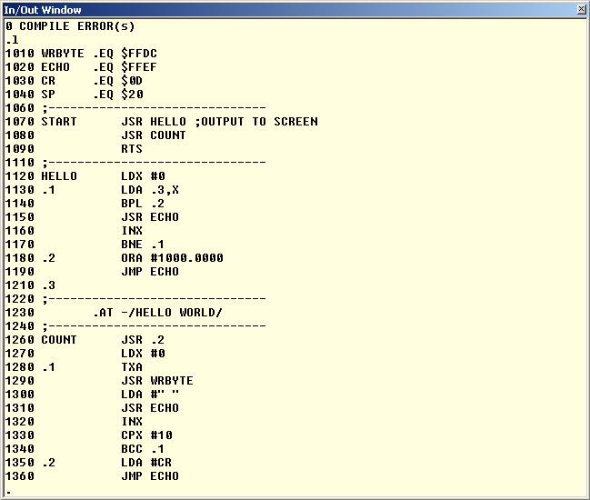

# Command Memory (Y)

#### Y lomem,himem

This command can be used to examine or change the memory configuration.

With no parameters this command will show you the current **Lower Limit(**LOMEM), **Total RAM** and end of source address. Your source file starts at address Lower Limit and may extend almost to address **UPPER Spent**(HIMEM). The end of your source file is at the same time the beginning of the symbol table which is built during pass 1 of the assembler. The symbol table will hold all your label declarations and may grow from the end of the source text all the way up to UPPER Spent.

Each global label will occupy 6 bytes in the symbol table, while each local label will occupy 2 bytes. This should give you a rough idea about the required amount of memory for the symbol table.

You can use the MEMORY (Y) command to find out what part of memory to save to file/cassette in order to store your source text. Lower Limit will be the start address and end of source will be the end address to write.

Generated code can be stored from address $0200 up to LOMEM, unless you have set the user safe area which can be set with the zero page addresses USR_OBJLO and USR_OBJHI.

Y

0600.$8000 lomem,himem

0F14 end of source text

At start up LOMEM will be set to $0600 and HIMEM to the highest available RAM address (max $8000). You may change LOMEM and HIMEM to your own liking, and I mean that!

Sensible values are from address $0200 up to the last available RAM .Any other values will probably crash your computer sooner or later!

Changing LOMEM and/or HIMEM will delete your current source text!

Y $1000,$8000

$1000.$8000

$1000

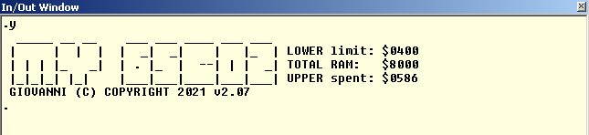

# Command NEW (N)

With this command you simply delete your current source text so you can start from scratch.

# Command OLD (O)

If you accidentally typed the NEW command you may restore your program. This will only work if you haven't entered any new source lines after executed the NEW command!

# Command Assemble Code (S)

This command effectively starts the 2 pass assembler. If no errors are found this command will inform you about the memory locations which are used to store the generated code.

The first column starts after the first space behind the line number. This column may contain a label or may be blank. A global label always starts with a character from A to Z and may contain any number of characters from A to Z, 0 to 9, or dots. Global label definitions may be followed by a colon, which is customary in some assemblers. Local labels always start with a dot, followed by a decimal number from 0 to 99.

If the first column does not contain a label it must start with a space. Or a line can start with a semi-colon in the first column, which indicates that the rest of the line is a comment. Comments are ignored by the assembler and are only there for us humans.

1000 LABEL

1010 ECHO:

1020 .59

1030 LABEL.WITH.A.VERY.LONG.NAME

1040 ; THIS LINE CONTAINS A COMMENT

1050 ; COMMENT LINES ARE IGNORED BY

1060 ; THE ASSEMBLER

1070 NOP NO LABEL ON THIS LINE

If the first character is a space the first column is considered empty, and thus contains no label (See line 1070). Please note that would make 2 spaces if you also count the space which always follows the line number!

Per default a label gets the value of the current program counter. Only global labels may get a different value if the source line contains an .EQ directive.

Please note that global labels may contain virtually any number of characters (from 1, up to the maximum line length). All these characters are significant!

However in order to preserve memory keep your labels as short as possible but keep them meaningful. Every character is one byte of your valuable memory, for every reference to that label!

If your source text contains errors the line numbers of the offending lines are listed, followed by a short description of the error which occurred. No code will be generated if errors occur during pass 1. Code generated in pass 2 will not be reliable if any errors occur during assembly.

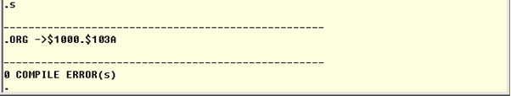

Compiling Errors will show you will which lines have errored on.

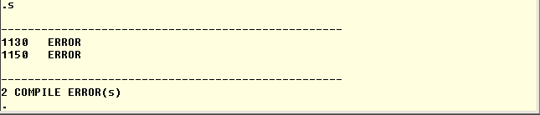

The second column starts at least one space behind the first column. It contains an assembler directive or a mnemonic.

An assembler directive always starts with a dot, followed by 2 characters. See the description of the available directives further down this page. A mnemonic always consists of 3 characters

The second column may also start with a semicolon, which means that the rest of the line contains comments only.   
  
If the second column is left empty, the entire rest of the line must remain empty. This is not a problem for the assembler. It is perfectly legal to place only a single label on a separate source line.

1000 START ; THE PROGRAM STARTS HERE

1010 INX

1020 .1 RTS

1030 TEXT

1040 .AS -/HELLO/

The third column starts at least one space behind the second column. It contains the operand of the previous mnemonic or assembler directive, if one is required. If the previous mnemonic or assembler directive did not need an operand this column is simply regarded as comment.

Some mnemonics have an optional operand. One such an example is the ROL instruction. Without operand it Rolls the contents of the Accumulator. With an operand it Rolls the contents of the address indicated by the operand.

In such cases you will have to use a semi-colon as a comment delimiter.

1000 ROL

1010 ROL MEMORY

1020 ROL ;THIS IS A COMMENT

1030 ROL ; OR COMMENT LIKE THIS

# Command Clear Sceen (z)

Clear screen via ANSI Screen codes to the terminal.

# Command Help (?)

Shows help screen

# Command Go (G)

G *address or label*

Execute the code from address or from label

# Command Erase Line (E)

*Erase begin,end*

Use this command to delete multiple lines at a time. Be careful though, undo is not possible. Once deleted the lines are gone forever!

Both the *begin* and *end* parameters are optional. However you'll have to enter at least one parameter for safety reasons.

ERASE 2000 delete only line 2000

ERASE 2000,2300 delete lines from line 2000 to 2300

ERASE 2000, delete from line 2000 until the end of source

ERASE,2300 delete from begin of source to line 2300

# Command Value (V)

VALUE expression,expression

This command can be used to view the value of labels, convert numbers from one radix to another, or even to do some simple calculations. Label values are only valid after a successful assembly run.

VALUE $1234

4660 +4660 $1234 %0001.0010.0011.0100

VALUE -1

65535 -1 $FFFF %1111.1111.1111.1111

VALUE $1234+135

4795 +4795 $12BB %0001.0010.1011.1011

VALUE ECHO

65519 -17 $FFEF %1111.1111.1110.1111

VALUE $1234,1234,%0101.1010

4660 +4660 $1234 %0001.0010.0011.0100

1234 +1234 $04D2 %0000.0100.1101.0010

90 +90 $005A %0101.1010

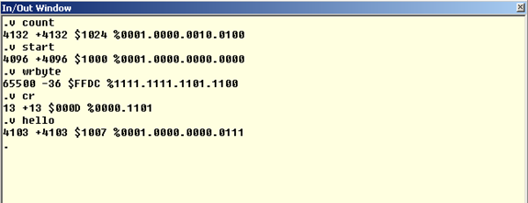

# Command Ascii (I)

i *address*

Ascii dump address. Address with $ is considered hex value.

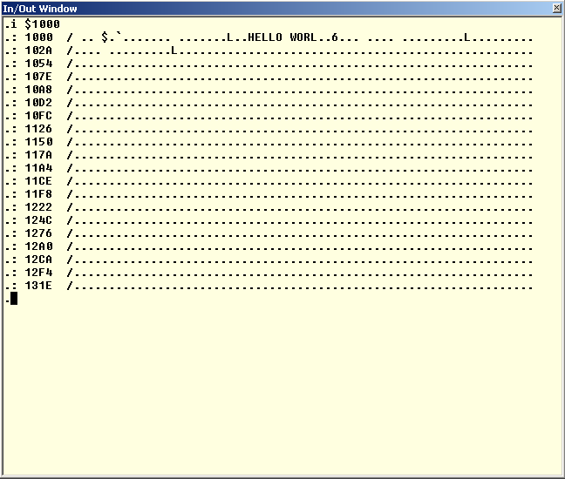

# Command User Command ( @ )

*@ command*

The @ command allows users to extend the commands to the monitor. Changing the USERKEYDEF vector, will mean that you can then add commands to the keyboard input. Ie; @ command will jump to USERKEYDEF where the user then needs to parse the IN keyboard buffer for addition keys/commands.

For example @S would jump to USERKEYDEF {aka *JMP (USERKEYDEF)* } where your routine would parse the IN for S and then act accordingly if found. See routine KEYDEF for example of how current commands are parsed.

#### **Command Renumber (R)** RENUMBER from,first,increment

From time to time you may want to renumber your source, or part of your source. Usually you want to do that to tidy up a bit, or to make room for more than a few new source lines between two other lines. For that purpose you can use the RENUMBER command.

The *from* parameter determines the line from which to start renumbering. If you omit it you will renumber your entire program.

*first* will be the first new line number to be used for the renumbered part of your source. If this line number is omitted the default AUTO line number will be used (1000).   
Finally the *increment* parameter will determine the increment of the renumbered part of your source. If it is omitted the default increment of 10 will be used. The valid range for *increment* is from 1 to 255.

You can't set *from* higher than *first*, otherwise you may get duplicate line numbers which would definitely confuse the editor.

After renumbering the next auto line number will be the last renumbered line number + increment. The new increment will also be set according to the renumbered increment.

RENUMBER renumbers entire source, same as RENUMBER 0,1000,10

RENUMBER 2000,3000 renumbers source from 2000 until end, increment 10

RENUMBER ,4000 renumbers entire source, new source starts at 4000

RENUMBER 1000,2000,5 renumbers from line 2000, new line 2000, increment 5

# Command Disassembler (D)

*D address (or label)*

This will dissemble code from start address or from label. When just press d will continue down one page.

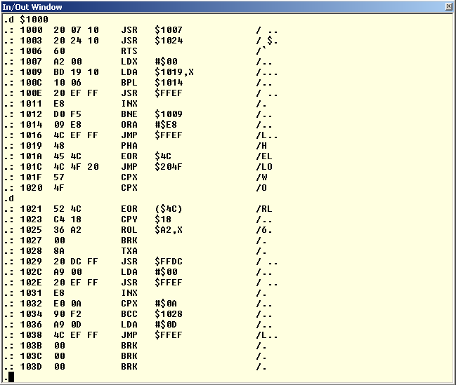

# Command Mem Dump (M)

M *address*

Byte and asci dump of ram. Consecutive M , will continue page through the memory.

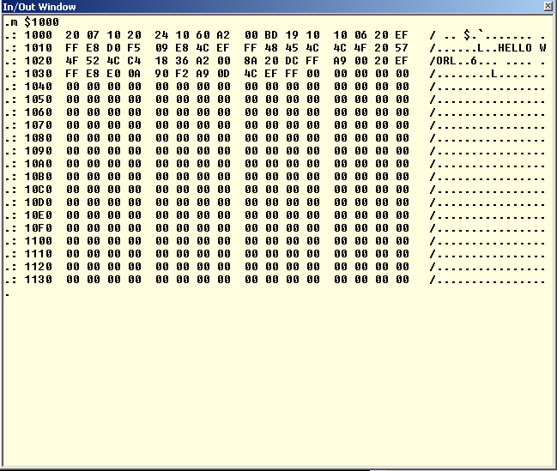

# Command Trace (T)

T *address*

This is steps through the code one line at time. Pressing **t** will continue to step through each line. The flags, PC, registers show the values of the last actioned command.

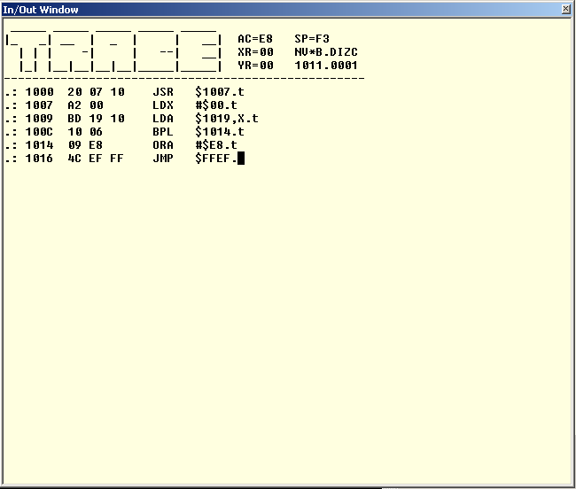

# Directives

Directives are often called pseudo opcodes. They are always to be found in column 2, where you would also find processor opcodes (mnemonics). A directive is a command to the assembler, for instance to generate data bytes or change the current program counter.

## .AS -/*string*/

This directive allows you to enter an entire string as data into your program. If the first character of the operand is — sign the entire string will be in negative ASCII (128 .. 256), the way the Apple 1 likes to get its ASCII characters. If the first character is not a — sign the string will be in positive ASCII (0 .. 127).

The string of characters must be surrounded by a so called delimiter. A delimiter can be virtually any ASCII character, which should be the same at the beginning and at the end of the string. Usually the characters / \ " or ' are used as delimiters, that is if you can type \ of course. The delimiter you use may not occur in the string, otherwise you'll get an error message.

1000 .AS /ABC/ generates 41 42 43

1010 .AS !123! generates 31 32 33

1020 .AS -"ABC" generates C1 C2 C3

1030 .AS -'1234567890' generates B1 B2 ... B3 B0

Please note that the Assembler does not allow you to use more than one operand after

## .AT -/*string*/

This directive is almost identical to the .AS directive. The only difference is the polarity of the last generated character, which is opposite from the rest of the string. This opposite polarity can be used by the software to signal the end of the string to be printed.

1000 .AT /ABC/ generates 41 42 **C3**

1010 .AT !123! generates 31 32 **B3**

1020 .AT -"ABC" generates C1 C2 **43**

1030 .AT -'1234567890' generates B1 B2 ... B3 **30**

## .BS expression

This directive skips the number of bytes indicated by the *expression*. Therefore the *expression* may not contain forward referenced labels, otherwise the assembler would not know how many bytes to skip.

Skipped bytes are not altered! The only thing that happens is that the current program counter is incremented by *expression*.

You can use .BS for instance to declare RAM addresses easily (like i.e. Zero Page locations).

1000 .OR $0080

1010 POINTER .BS 2 A 2 BYTE POINTER

1020 COUNT .BS 1 A 1 BYTE COUNTER

1030 BUFFER .BS 10 A 10 BYTE BUFFER

1040 FLAG .BS 1 A 1 BYTE FLAG

You may use any value as *expression*, even quite silly values like $FFFF, the A1-Assembler couldn't care less.

## .DA *expression*

With this directive you can include data bytes and words into your program. You can include as many operands as you like (until the program line is full), all separated from the previous one by a comma. Any combination of word, LSB and MSB operands is possible.   
For byte data the *expression* must be preceded by a # or a / symbol. The # symbol will use only the LSB of the 16-bit *expression*, whereas the / symbol will use the MSB.   
Word data is generated with LSB first (little endian). This is the way the 6502 likes it best.

1000 .DA $1234 generates 2 bytes, 34 12

1010 .DA #$1234 generates 1 byte, 34

1020 .DA /$1234 generates 1 byte, 12

1030 .DA $1234,#$5678,/$9ABC multiple operands, 34 12, 78, 9A

## .EQ expression

Normally a label will get the value of the Program Counter at the beginning of the line on which the label is assigned. This behaviour can only be changed by this directive.   
Column 1 must contain a global label when the second column contains the .EQ directive. You can't use the .EQ directive on local labels.

The label in column 1 gets the value which is represented by *expression*. This *expression* may not contain forward referenced labels!

PRBYTE .EQ $FFDC

ECHO .EQ $FFEF

CR .EQ $8D

SPACE .EQ " "

CHOUT .EQ ECHO CHOUT will get the value $FFEF

It doesn't matter what type of data is assigned to a label. It may be an address, a constant value, an ASCII value, or whatever. You can however only assign values to labels. This means that you cannot assign a string of characters to a label.

## .OR *expression*

This directive sets the starting address of your program, or parts of it. It also sets the target address to the same value (See .TA directive). If this directive is omitted the default starting address will be $1000. See DEF_ORG in Constants.65s

You can set the starting address *expression* anywhere in memory. However you can not store code just about anywhere in memory. If you haven't set a user safe area you can only generate code to the range from $0200 (DEF_OBJLOW) to LOMEM, otherwise you'll get a memory error.

You may change the starting address of your program as often as you like. Every block of memory generated is reported by the assembler, which makes it easier for you to locate your code.

The *expression* may not contain forward referenced labels.

1000 .OR $0080 ;START ZP DEFINITION

1010 PNTR .BS 2

1020 CNTR .BS 1

1030 BFFR .BS 10

1040 .OR $0300 ;START CODE HERE

1050 NOP

1060 NOP

1070 .OR $0400 ;MORE CODE HERE

1080 NOP

1090 NOP

1100 NOP

(.BS directive does not generate code)

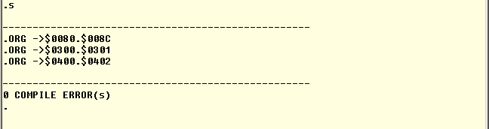

## .TA expression

You can't generate code in protected memory. Normally you can only generate code from address $0200 until LOMEM, the rest of memory is protected.

You may indicate a user safe area by setting the memory addresses USR_OBJLO and USR_OBJHI to declare another part of memory to be safe. However you're in charge there, you're the one who should be absolutely sure that it IS safe! Setting these two values doesn't automatically make the area safe, it only allows the assembler to store generated code there.

But what if you want to create a program which should run in a protected area, let's say from address $E000? Simple, you set the .OR to $E000, and change the target address to a safe area, e.g. $0300 (see example below).

The assembler will generate all addresses as if it was actually using address $E000. However the code is stored at address $0300. Obviously this will result in a program which does not work as is. You'll have to move the program to the intended destination before it can be run.

Moving the code to its final destination can be done with the COPY (C) command, or by saving it to file and loading it at a different address.

The *expression* may not contain forward referenced labels.

1000 .OR $E000

1010 .TA $0300

1020 START NOP

1030 NOP

START

----------------------------------------------------------

ORG -> $0300.$0301 this proves that the right target address is used

----------------------------------------------------------

0 COMPLIE ERRORS

VALUE START here's some more proof

57344 -8192 $E000 %1110.0000.0000.0000

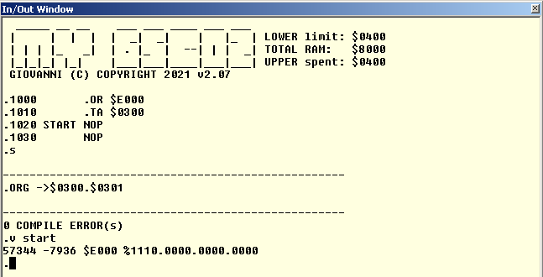

## .DB expression

Single byte definition.

Note: < WORD –returns lower byte

>WORD – returns upper byte

# Numbers And Expressions

Many commands and operands accept numbers and expressions. An expression is simply a mathematical combination of several numbers.   
Any number is limited to 16-bits only. Enter larger numbers than that and you'll be treated with a range error.   
You may precede any number with a negative sign to make it negative (2's compliment).

Wherever the Assembler expects a number you can supply it in one of the following options:

## Decimal numbers

Start with a digit from 0 to 9, and may only contain these numbers.

123

-500

## Hexadecimal numbers

Start with a dollar symbol, and contains only normal digits 0 to 9 and extra digits A to F.

$10

$FFEF

-$100

## Binary numbers

Start with a percent symbol and may contain only the digits 0 and 1. You may place dots anywhere in a binary number to make them easier to read. The assembler simply ignores the dots.

%1000.1101

%1111100101110101

%1111.1001.0111.0101 same value as above!

-%1000

## Positive ASCII

Generates values between 0 and 127, depending on the character enclosed in single quotes.

'A' TRANSLATES TO $41

'2' TRANSLATES TO $32

## Negative ASCII

Generates values between 128 and 255, depending on the character enclosed in double quotes. Please note that this is the native Apple 1 mode to represent ASCII characters!

"A" TRANSLATES TO $C1

"3" TRANSLATES TO $B3

## Current PC

A single dollar symbol, not followed by a legal hexadecimal digit, will result in the current program counter value. The value used was the program counter at the start of the current source line.

$

#### Labels

Simply the label's value is used. Only assembly pass 1 allows the use of labels which are not defined yet. In that case we speak of forward referenced labels.   
  
An undefined label during pass 2 of the assembly will result in a definition error.  
   
In case of forward referenced labels we can not know their actual value during pass 1 of the assembler. Therefore some instructions which can use shorter addressing modes will fall back on the worst case scenario and use long addressing mode instead.

Expressions can be used to combine 2 or more values to get a new final value. You can use one of the 4 basic operators in expressions:

|  |  |
| --- | --- |
| + | Addition |
| - | Subtraction |
| * | Multiplication |
| / | Division |

All expressions are evaluated from left to right. No priority is given to multiplication and division over addition and subtraction unlike in normal math. Parentheses can not be used to change priority in expressions. Overflows in expressions are ignored and the result is always truncated to 16-bit integers.   
You can mix any legal number form with any number of operations.

1234+$1200 RESULTS IN $16D2

$F000-123 RESULTS IN $EF85

%101*2 RESULTS IN $000A

$5678/4 RESULTS IN $159E

LABEL*2 RESULTS IN THE VALUE OF LABEL TIMES 2

All results are 16-bits long integers. No errors are reported if the result exceeds the limits of a 16-bit number, only the least significant 16-bits are used as result. This may sometimes give some strange results, especially if the expression contains multiple operations.

For example 7/8*100 results in 0. This is because 7/8 is 0.875, which is truncated to 0 caused by the integer division. You'll get a much better result by rewriting the expression to 100*7/8, which is still an integer.

The data directive (.DA) and all immediate addressing mode instructions normally use the < symbol to identify the 8 least significant bits of the expression. If you need the most significant bits however you can substitute the <symbol by the >symbol.

.DA $1234 16-Bit data result ($34 $12)

.DA <$1234 8-Bit data result LSB ($34)

.DA >$1234 8-Bit data result MSB ($12)

LDA <$1234 Load Accu with LSB ($34)

LDX >$1234 Load X with MSB ($12)