Dual-Booting Ubuntu

***Please come ask if you have any problem with any of these steps! Everyone needs Ubuntu on their computer to participate in the programming for the CV system***

The first step to dual boot operating systems is to partition your hard drive. Basically, this is just taking your storage space and cutting it into parts so that the new operating system you install doesn’t interfere with anything you currently have on your computer. Then, you need to boot that operating system externally (typically done via a formatted flash drive). Follow the respective guide for your computer to boot from a flash drive. Then proceed with the installation steps to install the new operating system to the partition you made in the first step. I know it sounds annoying, but trust me, it’s much more annoying when you actually do it :)

Also, keep in mind that on some systems Ubuntu is a little buggy – your keyboard and touchpad may not be detected (typically a problem for Mac users). More info on this is listed at the end of this guide in case you do encounter this issue.

-- Step 1: Partitioning a Hard Drive –

**Partitioning a Hard Drive in Mac OS:**

1. If you’re paranoid about messing something up on your computer, just make sure your important documents are backed up. If you accidentally make your partition too big, your files in the main partition may get deleted due to the lack of empty space in your main drive. Just be careful.
2. Launch Disk Utility from /Applications/Utilities/ .
3. Select the hard disk you want to partition from the left side of the screen. Make sure the one you select has plenty of space open (40Gb minimum) to create the partition for your new operating system.
4. Click the tab in the middle of the screen that says “Partition”. (you may need to confirm this in a pop up window – just press “partition” again)

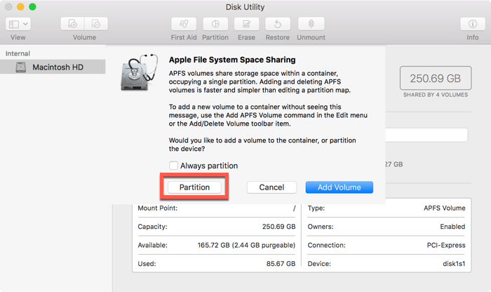

1. Click the “+” button to add a new partition. Choose a name for it (can be anything), choose a size (40Gb is good, 50Gb is better). Click “Apply”. Your screen for this step should look like one of the images below. (If you also need to select a format for the partition, select “MS-DOS (FAT)” ).

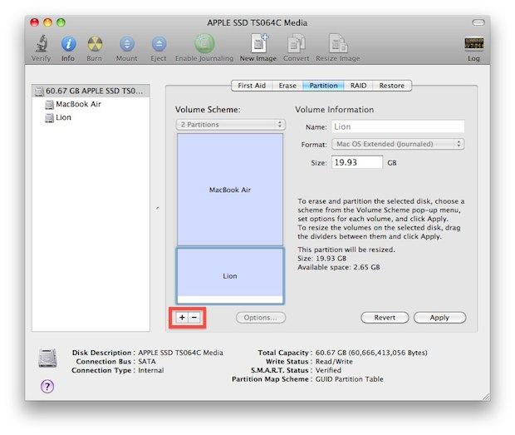

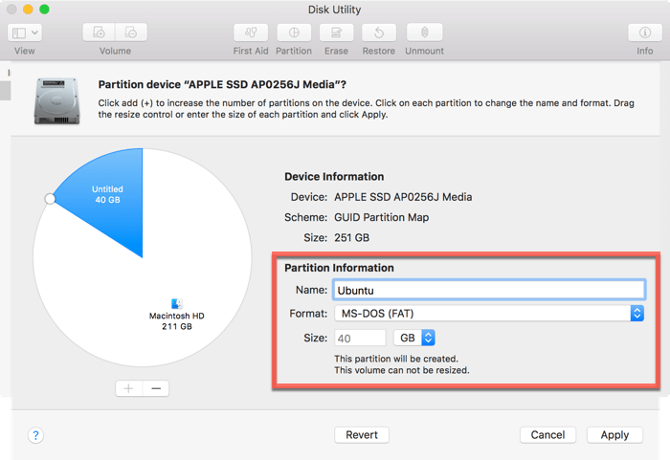

1. Click “Apply”, then “Partition” to execute!

**Partitioning a Hard Drive in Windows 10 OS:**

1. Right click on the windows icon in the bottom left corner of the screen.
2. Select “Disk management”.
3. Your screen should look like the one below: 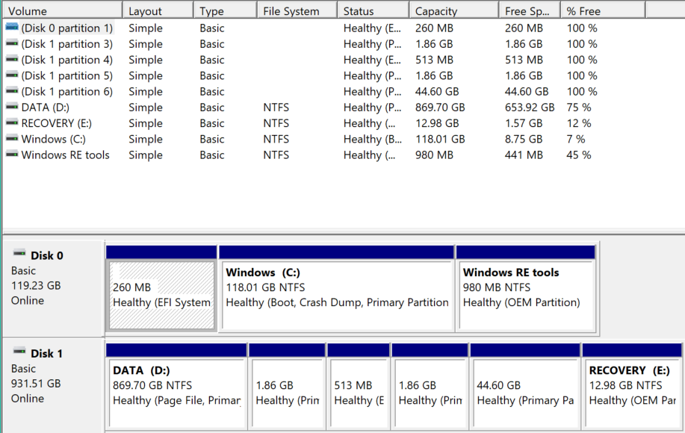

Here, you can see that there are several partitions on your computer. Your main drive is your C: drive (this contains your windows operating system). Choose either your C: or your D: drive (preferably C:, but D: usually has more empty space) and right click it. Choose the option “Shrink Volume”.

1. You should see a pop up that looks like the one below. Choose the size of your partition (40Gb is about 40000Mb). Then select “Shrink”.

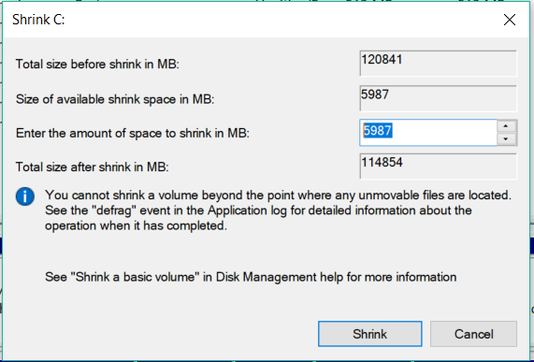

1. Finally, you should see a screen similar to that of step 3. Now, there should be a partition that, instead of blue, has a black border and is “Unallocated”. This is the partition for your operating system.

-- Step 2: Booting from a USB Drive --

**Flash Drive Booting in Mac OS:**

1. Download the preferred distribution of Ubuntu onto your computer (Ubuntu 18.04)
2. Get a flash drive with at least 2Gb of storage (make sure this flash drive is empty and not being used for anything important).
3. Insert the USB into your computer and open Disk Utility from “Application/Utilities”.
4. Select the USB from the sidebar on the left. You should see a few options at the top of the screen now. Click “Erase”. This will format the drive.

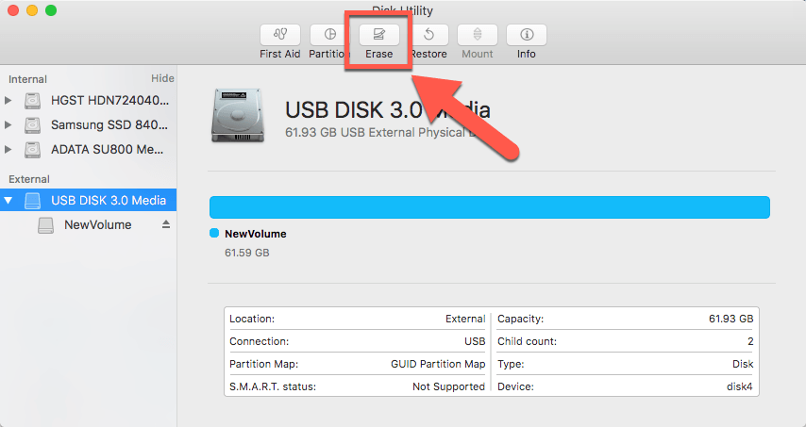

1. You should see a pop-up screen asking if you want to erase it. Change the format to “MS-DOS (FAT)” and change the scheme to “GUID Partition Map”. Then click “Erase” and it will begin the formatting process.

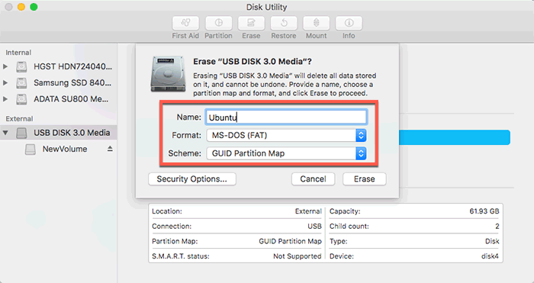

1. Download a software called Etcher here: <https://www.balena.io/etcher/>
2. Open the software and click “select image”. Choose the Ubuntu file you downloaded on your computer earlier.

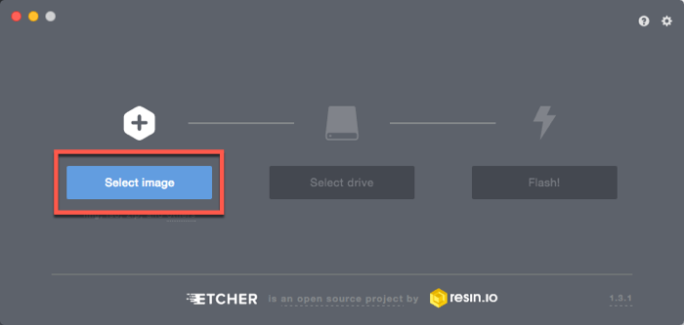

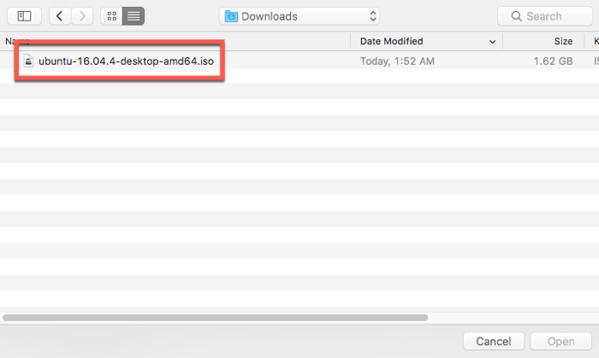

1. Now select “select drive” and choose the USB.

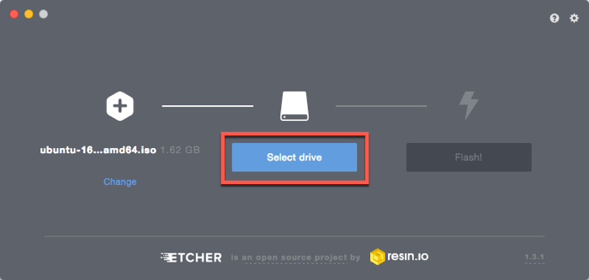

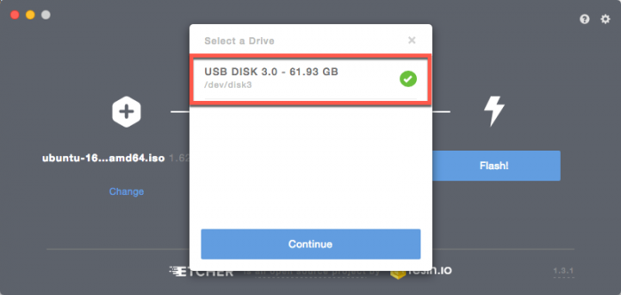

1. You need to disable System Integrity Protection (SIP). To do this, turn off your computer. Now press the on button again, but while it’s booting hold command + R until the Apple logo appears. This will bring you to recovery mode. Once you’re there, click “Utilities -> Terminal”. In the terminal window, type “csrutil disable” (without the quotation marks) and press Enter. Now restart your computer again.
2. You’re probably sick of having to install third party stuff by now but I promise this is the last one. Anyway, download the binary package for the software rEFInd here: <https://sourceforge.net/projects/refind/files/0.11.2/refind-bin-0.11.2.zip/download> (the download will begin right when you open the link). Unzip the downloaded file.
3. Open Terminal (ooh scary) from “/Applications/Utilities/Terminal”
4. Drag “refind-installer” file onto the terminal icon. This will run the script.

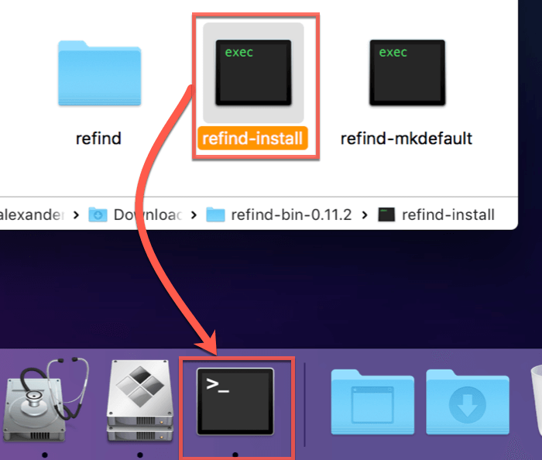

1. Reboot your computer to ensure that rEFInd is operational. The purpose of this software is to allow you to choose between operating systems upon booting up your computer. Now, when your computer boots up, you can choose which operating system to use, otherwise it will automatically boot within a few seconds to your primary operating system.

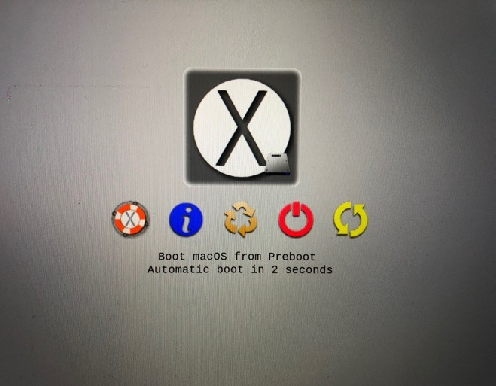

1. After all that setup, now we can actually boot Ubuntu from the flash drive. Reboot your computer again and select the USB drive in rEFInd to boot from it.

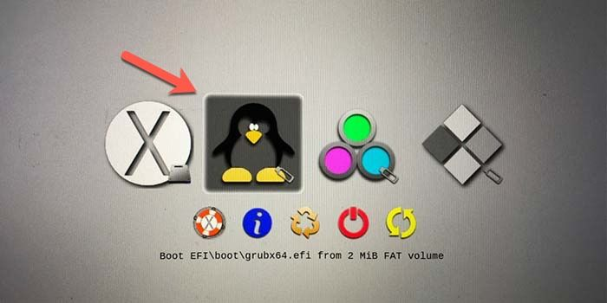

1. Proceed to the “Step 3: Installing Ubuntu” portion of this guide.

**Flash Drive Booting in Windows 10:**

1. Download the preferred distribution of Ubuntu onto a flash drive (Ubuntu 18.04)
2. Open the BIOS startup menu on your computer. This is done by shutting off the computer and pressing a certain button (depending on your computer) while the computer is booting up again. For instance, on some Lenovo computers there is a small button on the side of the computer. On other computers, you may have to repeatedly press F2 during startup. For your specific computer, you can google “bios menu [computer brand]” and it should tell you how to get there.
3. Once you’re in the BIOS menu, navigate to “Secure Boot” and make sure it is disabled. If not, disable it. This is shown in the photo below (might not look exactly like this, but explore until you find it).

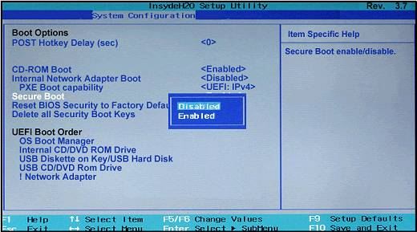

1. Save the changes in the BIOS menu and restart the computer so that you are back in Windows. Type in the search bar “Change Advanced Startup Options” or navigate to this in the Windows settings. Choose “Restart Now”.

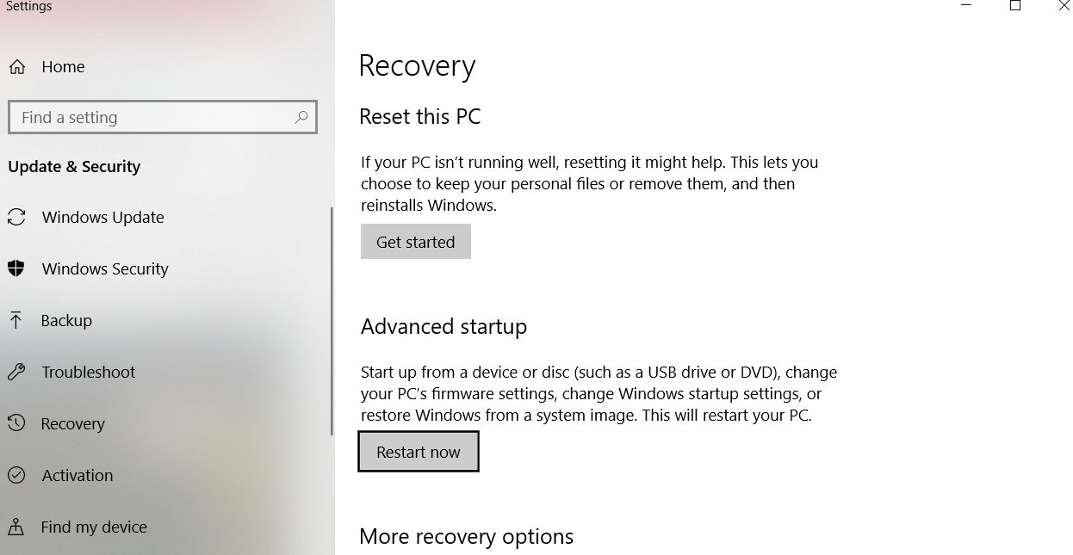

Once you do this, you will be brought to your computer’s startup options menu, where you will choose “Boot from Device” -> “USB Drive (UEFI)”. It may not be exactly this but something along these lines. Once you complete this step, your computer should boot Ubuntu from the USB. You will then be prompted to either try or install Ubuntu. (Troubleshooting – if this doesn’t work, go back in the BIOS settings and change the boot priority setting. There should be something called “Boot Order” (or something along these lines). Use the keys listed at the bottom of the screen to change the order so that external drives is first on the list. You can change it back to Windows if it still doesn’t boot from your flash drive).

-- Step 3: Installing Ubuntu --

These steps are universal regardless of the operating system you started in. Follow these steps once you have successfully installed Ubuntu.

1. The first few steps are straightforward:

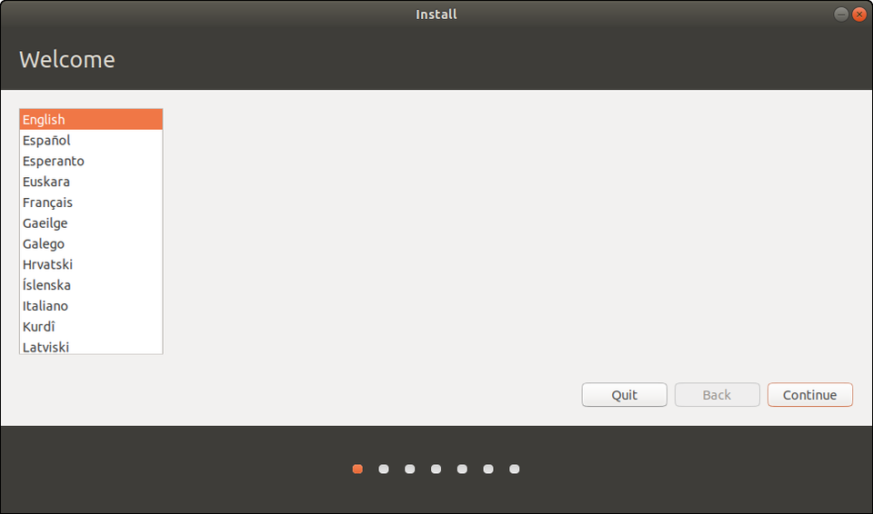

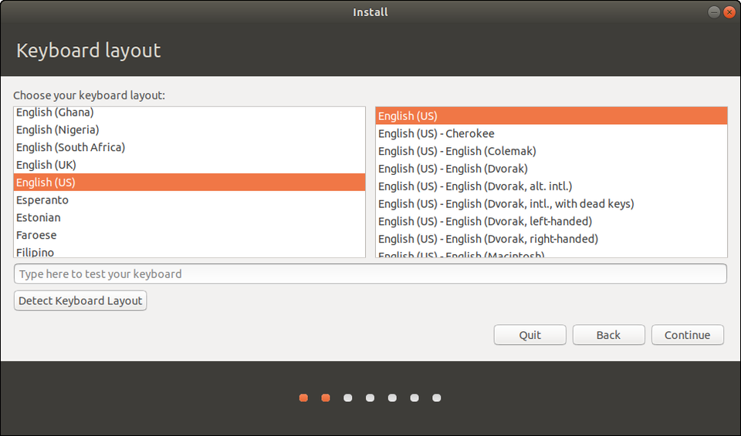

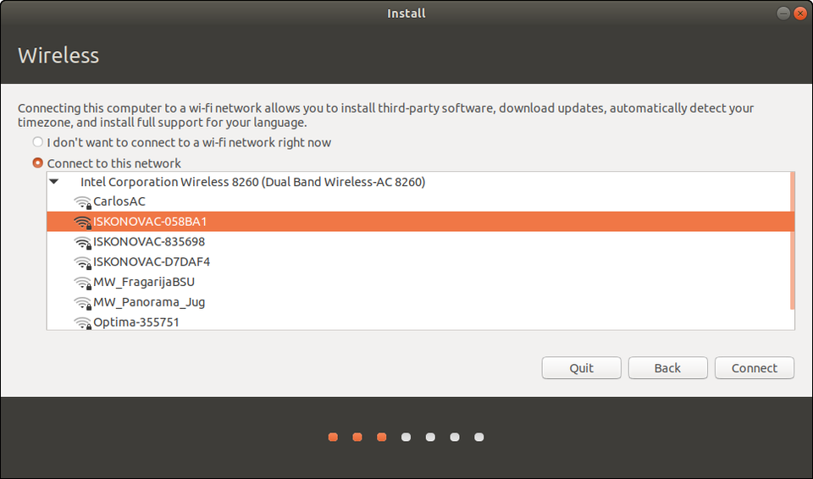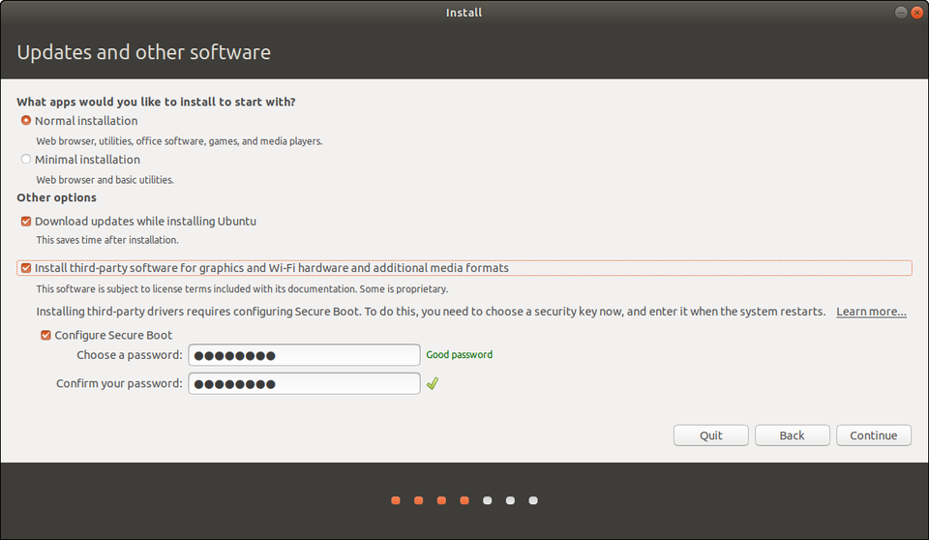

You can skip the 3rd party software installation and can postpone entering a WiFi password until after the installation if you want.

1. The next step after the above one is to choose the type of installation. Choose “Something Else”.

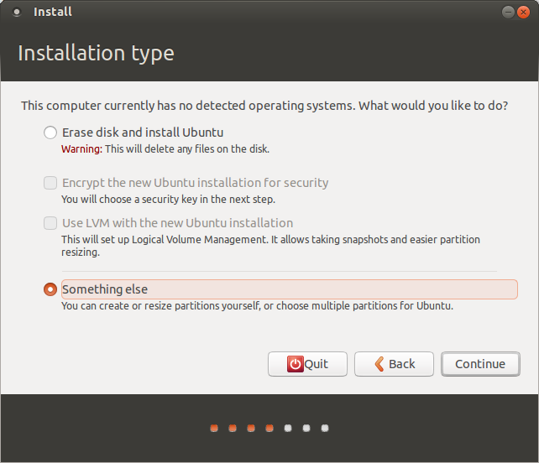

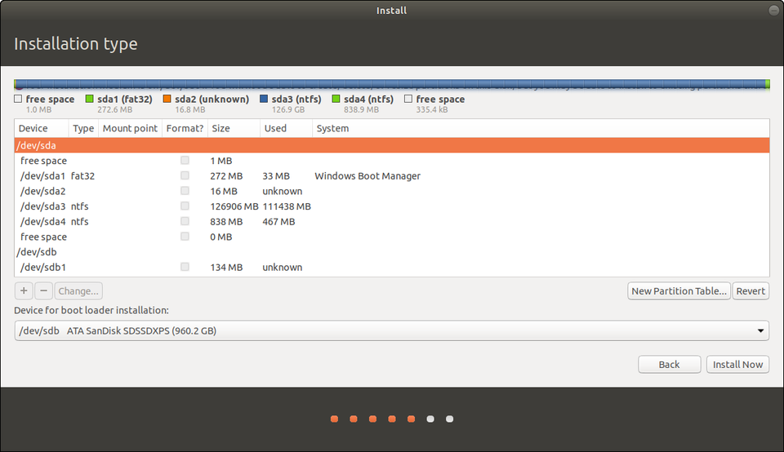

You should be directed to a screen that looks like this^. Choose your disk. It should be listed as /dev/sda or dev/mapper/pdc_*. It might be called something else, but the general rule is that it’s the one that’s the same size as the partition you made earlier in your main operating system. Just make sure you select the right one or you might delete important files on your main partitions. Select “New Partition Table” (Note: if you don’t have the option to click New Partition Table, skip this step).

1. Find a partition called “Free Space” that has the same amount of space as the partition you made in the beginning (it’s listed in megabytes, just convert it to gigabytes). Click on the partition and press the “+” button in the lower left corner. You should see a screen like this:

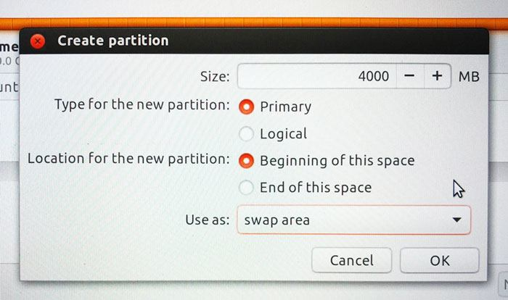

1. Choose the same exact settings as shown here.
2. Press OK. Then choose “free space” again (the same one you clicked before, that might be 4000MB less than it was before now) and click “+”. Choose the same settings as below, but with the size equal to the entire free space you have left.

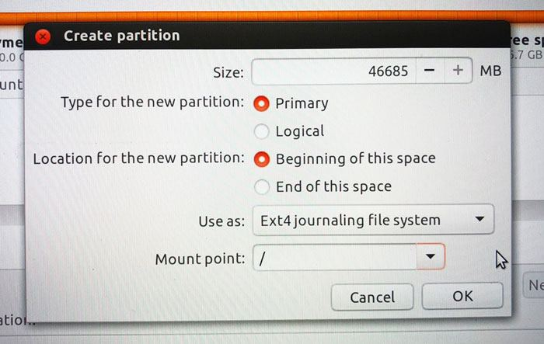

Click OK.

1. Choose the ext4 partition you just made under “device for bootloader installation”

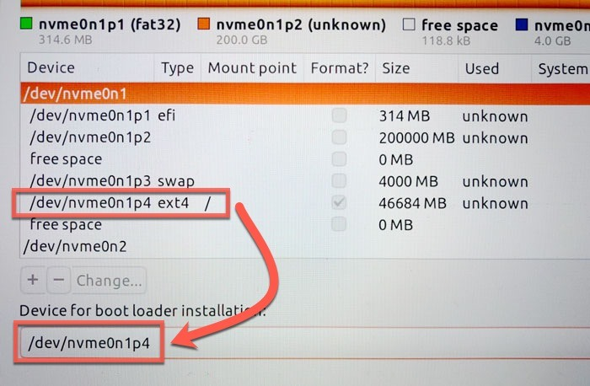

1. Click “install now”.
2. Let the installation complete.
3. ***Mac users only*** Now your computer thinks that Ubuntu is your main operating system and will automatically boot to it when you turn on your computer. To change the boot order, follow these instructions in a Terminal window in Ubuntu:

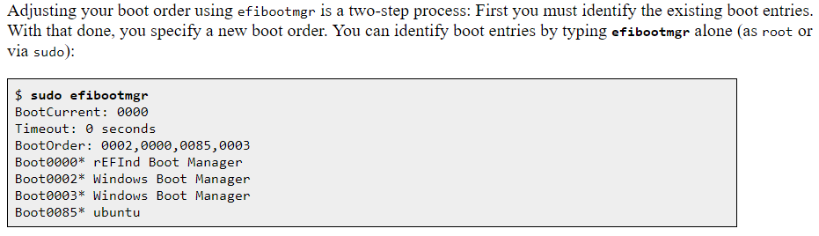

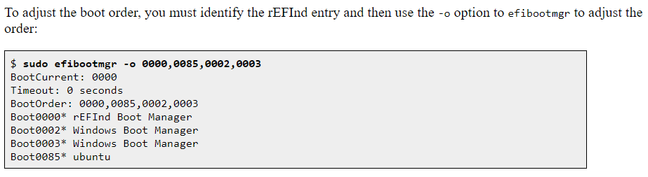

Basically what’s going on here is that you’re first checking the boot order with the command “sudo efibootmgr”. The output when you type this in the command line and press “enter” is the BootOrder, which is the order of the systems that boot on your computer. In the first grey block, we see that the BootOrder is 0002, 0000, 0085, 0003. This indicates that Boot0002 will execute upon startup, which is the Windows Boot Manager in this case. On your computer, you want rEFInd Boot Manager to run first. That software allows you to choose which operating system you run every time you start up your computer. Use the command in the last grey block to change the boot order. In the example above, the command typed is “sudo efibootmgr -o 0000, 0085, 0002, 0003. Thus, they change Boot0000 (rEFInd Boot Manager) to the first thing that boots upon startup. The numbers likely won’t be the same on your computer, but the steps are analogous. Change your highest priority boot to rEFInd Boot Manager.

1. Finally, when you restart your computer, you should have the option to boot your Ubuntu operating system or your main (Windows/Mac) operating system. 😊
   1. On Windows, the menu will appear automatically when you shut down and turn on the computer again.
   2. On Mac, when you turn on the computer, you will need to hold down the “options” key to select an operating system. Otherwise, it will boot to the default one you chose in the previous step.

**Keyboard/Touchpad Troubleshooting**

Now obviously if your keyboard and touchpad aren’t working you’ll need USB alternatives to make it through the installation. Get yourself a USB hub if your computer doesn’t have 3 or more ports (one for the flash drive you’re installing off of and two more for the keyboard/mouse, or if you’re a real rebel you can get away with just 2 ports and constantly switch between the keyboard and mouse). Once you’ve finished the installation, try following these instructions (that might require you to enter some witchcraft into the command line):

1. Go on this GitHub repository: <https://github.com/cb22/macbook12-spi-driver>
2. Learn how to recompile the kernel (<https://askubuntu.com/questions/163298/whats-a-simple-way-to-recompile-the-kernel>) which requires some basic understanding of Linux
3. Follow the steps on the GitHub and you should be good to go. Ask me for help with this part if you don’t know how to Linux.

The last thing to mention about this is that in the accessibility options there is an option to turn on the on-screen keyboard in case you don’t have a USB one (only works after you’ve successfully installed Ubuntu), which is a temporary solution.

I stole probably half of these images from google (that half being the Mac images because I don’t have a Mac) so don’t post this anywhere because I don’t want to get sued. If you still need help come find me!