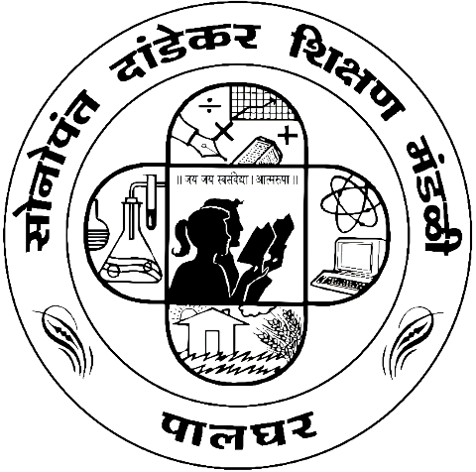

SONOPANT DANDEKAR ARTS, V.S. APTE COMMERCE & M.H. MEHTA SCIENCE COLLEGE, PALGHAR MAHARASHTRA - 401404

DEPARTMENT OF INFORMATION TECHNOLOGY

This is to certify that Mr. / Miss. _____________________________________________ of M. Sc. (I. T.) - Part 1, Semester I, Seat. No: _______________ has successfully completed the practicals in the subject of SOFT COMPUTING TECHNIQUES as per the requirement of the University of Mumbai in part fulfillment for the completion of Degree of Master of Science (Information Technology). It is also to certify that this is the original work of the candidate done during the academic year 2024-25.
Internal Examiner | Head of Department
External Examiner
Date: | College Seal

