SONOPANT DANDEKAR ARTS, V.S. APTE COMMERCE & M.H. MEHTA SCIENCE COLLEGE, PALGHAR MAHARASHTRA - 401404
(Affiliated to University of Mumbai)
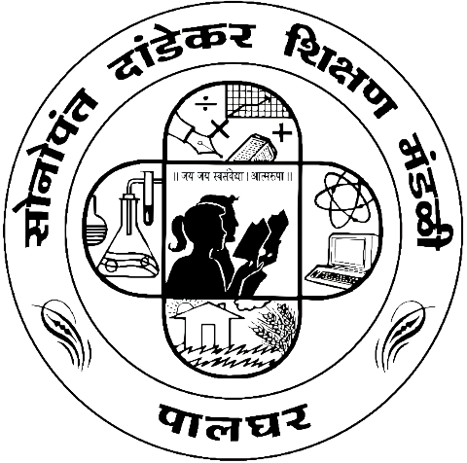

DEPARTMENT OF INFORMATION TECHNOLOGY
Master of Information Technology [M. Sc. (I. T.)]
SEMESTER - I

Practical Journal
In
SOFT COMPUTING TECHNIQUES

Submitted by
SUSHANT A. TARE
1310413
For the academic year
2024 - 25

