Software Requirements Specification
FontID — Typographic-Hallucination Font Matcher Web demonstrator for “Addressing Typographic Hallucination in Generative AI Images: An Open-Set Metric Learning Approach to Font Style Recognition.”
Version 1.0 · IEEE 830 / ISO·IEC·IEEE 29148 (thesis-scoped)
Date | Version | Description | Author
2026-07-16 | 1.0 | Initial thesis-scoped SRS | Research team

1. Introduction

1.1 Purpose
This document specifies the requirements for FontID, the web demonstrator that exposes the thesis’s font-recognition model to a user. It is the artifact half of the study’s build method (§4.10): a single-page application that accepts a generative-AI image, runs the open-set metric-learning pipeline, and returns a ranked shortlist of the closest Google Fonts for each detected line of text — or rejects the text as out-of-palette. The document is written for the two researchers (developers), the faculty adviser, and the panel evaluating the demonstrator.
Requirements use shall for mandatory behavior, should for desired behavior, and are labeled REQ-<section>-<n> with priority High / Med / Low.

1.2 Scope
FontID is a local demonstration harness, not a production service. It wraps the trained model so that hallucinated text crops map to a localized palette of the top 50–100 Google Fonts for free template reconstruction. Explicitly out of scope: user accounts, multi-user scaling, persistent storage, payment/licensing, and font vectorization. The app is single-page with three zones — Input → Processing → Results — and runs on one machine for the defense demo.

1.3 Definitions and Acronyms
Term | Meaning
Typographic hallucination | Probabilistic glyph deformation (warping, kerning jitter, smear) that GenAI introduces into rendered text.
Palette | The curated closed set of 50–100 known Google Fonts the model can name.
Open-set / reject | Returning “unknown” when a crop’s best match falls below threshold τ, instead of forcing a wrong label.
Top-K | The K highest-ranked font candidates for one text crop (K = 3 in the demo).
Embedding | The fixed-length style vector produced by the DINOv2 encoder + metric head.
SSIM | Structural Similarity Index — re-render score between the input crop and the predicted font.

2. Overall Description

2.1 Product Perspective
FontID is a new, self-contained front end over an existing trained model; it adds no new learning logic. The runtime path is layered — React client → FastAPI backend → PyTorch inference service → model weights and font assets — as detailed in the system-architecture diagram (Ch4 §4.5.2, Fig 9). The trained metric head is produced offline; the app only loads and serves it.

2.2 Product Functions
- Accept a GenAI image by drag-drop, file browse, or bundled sample.
- Localize the text region(s) in the image and crop each one.
- Embed each crop and rank it against the font palette.
- Return a Top-K shortlist per crop with a similarity score, or reject it as out-of-palette.
- Render each candidate font as a live preview of the detected text for visual confirmation.

2.3 User Classes
User class | Characteristics | Use of the app
Designer / end user | Non-technical; wants a free font match to rebuild a template. | Uploads an image, reads the Top-K shortlist.
Researcher / evaluator | The team + panel; technical. | Drives the demo, inspects scores, confirms open-set reject behavior.

2.4 Operating Environment
- Client: current Chrome / Firefox / Edge (latest two versions), desktop viewport.
- Server: Python 3.11+, FastAPI, PyTorch, packaged with Docker; runs on the presenter’s laptop (localhost). GPU optional — CPU inference acceptable for single-image demo latency.
- Assets: DINOv2 + baseline weights from HuggingFace Hub; Google Fonts files for palette matching and preview rendering.

2.5 Design and Implementation Constraints
- Stack is fixed by the methodology (§4.8): React (frontend), FastAPI (backend), PyTorch + HuggingFace (inference), Docker (deploy).
- Preprocessing (square-pad → 224² → ImageNet normalize) shall run inside the model forward pass to avoid train–serve skew (§4.3.2).
- Only open-source fonts (the Google Fonts palette) may be returned — no commercial font identifiers or licenses.

2.6 Assumptions and Dependencies
- The trained metric head and palette are available on disk at startup.
- The uploaded image contains legible rendered text (not handwriting / heavy occlusion).
- The off-the-shelf text-localization component is available and returns bounding boxes.

3. External Interface Requirements

3.1 User Interface
Single page, three vertically stacked zones (wireframe below):
- Input — a drag-drop/browse dropzone, sample thumbnails, and an Identify Fonts action.
- Processing — the uploaded image with detected text regions boxed, plus a pipeline status/progress indicator.
- Results — one card per detected crop: the crop thumbnail, its Top-K font shortlist (name · preview · similarity bar), and a KNOWN / UNKNOWN badge for the open-set decision.
The interface shall work at desktop widths and keep all three zones reachable on one page. Standard affordances: every result font preview offers a copy-name / preview action.
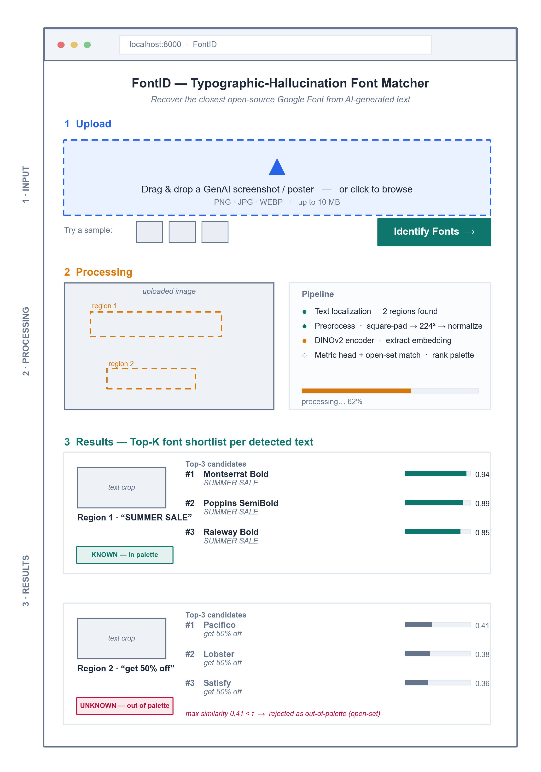
Figure — FontID single-page wireframe (Input → Processing → Results).
Figure. FontID wireframe: three-zone single page. Region 1 accepts (Top-3 in palette); Region 2 is rejected as out-of-palette (max similarity < τ), demonstrating open-set behavior.

3.2 Software Interfaces
Interface | Purpose | Data exchanged
POST /predict (FastAPI REST) | Client sends the image; server returns results. | Request: image (multipart). Response: JSON — per crop, bounding box + Top-K {font, score} + known flag.
HuggingFace Hub | Load DINOv2 + baseline weights at startup. | Model tensors (read-once).
Google Fonts assets | Palette matching + preview rendering of candidate fonts. | Font files (.ttf/.woff2).
All client–server traffic is local HTTP over localhost.

4. System Features (Functional Requirements)

4.1 Image Input — Priority: High
User supplies a GenAI image. Stimulus/response: user drops/selects an image → client shows a preview and enables Identify Fonts → click posts to /predict.
ID | Requirement | Priority
REQ-4.1-1 | The system shall accept an image via drag-drop, file picker, or a bundled sample. | High
REQ-4.1-2 | The system shall accept PNG, JPG, and WEBP up to 10 MB and reject other types with a clear message. | High
REQ-4.1-3 | The system shall display a preview of the uploaded image before processing. | Med

4.2 Text Localization and Processing — Priority: High
The backend finds text regions and prepares each crop. Stimulus/response: /predict receives the image → localizer returns boxes → each crop is preprocessed and embedded → status advances in the Processing zone.
ID | Requirement | Priority
REQ-4.2-1 | The system shall detect one or more text regions and crop each region for independent matching. | High
REQ-4.2-2 | The system shall preprocess each crop (square-pad → 224² → normalize) inside the model forward pass. | High
REQ-4.2-3 | The system shall show processing status/progress and detected-region boxes while inference runs. | Med
REQ-4.2-4 | The system should return an informative error if no text region is found. | Med

4.3 Font Matching and Top-K Results — Priority: High
For each crop, rank the palette and decide known vs. unknown. Stimulus/response: embedding is compared to the palette → if best similarity ≥ τ, return ranked Top-K; else mark the crop out-of-palette.
ID | Requirement | Priority
REQ-4.3-1 | The system shall return a Top-K (K = 3) ranked shortlist of Google Fonts per crop, each with a similarity score. | High
REQ-4.3-2 | The system shall reject a crop as “unknown / out-of-palette” when its best similarity falls below threshold τ (open-set). | High
REQ-4.3-3 | The system shall present each crop’s result as its own card, labeled KNOWN or UNKNOWN. | High
REQ-4.3-4 | The system should report a typographic-distance (SSIM) score between the crop and the top match. | Low

4.4 Font Preview — Priority: Med
Let the user visually confirm a match. Stimulus/response: for each candidate the app renders the detected text string in that font.
ID | Requirement | Priority
REQ-4.4-1 | The system shall render each shortlisted font as a live preview of the detected text. | Med
REQ-4.4-2 | The system should let the user copy a candidate font’s name for reuse. | Low

5. Non-Functional Requirements

5.1 Performance
ID | Requirement | Priority
REQ-5.1-1 | The system shall return results for a single-image, ≤5-region upload within ~10 s on the demo laptop (CPU acceptable). | High
REQ-5.1-2 | Model weights shall load once at startup, not per request. | High

5.2 Usability
ID | Requirement | Priority
REQ-5.2-1 | A first-time user shall complete upload → results without instructions, in one page with no navigation. | High
REQ-5.2-2 | Scores and known/unknown status shall be visible without interaction. | Med

5.3 Reliability and Portability
ID | Requirement | Priority
REQ-5.3-1 | The system shall handle an unreadable/oversized/textless upload without crashing, returning a clear message. | High
REQ-5.3-2 | The system shall run from a single Docker image on a clean machine with no manual dependency setup. | Med
Security note: as a single-user local demo the app has no authentication, no persistence, and stores no uploads beyond the request lifetime; uploaded images are processed in memory and discarded.

Appendix A — Traceability
Functional features 4.1–4.4 realize the §4.5.1 functional requirements (upload · isolate crop · Top-K or unknown · font preview) and are served by the §4.5.2 architecture (Fig 9). Zones in the §3.1 wireframe map one-to-one to features 4.1 (Input), 4.2 (Processing), and 4.3–4.4 (Results).

July 16, 2026
MARK CANETE <Position> <Address>
Dear <Mr./Ms.> Canete,
Greetings!
We respectfully request your participation as an expert evaluator and consultant for our thesis project entitled “Addressing Typographic Hallucination in Generative AI Images: An Open-Set Metric Learning Approach to Font Style Recognition.” Generative AI image tools (e.g., DALL·E, Midjourney) render text with typographic hallucinations (warped glyphs, irregular kerning, and character smearing) that cause commercial font identifiers to fail. Our system applies a deep-learning metric-learning pipeline that matches such distorted text to the closest open-source Google Font, so that a designer can rebuild the typography from a free, license-clear font.
Given your expertise in <field, e.g., typography / graphic design>, we specifically seek your help with the following:
- Serving on our expert-evaluation panel. You would visually identify and rank the closest matching Google Font for a curated set of approximately 100 AI-generated text samples. This expert consensus establishes the human ground-truth benchmark against which we measure our system’s accuracy.
- Validating our research instrument. You would review our curated palette of the top 50 to 100 Google Fonts and the realism of our synthetic text-degradation samples.
Your involvement would take approximately <estimated time> and would be conducted entirely online and asynchronously: you would complete a self-paced web-based rating form at your own convenience, with no scheduled session required. All responses will be used solely for academic purposes and reported in aggregate.
This research study is being conducted as part of the requirements for the completion of the Bachelor of Science in Computer Science program under the Department of Computer and Information Sciences and Mathematics, University of San Carlos. We believe that the findings of this study will contribute meaningfully to the advancement of knowledge and provide benefits to the community.
We sincerely appreciate your time and consideration, and we look forward to your positive response.
Thank you very much.
Respectfully,
Matt Cabarrubias Student Researcher
Janritch Diputado Student Researcher
Noted by:
Christine D. Bandalan, MEng Thesis Project Adviser
Approved by:
<Name of the Owner/Head> <Position>

July 16, 2026
RACHEL SALUNA <Position> <Address>
Dear <Mr./Ms.> Saluna,
Greetings!
We respectfully request your participation as an expert evaluator and consultant for our thesis project entitled “Addressing Typographic Hallucination in Generative AI Images: An Open-Set Metric Learning Approach to Font Style Recognition.” Generative AI image tools (e.g., DALL·E, Midjourney) render text with typographic hallucinations (warped glyphs, irregular kerning, and character smearing) that cause commercial font identifiers to fail. Our system applies a deep-learning metric-learning pipeline that matches such distorted text to the closest open-source Google Font, so that a designer can rebuild the typography from a free, license-clear font.
Given your expertise in <field, e.g., typography / graphic design>, we specifically seek your help with the following:
- Serving on our expert-evaluation panel. You would visually identify and rank the closest matching Google Font for a curated set of approximately 100 AI-generated text samples. This expert consensus establishes the human ground-truth benchmark against which we measure our system’s accuracy.
- Validating our research instrument. You would review our curated palette of the top 50 to 100 Google Fonts and the realism of our synthetic text-degradation samples.
Your involvement would take approximately <estimated time> and would be conducted entirely online and asynchronously: you would complete a self-paced web-based rating form at your own convenience, with no scheduled session required. All responses will be used solely for academic purposes and reported in aggregate.
This research study is being conducted as part of the requirements for the completion of the Bachelor of Science in Computer Science program under the Department of Computer and Information Sciences and Mathematics, University of San Carlos. We believe that the findings of this study will contribute meaningfully to the advancement of knowledge and provide benefits to the community.
We sincerely appreciate your time and consideration, and we look forward to your positive response.
Thank you very much.
Respectfully,
Matt Cabarrubias Student Researcher
Janritch Diputado Student Researcher
Noted by:
Christine D. Bandalan, MEng Thesis Project Adviser
Approved by:
<Name of the Owner/Head> <Position>

July 16, 2026
VICTORIENNE TIU <Position> <Address>
Dear <Mr./Ms.> Tiu,
Greetings!
We respectfully request your participation as an expert evaluator and consultant for our thesis project entitled “Addressing Typographic Hallucination in Generative AI Images: An Open-Set Metric Learning Approach to Font Style Recognition.” Generative AI image tools (e.g., DALL·E, Midjourney) render text with typographic hallucinations (warped glyphs, irregular kerning, and character smearing) that cause commercial font identifiers to fail. Our system applies a deep-learning metric-learning pipeline that matches such distorted text to the closest open-source Google Font, so that a designer can rebuild the typography from a free, license-clear font.
Given your expertise in <field, e.g., typography / graphic design>, we specifically seek your help with the following:
- Serving on our expert-evaluation panel. You would visually identify and rank the closest matching Google Font for a curated set of approximately 100 AI-generated text samples. This expert consensus establishes the human ground-truth benchmark against which we measure our system’s accuracy.
- Validating our research instrument. You would review our curated palette of the top 50 to 100 Google Fonts and the realism of our synthetic text-degradation samples.
Your involvement would take approximately <estimated time> and would be conducted entirely online and asynchronously: you would complete a self-paced web-based rating form at your own convenience, with no scheduled session required. All responses will be used solely for academic purposes and reported in aggregate.
This research study is being conducted as part of the requirements for the completion of the Bachelor of Science in Computer Science program under the Department of Computer and Information Sciences and Mathematics, University of San Carlos. We believe that the findings of this study will contribute meaningfully to the advancement of knowledge and provide benefits to the community.
We sincerely appreciate your time and consideration, and we look forward to your positive response.
Thank you very much.
Respectfully,
Matt Cabarrubias Student Researcher
Janritch Diputado Student Researcher
Noted by:
Christine D. Bandalan, MEng Thesis Project Adviser
Approved by:
<Name of the Owner/Head> <Position>

